Cloud Forensics Challenges in Bangladesh:
A PRISMA Systematic Review with AI-Enhanced Resolution Strategies
Md. Ahsan Kabir
Department of Computer Science and Engineering
United International University, Dhaka, Bangladesh
mkabir2520016@mscse.uiu.ac.bd

Abstract—Bangladesh’s accelerating cloud adoption—over 100 million internet-enabled devices and more than $1.2 billion in public-sector cloud procurement since 2020—has outpaced the legal and procedural infrastructure governing digital investigations. The country’s investigative statutes (ICT Act 2006, Digital Security Act 2018, Cyber Security Act 2023) were drafted for physical endpoint devices and are silent on cloud-hosted evidence, statutory log preservation, and cross-border jurisdictional complexity. The result is a growing gap: the Cyber Tribunal records a disproportionately high acquittal rate on cloud-sourced evidence cases, driven not by disputed facts but by chain-of-custody failures and Section 65B admissibility deficiencies.
This paper addresses that gap through a PRISMA 2020-compliant review of 16 open-access publications (2021–2026), identifying five challenge clusters (C1–C5) and mapping each to a validated AI resolution strategy with quantitative evidence. The resulting AI-Enhanced Cloud Forensic Readiness Framework for Bangladesh (AI-CFRF-BD) provides a phased, locally implementable pathway for Bangladesh’s law enforcement and policymakers.
Index Terms—cloud forensics, digital evidence, Bangladesh cyber law, PRISMA systematic review, AI forensics, blockchain chain-of-custody.
I. INTRODUCTION
Bangladesh has undergone a rapid digital transformation driven largely by mobile connectivity. By 2023, over 66.94 million citizens used the internet regularly, with more than 100 million internet-enabled devices in circulation [15]; public-sector cloud procurement had surpassed $1.2 billion since 2020 [16]. Government ministries, financial institutions, and private enterprises have rapidly migrated critical workloads to cloud platforms, yet the country’s investigative framework was designed for seized hard drives and physical devices—not for evidence residing on foreign cloud servers [12]. Cloud forensics demands fundamentally different assumptions about data custody, access rights, evidence provenance, and jurisdictional authority [13]. Bangladesh’s Cyber Security Act 2023 (CSA 2023), despite establishing a dedicated Cyber Tribunal, is entirely silent on cloud-hosted evidence, statutory log preservation, and cross-border jurisdictional complexity—leaving a growing enforcement gap.
A. Motivation
The practical cost of this gap is visible in the Cyber Tribunal’s case record. Cloud activity logs are automatically deleted on 30-to-90-day retention cycles, yet Bangladesh has no statutory data-hold mechanism to compel CSPs to suspend deletion while investigators obtain a court order [10]. Section 65B of the Evidence Act—the sole mechanism for certifying digital evidence admissibility—was drafted for records derived from devices physically in the investigator’s possession, a precondition almost never met for remotely hosted cloud logs [10], [11]. Uzzal’s review documents a consistent pattern: acquittals driven not by disputed facts but by broken custody chains, malformed certificates, and forensic reports that ignore the cloud storage layer separating the alleged offence from the physical exhibit [11].
B. Research Gap
No prior study applies PRISMA 2020 to systematically map cloud forensics challenges within Bangladesh’s legal context. Alshabibi et al.’s global SLR (31 studies) includes no Bangladesh-specific analysis, omits the Section 65B barrier, and predates the 2025 legislative instruments [1]. Bangladesh-authored works [10], [13], [15] address individual challenges but do not map them to validated AI tools. No prior work simultaneously addresses all five challenge dimensions with Bangladesh relevance; the present review is the first to do so.
C. Research Questions
Four RQs were pre-registered before any database search commenced:
RQ | Question
RQ1 | What technical challenges do cloud environments pose to digital forensics in Bangladesh?
RQ2 | What legal barriers prevent admissibility of cloud-sourced evidence under Bangladesh’s legal framework?
RQ3 | How do AI-enhanced tools address the challenges in RQ1 and RQ2?
RQ4 | What implementable framework can improve cloud forensic readiness for Bangladesh law enforcement?

D. Contributions
• The first PRISMA 2020 SLR mapping cloud forensics challenges to Bangladesh’s legal and institutional context (16 open-access studies, 2021–2026), with comparative analysis of prior work in Table I.
• A five-cluster challenge taxonomy (C1–C5) cross-referenced against concrete gaps in the CSA 2023, Evidence Act Section 65B, MLAT mechanism, and CSP data-sharing frameworks (Table II).
• The AI-CFRF-BD framework: five validated AI tools mapped to the five clusters, each deployable within Bangladesh’s existing legal authority (Figs. 1–2).
II. LITERATURE REVIEW
A. Cloud Forensics: Global Landscape
Cloud computing’s defining features—on-demand provisioning, elastic scaling, resource pooling across IaaS, PaaS, and SaaS layers, support for public, private, and hybrid deployments—are also what makes it difficult to investigate [13]. The business advantages and the forensic disadvantages come from the same source.
Alshabibi, Liatsis, and Emhemed’s 2024 systematic review of 31 studies is the most comprehensive treatment of this problem to date [1]. They identify seven technical barriers—volatile data, multi-tenancy, encryption, virtualisation, jurisdictional fragmentation, insufficient readiness, inadequate tooling—and five legal ones: inadequate legislation, admissibility uncertainty, jurisdiction conflicts, no international framework, and privacy constraints. These categories are not independent. A single investigation can hit several simultaneously, and the legal barriers often make the technical ones worse.
Two theoretical contributions help frame what follows. Karagiannis and Vergidis coined the “Power of Disposal” concept: the party with legal authority to grant access to cloud data is the service provider, not the state issuing the warrant [8]. This inverts the traditional evidence-access model, for which most domestic legal frameworks—including Bangladesh’s—have no analogue. Separately, Prakash et al. mapped a five-stage forensic lifecycle and found that evidence preservation—not analysis, not presentation—is where cloud investigations most often fail [3]. In many cases, the window between detecting an incident and losing the logs to routine deletion is shorter than the time needed to obtain a court order.
B. Bangladesh Legal and Institutional Context
Subsequent 2025-2026 legislation has clarified rather than closed the gap. The Cyber Security Ordinance, 2025 (Ordinance No. 25 of 2025, gazetted 21 May 2025) repealed CSA 2023 outright -- removing nine contentious speech-restriction provisions, making previously non-bailable offences bailable, and reducing maximum penalties -- but it carries forward the same evidentiary machinery: proceedings still rely on the Tribunal search-warrant mechanism together with the Code of Criminal Procedure 1898, the Evidence Act 1872, and the ICT Act 2006, so the underlying cloud-evidence gap this paper identifies persists unchanged under the new law [20]. The Personal Data Protection Ordinance, 2025 (Ordinance No. 61 of 2025, gazetted 6 November 2025) imposed data-localisation duties, with full enforcement phased in over eighteen months. Its 2026 amendment, the Personal Data Protection (Amendment) Ordinance (Ordinance No. 23 of 2026, signed 5 February 2026), sharpened this requirement: at least one synchronised, real-time cloud copy must now be kept inside Bangladesh specifically for data classified as restricted or processed by Critical Information Infrastructure (CII) as defined under the Cyber Security Ordinance 2025, while replacing director-level criminal liability with financial penalties of up to 5% of annual turnover [21]. Neither ordinance grants a regulator or investigator forensic audit access to that mandated in-country copy, so the CII data-residency requirement -- though not designed with forensics in mind -- creates exactly the kind of local access point this paper's framework would need, if a future amendment added an audit-access provision. Separately, a 171-page National Digital Transformation Strategy released by the ICT Division and UNDP in February 2025 sets out a 2025-2030 roadmap for cloud-first digital public infrastructure, but remains a draft strategy document, not enacted law, and carries no forensic-readiness mandate [22].
C. Cross-Border Evidence Access
When cloud data is stored on foreign infrastructure, it falls under that country’s laws. Accessing that data for a domestic investigation nominally requires an MLAT request—a mechanism designed for physical evidence transfer between cooperating states. Akilal and Kechadi’s analysis of 47 jurisdictions found average MLAT processing times of six weeks to ten months, strongly correlated with the closeness of bilateral relationships and the availability of a specialist digital evidence track [9]. Neither condition currently applies to Bangladesh. Ekwempu’s 2026 analysis of United States v. Microsoft Corp. and the Yahoo Data Breach further demonstrates that even court-ordered access to extraterritorial cloud data is contested, and that resolution required years of primary legislation [14]. Rana’s comparative study of Colombia, India, and the United States shows that domestic legislative adaptation to the cloud paradigm—not the extension of endpoint-focused provisions—is the only effective remedy [16].
D. Research Gap and Motivation
Table I positions the eight most relevant prior studies against the five challenge clusters identified in this review. Three things stand out.
Akter and Rahman [13] come closer than anyone to covering the full picture—they address C1 through C4—but their work predates the CSA 2023 and proposes no AI-based resolution strategy. The four AI-tool papers [5]–[7], [9] are technically strong, but every one of them was validated in US or EU environments. None grapples with Section 65B. None considers what it means to operate in a jurisdiction with no statutory data-hold mechanism. The Bangladesh-specific studies [10], [11], [15] document the failures well but stop at diagnosis. They do not connect the observed problems to the AI-based tools available in the international literature.
What is missing, in short, is a study that takes the Bangladesh legal context seriously, applies reproducible methodology, covers all five challenge dimensions, and recommends actions grounded in peer-reviewed evidence. The present review addresses it by applying PRISMA 2020 methodology to produce the first such synthesis.

TABLE I. COMPARATIVE ANALYSIS OF MOST RELEVANT PRIOR STUDIES AGAINST THE FIVE CHALLENGE DIMENSIONS
Ref | Focus & Contribution | C1 | C2 | C3 | C4 | C5 | AI Tech. | BD Rel. | Method | Year
[1] | Alshabibi et al. -- SLR, 7 tech. + 5 legal barriers | Y | Y | P | P | Y | ML survey | N | SLR | 2024
[5] | Alharthi & Garcia -- CIAF LLM (93% F1) | Y | Y | P | N | P | LLM/GenAI | P | Framework | 2025
[6] | Igonor et al. -- blockchain CoC, 14/17 jurisd. | N | P | Y | Y | N | Blockchain | P | Prototype | 2025
[7] | Tageldin & Venter -- ML-CF, ISO/IEC 27043 | Y | Y | P | N | Y | ML/LSTM | P | SLR | 2023
[9] | Akilal & Kechadi -- CLERMS, 40-70% MLAT | Y | N | N | Y | P | NLP/Log | P | Prototype | 2025
[12] | Ahmed & Arifuzzaman -- CSA 2023 BD gap | Y | Y | Y | P | Y | Statistical | Y | Survey | 2025
[13] | Akter & Rahman -- cloud forensic dims., UIU | Y | Y | Y | Y | P | Process ML | Y | SLR+Model | 2023
[15] | Sharmin & Rahman -- BD Police survey (52) | P | N | Y | Y | Y | Statistical | Y | Survey | 2025
[P] | This study -- AI-CFRF-BD (PRISMA SLR) | Y | Y | Y | Y | Y | LLM+ML+BC | Y | PRISMA | 2026

Y = Fully addressed, P = Partially, N = Not addressed. BD Rel. = Bangladesh relevance. [P] = This study.

III. METHODOLOGY
This review follows a PRISMA 2020-guided systematic literature review (SLR) design [18]. PRISMA provides explicit, auditable procedures for every stage of source selection, distinguishes this study from narrative reviews, and allows future replication as the legislative landscape evolves. Figure 1 shows the PRISMA 2020 selection flow; Figure 2 illustrates the complete five-phase research process.
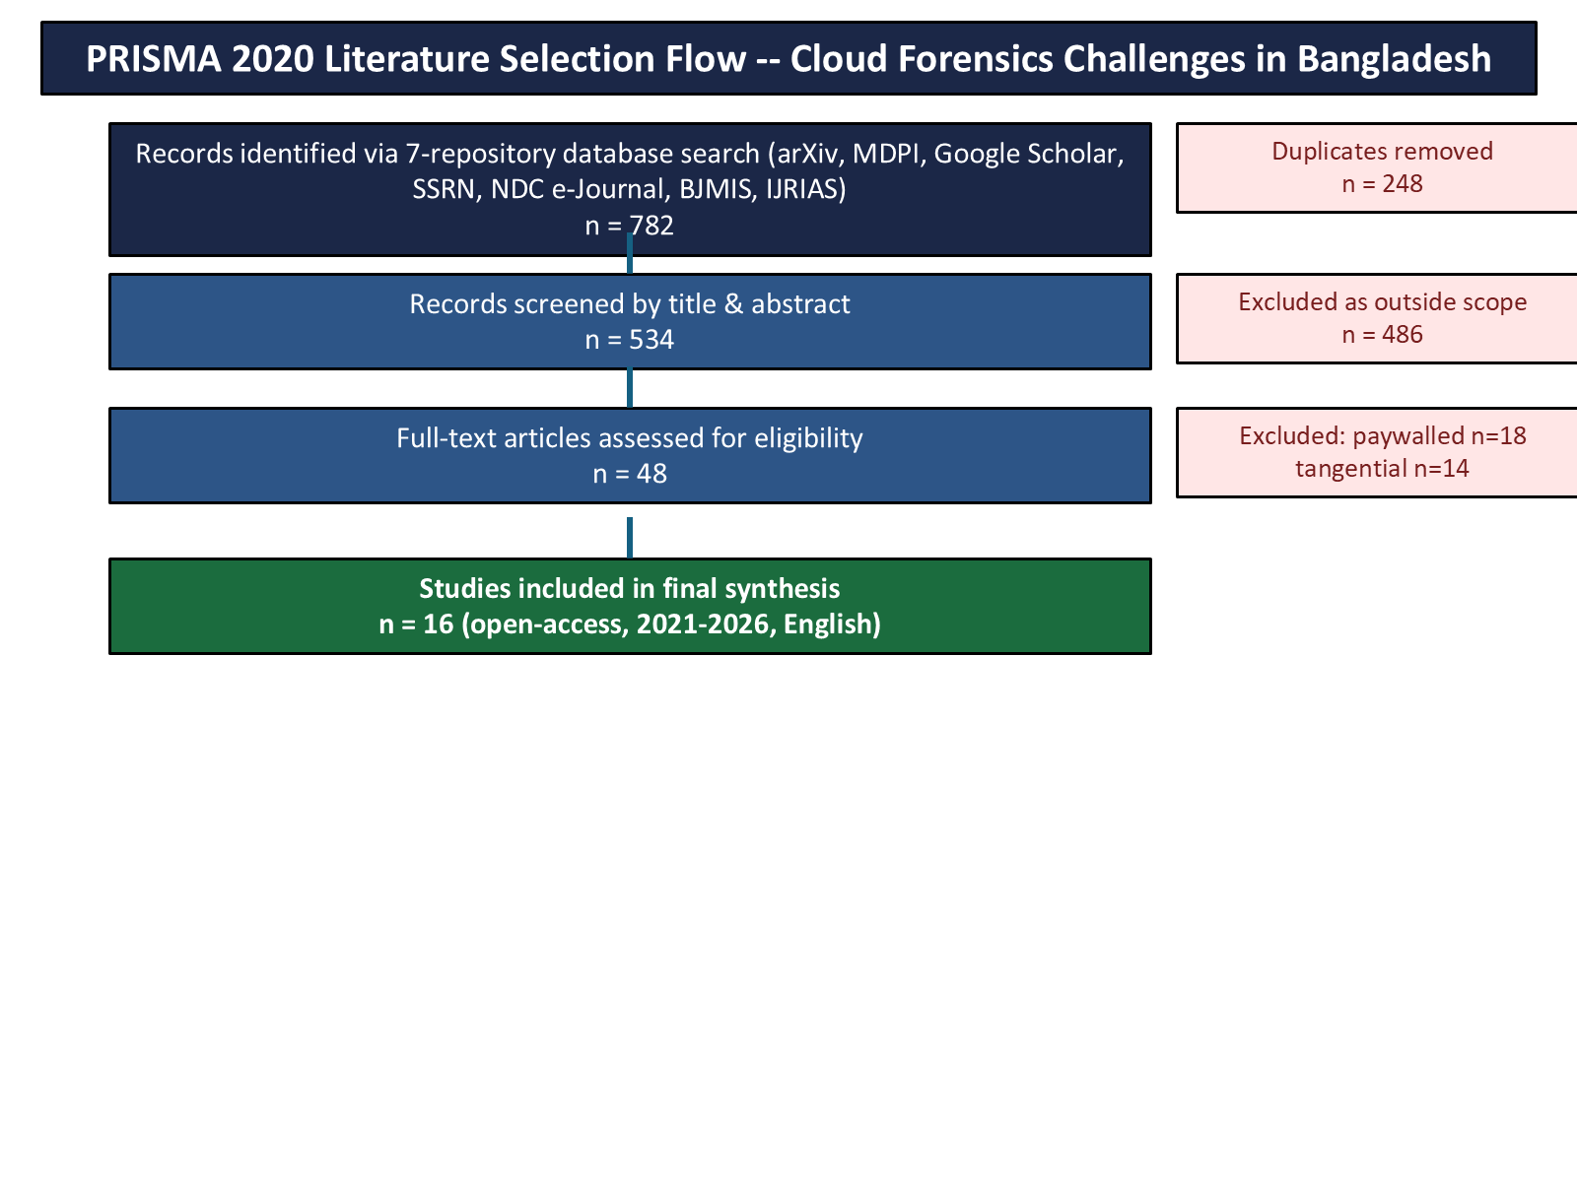
Fig. 1. PRISMA 2020 literature selection flow.
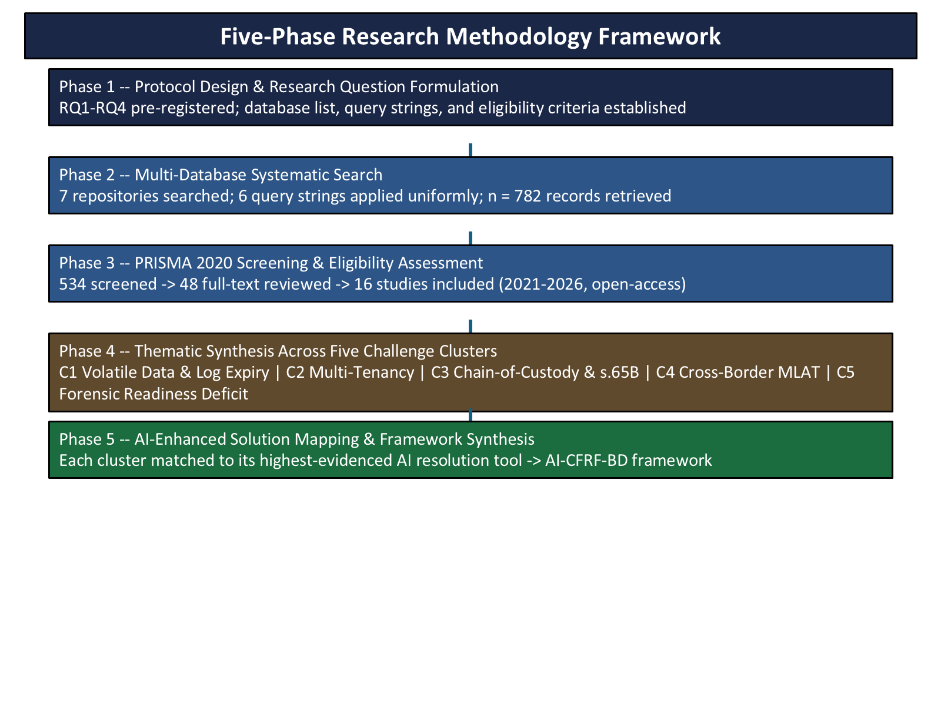
Fig. 2. Five-phase research methodology framework.
A. Search Strategy
Seven repositories were searched: arXiv (cs.CR) for current AI forensics preprints—the source of key papers including CIAF and CLERMS—MDPI Open Access for peer-reviewed forensics journals, Google Scholar and SSRN for broader coverage, and the NDC e-Journal, BJMIS, and IJRIAS for Bangladesh-specific policy literature that rarely surfaces in international databases. Six query strings were applied uniformly: “cloud forensics”, “digital evidence Bangladesh”, “AI forensics cloud”, “blockchain digital forensics”, “blockchain chain-of-custody”, and “cyber law BD”. We chose the 2021–2026 window to align with the post-DSA 2018 period and to capture studies engaging with the CSA 2023 environment. The search yielded 782 records.
B. Inclusion and Exclusion Criteria
A paper was included if it met four conditions: it addressed at least one of the five challenge dimensions derived from RQ1 and RQ2; it was published between 2021 and 2026; it was available in full text without a paywall; and it was in English.
The paywall criterion deserves a brief note. This review is itself open-access, and including paywalled sources would undermine reproducibility—readers checking the synthesis against the cited papers should be able to read those papers. Papers were excluded if they addressed only physical-device forensics without touching on the cloud context, or if they were conference abstracts lacking a methodology section. The latter exclusion is conservative but defensible: abstracts do not provide enough information to assess the quality of the underlying work.
C. PRISMA Screening Process
Of 782 initial records, 248 duplicates were removed. Screening the remaining 534 records by title and abstract, we excluded 486 as outside scope. The 48 full-text papers were read in full: 18 were paywalled, and 14 proved too tangentially connected to any of the five clusters to justify inclusion. The final 16 studies are all open-access, span 2021–2026, and each addresses at least one challenge dimension directly. Fig. 1 shows the full flow.
D. Thematic Synthesis and Framework Construction
A single reviewer coded all 16 studies using the thematic synthesis procedure of Thomas and Harden [17]; the absence of inter-rater verification is a stated limitation. Each study was coded on three dimensions: (a) which challenge cluster(s) it addresses; (b) whether Bangladesh relevance is direct, partial, or absent; and (c) whether it proposes an AI or automation-based resolution tool. The comparative matrix is in Table I. We then matched each cluster to the highest-evidenced resolution tool (RQ3) based on empirical metrics—F1-scores, jurisdiction counts, and latency and cost reductions—yielding the AI-CFRF-BD framework (RQ4). Table II presents the complete taxonomy.

TABLE II. TAXONOMY OF CLOUD FORENSICS CHALLENGES, AI SOLUTIONS, AND BANGLADESH CONTEXT
ID | Challenge & Root Cause | BD Legal Gap | AI Resolution Tool | BD Impact | Metric
C1 | Volatile Data & Log Expiry. CSP logs auto-deleted (30-90 days); detection window closes before court order issues. | No data-hold statute; ICT Act 2006 & CSA 2023 silent. | CIAF (Alharthi & Garcia, 2025): LLM hash-stamps logs before deletion; no CSP cooperation required. | Evidence stamped in window; no legislative change; deploys with NTMC. | 93% F1
C2 | Multi-Tenancy & Evidence Contamination. Shared infra; container isolation weak; one-tenant extraction risks co-resident exposure. | BD criminal code silent on commingled evidence; CSA 2023 does not address this. | ML-CF (Tageldin & Venter, 2023): RF, LSTM, CNN isolate forensic artefacts; ISO/IEC 27043-aligned. | Artefacts from NTMC feeds; no new legislation; ISO/IEC 27043 aligned. | ISO/IEC 27043
C3 | Chain-of-Custody & s.65B Admissibility. No CSP-to-court custody record; s.65B drafted for physical devices. | s.65B precondition unmet for cloud logs; no MoL blockchain guidance; Tribunal acquittals [11]. | Blockchain CoC (Igonor et al., 2025): smart contracts hash + timestamp each custody step. | Admissible s.65B; MoL note suffices; no single-custodian trust. | 14/17 jurisdictions
C4 | Cross-Border MLAT Latency. MLAT delays 6 wk-10 mo; BD: under 50/yr; Budapest Convention not ratified. | No US/EU CSP data-sharing; no specialist digital-evidence track in MLAT. | CLERMS (Akilal & Kechadi, 2025): NLP pre-validates MLAT requests; catches errors pre-submission. | Low-cost MoFA/MoL change; faster preservation; fewer wasted requests. | 40-70% MLAT reduction
C5 | Forensic Readiness Deficit. No pre-incident logging; reactive posture; endpoint tools; primary logs never captured. | BTRC & CSA 2023 impose no logging standard or pre-incident config in BD. | Self-Hosted CF (arXiv 2510.21246, 2025): NTMC integration; no CSP cooperation; existing intercept authority. | Pre-incident capture; within legal authority; reduces investigation costs. | 60% cost reduction

CIAF=Cloud Intelligence & AI Forensics; CoC=Chain of Custody; MoL=Ministry of Law; CLERMS=Cross-border LE Request Mgmt.; MoFA=Ministry of Foreign Affairs; NTMC=National Telecom Monitoring Centre.

IV. RESULTS: THE AI-CFRF-BD FRAMEWORK
Table II's five cluster-to-tool mappings translate into a three-phase, locally implementable pathway, sequenced by the size of the institutional or legislative change each requires.
Phase 1 -- Deployable Without Legislative Change. Three of the five tools require no new statute: CIAF's LLM-based log hash-stamping (C1) operates unilaterally, hash-stamping cloud logs before their 30-90-day deletion window closes, without requiring CSP cooperation; ML-CF's random-forest/LSTM/CNN artefact isolation (C2) can run against feeds Bangladesh's National Telecommunication Monitoring Centre (NTMC) already receives; and the Self-Hosted CF framework (C5) captures pre-incident logs under NTMC's existing intercept authority. All three are technically ready for pilot deployment today, within Bangladesh's current legal authority.
Phase 2 -- Administrative Clarification. Blockchain-based chain-of-custody (C3) requires no new primary legislation, but its evidentiary weight under Section 65B depends on a single administrative step: a Ministry of Law practice note recognising smart-contract-hashed custody logs as satisfying, or supplementing, the existing certificate requirement. Igonor et al.'s framework has already demonstrated admissibility compatibility across 14 of 17 studied jurisdictions [6], suggesting this is a comparatively low-risk administrative change rather than a legislative one.
Phase 3 -- Inter-Ministerial Coordination. CLERMS' NLP-based MLAT pre-validation (C4) is the only tool in the framework requiring coordination beyond a single agency -- specifically, integration between the Ministry of Foreign Affairs (which transmits MLAT requests) and the Ministry of Law (which certifies their legal sufficiency). Akilal and Kechadi report a 40-70% reduction in processing time where similar pre-validation was piloted [9], suggesting the coordination cost is justified by the latency this review documents as Bangladesh's most severe cross-border barrier.
This phased sequencing directly answers RQ4: an implementable pathway exists, and it does not require Bangladesh to wait for comprehensive cyber-law reform before making measurable progress on four of five challenge clusters.
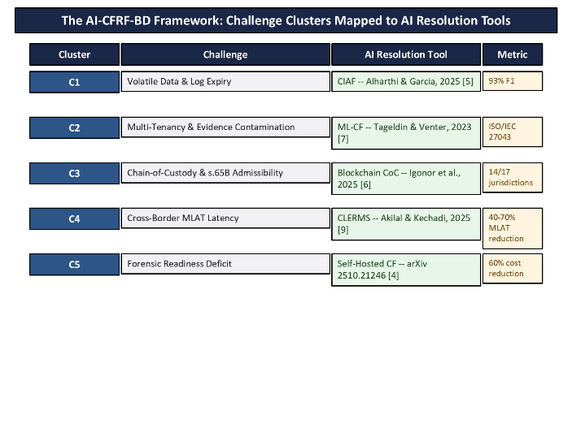
Fig. 3. The AI-CFRF-BD framework: five clusters mapped to five validated AI resolution tools.
V. DISCUSSION
The AI-CFRF-BD framework's central finding, in response to RQ3, is that validated resolution tools already exist for every challenge cluster identified under RQ1 and RQ2 -- the gap is one of adoption and legal recognition, not of technical availability. This reframes Bangladesh's cloud forensic readiness problem: rather than requiring novel AI research, it requires deploying tools already proven elsewhere and closing the specific legal gaps -- Section 65B's custodian assumption, the absence of a data-hold statute, and the MLAT bottleneck -- that currently prevent their outputs from being admissible or actionable.
The regulatory developments reviewed in Section II-B complicate this picture in one instructive way. The Personal Data Protection (Amendment) Ordinance, 2026's requirement that a real-time cloud copy of restricted or CII data be kept inside Bangladesh was not written with forensic access in mind, but it incidentally creates the local access point that Karagiannis and Vergidis's "Power of Disposal" problem [8] shows Bangladesh currently lacks: today, only the foreign cloud provider can grant access to Bangladeshi-held cloud data, but once a domestic copy of CII/restricted data exists, a future, narrowly scoped amendment authorising regulator or Tribunal audit access to that specific domestic copy -- without reopening the broader data-protection debate -- could resolve a meaningful share of the C1 and C3 gaps this review identifies, for the specific data categories the residency rule already covers.
The framework's institutional pathway (Section IV) also clarifies which of Bangladesh's four RQs are answerable now versus later. RQ1-RQ3 are addressed by this review's synthesis; RQ4's phased pathway is a proposal, not a deployment -- Phase 1's three tools have not been piloted against Bangladeshi cloud infrastructure or NTMC data feeds, and their reported F1-scores, jurisdiction-compatibility counts, and latency reductions (Table II) were measured in the source studies' own US/EU/multi-jurisdiction contexts, not in Bangladesh. Validating the framework against real Bangladeshi cases is accordingly the most immediate next step, discussed further in Section VII.
VI. LIMITATIONS
Four limitations qualify this review's conclusions. First, thematic coding was performed by a single reviewer without inter-rater verification, a limitation already noted in Section III-D; a second coder would strengthen confidence in the cluster assignments underlying Table I and Table II. Second, the search was restricted to English-language, open-access sources, which may have excluded relevant Bangla-language legal commentary and paywalled empirical studies -- 18 of the 48 full-text-screened papers were excluded on paywall grounds alone (Section III-C), and it is possible some contained Bangladesh-specific findings not otherwise captured. Third, and most significantly, the AI-CFRF-BD framework is a synthesis-level proposal: none of its five component tools has been piloted against Bangladeshi cloud infrastructure, NTMC data feeds, or an actual Cyber Tribunal case, so the quantitative metrics in Table II describe performance in each tool's original study context, not a Bangladesh deployment. Fourth, Bangladesh's cloud-forensics-relevant legal landscape changed twice during this review's own timeline -- the Cyber Security Ordinance 2025 and the Personal Data Protection Amendment Ordinance 2026 were both gazetted after the original literature search window closed -- underscoring that any cloud forensic readiness framework for Bangladesh must be treated as a living document requiring periodic re-verification against primary legal text, not a one-time synthesis.
VII. CONCLUSION AND FUTURE WORK
This review applied PRISMA 2020 methodology to the first systematic synthesis of cloud forensics challenges specific to Bangladesh's legal and institutional context, identifying five challenge clusters and mapping each to a validated AI resolution tool. The resulting AI-CFRF-BD framework shows that three of five clusters have tools deployable today without legislative change, one requires only an administrative practice note, and one requires inter-ministerial coordination -- a concrete, phased answer to RQ4 that does not depend on comprehensive cyber-law reform.
Three directions follow directly. First, a pilot deployment of one Phase 1 tool -- CIAF, ML-CF, or Self-Hosted CF -- in coordination with NTMC would provide the empirical Bangladesh-specific validation this synthesis-level review cannot. Second, given the Personal Data Protection (Amendment) Ordinance 2026's new domestic-copy requirement for restricted and CII data, engaging the Ministry of Law and Bangladesh Bank's Payment Systems Department on a narrowly scoped forensic-audit-access amendment is a concrete, near-term legislative target more tractable than reopening the Cyber Security Ordinance itself. Third, structured practitioner consultation with CID's Digital Forensics & Cyber Police Centre and BGD e-GOV CIRT would sanity-check this review's cluster taxonomy against current operational experience, closing the single-reviewer limitation noted in Section VI.

REFERENCES
[1] A. Alshabibi, P. Liatsis, and A. Emhemed, “Cloud forensic investigation challenges: A systematic literature review,” Computers, vol. 13, no. 8, p. 213, Aug. 2024. [Online]. Available: https://doi.org/10.3390/computers13080213
[2] M. Alenezi, “Cloud forensics challenges: A technical and legal taxonomy,” arXiv preprint arXiv:2305.03059, May 2023. [Online]. Available: https://arxiv.org/abs/2305.03059
[3] A. Prakash, A. V. Srivastava, and R. Gupta, “Forensic investigation in cloud and edge computing environments,” Electronics, vol. 10, no. 11, p. 1229, 2021. [Online]. Available: https://doi.org/10.3390/electronics10111229
[4] “Self-hosted cloud forensics: An open-source framework for evidence acquisition,” arXiv preprint arXiv:2510.21246v2, 2025. [Online]. Available: https://arxiv.org/abs/2510.21246
[5] B. S. Alharthi and L. F. Garcia, “Cloud intelligence and AI forensics (CIAF): Large language models for automated cloud forensics,” arXiv preprint arXiv:2510.00452, Oct. 2025. [Online]. Available: https://arxiv.org/abs/2510.00452
[6] A. Igonor, A. Nweke, O. Adigwe, and V. Ahiwe, “A systematic review of blockchain technology for digital forensics,” Blockchains, vol. 3, no. 1, p. 5, 2025. [Online]. Available: https://doi.org/10.3390/blockchains3010005
[7] M. Tageldin and H. S. Venter, “Proposing a machine learning-based cloud forensics investigation framework,” Applied Sciences, vol. 13, no. 18, p. 10169, 2023. [Online]. Available: https://doi.org/10.3390/app131810169
[8] S. Karagiannis and E. Vergidis, “Digital evidence and cloud forensics: Contemporary legal challenges and prospects,” Information, vol. 12, no. 5, p. 181, 2021. [Online]. Available: https://doi.org/10.3390/info12050181
[9] M. Akilal and M.-T. Kechadi, “A cross-border law enforcement request management system (CLERMS) for digital forensics,” arXiv preprint arXiv:2507.04174, Jul. 2025. [Online]. Available: https://arxiv.org/abs/2507.04174
[10] M. A. Ali, “Digital evidence and cyber crime investigation: Bangladesh perspective,” NDC e-Journal, vol. 22, no. 2, 2023.
[11] M. R. Uzzal, “Cybercrime and digital evidence in Bangladesh: A critical analysis,” SSRN preprint, 2025. [Online]. Available: https://doi.org/10.2139/ssrn.5079527
[12] S. Ahmed and M. Arifuzzaman, “Cyber security law in Bangladesh: A critical analysis of the Cyber Security Act 2023,” Asian Journal of Social Sciences and Legal Studies, vol. 7, no. 4, pp. 347–357, 2025.
[13] S. S. Akter and M. S. Rahman, “Cloud forensic: Issues, challenges and solution models,” in A Practical Guide on Security and Privacy in Cyber Physical Systems. Singapore: World Scientific, 2023.
[14] F. C. Ekwempu, “Investigating the legal complexities of cloud forensic investigations in cross-border scenarios and developing strategies for international cooperation,” Int. J. Res. Innov. Appl. Sci., vol. 11, no. 1, pp. 1334–1343, Jan. 2026. [Online]. Available: https://doi.org/10.51584/IJRIAS.2026.110100113
[15] K. Sharmin and I. M. Rahman, “Digital forensics empowerment of Bangladesh police: A comprehensive analysis of its role in preventing crimes and enhancing investigative capabilities,” Bangladesh J. MIS, vol. 11, no. 1, 2025. [Online]. Available: https://doi.org/10.61606/BJMIS.V11N1.A1
[16] M. S. Rana, “Criminal investigation in the digital era: Lessons for Bangladesh from Colombia, India, and the United States,” Conhecimento & Diversidade, vol. 17, no. 47, pp. 91–107, Jul.–Sep. 2025.
[17] J. Thomas and A. Harden, “Methods for the thematic synthesis of qualitative research in systematic reviews,” BMC Medical Research Methodology, vol. 8, p. 45, 2008. [Online]. Available: https://doi.org/10.1186/1471-2288-8-45
[18] M. J. Page et al., “The PRISMA 2020 statement: An updated guideline for reporting systematic reviews,” BMJ, vol. 372, p. n71, Mar. 2021. [Online]. Available: https://doi.org/10.1136/bmj.n71
[19] International Organization for Standardization, ISO/IEC 27037:2012 — Information Technology: Security Techniques — Guidelines for Identification, Collection, Acquisition and Preservation of Digital Evidence. Geneva, Switzerland: ISO, 2012.
[20] Government of the People's Republic of Bangladesh, Cyber Security Ordinance, 2025 (Ordinance No. 25 of 2025), gazetted 21 May 2025.
[21] Government of the People's Republic of Bangladesh, Personal Data Protection Ordinance, 2025 (Ordinance No. 61 of 2025), gazetted 6 Nov. 2025, as amended by the Personal Data Protection (Amendment) Ordinance, 2026 (Ordinance No. 23 of 2026), signed 5 Feb. 2026.
[22] ICT Division, Government of Bangladesh, and UNDP Bangladesh, "National Digital Transformation Strategy" (draft), Feb. 2025.

