

**E-COMMERCE WEBSITE**

**Software** **Project-1**

**Submitted** **By**

|  |  |
| --- | --- |
| 14-25533-1 | TANIM, KAZI ASIF |
| 14-26060-1 | PRODHAN, MOHAMMAD AREFIN ALAM |
| 14-25955-1 | HASAN, MD MAHADI |
| 14-25591-1 | ISLAM, SHANTA |

**Department** **of** **Computer** **Science**

**Faculty** **of** **Science** **&** **IT**

**American** **International** **University** **Bangladesh**

Date of Submission 19th April,2017

**Declaration**

We declare that this thesis is our original work and has not been submitted in any form for another

degree or diploma at any university or other institute of tertiary education. Information derived from the published and unpublished work of others has been acknowledged in the text and a list of references is given.

__________________________

**TANIM, KAZI ASIF**

14-25533-1

CSSE

__________________________

**Hasan, Md Mahadi**

14-25955-1

CSSE

__________________________

**PRODHAN, MOHAMMAD AREFIN Alam**

14-26060-1

CSSE

__________________________

**Islam, Shanta**

14-25591-1

CSSE

**Approval**

The thesis titled “E-COMMERCE WEBSITE” has been submitted to the following

respected members of the board of examiners of the department of computer science in partial fulfillment of the requirements for the degree of Bachelor of Science in Computer Science on (19th April, 2017) and has been accepted as satisfactory.

__________________________

**VICTOR** **STANY** **ROZARIO**

Lecturer and Supervisor

Department of Computer Science

American International University-

Bangladesh (AIUB)

__________________________

**DR.DIP** **NANDI**

Associate Professor & Head(Undergraduate)

Department of Computer Science

American International University-

Bangladesh (AIUB)

____________________________

**SHOVRA** **DAS**

Assistant Professor And External

Department of Computer Science

American International University-

Bangladesh (AIUB)

________________________________________

**Professor** **DR.** **TAFAZZAL** **HOSSAIN**

Dean

Faculty of Science & Technology

American International University-

Bangladesh (AIUB)

_______________________________________

**Dr.** **Carmen** **Z.** **Lamagna**

Vice Chancellor

American International University-Bangladesh (AIUB)

**Acknowledgements**

First of all we would like to be grateful to the almighty **ALLAH** who gives us the effort to work on the project. Thanks to our respectable parents for their outstanding support at every point in our life. We would like to thank our supervisor & co- supervisor **VICTOR** **STANY** **ROZARIO** & **SHOVRA DAS** for his enormous support, inspiration and helpful criticism. We are very grateful to him for giving us opportunity to work with him. Without this continuous support, it would be very difficult for us to complete this project. We would also like to thank all the faculty members for their guideline for making proper documentation of our project. We convey our thanks to our honorable Dean, **PROF.** **DR.** **TAFAZZAL** **HOSSAIN** for encouragement. We convey our thanks to our honorable Vice Chancellor, **DR.** **CARMEN** **Z.** **LAMAGNA** for encouragement. We wish to express our gratitude American International University-Bangladesh (AIUB) providing an excellent environment for research.

**Table** **of** **Contents**

**Chapter 1: Statement of Work .............................................................................................10 1.1 Documentation History and Distribution..................................................................................10 1.2 Objectives.......................................................................................................................................10**

**1.3 Anticipated Benefits...................................................................................................................10 1.4 User Impacts................................................................................................................................11 1.5 Deliverable Included in Scope.................................................................................................... 11**

**1.6 Project Schedule...........................................................................................................................11 1.7 SWOT........................................................................................................................................... 12 1.7.1 Strengths............................................................................................................................12 1.7.2 Opportunities.....................................................................................................................12 1.7.3 Weakness ...........................................................................................................................12**

**1.8 Risk management....................................................................................................................12 1.8.1 Risk Assessment...............................................................................................................12 1.8.2 Assessing Overall Project Risk .......................................................................................13**

**Chapter 2: Software Requirement Specification................................................................15**

**2.1 Objectives..................................................................................................................................... 15**

**2.2 Project Scopes..............................................................................................................................16 2.3 Overall Description.....................................................................................................................16 2.3.1 Product Perspective.......................................................................................................... 16 2.3.3 Overview of the Proposed System ...................................................................................17 2.3.4 Operation Environment ................................................................................................... 17 2.3.5 Design and Implementation Constraints ........................................................................ 17 2.3.6 Hardware Constraints...................................................................................................... 17 2.3.7 Software Constraints........................................................................................................ 17 2.3.8 Design Constraints............................................................................................................17 2.3.9 Human Resource Requirements......................................................................................17**

**2.4 System Features……………………………………………………………………………....18**

**2.4.1 User Option........................................................................................................................22**

**2.4.2 Response Sequences.......................................................................................................... 22**

**2.4.3 User Interface....................................................................................................................22**

**Chapter 3: Software Design Specification Plan .................................................................. 23**

**3.1 Documentation History and Distribution.............................................................................23**

**3.2 Introduction.............................................................................................................................23**

**3.3 Overview.................................................................................................................................. 23**

**3.4 Constraints...............................................................................................................................23**

**3.5 Diagrams.................................................................................................................................. 24**

**3.5.1 Use Case Diagrams……………………………………………………………………......24**

**3.5.2 Class Diagram.....................................................................................................................26**

**3.5.3 Activity Diagram.................................................................................................................27**

**3.5.4 User Interface…………………………...…………………………………………………27**

**Chapter 4: Web Project Management Plan ........................................................................ 28 4.1 Project Summary....................................................................................................................28 4.1.1 Objectives...........................................................................................................................28 4.1.2 Scopes................................................................................................................................. 28 4.1.3 Assumptions.......................................................................................................................28 4.1.4 Constraints.........................................................................................................................28 4.1.5 Project Deliverables.......................................................................................................... 28 4.1.6 Schedule Summary ...........................................................................................................29 4.1.7 Evolution of the WAPMP................................................................................................. 29**

**4.2 Glossary…………………………………………………………………………………………29**

**4.3 Project Organization .............................................................................................................30 4.3.1 Internal Structure.............................................................................................................30 4.3.2 Roles and Responsibilities................................................................................................30 4.4 Managerial Process Plan........................................................................................................ 30 4.4.1 Project Start-up Plan........................................................................................................ 30 4.4.2 Estimation Plan.................................................................................................................30 4.4.3 Staffing Plan......................................................................................................................30 4.4.4 Resource Acquisition Plan................................................................................................31 4.4.5 Project Staff Training Plan..............................................................................................31 4.5 Work Plan................................................................................................................................31 4.5.1 Work & Schedule Allocation ...........................................................................................31**

**4.6 Process Model..........................................................................................................................32**

**4.7 Project Requirement Plan...................................................................................................... 33 4.7.1 Tools................................................................................................................................... 33 4.7.2 Infrastructure Plan...........................................................................................................33**

**4.7.3 Project Acceptance Plan................................................................................................... 33**

**4.8 Supporting Process Plan......................................................................................................... 33**

**4.8.1 Configuration and Management Plan.............................................................................33**

**4.8.2 Verification and Validation Plan.....................................................................................33**

**4.8.3 Documentation Plan.......................................................................................................... 34**

**4.8.4 Review and Audit Plan..................................................................................................... 34**

**4.8.5 Problem Resolution Plan.................................................................................................. 34**

**4.8.6 Process Improved Plan..................................................................................................... 34**

**4.9 Supporting Testing Plan......................................................................................................... 34**

**4.9.1 Unit Testing……………………………………………………………………………….35**

**4.9.2 Regression Testing………………………………………………………………………..35**

**Chapter** **5:** **Conclusion...........................................................................................................36**

**5.1 Future aspect………………………………………………………………………….36**

**5.2 Conclusion……………………………………………………………………………..36**

**Refferences …………………………………………………………………………………..37**

**List** **of** **Figures**

**Fig** **1** **Use** **Case** **Diagram** **For** **Customers** **20**

**Fig** **2** **Use** **Case** **Diagram** **For** **Admin** **21**

**Fig** **3** **Class** **Diagram** **24**

**Fig** **7** **Rapid** **Action** **Development** **(RAD)** **Model** **34**

**Chapter** **1:** **Statement** **of** **Work**

**1.1** **Documentation** **History** **and** **Distribution**

**Table** **1-A:** **Revision** **History**

|  |  |
| --- | --- |
| Tanim, Kazi Asif | 14-25533-1 |
| Prodhan, Mohammad Arefin Alam | 14-26060-1 |
| Hasan, Md Mahadi | 14-25955-1 |
| Islam, Shanta | 14-25591-1 |

**Table** **1-B:** **Distribution**

|  |  |  |
| --- | --- | --- |
| Recipient Name | Recipient Organization | Distribution Method |
| Victor Stany Rozario | AIUB | Hard Copy |
| Victor Stany Rozario | AIUB | Soft Copy |

**1.2** **Objectives**

**1.2.1 Group and individual learning activities.**

**1.2.2 Student grade/mark book and criteria sheets.**

**1.2.3 Quizzes and surveys.**

**1.2.3 Full online courses with modules of work.**

**1.2.4 Forums and synchronous chat sessions.**

**1.2.5 Discussions and chats with students, parents and guests.**

**1.2.6 Calendar and timetables.**

**1.2.7 Student grade/mark book and criteria sheets.**

**1.3** **Anticipated** **Benefits**

**1.3.1 Access to coursework from anywhere at any time.  
1.3.2 Effective time management.**

**1.3.3 Asynchronous discussions with classmates.**

**1.3.4 Immediate feedback on tests.**

**1.4** **User** **Impacts**

**1.4.1 Only valid students and teachers can use the virtual system.**

**1.4.2 A user must need an active internet connection to use this system.**

**1.4.3 System will automatically start the session according to the schedule only if concerned teacher or presenter will have logged in.**

**1.4.4 The system is developed to an easy interface to perform corresponding functionality.**

**1.4.5 The system allows the teacher to access the user(students) computer through remote access.**

**1.4.6 Live tranning classes will help the students to develop their skills and get a perfect knowledge about any subject.**

**1.4.7 Student and guest feedback forum will help each and everyone to develop their skill and many more things.**

**1.5** **Deliverable** **Included** **in** **Scope**

**1.5.1 A full user manual.**

**1.5.2 All the details information about the developers and teachers.**

**1.5.3 Documentation on full web based virtual classroom project.**

**1.5.4 Documentation on project management plan.**

**1.6** **Project** **Schedule**

**Table** **1-C**

|  |  |
| --- | --- |
| **Milestone** | **Planned Computation Week** |
| **SOW** | **1** |
| **SRS** | **3** |
| **SPMP** | **4** |
| **SDP** | **5** |
| **Software Testing Plan** | **6** |
| **Building Prototype** | **17** |
| **Thesis Paper** | **With completed product** |
| **Software Testing and Analysis** | **Along with final submission** |

**1.7** **SWOT**

**1.7.1** **Strengths**

**1.7.1.1 A huge data saving database is available for the users.**

**1.7.1.2 Less manpower needed for the maintainence.**

**1.7.1.3 Payment system is more secure.**

**1.7.1.4 Software maintainance is competitively easy.**

**1.7.1.5 Rapid development**

**1.7.2** **Opportunities**

**1.7.2.1 A registered user can check the offline stored video tutorial and can participate many free classes.**

**1.7.2.2 ASP.net is implemented to builed the web based software.**

**1.7.2.3 A handy design is made for all types of user.**

**1.7.2.4 Specific and well designed UI & UX has been created.**

* + 1. **Weakness**

**1.7.3.1 Database backup is not featured.**

**1.7.3** **Threats**

**1.7.3.1 Internet shorthand (acronyms, emoticons and playful spelling) used in student assignments.**

**1.7.3.2 Auto spelling system is provided for students to help them to develop their ability of learning.**

**1.8** **Risk** **management**

**1.8.1** **Risk** **Assessment**

The impact of each risk driver on the risk component is divided into one of four impact categories— negligible, marginal, critical, or catastrophic.

Table 1-D

|  |  |  |  |  |
| --- | --- | --- | --- | --- |
|  | **Catastrophic** | **Critical** | **Marginal** | **Negligible** |
| **Schedule** **slip** |  | Project delay |  |  |
| **System** **goes** **sour** |  | Schadule will broke down |  |  |
| **Project** **cancelled** |  |  |  | Communication cancellation with client |
| **False** **features** | System doesn’t give proper output |  |  |  |
| **Infrastructure risk** |  |  | Delay will happend |  |

|  |  |  |  |  |
| --- | --- | --- | --- | --- |
| **Frustrated** **team** **members** |  |  |  | Fail to meet deadline |
| **Overloading** |  |  | Too much stored data may be difficult to maintain |  |

**1.8.2** **Assessing** **Overall** **Project** **Risk**

**1.8.2.1 Have** **developer** **team** **formally** **committed** **to** **support** **the** **project?**

**Answer:** Yes. All the members are formally committed to support the project. They also ensure that they will give all types of available facilities.

**1.8.2.2** **Are** **requirements** **fully** **understood** **by** **the** **Users?**

**Answer:** Yes. Web developer team has the sound knowledge about the requirements so it is easily understandable by the team. The requirements details are well organized also informative, so it is under stable by the Students and Faculty Members.

**1.8.2.3**  **Have** **user** **been** **involved** **fully** **in** **the** **definition** **of** **requirements?**

**Answer:** Yes. The user has been fully involved in the definition of requirements. They are aware of the application requirements.

**1.8.2.4**  **Is** **project** **scope** **stable?**

**Answer:** Yes. Project scope is stable because the minimum and mandatory scope is almost covered by the software engineering team. If any further scope will arise then just adding it with the old ones.

**1.8.2.5**  **Does** **the** **developing** **team** **have** **the** **right** **mix** **of** **skills?**

**Answer:** Yes. The developing team has the right mix of skills. The team members have the capability of doing their work in a team, ability to work in pressure and also have sound knowledge according to the implementation.

**1.8.2.6**  **Are** **project** **requirements** **stable?**

**Answer:** Yes. Currently all possible requirements are being listed, and seem that if anything would be added later to the list will not make the project unstable. All requirements for this project are easily available that will enthusiast the end-user to use it.

**1.8.2.7 Does** **the** **project** **team** **have** **experience** **with** **the** **technology** **to** **be** **implemented?**

**Answer:** Yes. The project team has experience with the technology to be implemented because they have the sound knowledge about the technologies and the technologies are also implemented by them before.

**1.8.2.8 Does** **the** **project** **team** **are** **aware** **about** **the** **possible** **risks?**

**Answer:** Yes. Project team prepare the possible risk assessment and aware of handling the risk

**Chapter** **2:** **Software** **Requirement** **Specification**

**2.1** **Objectives**

This document is broken into a number of sections used to logically separate the software requirements into easily referenced parts.

This Software Requirements Specification aims to describe the Functionality, External Interfaces, Attributes and Design Constraints imposed on Implementation of the software system described throughout the rest of the document. Throughout the description of the software system, the language and terminology used should  
unambiguous and consistent throughout the document. It’s a web application. This will be a complex web development project which will take approximately 6 months and 4 developers to complete. The project will be split up into stages and documentation thoroughly.

**2.2** **Project** **Scopes**

The software system being produced is called E-Commerce System or ECS. It is being produced for a customer interested in selling different kind of products via the Internet. This system is designed to “provide automation support” for the process of placing different products for sale on the Internet and facilitating the actual sale. This system is largely cross-platform and is available to anyone using smart device. The system will be run on a central server with each user having a remote user interface through a web browser to interact with it.

* The E-Commerce System will allow any user to create an account to become a  
  customer.
* The system will allow customers to browse, search, select,  
  and add products to a shopping cart.
* Provided they have item in their shopping cart,  
  check out products in shopping cart and decrement the stock that the inventory the system  
  maintains.
* The ECS also allows a admin to manage the inventory with full create,  
  retrieve, update and delete (CRUD) functionality with regards to items in the system.
* It will also allow, on an inventory wide basis, customers and managers to interact with a  
  promotion system that handles percentage-off promotions that can be applied to  
  member’s orders.
* The ECS has full email capabilities; the  
  automated email functionality will be used to send promotions to members of the system  
  as well as provide the managers or admins with low-stock notifications.

The ECS will have numerous constraints on what it can do. The system will have  
fully secure credit-card processing capabilities, Cash on delivery, Bkash and Rocket for payment option. It will not allow managers to be customers. The system will not allow multiple promotions to be added to a single shopping cart nor will it allow a customer to add more than one of each item to their cart. The system will allow users to modify personal details and shipping address.

**2.3** **Overall** **Description**

This section includes details about what is and is not expected of the ECS system in  
addition to which cases are intentionally unsupported and assumptions that will be used  
in the creation of the ECS system

**2.3.1** **Product** **Perspective**

ECS is an online products buying website which supports a number of functions for both the consumer and store's management.

The website must be available to anyone who is registered member and system will work  
correctly in all browser. As stated by the customer, there are no hardware or software requirements beyond these including, but not limited to, memory or specific software packages that need to be utilized nor software packages that need not be utilized.

**2.3.2** **Project** **Features**

* Shopping Cart, Search Bar, and Customer Login
* Deals, Special Offers, and Free Stuff
* News on Products
* Contact Information
* Important Links and Icons
* High-Resolution Photos and Video
* Mobile-Friendly Website
* User-Generated Reviews
* Special Offers
* Wish Lists
* Find-in-Store
* Related Items
* Frequently Asked Questions (FAQ)
* Security Features
* Advanced Payment Options
* Detailed Shipping Information

**2.3.3** **Overview** **of** **the** **Proposed** **System**

E-Commerce or Electronics Commerce is a methodology of modern business which addresses the need of business organizations, vendors and customers to reduce cost and improve the quality of goods and services while increasing the speed of delivery.

**2.3.4** **Operation** **Environment**

This software need online web server running with MySQL database and apache server configuration server and operating system of Windows/Linux.

**2.3.5** **Design** **and** **Implementation** **Constraints**

As stated by the customer, security is not a concern for this system. The database may store passwords in plain text and there doesn't need to be a password recovery feature nor lockout after numerous invalid login attempts. As such, the system may not work correctly in cases when security is a concern. These cases include those listed above in addition to lack of an encrypted connection when sending credit card information and forcing users to use “strong” passwords. A strong password is a password that meets a  
number of conditions that are set in place so that user's passwords cannot be easily guessed by an attacker. Generally, these rules include ensuring that the password contains a sufficient number of characters and contains not only lowercase letters but also capitals, numbers, and in some cases, symbols.

**2.3.6** **Hardware** **Constraints**

The system requires a database in order to store persistent data also need domain hosting. They should have backup capability. A server is needed to run the system.

**2.3.7** **Software** **Constraints**

The development of the system will be constrained by the availability of the required software such as database and development tools.

**2.3.8** **Design** **Constraints**

The system must be designed to allow desktop usability. That system must be designed in such a way that it will be easy to use and comfortably visible on the device.

**2.3.9** **Human** **Resource** **Requirements**

One server administrator will needed to validate all the information and handle any system manually as well as maintain the server

**2.4** **System** **Features**

|  |  |  |
| --- | --- | --- |
| User | Activity | Description |
| Consumer | Account Create | User can create new account by clicking registration button from login page. |
| Mail verification | Mail verification by server. Go to mail and system will show mail in the screen. |
| Update Personal Info. | User can edit or update their information by using edit button in their profile |
| Update Shipping Address |  |
| Purchase History | User can check all of their purchase history by clicking purchase history button form their profile. |
| Purchase History Print | User can download all history in PDF format |
| Username & Password Update | User can change password using change password button |
| Product Add to Cart | User can add product in cart form main website |
| Cart modification | User can edit or delete cart |
| Check Out | Checkout product that are added to cart. It will redirect to payment page. |
| Wish list Create | Add a product to wish list for future purchase |
| Payment system Update | Update billing information |
| Purchase Return | Return order item within a specific time |
| Gift card /Point | Gift card for purchase |
| Order / Service Feedback | Customer support |
| Product Review | Review a purchased Product for future improvement. |
| Admin | Account Create | Admin can add another Admin by clicking Admin button and then Add Admin Button. and then fill up all the field and then submit . |
| View Profile | For view go to profile and then click view profile. After click this button admin can view their own profile. |
| Edit Profile | Admin can edit their Profile .for edit profile go to profile then edit button. then All the information will show the text box .then Admin can change their own information and then click submit . after clicking submit information will be update. Can change profile picture as well. To change picture just go profile then change picture and browse the new picture and submit. |
| Change password | Admin can change their own password. First they should go profile and then change password . then the system will show two text box .one is new password and another is confirm password. Give the value in the text box and click the submit button to save . if any wrong with given value then they can reset to clean all the box. |
| Product Upload, update, delete and Show all product | Admin can Upload Product in the database by upload product option and they can Edit Product, Delete data Product from the Product list. |
| Report analysis | Admin can Analysis total report of Buying and selling by graph also they can see total amount or selling product. |
| Customer purchase/delivery report | Check delivery reports |
| Order list | When a customer ordered for something it will save the Ordered list in the admin side and the specific customer’s site. So that admin easily identify the product to deliver. |
| Mail Check | Admin can Check mail. Mail come from customer. A Mail option will be available in the Admin site and they can check the mail and customer id , and their email address also in the list. |
| Product upload and edit | Admin will upload a new product and also can edit an existent product. |
| Employee | Order list check | Admin can see all the order product from here. Option is available in admin menu. |
| Mail Response | Admin will see all then mail sent by users by clicking mail button. |
| Server | Product low quantity warning | Suggestions field will show the all product low quantity suggestions. |
| Mail verification |  |
| Encrypt confidential information | System will encrypt all password using md5 algorithm |
| Product analysis | Analysis best selling products,  Best review etc |
| Order/purchase mail | A mail will sent to user when a order created |

**2.4.1** **User** **Option**

User will able to log into the system with some credentials. A well functional dashboard will appear on successful login. Functionality of the system depends on user type. User has different features on the other hand admin has more feature to use the system.

**2.4.2** **Response** **Sequences**

The user can log in and logout. When the user login the login page, the system will check validity of login. If the login id and password are valid, the response to this action is the user will be able to modify.

**2.4.3** **User** **Interface**

User interface will describe all the features of management. This part shows all the features part by part which is faced by the user when they use the system**.**

**2.4.4** **Specifications**

**Specification** **for** **standalone** **user**

● Operating System: Linux / Windows / OSX Latest version ● Processor: Minimum Intel Dual Core

● RAM: 2 GB or More ● HDD: 5 GB or More

● Browser : Chrome , Firefox

**Specification** **for** **Server**

● Operating System: Linux / Windows / OSX ( where php and MySQL runs)

● Processor: Minimum Intel core i3 or higher

● RAM: 8 GB or More ● HDD: 20 GB or More

**2.4.5** **Software** **Interface**

**For** **standalone** **user** **and** **for** **server**

● Web browser : chrome , Firefox , safari ● Programming language : Php

● Database : MySQL 5

**Chapter** **3:** **Software** **Design** **Specification** **Plan**

**3.1** **Documentation** **History** **and** **Distribution**

**Table** **3-A:** **Revision** **History**

|  |  |
| --- | --- |
| Version 1.0 | Tanim, Kazi Asif |
| Version 1.0 | Prodhan, Mohammad Arefin Alam |
| Version 1.0 | Hasan, Md Mahadi |
| Version 1.0 | Islam, Shanta |

**Table** **3-B:** **Distribution**

|  |  |  |
| --- | --- | --- |
| Recipient Name | Recipient Organization | Distribution Method |
| Victor Stany Rozario | AIUB | Hard Copy |
| Victor Stany Rozario | AIUB | Soft Copy |

**3.2** **Introduction**

In web application design specification plan some design diagram, human interface design, system architecture, system overview is included.

**3.3** **Overview**

This sub-clause of the WADSP shall describe what the rest of the SDSP contains and explain how the SDSP is organized.

**3.4** **Constraints**

This sub-clause of the WADSP will briefly describe any restrictions, limitations or constraints that impact the design implementation.

**3.5** **Diagrams**

**3.5.1** **Use** **Case** **Diagrams**

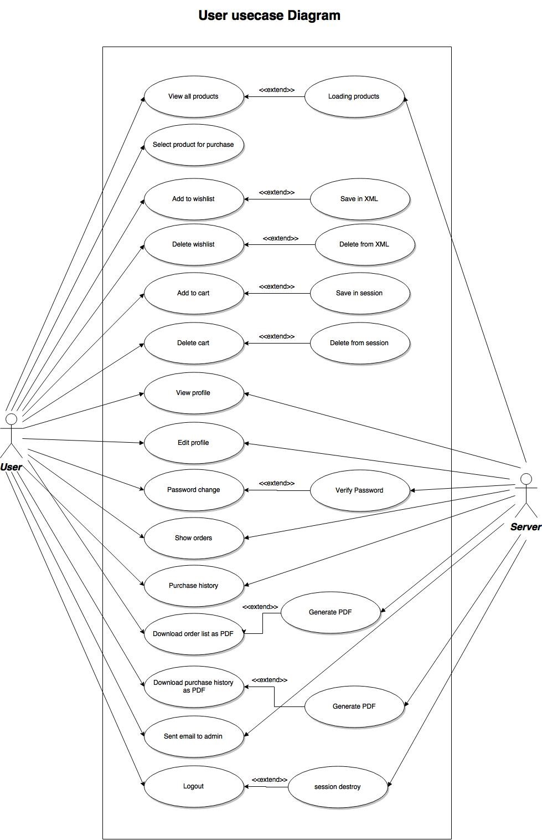

**Fig** **1:** **Use** **Case** **Diagram** **for** **Customer**

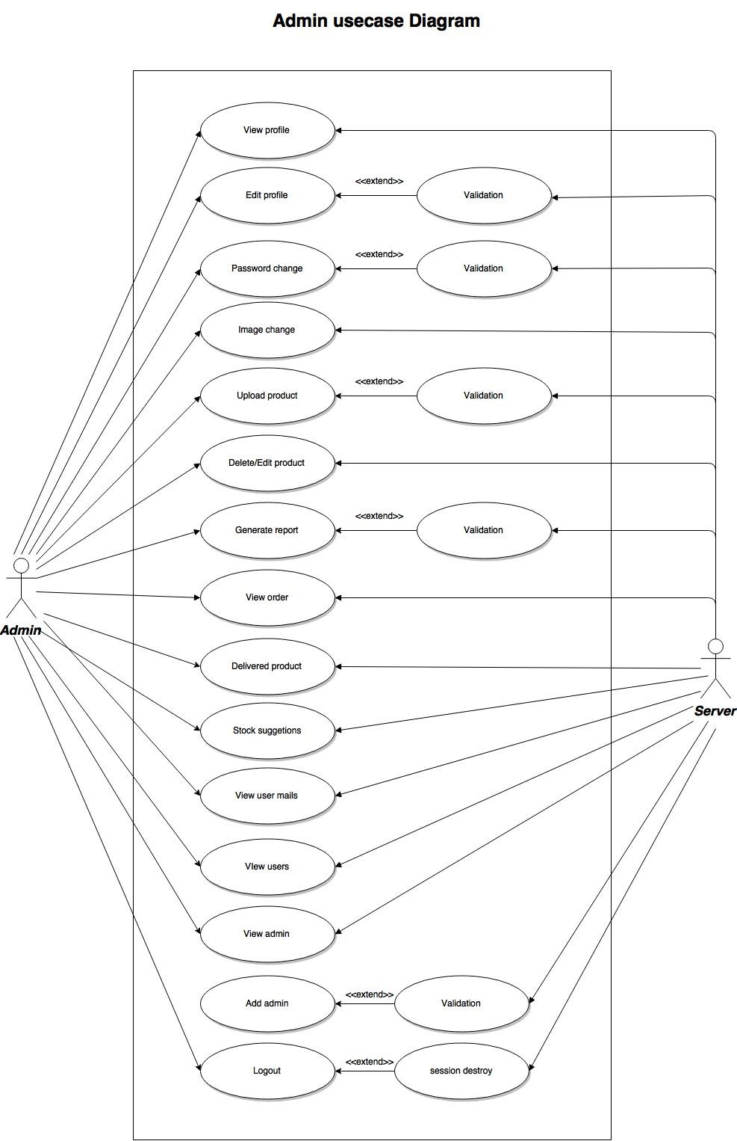

**Fig** **2:** **Use** **Case** **Diagram** **for** **Admin**

**3.5.2** **Class** **Diagram**

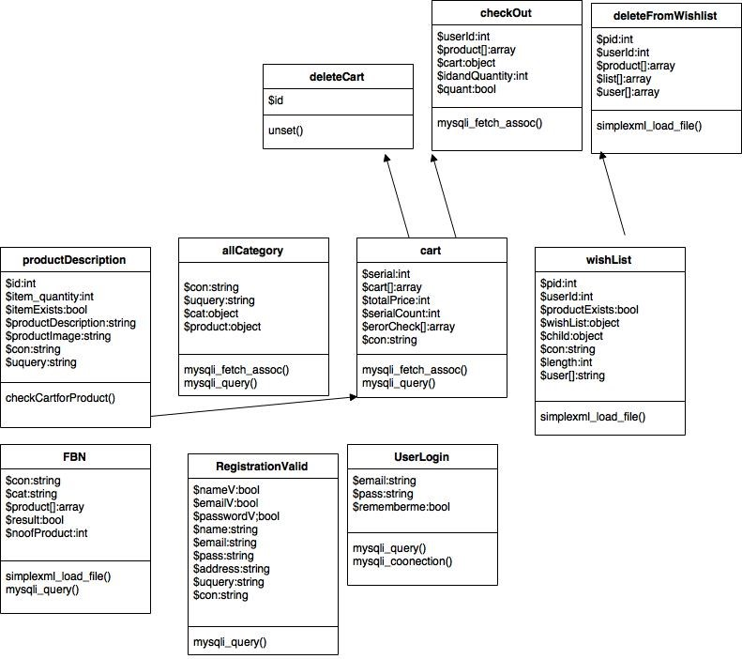

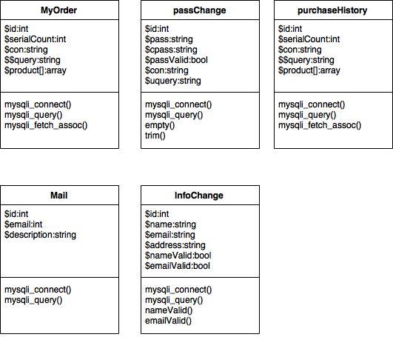

**Fig** **3:** **Class** **Diagram for Customers**

**3.5.3** **Activity** **Diagram**

**3.5.4** **User** **Interface**

**Chapter** **4:** **Web** **Project** **Management** **Plan**

**4.1** **Project** **Summary**

**4.1.1** **Objectives**

The main objective of the document is to describe the requirement of the project “E-Commerce Website”. The documentation gives the detailed description of the both functional and nonfunctional requirement for this. The document is developed after a number of studying the requirement specification paper of the given project. The final products of the team will be meeting the requirements of the document.

**4.1.2** **Scopes**

The project is designed to run on desktop. User uses this application to save time and money and they can buy products form online easily.

**4.1.3** **Assumptions**

● The team members are used to this type of project

● Team members will gather all technical help they need

● Team members have the full access of minimal amount of hardware resources

**4.1.4** **Constraints**

● Project must be finished within time. ● Technology availability is limited.

**4.1.5** **Project** **Deliverables**

The list of project deliverable is

● Statement of Work (SOW)

● Web Application Requirement Specification (WARS) ● Web Application Project Management Plan (WAPMP) ● Web Application Design Plan (WADP)

**4.1.6** **Schedule** **Summary**

**Table** **4-A**

|  |  |
| --- | --- |
| Milestone | Planned Computation Week |
| SOW | 1 |
| WARS | 2 |
| WAPMP | 3 |
| WADP | 4 |
| Testing Plan | 6 |
| Building Prototype | 18 |
| Thesis Paper | With completed product |
| Testing and Analysis | Along with final submission |

**4.1.7** **Evolution** **of** **the** **WAPMP**

The preliminary draft of the WAPMP will be submitted to the project manager and after the approval, copies of the same will be distributed to the members on the date as referred in section 1.1 for configuration management, refer to section 1.7 for configuration management plan.

**4.2** **Glossary**

**Table** **4-B**

|  |  |
| --- | --- |
| Terms | Description |
| SOW WARS WAPMP WADP SQATP | Statement of Work  Software Requirement Specification Software Project Management Plan Software Design Plan  Software Quality Assurance & Testing Plan |
| Impact | Catastrophic Critical Marginal Negligible |

**4.3** **Project** **Organization**

**4.3.1** **Internal** **Structure**

There are Four Developers for this project. All members have specified areas of responsibility and everybody contributes equally to the project. Each member will continue to have more than one role. The team members will change roles throughout the project lifetime.

**4.3.2** **Roles** **and** **Responsibilities**

The software developers are responsible for all documentation to be developed and also for all week to be done.

**4.4** **Managerial** **Process** **Plan**

**4.4.1** **Project** **Start-up** **Plan**

The section describes the materials and resources required to start the project. Because most of the information was predefined for the team, the section will not describe the rationale for many of these choices.

**4.4.2** **Estimation** **Plan**

As previously stated in the section 1.1 and 4.5.1 the total development time is estimated to be 25 weeks. The figures were obtained by expert judgment by analogy that is by compression with similar projects.

**4.4.3** **Staffing** **Plan**

Four people will be working for this project. Each of them is allowed with minimum 1 hour a day and 5 days a week to complete their allocated task for that week. The tasks of each proposal are maintained in the task scheduling plan.

**Table** **4-C**

|  |  |  |
| --- | --- | --- |
| **Team Members** | **Time commitment** | **Responsibilities** |
| Tanim, Kazi Asif | 2 hours per day | Design, Coding & Documentation |
| Prodhan, Mohammad Arefin Alam | 2 hours per day | Design, Coding & Documentation |
| Hasan, Md Mahadi | 2 hours per day | Design, Coding & Documentation |
| Islam, Shanta | 1 hour per day | Testing & Documentation |

**4.4.4** **Resource** **Acquisition** **Plan**

All types of resources for the project will be available at the start of the project and will not change substantially over time.

**4.4.5** **Project** **Staff** **Training** **Plan**

No additional staff training is needed for this project.

**4.5** **Work** **Plan**

**4.5.1** **Work** **&** **Schedule** **Allocation**

**Table** **4-D**

|  |  |  |
| --- | --- | --- |
| Number | Deliverable | Deadline(Week) |
| 1 | SOW | 01 |
| 2 | WARS | 02 |
| 3 | WAPMP | 03 |
| 4 | WADP | 04 |
| 5 | SQAT Plan | 05 |
| 6 | Presentation on Project Plan | 06 |
| 7 | Technical Documentation | 08 |
| 8 | Code with Comments | 12 |
| 9 | Building Prototype | 18 |
| 10 | Software Testing and Analysis | 19 |
| 11 | Thesis Paper | 22 |
| 12 | Project Report | 24 |
| 13 | Final Submission | 25 |

**4.6** **Process** **Model**

The development lifecycle model we have decided for this particular software is the “Rad Model”.

**4.6.1** **Rapid** **Application** **Development** **(RAD)** **Model**

● Type of incremental model

● RAD model devotes less time on model and more time on development

● Knowledge gathered from the development is used as feedback for requirements and designs

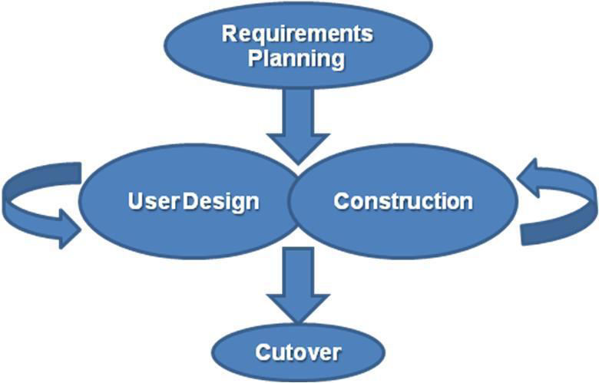

**Fig** **7:** **Rapid** **Action** **Development** **(RAD)** **Model**

**4.7** **Project** **Requirement** **Plan**

**4.7.1** **Tools**

Following tools are used to developed the software

* MYSQL 5.0
* PHP 5.6.30
* HTML 4.01

**4.7.2** **Infrastructure** **Plan**

The hardware resources are referred in the section 2.4.4

**4.7.3** **Project** **Acceptance** **Plan**

Every milestone of the project will be accepted formally by the project manager by signing appropriate acceptance documentation. At the end of every phase the project manager will perform an acceptance test. This may result in additional request for change and improvements. The project manager tests the final product/application for acceptance.

**4.8** **Supporting** **Process** **Plan**

The WAPMP will include the plans for the supporting process that are part of software projects. These plans include: Configuration & Management Plan, Verification and Validation, Software Documentation, Quality Assurance, Problem Resolution and Subcontractor Management.

**4.8.1** **Configuration** **and** **Management** **Plan**

All the project deliverable is to be considered as configuration item. The configuration items as well as their files would be named after the document line SOW, WARS and followed by version number.

**4.8.2** **Verification** **and** **Validation** **Plan**

The WAPMP for this project shall contain the verification and validation plan for the software project and it will include tools, techniques and responsibilities for the verification and validation activities.

**4.8.3** **Documentation** **Plan**

The IEEE standard would be followed for all documentation purposes. All the documentation would be discussed and reviewed with project manager before their baseline version are issued and distributed to the members of the committee on the due dates.

**4.8.4** **Review** **and** **Audit** **Plan**

Reviews and audits would be addressed as a part of the software quality assurance and verification and validation plan that would be developed.

**4.8.5** **Problem** **Resolution** **Plan**

All the problems would be resolved informally by the developer and the project manager. That is there is no specification plan but the WAPMP will be updated accordingly should the need for such a plan arises.

**4.8.6** **Process** **Improved** **Plan**

After the development, the project will be regularly checked by the project manager and he will be suggesting if any kind of improvement is needed.

**4.9** **Supporting** **Testing** **Plan**

Test planning has been done throughout the development cycle, especially early in the development cycle. A test plan is a document describing the scope, approach, resources, and schedule of intended test activities. It identifies test items, the features to be tested, the testing tasks, who will do each task, and any risks requiring contingency plans. An important component of the test plan is the individual test cases. A test case is a set of test inputs, execution conditions, and expected results developed for a particular objective, such as to exercise a particular program path or to verify compliance with a specific requirement. It is also very important to consider test planning and test execution as iterative processes. As soon as requirements documentation is available, it is best to begin to write functional and system test cases. When requirements change, revise the test cases. As soon as some code is available, execute test cases. When code changes, run the test cases again. By knowing how many and which test cases actually run we have accurately track the progress of the project. All in all, testing should be considered an iterative and essential part of the entire development process. Software testing is one of the “verification and validation,” or V&V, software practices. Some other V&V practices, such as inspections and pair programming, have followed during the project implementation. Verification (the first V) is the process of evaluating a system or component to determine whether the products of a given development phase satisfy the conditions imposed at the start of that phase. Verification activities include testing and reviews. Validation is the process of evaluating a system or component during or at the end of the development process to determine whether it satisfies specified requirement. At the end of development validation (the second V) activities are used to evaluate whether the features that have been built into the software satisfy the requirements. There are several types of testing that we have been done on the software system.

**4.9.1** **Unit** **Testing**

**Opacity:** White box testing

**Specification:** Low-level design and/or code structure

Unit testing is the testing of individual hardware or software units or groups of related units. Using white box testing techniques, we have verified that the code does what it is intended to do at a very low structural level. For example, the tester will write some test code that will call a method with certain parameters and will ensure that the return value of this method is as expected. Looking at the code itself, we have noticed that there is a branch and might write a second test case to go down the path not executed by the first test case. When available, we have examined the low-level design of the code; otherwise, we have examined the structure of the code by looking at the code itself. Unit testing is generally done within a class or a component.

**4.9.2** **Regression** **Testing**

**Opacity:** Black- and white-box testing

**Specification:** Any changed documentation, high-level design

Throughout all testing cycles, regression test cases are run. Regression testing is selective retesting of a system or component to verify that modifications have not caused unintended effects and that the system or component still complies with its specified requirements. Regression tests are a subset of the original set of test cases. These test cases are re-run often, after any significant changes (bug fixes or enhancements) are made to the code. The purpose of running the regression test case is to make a “spot check” to examine whether the new code works properly and has not damaged any previously working functionality by propagating unintended side effects. Most often, it is impractical to re-run all the test cases when changes are made. Since regression tests are run throughout the development cycle, there can be white box regression tests at the unit and integration levels and black box tests at the integration, function, system, and acceptance test levels.

**Chapter** **5:** **Conclusion**

**5.1** **Future** **Aspects:**

* Add Bulk sms service
* We will use Laravel php framework
* Search option will be more advanced
* Complete the work For thesis and project members
* More user friendly
* More requirements will be taken
* Security will be stronger than before

**5.2** **Conclusion:**

It has been a matter of immense pleasure, honor and challenge to have this opportunity to take up this project and complete it successfully. While developing this project we have learnt a lot about E-Commerce system, we have also learnt how to make it user friendly (easy to use and handle) by hiding the complicated parts of it from the users. During this development process we studied carefully and understood the criteria for making software more demanding we also realized the importance of maintaining a minimal margin for error. So we will try to develop a good quality software which will be good for users. We will try to make it more secure and more bug free in near future.

**References**

**[1]** www.stackoverflow.com

**[2]** www.W3school.com

**[3]** https://www.projectmanagement.com

**[4]** A. Fox, P. Davis, C. Giordano, C. Giordano, M. Baker, C. Giordano and A. Fox, "TechWhirl • Content Management and Technical Communication", *TechWhirl*, 2016. [Online]. Available: htw.m, Shantass are used to developed the softwareent features on the other hand admin has more feature to use the systemwww.techwhirl.com.