Course: ADVANCED PROGRAMMING IN WEB TECHNOLOGY

Group: Section: C

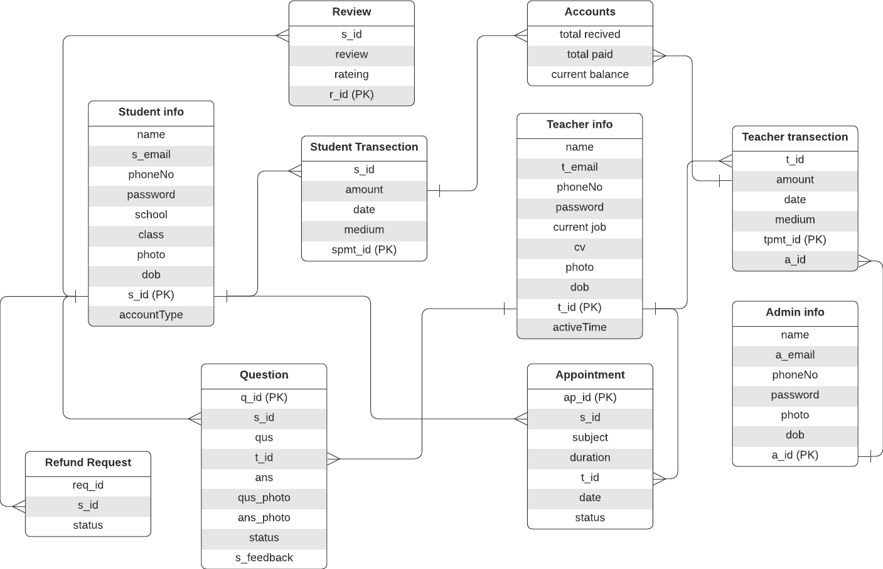

Qus_quntity

ER Diagram of Shomadhan

|  |  |
| --- | --- |
| Table Name | Stored Value |
| Student info | Information about students |
| Teacher info | Information about teachers |
| Admin info | Information about admin |
| Question | Question asked by students and related information |
| Appointment | Information about appointment request by student |
| Student Transection | Premium students’ payment information |
| Teacher Transection | Teacher payment information |
| Accounts | Total Balance |
| Refund Request | Premium students can request a refund |
| Review | Review given by students about us |