**GSORE**

**Organic food delivery system**

High Level Document

Doc v.1

**Technical Specification**

**Hardware requirements :**

1. **Processor : Intel Core 2 Duo ( or similar ) and after**
2. **RAM : 4GB and above**
3. **Internet connection : 50 Mbps and above**
4. **Hard disk : 150GB and above**

**Software requirements :**

1. OS : **Windows OS 7 and above**
2. **IIS feature enabled**
3. **Visual studio 2019**
4. **SQL Server 2012 and above**
5. **SQL server management studio 2012 and above**
6. **Microsoft .Net**
7. **Framework 4.7**

**Technologies Used**

**Front End :**

1. CSS 3
2. HTML 5
3. Jquery
4. Bootstrap
5. Razor view engine

**Middle tier and backend :**

1. **ASP .Net MVC** **architecture**
2. **C# programming language for coding**
3. **SQL server as database**

**Source control:**

**Github**

**Project Architecture**

**Database :**

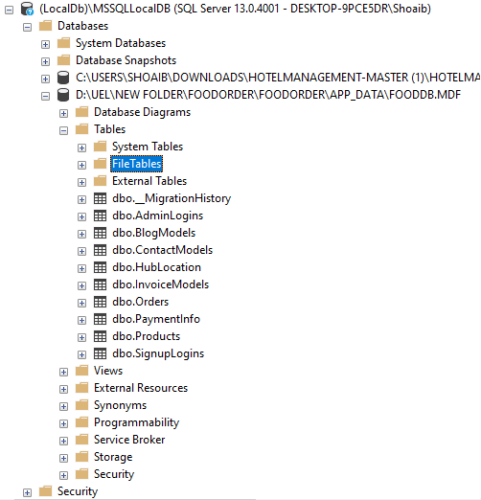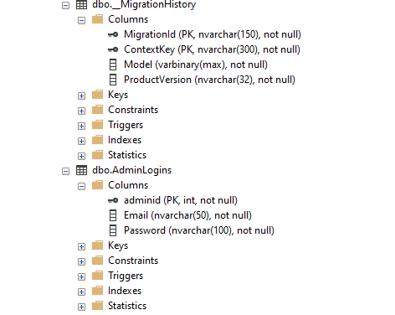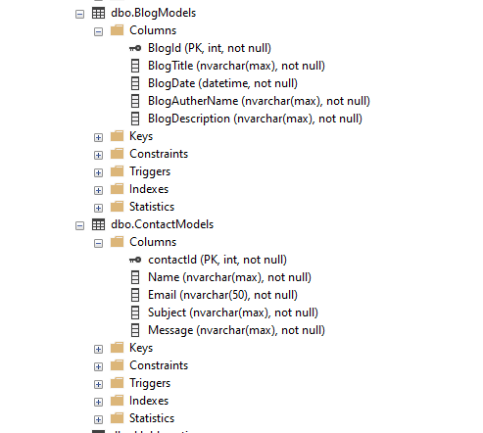

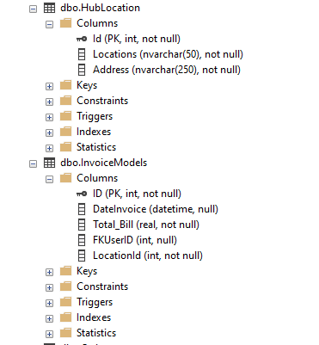 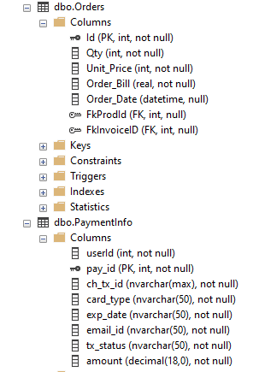 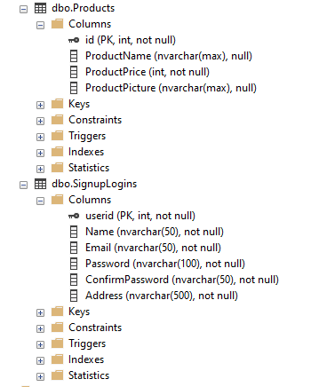

**Application :**

