Threat Modeling of Token Controller V2 (Keystone)

1.1 System Overview

Application version | Keystone Havana Stable Release
Application  Description | - The V2 Token Controller routes and glues the requests from public router to the appropriate internal services. It also performs filtering on incoming and outgoing requests. Authenticated users are issued bearer token.
Version | Havana Stable
Participants
Additional Info

1.2 Implementation Overview

Major Components | Keystone/token/controllers.py
Dependent components | Keystone/token/routers.py  TOKEN API, IDENTITY API, TOKEN PROVIDER API, TRUST API, POLICY
Description | Major process:  POST /token authenticate  GET /token/token_id validate  HEAD /token/token_id validate_token_head  DELETE /token/token_id delete  GET /token/revoked revocation_list  GET /token/token_id/endpoints endpoints (not covered)

1.3 System Assumptions (External Dependencies)

ID | Description
1 | The communication channel between end user and keystone is SSL protected.
2 | Only V2.0 API is covered in this doc.
3

2. Security Objective

System Security objective | - Authentication of user  - Validate the authenticity of the token  - Issuance of consistent and integrity protected token revocation list

3. 1 Data Flow Diagrams

AUTHENTICATE
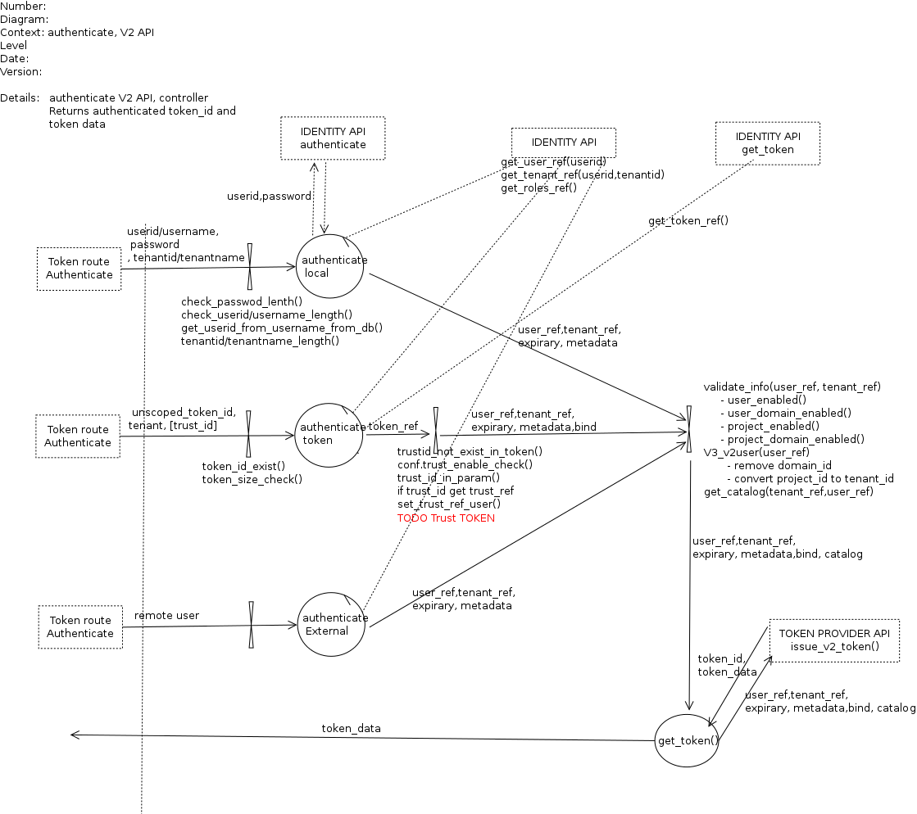

Related process: IDENTITY_API Authenticate
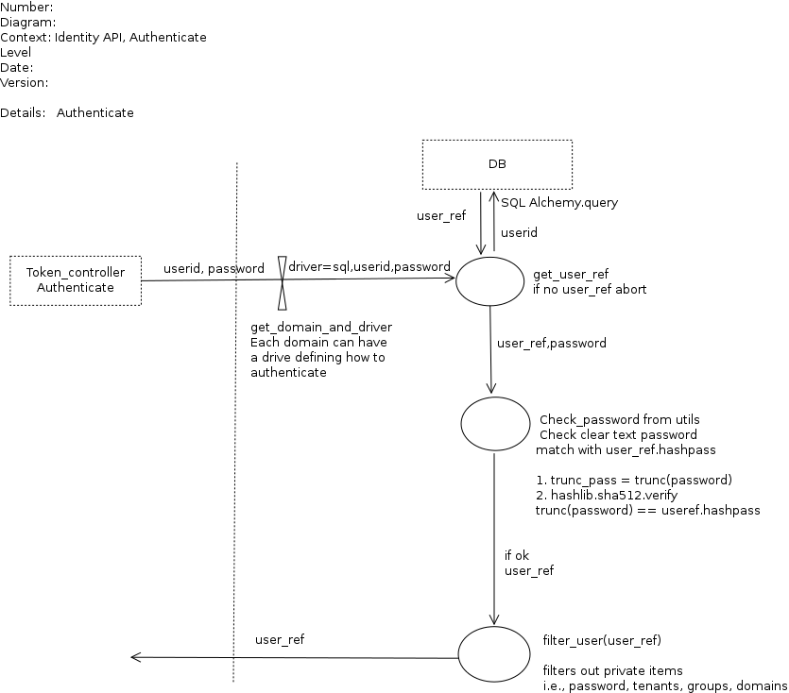

VALIDATE TOKEN

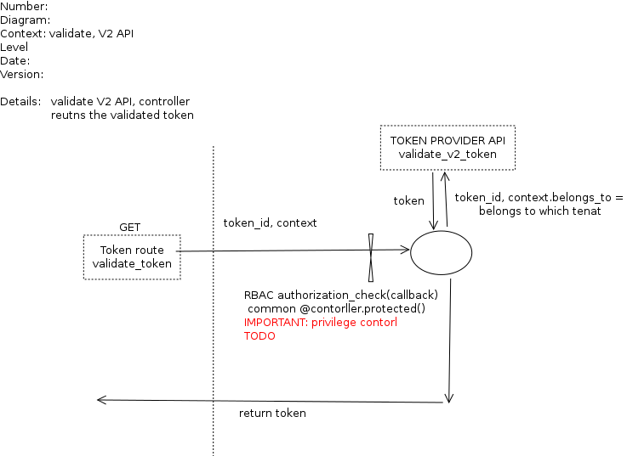

DELETE TOKEN
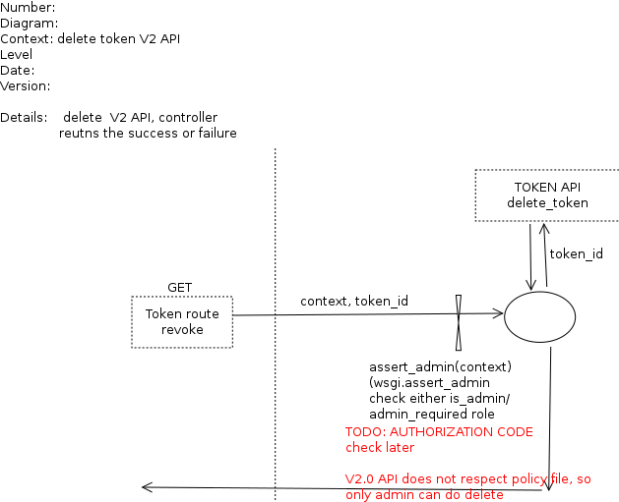

REVOCATION LIST

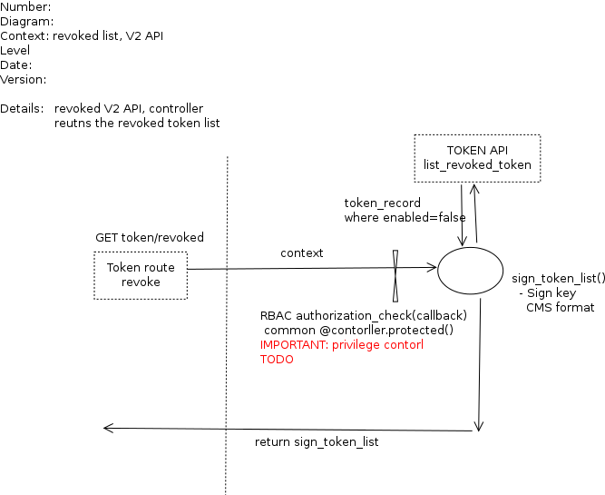

3.2 Entry points

ID | Name | Description | Accessible To
1 | Public router |  | 11) Keystone Process user  7) System admin
2

3.3 Assets

ID | Name | Details |  | Required Trust Levels
1 | User |  | Assets related to a user
1.1 | User auth credentials |  |  | 9) User  7) System Admin
1.1.1 | Tenant Admin auth credentials |  |  | 3) Tenant admin  4) Keystone Identity Admin  7) System admin  8) DB User
1.1.2 | Keystone Identity admin auth credentials |  |  | 4) Keystone Identity Admin  7) System admin  8) DB User
1.2 | User details |  | Information related to a user e.g., email, | 9) User  3) Tenant admin  4) Keystone Identity Admin  7) System admin  8) DB User
1.4 | Project
1.4.1 | User to Project relation
1.6 | User-Project-Role relation
1.8 | Trust
1.9 | Catalog data related to user and tenant (endpoints) |  |  | 9) user  3) Tenant admin  4) Keystone Identity Admin  7) System admin  8) DB User
1.9.1 | Auth Token related to a user |  |  | 9) User  7) System admin  8) DB User  11) Keystone Process user
 | System | Assets related to configuration and system
2.1 | Audit data |  |  | 7) System admin  11) Keystone Process user
2.3 | PKI/SSL signing cert |  |  | All
2.4 | Availability of keystone service |  |  | 4) Keystone Identity Admin  7) System admin
2.6 | Configuration parameter set |  | e.g., expiry time, max_param_size | 7) System admin  11) Keystone Process user
2.7 | REMOTE_USER set |  |  | External Identity admin  11) Keystone Process user
 | Revocation_list

3.4 (Existing Security Controls)

Not Done

4. Threat Identification and Analysis

Result-

Link to Excel Sheet
(check analysis_result folder)

