Threat Modeling of TOKEN API Service(Keystone)

1.1 System Overview

Application version | Keystone Havana Stable Release
Application  Description | Token API includes the manager and the driver. The manager receives requests and fulfills the request with the help of specific driver. The driver is configurable using keystone.conf. The driver in turn fulfills the operation by calling a persistent storage layer (SQL alchemy or other backend)
Version | Havana Stable
Participants
Additional Info

1.2 Implementation Overview

Major Components | Keystone/token/core  Keystone/token/backends/driver {sql/kvs/memchace}
Dependent components | Dogpile.cache  SQLAlchemy,  IDENTITY_API
Description | Major process  Create_token  Validate_token  Delete_token  Revocation_list

1.3 System Assumptions (External Dependencies)

ID | Description
1 | Only considered SQL backend
2 | Parameters of the incoming request to TOKEN_API is trustworthy
3 | The incoming request to TOKEN_API is trustworthy

2. Security Objective

System Security objective | - Internal operations to fulfill a request must ensure integrity of the intended requested operations

3. 1 Data Flow Diagrams

CREATE_TOKEN
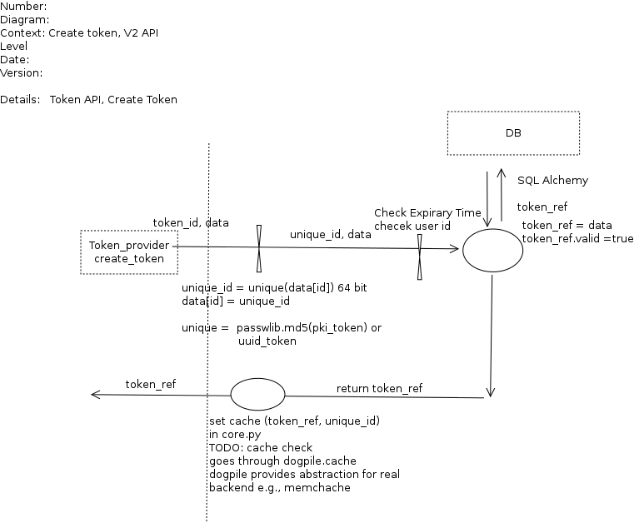

GET TOKEN /VALIDATE

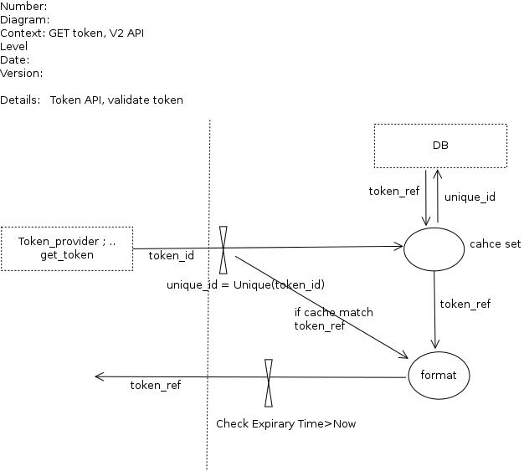

DELETE TOKEN

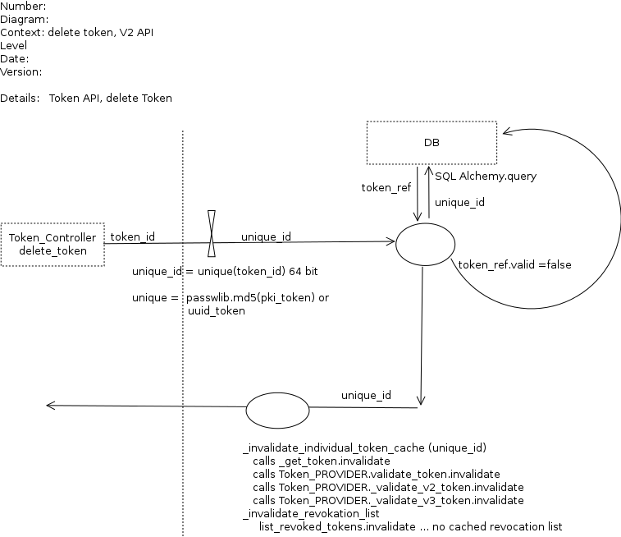

REVOKATION LIST

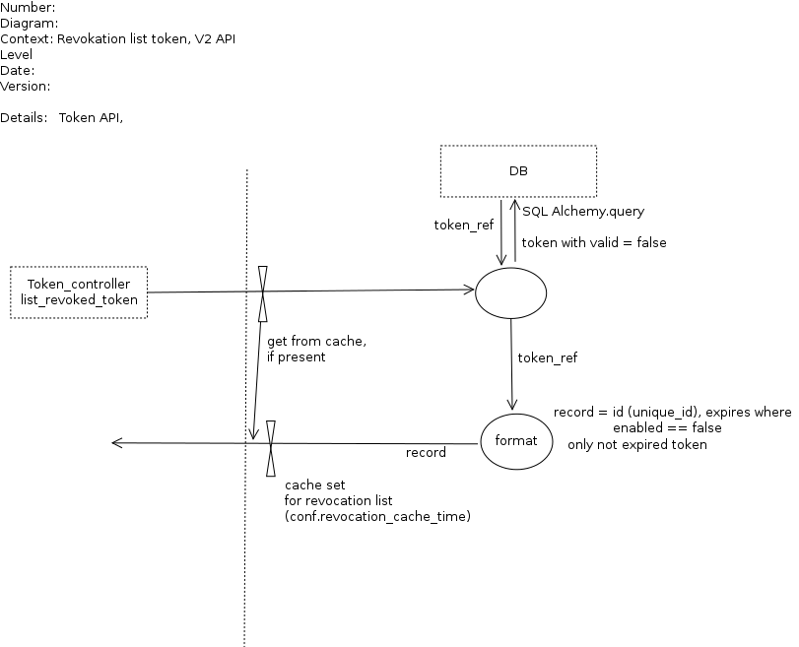

3.2 Entry points

ID | Name | Description | Accessible To
1 | Internal | E.g., Token Controller | Only Authenticated User, Keystone process
2

3.3 Assets

ID | Name | Details |  | Required Trust Levels
1 | User |  | Assets related to a user
1.2 | User details |  | Information related to a user e.g., email, | 9) User  3) Tenant admin  4) Keystone Identity Admin  7) System admin  8) DB User
1.4 | Project
1.4.1 | User to Project relation
1.6 | User-Project-Role relation
1.8 | Trust
1.9 | Catalog data related to user and tenant (endpoints) |  |  | 9) user  3) Tenant admin  4) Keystone Identity Admin  7) System admin  8) DB User
1.19 | Auth Token |  |  | 9) User  7) System admin  8) DB User  11) Keystone Process user
2 | System |  | Assets related to configuration and system
2.1 | Audit data |  |  | 7) System admin  11) Keystone Process user
2.4 | Availability of keystone service |  |  | 4) Keystone Identity Admin  7) System admin
2.5 | Access & execute Query in DB |  |  | 8) DB User
2.6 | Configuration parameter set |  | Cache time, revocation list cache time | 7) System admin  11) Keystone Process user
2.7 | Revocation_list |  | Not signed state

3.4 (Existing Security Controls)

Not Done

4. Threat Identification and Analysis

Result-

Link to Excel Sheet ( check Analysis_Result folder)

