Threat modeling of Keystone (High Level)

Keystone provides identity and access management service for OpenStack Cloud.

1.1 System Overview

Application version | Keystone Havana Stable Release
Application  Description | Keystone provides identity and access management for users of OpenStack Cloud. For this, it provides a shim and most of the underlying components are pluggable. It provides authentication of users, can contain a repository of users (identities) and roles. It also performs account and entitlement management of users. The entitlements are managed by assigning roles for users and enforcing access control on the target service (object).  - username/user id identifies the user. A user is authenticated by a configured authentication mechanism. Keystone also performs account provisioning e.g., users, tenant, domain and role provisioning, and their assignment.  - Authorization (entitlement) is performed for each request based on attached role of the token (user). The entitlement decision is made by the respective service.  - Each successful and unsuccessful request is logged.  - User and system data is protected by access control and sensitive data (only password) is protected by one way hashing.  - Keystone provides catalog information. Integrity of Catalog information?
Version
Participants
Additional Info

1.2 Implementation Overview

Major Components | Pipe line middleware: url_nomalizer, token_auth, admin_token_auth, xml_body, Json_body, ec2_extension, S3_extension, crud_extension, admin_service, public_service  Input validation filters within controllers  Services: Identity, Assignment, Catalog, policy, Token  Drivers: SQL , FILE, KVA, LDAP
Dependent components | Webservers: WSGI  OS and Libraries: oslo.config,  Crypto: OpenSSL library, hashlib, passlib, uuid generator
Description | - It consists of a combination of services: identity , Assignment, catalog, Policy and Token service. Each of the service has specific drivers, which can be plugged using configuration profile.  - Keystone performs authentication of users. The authentication process can be performed using three mechanisms: username/password (matching), un-scoped token, and External authentication (including external authentication middleware or external AUTH mechanism which set REMOTE_AUTH). A successful authentication issues a token.  - Keystone provides roles associated with each user. The roles are primitive in feature.  - Keystone provides provisioning of users, tenants, groups, roles, domains and their associations.  - Keystone also provides catalog services (description of service endpoint) associated with a users

1.3 System Assumptions (External Dependencies)

ID | Description
1 | Keystone server is running in Ubuntu 12.04. Keystone running in WSGI server which is accessible via public port 5000 and admin port 35357
2 | The database server is Mysql and related driver is sql via SQLAlchemy.
3 | The document will cover both V2.0 and V3.0 configuration options. (Now only V2.0)
4 | Keystone.conf – unless stated otherwise, the default values of the configuration file is used (keystone/etc/keystone.conf.sample and devstack conf)  - PKI token  - SSL endpoint
5 | The communication channel between end user and keystone service is SSL protected.
6 | Operating systems, databases, webserver, and physical machine are hardened
7 | The system admin follows security best practice
8 | Havana stable release requirement.txt trustworthy

2. Security Objective

IdAM system Security objective | An IdAM system must provide  - Identification and authorization (entitlement) of users  - Authorization of user-initiated request  - Auditing of each request  - Protection of system and user data  In addition, from business logic  - Integrity of catalog information

3. 1 Component Interaction diagram

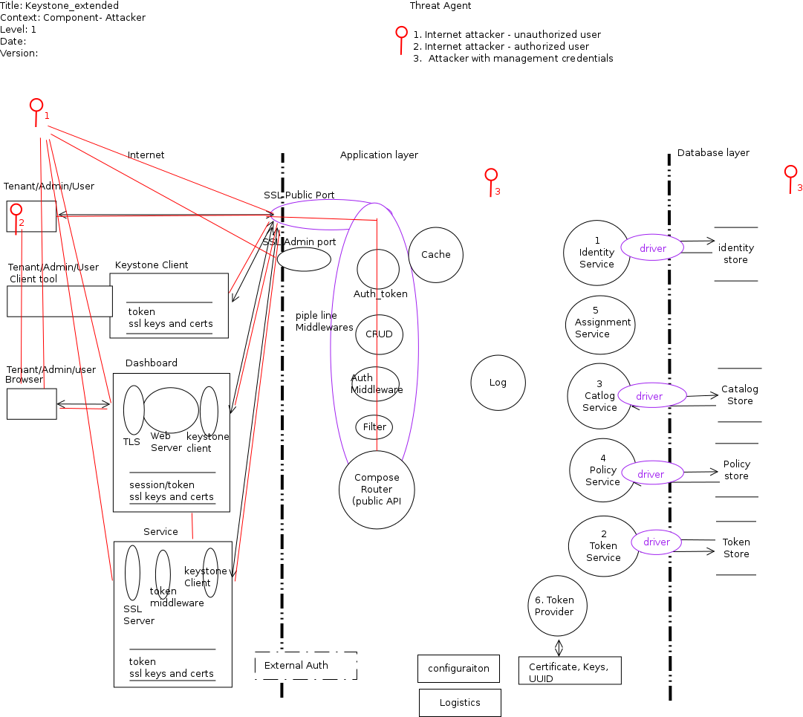

Link to Picture:

3.2 Entry points

The interfaces through which an attacker can request for resources or supply data

ID | Name | Description | Accessible To
1 | Public port | TLS protected port, used to access token and verify token for a user. Login functions are layered in this port | 1) Anonymous  2) Tenant user  3) Tenant admin  4) Keystone Identity Admin
2 | Admin port | TLS protected port, used to provision user, tenant, domain and role. ???? Only authorized request can pass to the respective operation. | 1) Anonymous  2) Tenant user  3) Tenant admin  4) Keystone Identity Admin
3 | External port (optional) | Protected, used to authenticate users from external system | 5) External Identity admin  4) Keystone Identity Admin

3.3 Assets

ID | Name | Details | Required Trust Levels
1 | User | Assets related to a user
1.1 | User auth credentials |  | 9) User  7) System Admin
1.1.1 | Tenant Admin auth credentials |  | 3) Tenant admin  4) Keystone Identity Admin  7) System admin  8) DB User
1.1.2 | Keystone Identity admin auth credentials |  | 4) Keystone Identity Admin  7) System admin  8) DB User
1.2 | User details | Information related to a user e.g., email, | 9) User  3) Tenant admin  4) Keystone Identity Admin  7) System admin  8) DB User
1.4 | Project
1.4.1 | User to Project relation
1.5 | Group
1.5.1 | User to Group relation
1.6 | User-Project-Role relation
1.7 | domain
1.7.1 | User to domain relation
1.8 | Trust
1.9 | Catalog data related to user and tenant (endpoints) |  | 9) user  3) Tenant admin  4) Keystone Identity Admin  7) System admin  8) DB User
1.19 | Auth Token related to a user |  | 9) User  7) System admin  8) DB User  11) Keystone Process user
2 | System | Assets related to configuration and system
2.1 | Audit data |  | 7) System admin  11) Keystone Process user
2.2 | PKI/SSL private key |  | 7) System admin  11) Keystone Process user
2.3 | PKI/SSL signing cert |  | All
2.4 | Availability of keystone service |  | 4) Keystone Identity Admin  7) System admin
2.5 | Access & execute Query in DB |  | 8) DB User
2.6 | Configuration parameter set |  | 7) System admin  11) Keystone Process user
2.7 | REMOTE_USER set |  | External Identity admin  11) Keystone Process user
2.8 | Ability to manage users (account provisioning) |  | 3) Tenant admin  4) Keystone Identity Admin
2.9 | UUID generator |  | 7) System admin  4) Keystone Identity Admin
2.10 | Authorization policy management within keystone | Management of which user can access what (entitlement rules) i.e., policy definition file | 4) Keystone Identity Admin  7) System admin  11) Keystone Process user
3. | Web Application | Dashboard to access Keystone service
3.1 | Login session |  | 9) Authenticated user  10) Dashboard Admin

3.4 Security Profile of Keystone (Existing Security Controls)

Here we describe some model question to create a security profile for this application.
Ref: http://msdn.microsoft.com/en-us/library/ff648644.aspx

Not done

4 Threat Identification (High Level)

4.1 Threat Agents

ID | Name | Details
IA-U | Internet Attacker– Unauthorized
IA-A | Internet Attacker – Authorized
IN-I | Internal Attacker - Insider

4.2 Threat Identification and analysis

Analysis result:

Link to Excel Sheet

4.3. Component based Threat Analysis

4.4.1 Identified Major Components / Proxies:
Components layering two trust boundaries and performing critical operations are interesting for this analysis

ID | Name | Functionality
1 | Client
1.1 | Keystone client
1.2 | Dashboard – operations related to user login sessions
1.3 | OpenStack services e.g., Nova | How services consume keystone token – Auth Token
2 | Keystone application server
2.1 | Auth_token middleware
2.2 | Filters | Input validation filters
2.4 | Identity Service
2.5 | Token Service
2.6 | Assignment service
2.7 | Catalog Service
2.8 | Policy Service
2.9 | Token provider
2.10 | SSL end point
2.11 | Cache
2.12 | Trust
3 | Persistence Storage
3.1 | Sql Backend
3.2 | LDAP Backend
4 | System
4.1 | Web server – WSGI server
4.2 | SSL server
4.3 | Operating system
4.4 | Logistics ( PyPI, python packages) httplib2, requirements.txt
5 | External
5.1 | External Auth system

Result:

Token Provider Analysis:

Analysis Result Link

4.4.2 Use Case:

ID | Name | Details
1 | User authenticates through username/password
2 | User authenticates using External authentication
3 | User authentication from un-scoped token
4 | Tenant admin creates user
5 | Tenant admin assigns roles to a user

