Threat Modeling of Token Provider (Keystone)

1.1 System Overview

Application version | Keystone Havana Stable Release
Application  Description | Keystone has a customizable token provider. Token provider supports both UUID and PKI token. PKI as default.  UUID token is 128 bit, provides a random opaque, generated by uuid4()  PKI tokens are cryptographic Message syntax (CMS) string, generated by Openssl. PKI tokens require signing key and cert. The cert needs to be distributed to the token verifier.  Both PKI and UUID token are bearer tokens
Version
Participants
Additional Info

1.2 Implementation Overview

Major Components | Keystone.token.providers.pki/uuid  UUID driver  PKI driver
Dependent components | UUID generator  Crypto: CMS, Openssl  Other Kesytone components: Token API , Trust  Key: Signing key, Certflie
Description | Major process:  Issue token: Issue_v2_token, Issue_v3_token  Validate token: Validate_v2_token, Validate_v3_token  Revoke token: revoke_token

1.3 System Assumptions (External Dependencies)

ID | Description
1 | Token API service is trustworthy
2 | The input data i.e., token_ref and metadata are trustworthy
3 | Signing cert is obtained and distributed in a secure way ?

2. Security Objective

System Security objective | - Generate cryptographically secure random id  - Ensure Integrity protected token data (PKI token)

3. 1 Data Flow Diagrams

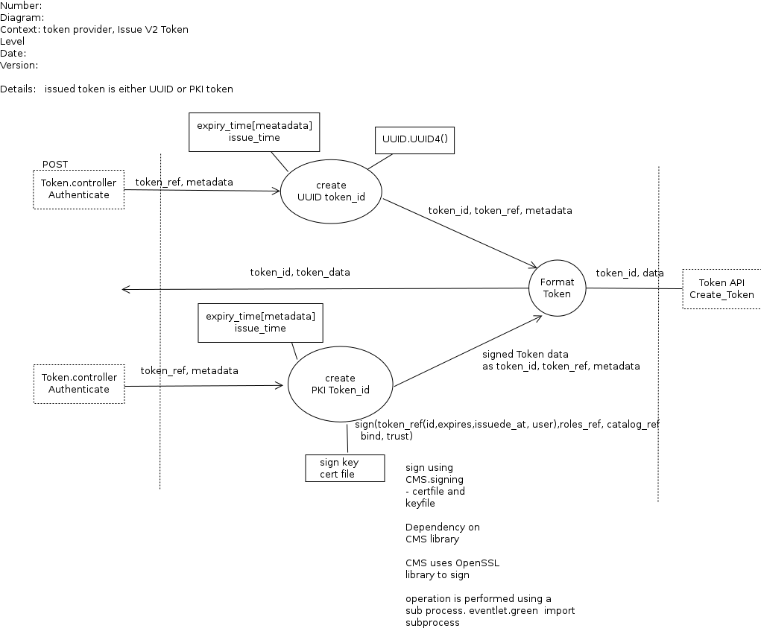
issue_v2_token

Link:

Issue_v3_token

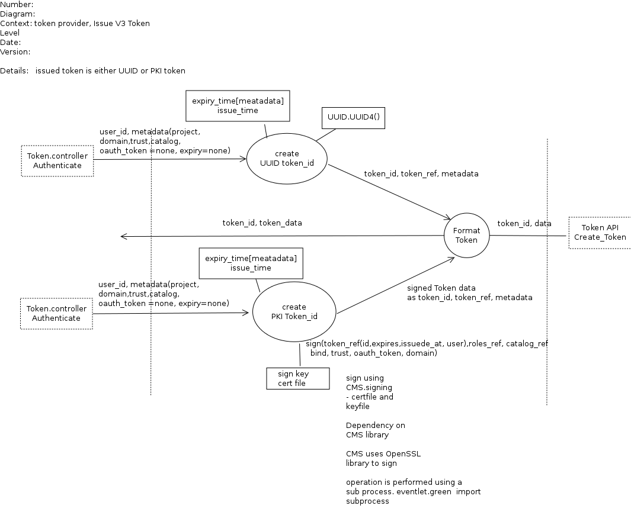

Link:

Validate V2/V3 Token

Link:
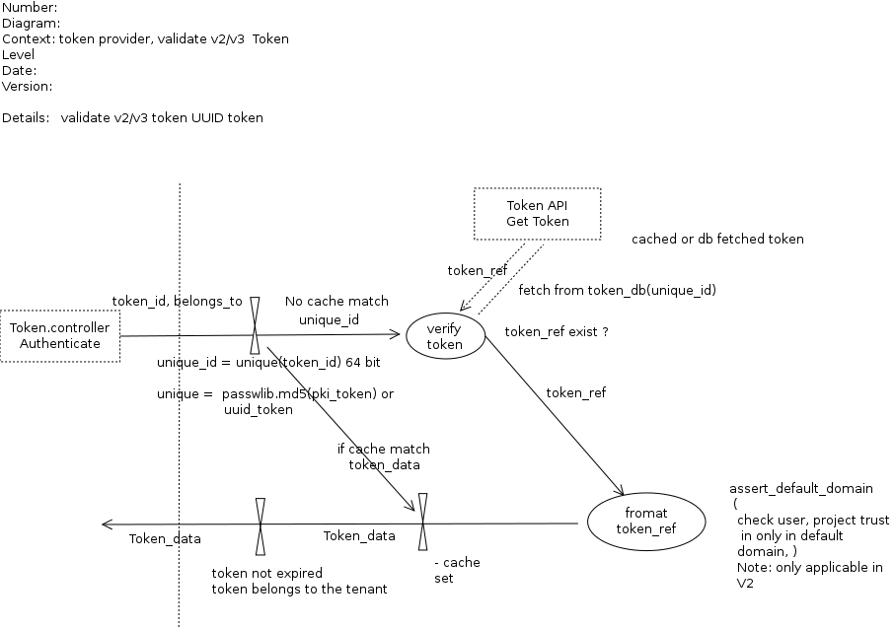

3.2 Entry points

ID | Name | Description | Trust Levels
1 | Token Controller |  | 11) Keystone Process user  7) System admin
2

3.3 Assets

ID | Name | Details | Required Trust Levels
1 | User | Assets related to user
1.1 | User_ref
1.7 | Token_ref |  | 9) User  7) System admin  8) DB User  11) Keystone Process user
 | Token_data |  | 9) User  7) System admin  8) DB User  11) Keystone Process user
1.7.1 | Token_id (Auth_token related to a user) |  | 9) Authenticated user  7) System admin  8) DB User  11) Keystone Process user
1.7.2 | Meta_data
 | System | Assets related to configuration and system
2.1 | Random source | UUID , OpenSSL
2.2 | PKI/SSL private key |  | 11) Keystone Process user  (7) System admin
2.3 | Expiry_time | Conf parameter
2.4 | Issue_time | System current time
2.4 | Audit data | Provides non reputable information

3.4 (Existing Security Controls)

Not Done

4. Threat Identification and Analysis

Result-

Link to Excel Sheet

