Threat Modeling of Keystone Client Middleware (AUTH_TOKEN)

1.1 System Overview

Application version | Keystone Havana Stable Release
Application  Description | The Keystone middleware architecture supports a common authentication protocol for all OpenStack projects. By using keystone as a common authentication and authorization mechanisms, the OpenStack project can plug in to existing authentication and authorization systems.  OpenStack is using a token based mechanism for authentication and authorization. An authentication middleware component is a proxy that intercepts HTTP calls from clients, validate the header, and populates HTTP headers in the request context for other WSGI middleware or applications to use
Version
Participants
Additional Info

1.2 Implementation Overview

Major Components | auth-token
Dependent components | Json utilties  Crypto: hashlib(md5)  Signing certificate, certificate authority  Token Caching (memcache)
Description | Major process:  Get user token, Validate user token, Build user header, Add user header, Data to service.

1.3 System Assumptions (External Dependencies)

ID | Description
1 | Token service is trustworthy
2 | Memcache is initialized.
3 | The communication channel is secure
4 | Signing cert and certificate authority are obtained and distributed in a secure way.

2. Security Objective

System Security objective | - Validation of the token.

3. 1 Data Flow Diagrams

Keystone Client Middleware

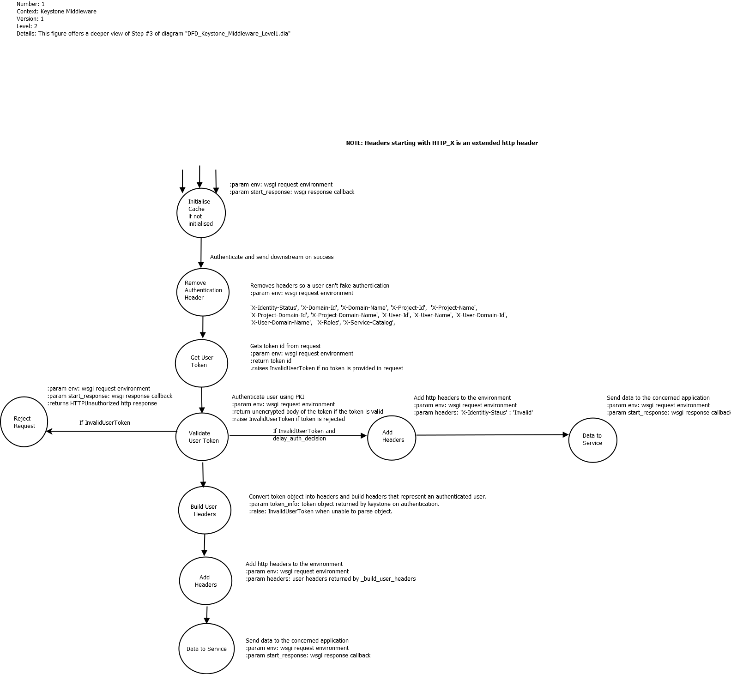

Link: Keystone Client Middleware Level 2

Token Validation (Expanded Validate User Token from previous, Level 2, DFD)

The following DFD expands and describes the token validation process in detail. It discusses the token validation UUID and PKI based tokens.

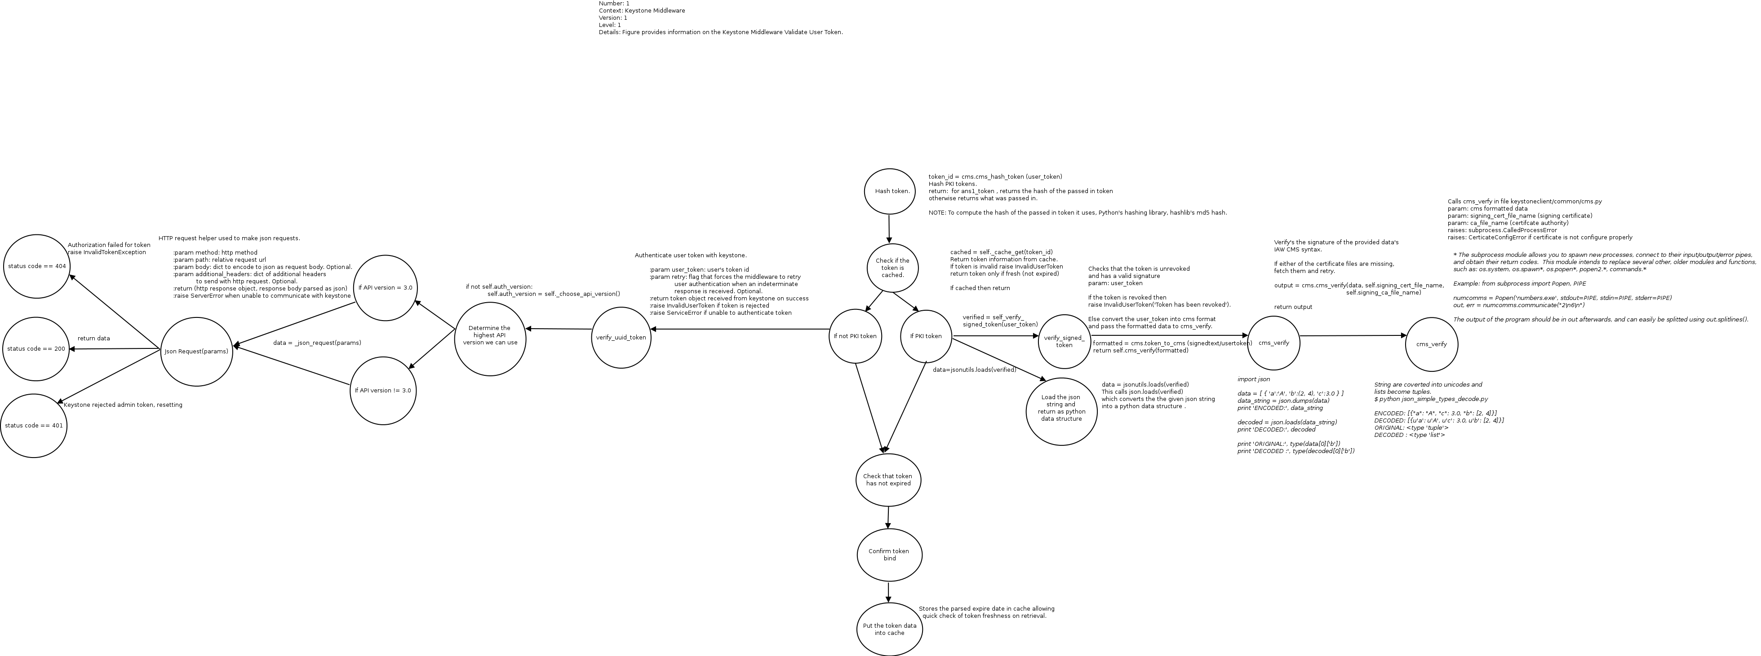

Link: Validate User Token

Token Validation Simplistic
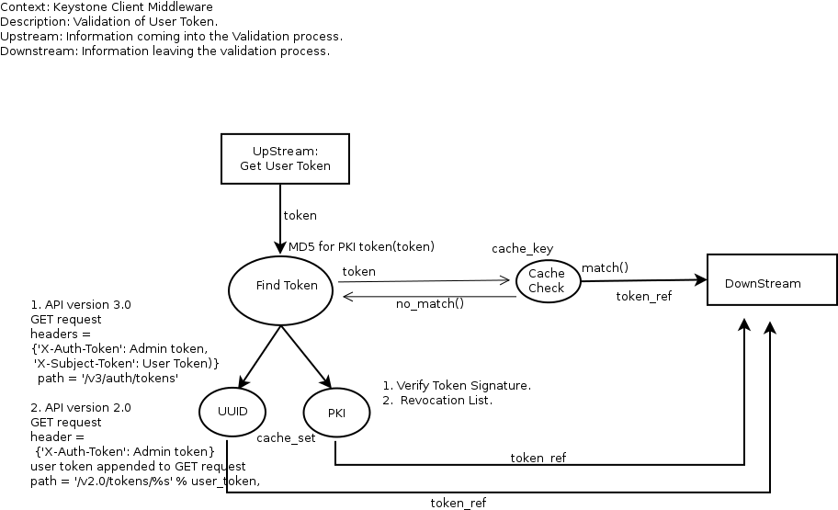

3.2 Entry points

ID | Name | Description | Trust Levels
1 | Public port | Request enters to the Keystone Middleware
2 | Private port | Middleware communicates with Keystone Server to obtain token information.

3.3 Assets

ID | Name | Details | Required Trust Levels
1 | User | Assets related to user
1.2 | User details | Information related to a user e.g., role/domain, username/id, groups and their relation.
1.6 | Catalog Data related to user and tenant
1.7 | Token Data
1.7.1 | Token (related to a user)
1.7.2 | Token (related to a the service)
 | System | Assets related to configuration and system
2.6 | Conf Parameter Set | Expiry Time  Issue Time
2.3 | Signing cert
2.4 | Availability of Keystone Service
2.1 | Audit Data
 | Memcache key
 | Availability of memchace

3.4 (Existing Security Controls)

Not Done

4. Threat Identification and Analysis

Result-

Link to excel sheet here !!!

