Threat modeling of Keystone (High Level)

Keystone provides identity and access management service for OpenStack Cloud.

1.1 System Overview

Application version | Keystone Havana Stable Release
Application  Description | Keystone provides identity and access management for users of OpenStack Cloud. For this, it provides a shim and most of the underlying components are pluggable. It provides authentication of users, can contain a repository of users (identities) and roles. It also performs account and entitlement management of users. The entitlements are managed by assigning roles for users and enforcing access control on the target service (object).  - Username/user id identifies the user. A user is authenticated by a configured authentication mechanism. Before authentication, account needs to be provisioned. Keystone also performs account provisioning e.g., users, tenant, domain, role, and their assignments. External authentication mechanisms e.g., Apache HTTP authentication can be integrated with keystone.  - Authorization (entitlement) is performed for each request based on assigned role within the token for a user and policy file defined in the system. The entitlement decision is decentralized i.e., made by the respective service.  - Each successful and unsuccessful request is logged.  - User and system data is protected by access control and sensitive data (only password) is protected by one way hashing.  - Keystone provides catalog information for other services.
Document Version | 0.1
Participants
Additional Info | Date: April, 2014

1.2 Implementation Overview

Major Components | Pipe line middlewares: url_nomalizer, token_auth, admin_token_auth, xml_body, Json_body, ec2_extension, S3_extension, crud_extension, admin_service, public_service  (check the middleware from paste.ini for specific Pipe). Currently this document focuses on [pipeline:api_v3], the keystone v3 API pipeline. The document also include some parts of [pipeline:public_api] – keystone v2 API pipeline.  Services/internal components: Identity, Assignment, Catalog, policy, Token, Token Provider, Trust  Drivers/persistence storage: SQL, FILE, KVA, LDAP
Dependent components | Webservers: WSGI (or any web server on top WSGI modules can run)  Operating system and libraries: oslo.config, dependencies.  Crypto: OpenSSL library, hashlib, passlib, UUID generator (Crypto library versions are considered)
Description | - Keystone consists of a combination of services: identity, assignment, catalog, policy, token and so on. Each of the service has specific drivers, which can be plugged using configuration profile.  - Keystone performs access control: authentication and authorization (entitlement) of users. The authentication process can be performed using three mechanisms: username/password, token, and External authentication (including external authentication middleware or an external authentication mechanism which set REMOTE_AUTH variable). A successful authentication issues a token to the requester.  - The authorization process consists of assignment of roles, policy definition file specific for specific OpenStack service, entitlement decision engine and enforcement points.  - Keystone provides identity provisioning service e.g., users, tenants, groups, roles, domains  - As an addition, Keystone provides catalog services (description of services and endpoints) for each user.

1.3 System Assumptions (External Dependencies)

ID | Description
1 | Application:  Keystone running in WSGI server which is accessible via public port 5000 and admin port 35357
 | The document will cover both V2.0 (limited only for Token service) and V3.0 API.
Keystone.conf – unless stated otherwise, the default values of the configuration file is used (keystone with devstack setting)
- PKI token (default token provider)
SSL endpoint (Keystone server endpoint. We assumed keystone server to client transport channel is SSL protected. OpenStack Security Guide and Keystone doc define steps for SSL endpoints)
 | The communication channel between client and keystone service endpoint is SSL protected (from assumption 4).
2 | Persistence (Database):  The database server is MySQL and related driver is  SQLAlchemy.
 | We assume the default config DB from keystone.conf and mysql.conf
3 | Platform:  Operating systems, webserver, and physical machines are hardened.
 | The system admin follows security best practice
 | Keystone server is running in Ubuntu 12.04.
 | Dependencies (keystone dependent libraries) in requirements.txt are trustworthy

2. Security Objectives

IdAM Security objective | An IdAM must provide  - Identification (authentication) and entitlements of users  - Entitlement decision (authorization) for user-initiated request  - Non-repudiable auditing for each request  - Protection of system and user data / state information.  In addition, for keystone case:  - Integrity of catalog information

3. 1 Component Interaction diagram

//TODO: Update the picture
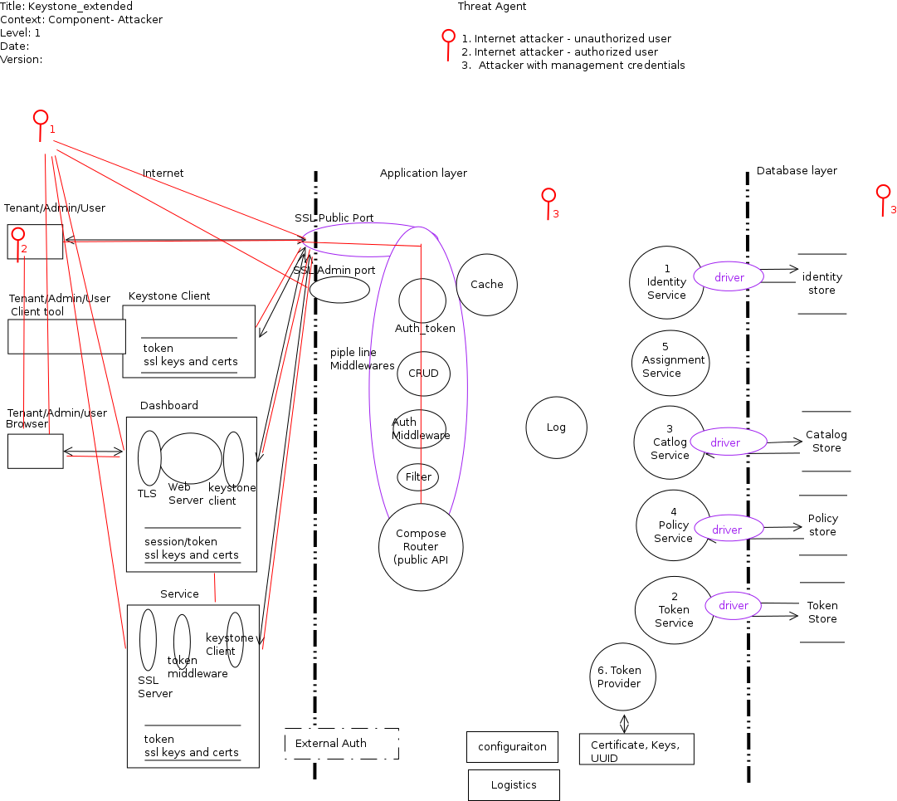

Link to Picture:

3.2. Actors/ Attackers

ID | Name | Actors | Details
IA-U | Internet Attacker– Unauthorized | 1. Anonymous
IA-A | Internet Attacker – Authorized | 2. Project User  3. Owner  4. Project Admin  5. Domain Admin  6. Cloud Admin  7. Admin (V2 case)
IN-I | Internal Attacker - Insider | 8. Keystone System user  9. Other System user  10. System Admin  11. DB Admin  12. Keystone DB user  12. External Identity provider user  13. service user

3.3 Entry points

Interfaces through which actors/attackers can request for assets/resources or interfaces through which the system returns asset information to the requester.

ID | Name | Description | Accessible To
1 | Public port | SSL protected port, used to access the keystone server. External requests come and return through this port. Default 5000. If you plan to use SSL proxy, it could be different. | All, however only authenticated user can get in.
2 | Admin port | SSL protected port, used to access the keystone server. External requests come and return through this port. Default 35357. If you plan to use SSL proxy, it could be different. Used only in V2 API | All, however, only admin role user can get in (V2 case)
3 | External port (optional) | Protected, used to authenticate users (user data) from external system | (8) Keystone System user  (10) System Admin (Does system admin needs this ?)  can access remote system to verify user data. Not the other way around.
4 | Interface towards persistence layer | Keystone server communicates with database backend . We only consider MySQL server. | (8) Keystone System user  access DB (through some DB user). Not the other way around. (10) Does System Admin needs this access?
5 | Cache interface | Keystone uses dogpile cache layer which stores data in one of the cache backend. | (8) Keystone System user  access cache server. Not the other way around. (10) Does System Admin needs this access?

3.4 Assets

ID | Name | Details |  |  |  | Accessible To
USER RELATED
1 | User | User_id - Unique within the system  User_name – unique within domain  Domin_id – unique within the system |  |  | CRUD by  5. (owning) Domain Admin  6. Cloud Admin
1.1 | User secret | User password – only hash password stored |  |  | (3) Owner
1.2 | User sensitive data
1.3 | User protected data | User_id - Unique within the system  User_name – unique within domain  Domin_id – unique within the system |  |  | Viewable to:  3. Owner  5. (owning) Domain Admin  6. Cloud Admin  13. OpenStack service user
2 | Project | Project_id – unique within system  Project_name-unique within domain  Domain_id-unique within system |  |  | CRUD by  5. (owning) Domain Admin  6. Cloud Admin
2.1 | Project Protected credentials | Project_id – unique within system  Project_name-unique within domain  Domain_id-unique within system |  |  | Viewable to:  3. Owner  5. (owning) Domain Admin  6. Cloud Admin  13. OpenStack service user
3 | Group | group_id – unique within system  group_name-unique within domain  Domain_id-unique within system |  |  | CRUD by  5. (owning) Domain Admin  6. Cloud Admin
3.1 | Group protected credentials | group_id – unique within system  group_name-unique within domain  Domain_id-unique within system |  |  | Viewable to:  3. Owner  5. (owning) Domain Admin  6. Cloud Admin  13. OpenStack service user
3.2 | CRUD user in Group | User_id  Group_id |  |  | 5. (owning) Domain Admin  6. Cloud Admin
4 | Role | Role_id – unique within system  Role_name – unique within system |  |  | CUD by  6. Cloud Admin  R by  7. Admin role also
5. | domain | doman_id – unique within system  domain_name-unique within system |  |  | CRUD by  6. Cloud Admin
6. | Grant
6.1 | User-project | User_id  Project_id  Role_id |  |  | CRUD by  4. Project Admin  5. (owning) Domain Admin  6. Cloud Admin
6.2 | User-domain | User_id  domain_id  Role_id |  |  | CRUD by  5. (owning) Domain Admin  6. Cloud Admin
6.3 | Group-project | group_id  Project_id  Role_id |  |  | CRUD by  4. Project Admin  5. (owning) Domain Admin  6. Cloud Admin
6.4 | Group-Domain | group_id  Project_id  Role_id |  |  | CRUD by  5. (owning) Domain Admin  6. Cloud Admin
7 | Trust | Trust_id  Trustor_user_id  Trustee_user_id  Impersonation  project  Deleted_at  Expire_at |  |  | C by (3) Owner – trustor  R by trustee (policy.json is empty)  UD by trustor , project admin, domain admin, cloud admin(policy.json is not compliant)
7.1 | Trust_role | Trust_id  Role_id |  |  | C by (3) Owner – trustor  RUD by  (Empty)
8 | Token | Token_id  Valid  Trust_id  Expires_at |  |  | C by  1) anonymous (authentication)  R by  7. Admin (v2)  13. service user  D by  3. Owner  5. (owning) Domain Admin
8.1 | Revocation_list | [Token_id,  Expires_at] |  |  | R by  7. Admin (v2)  13. Service user
9 | Credentials
10 | Service
11 | Endpoint
12 | Policy |  |  |  | CRUD by  6. Cloud Admin
20 | System | Assets related to configuration and system
21 | Audit data |  |  |  | 8. Keystone System user  9. Other System user  10. System Admin
22 | PKI/SSL private key |  |  |  | 8. Keystone System user  9. Other System user  10. System Admin
23 | PKI/SSL signing cert |  |  |  | All
24 | Availability of keystone service
25 | Access & execute Query in DB
26 | Configuration parameter set |  |  |  | 8. Keystone System user  9. Other System user  10. System Admin
27 | REMOTE_USER set |  |  |  | 8. Keystone System user  12. External Identity provider user
28 | UUID generator |  |  |  | 10. System Admin  12. Keystone DB user
30 | Crytpo libraries | Encryption and Hashing Algoritms |  |  | 10. System Admin
31 | Operation system
32 | Hosting Webserver
33 | Dependencies
34 | Persistence layer | Only MySQL backend |  |  | 8. Keystone System user  10. System Admin  11. DB Admin  12. Keystone DB user
50 | Client
51 | Dashboard | Dashboard to access Keystone service
52 | Keystone Client
53 | Browser
52 | Login session | User login session to dashboard

3.4 Security Profile of Keystone (Existing Security Controls)

Here we describe some model question to create a security profile for this application.
Ref: http://msdn.microsoft.com/en-us/library/ff648644.aspx

(Not done)

4 Threat Identification (High Level)

4.1 Threat Identification and analysis

Analysis result:

Link to Excel Sheet

4.2. Component based Threat Analysis

4.2.1 Identified Major Components / Proxies:
Components layering two trust boundaries and performing critical operations are interesting for the analysis

ID | Name | Functionality
1 | Client
1.1 | Keystone client
1.2 | Dashboard – operations related to user login sessions
1.3 | OpenStack services e.g., Nova | How services consume keystone token – Auth Token
2 | Keystone application server
2.1 | Token_auth middleware
2.2 | Filters | Input validation filters
2.4 | Identity Service
2.5 | Token Service
2.6 | Assignment service
2.7 | Catalog Service
2.8 | Policy Service
2.9 | Token provider
2.10 | SSL end point
2.11 | Cache
2.12 | Trust
3 | Persistence Storage
3.1 | SQL Backend
3.2 | LDAP Backend
4 | System
4.1 | Web server – WSGI server
4.2 | SSL server
4.3 | Operating system
4.4 | Logistics ( PyPI, python packages) httplib2, requirements.txt
5 | External
5.1 | External Auth system
(Note: The naming of asset and component is sometimes same. There are distinction between asset and component: an asset is something which has value and has a state. Component or proxies on the other hand manipulates /performs operation on top of asset. E.g., Trust is an asset – meaning it defines a relational state while ‘Trust component’ is the process to generate Trust asset)

4.2.2 Excluded from current Analysis

4.2.3 List of all Reports:

