Threat Modeling of Auth V3 (Keystone)

1.1 System Overview

Application version | Keystone Havana Stable Release
Application  Description | - The V3 Auth Controller routes and glues the requests from service_v3 middleware to the appropriate internal services. It also performs filtering on incoming and outgoing requests. Authenticated users are issued bearer token.
Version | Havana Stable
Participants
Additional Info

1.2 Implementation Overview

Major Components | Keystone/auth /controllers.py
Dependent components | Keystone/auth/routers.py  Keystone/auth/plugins/{authentication_plugin}  TOKEN API, IDENTITY API, TOKEN PROVIDER API, TRUST API, POLICY
Description | Each authentication requests is a POST request, must include  User credential, authentication method, and optionally ‘scope’. The scope is either project or domain, not both. Scope is also identifiable from trust_id. The authentication token is returned in X-Subject-Token header  POST /auth/tokens authenticate_for_token  GET validates the token. Only permitted roles (defined in policy.json) can validate a token  GET /auth/tokens validate_token  HEAD /auth/tokens check_token  Delete token disables a token by changing the ‘enable’ flag  DELETE /auth/tokens revoke_token  More info: http://api.openstack.org/api-ref-identity.html

1.3 System Assumptions (External Dependencies)

ID | Description
1 | The communication channel between end user and keystone is SSL protected.
2 | Only V3.0 API is covered in this doc.

2. Security Objective

System Security objective | - Authentication of user  - Validate the authenticity of the token

3. 1 Data Flow Diagrams

Top Level Flow:

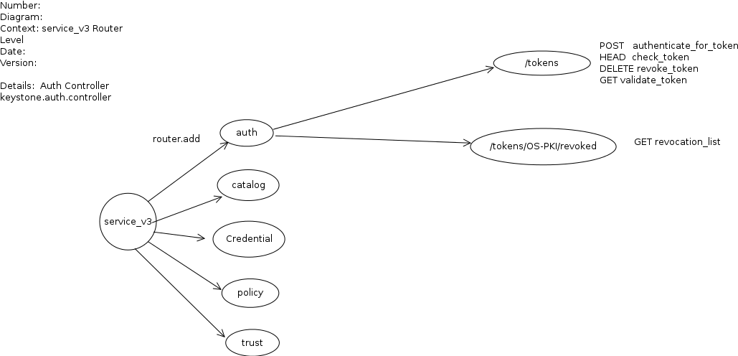

AUTHENTICATE

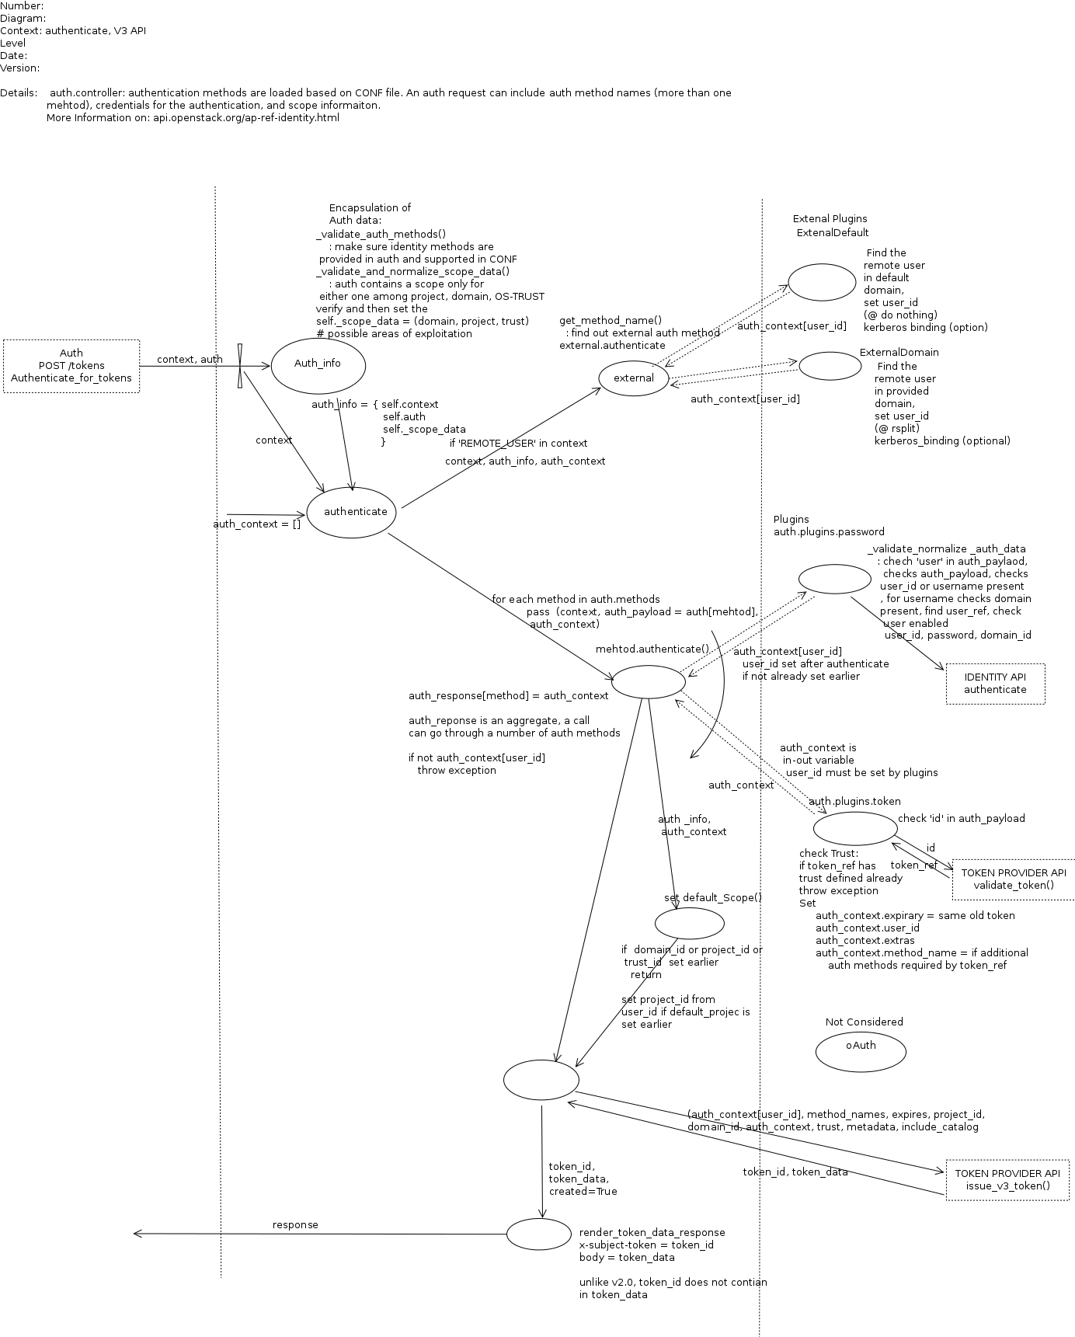

Related process: IDENTITY_API Authenticate

VALIDATE TOKEN

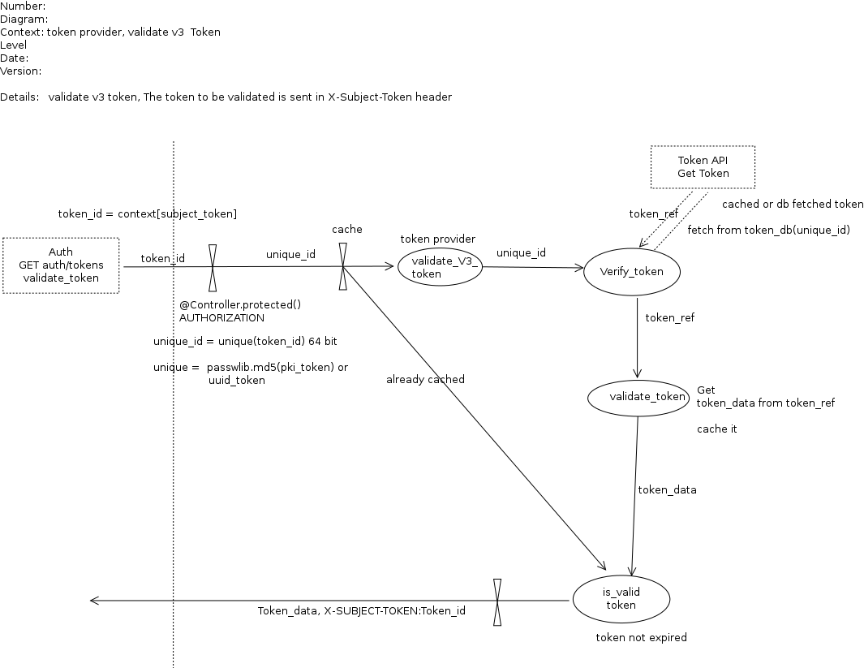

DELETE TOKEN
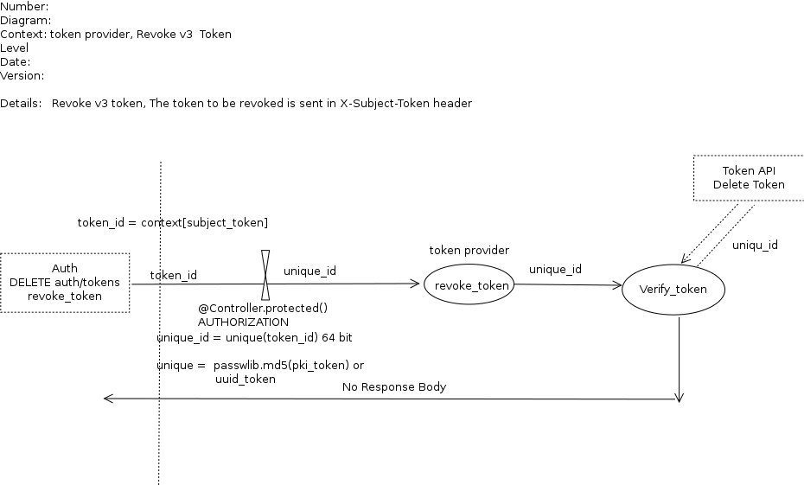

3.2 Entry points

ID | Name | Description | Accessible To
1 | S3_router |  | 11) Keystone Process user  7) System admin

3.3 Assets

ID | Name | Details |  | Required Trust Levels
1 | User  - user id  - user name |  | Assets related to a user  User_id unique in whole deployment  User_name is unique in each domain
1.1 | User auth credentials |  | Can be password, can be another token_id | 9) User  7) System Admin
1.1.1 | Tenant Admin auth credentials |  |  | 3) Tenant admin  4) Keystone Identity Admin  7) System admin  8) DB User
1.1.2 | Keystone Identity admin auth credentials |  |  | 4) Keystone Identity Admin  7) System admin  8) DB User
1.4 | Project  Project_id  Project_name |  | Project_id is unique  Project_name is unique in each domain
1.4.1 | User to Project relation
1.6 | User-Project-Role relation
1.8 | Trust
1.9 | Catalog data related to user and tenant (endpoints) |  |  | 9) user  3) Tenant admin  4) Keystone Identity Admin  7) System admin  8) DB User
1.10 | Auth Token related to a user  - Token_id |  |  | 9) User  7) System admin  8) DB User  11) Keystone Process user
1.10.1 | Token data
1.11 | Domain | Domain name or id is unique
1.12 | Scope | Scope contains project or domain scope
1.13 | Methods | Authentication methods defined by user request
 | System | Assets related to configuration and system
2.1 | Audit data |  |  | 7) System admin  11) Keystone Process user
2.4 | Availability of keystone service |  |  | 4) Keystone Identity Admin  7) System admin
2.6 | Configuration parameter set |  | e.g., expiry time, max_param_size | 7) System admin  11) Keystone Process user
2.7 | REMOTE_USER set |  |  | External Identity admin  11) Keystone Process user
 | Method | Authentication methods defined in the CONF
 | Revocation_list

3.4 (Existing Security Controls)

Not Done

4. Threat Identification and Analysis

Result-

Link to Excel Sheet
(check analysis_result folder)

