Threat Modeling of Keystone Identity And Assignment

1.1 System Overview

Application version | Keystone Havana Stable Release V3.0 API
Application  Description | The Identity service provides data about Users (projects), Group and as well as any associated metadata. In the basic case all this data is managed by the service, allowing the service to manage all the CRUD associated with the data.  Starting from Havana, several of the entities previously managed via the Identity backend were divided into a new backend called Assignments.  The Assignments driver manages:  - Projects (previously known as Tenants)  - Roles  - Role Assignments  - Domains  The Identity driver still manages:  - Users  - Groups  - Group Assignments  API version: v3
Version | 0.1
Participants
Additional Info

1.2 Implementation Overview

Major Components | Keystone Identity Controller.  Keystone Assignment Controller.  Identity and Assignment Drivers (example SQL, LDAP)
Dependent components | Keystone Policy Engine
Description

1.3 System Assumptions (External Dependencies)

ID | Description
1 | Assignment and Identity drivers should be configured in the Keystone configuration file.
2 | The path for policy.json file is rightly configured in the Keystone configuration file. In addition, it can be enforced.
3 | The default drivers for Identity and for Assignments is SQL.

2. Security Objective

1. | Provide authentic CRUD operations on Users, Tenants, Groups, Roles and Domains

3.1 Data Flow Diagrams
Identity API: http://api.openstack.org/api-ref-identity.html

I. USER OPERATIONS:

1 Create User

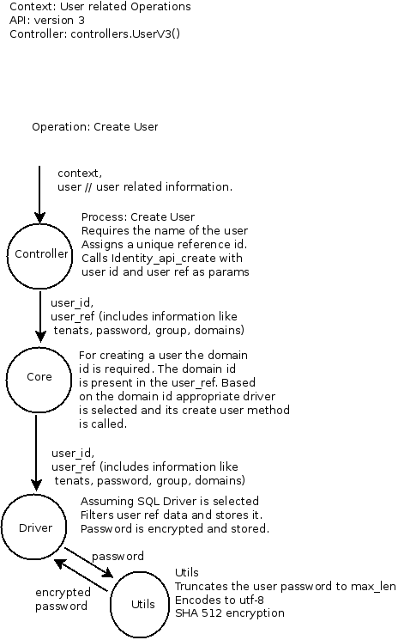

2 Delete User

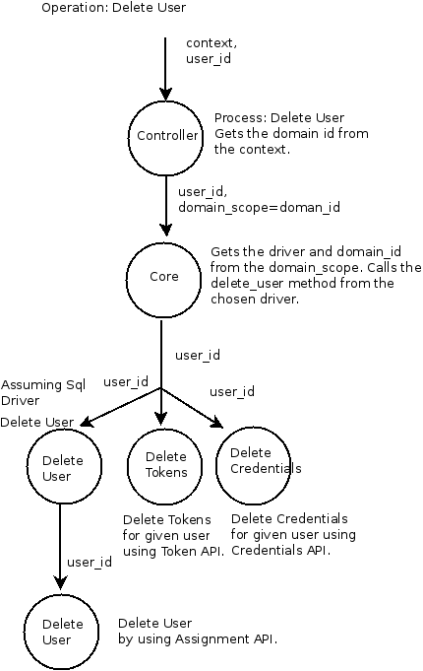

3 Change Password

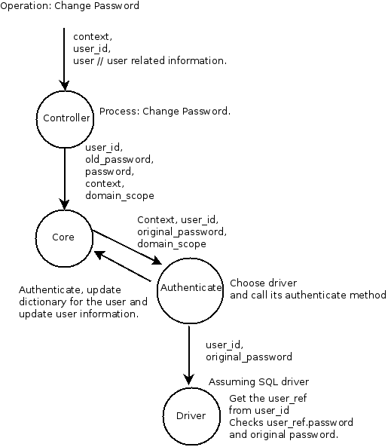

II. GROUP OPERATIONS:

1 Add user to group

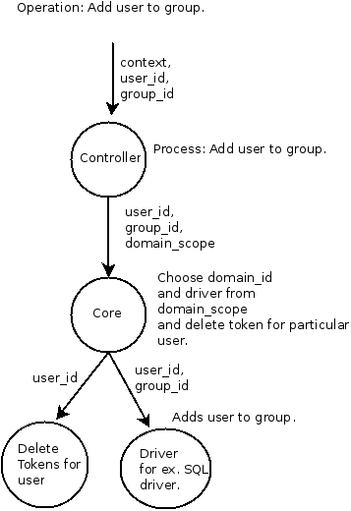

2 Remove users from group
# TODO(ayoung) revoking all tokens for a user based on group
# membership is overkill, as we only would need to revoke tokens
# that had role assignments via the group. Calculating those
# assignments would have to be done by the assignment backend.

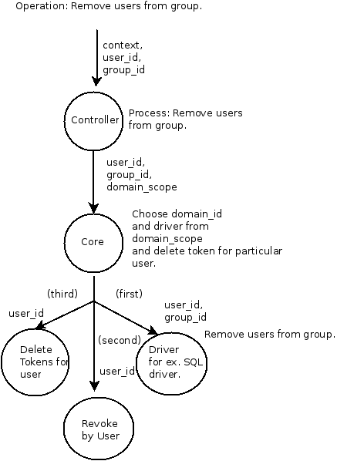

3 Delete group

# As well as deleting the group, (we need) to invalidate any tokens for users # who are members of this group.

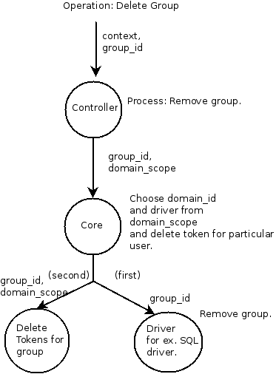

IV. Role Operation

1. Create Role

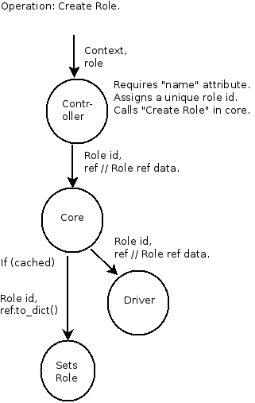

2. Delete Role

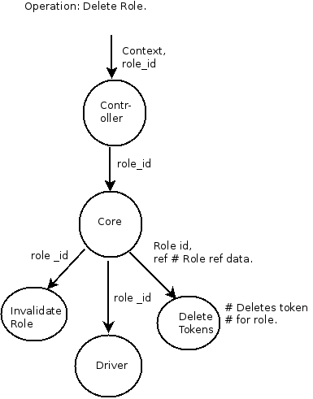

# Iterate over the assignments for this role and build the list of
# user or user+project IDs for the tokens we need to delete
# If we have a project assignment, then record both the user and
# project IDs so we can target the right token to delete. If it is
# a domain assignment, we might as well kill all the tokens for
# the user, since in the vast majority of cases all the tokens
# for a user will be within one domain anyway, so not worth
# trying to delete tokens for each project in the domain.

V. Grant Operation

1. Create Grant

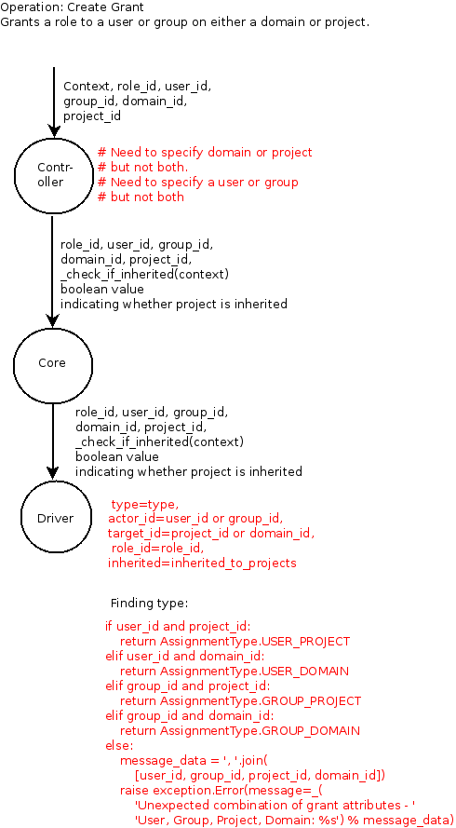

2. Revoke Grant

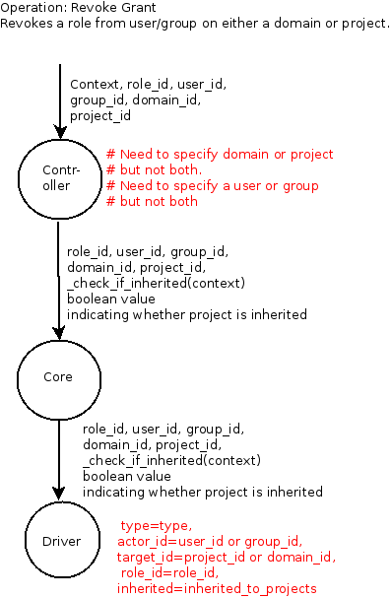

3.2 Entry points

ID | Name | Description | Trust Levels
1. | Port: 35357 | Endpoint: The Keystone endpoint to communicate with. The default endpoint is http://localhost:35357/v2.0
2. | Port: 5000 | --auth_url: The url of the Keystone auth server uses Port 5000. It defaults to http://localhost:5000/v2.0'.

3.3 Assets

ID | Name | Details | Required Trust Levels
1. | Context
2. | Credentials (creds) | User - Credentials required for Enforcing policies.
2.1 | User-ID | ID of a particular user.
2.2 | Tenant-ID / Project-ID | ID of the particular tenant or Project.
2.3 | Group ID | ID of a particular group
2.4 | Domain ID | ID of the particular Domain
2.5 | Role ID | ID of a particular Role.
3 | Domain Scope | Scope w.r.t a domain ?
4. | Action | String representing the action to be checked.
5. | Target | Dictionary representing the object of the action.
6. | System Assets: Policy File | The policy.json file defines additional access controls that apply to the Identity Service.

3.4 (Existing Security Controls)

Not Done

4. Threat Identification and Analysis
// TODO:

