RESUME

***Of***

**RAYHAN MOZUMDER**

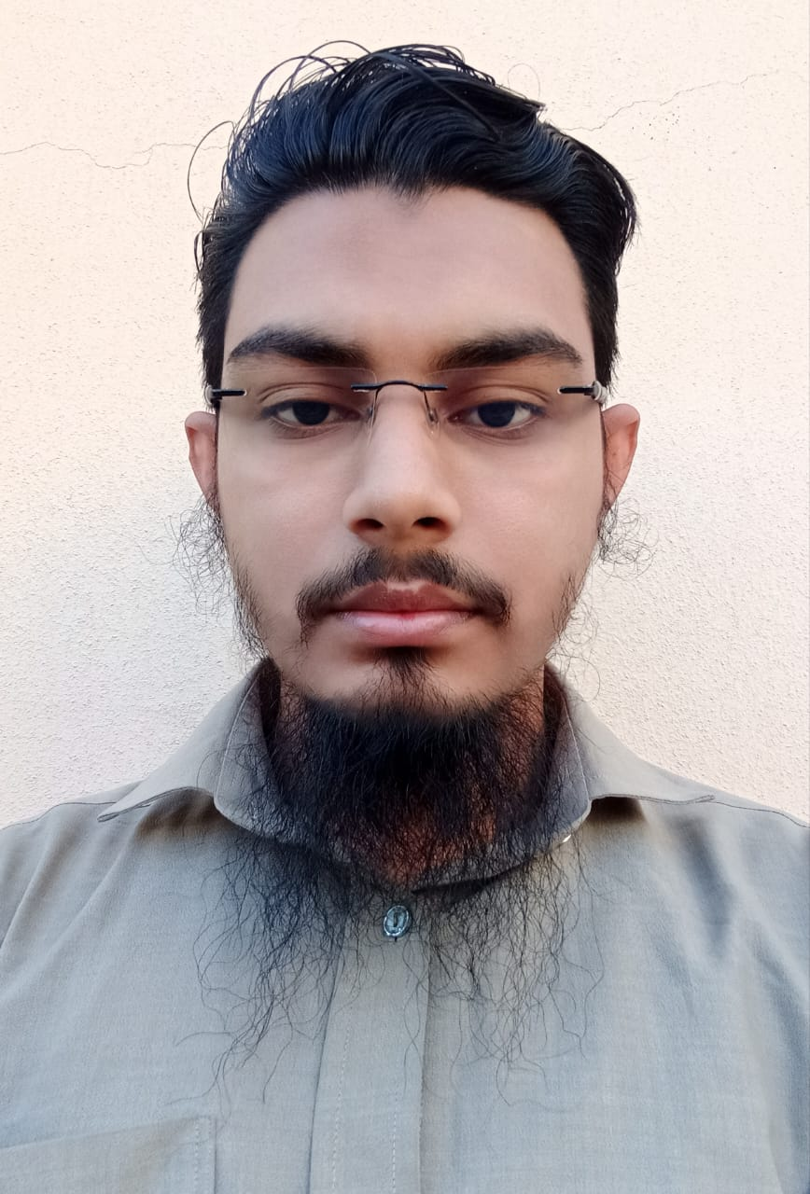

House #89/2, Sukrabad, Dhanmondi 32, Dhaka-1209. Contact Number: 01612884151

E-mail: [rayhanbinbashar@gmail.com](mailto:rayhanbinbashar@gmail.com)



My goal is to establish a career in a national or international organization with strong ethical values, where I can earn honestly, continuously learn, grow, and develop my knowledge, skills, and creativity. I aim to contribute in a way that aligns with the organization's purpose and supports both its financial and strategic objectives, benefiting the organization and the country. I have 2 years of experience in business operations, company roles, along with strong skills in mobile internet browsing, to contribute effectively in a dynamic organization. I am seeking a position that offers opportunities for professional growth and allows me to utilize my diverse skill set to support business goals and enhance operational efficiency.



| **SSC** | Board | Cumilla |
| --- | --- | --- |
|  | School | Badsha Mia Model High School and College |
|  | Group | Business Studies |
|  | Result | 4.00 out of 5.00 |
|  | Passing Year | 2010 |



Business shop & Company jobs 2 years’ experience and good on experience browsing mobile internet.



My confidence, good communication and interpersonal skills, organizational skills, honesty sincerity, helpful can work under pressure



Bengali: Good command in (Written & Oral) as well as Bengali.



 **Name** : Rayhan Mozumder

 **Father’s Name** : Abul Bashar

 **Mother’s Name** : Rahima Begum

 **Permanent Address :** Village- Angalkhowr

P.S: Bangodda Bazar Upazila: Nangalkot District: Cumilla

 **Date of Birth** : 27.12.1993

 **Religion** : Islam

 **Nationality** : Bangladeshi  **Marital Status** : Unmarried  **Blood Group** : A+

 **Sex** : Male



I certify that all information stared in this resume in true to the best of my knowledge.



***Rayhan Mozumder***