--Core Real Estate Data Analytics
--1. What is the average property price overall?

select
AVG(actual_worth) as avg_price
from Dubai_Residential
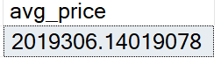

;with w as
(select *,
ROW_NUMBER() over (order by actual_worth desc) as rn,
count(*) over () as total_rows
from Dubai_Residential)
select
AVG(actual_worth) as Median_Price
from w
where rn in ((total_rows + 1)/2, (total_rows + 2)/2)

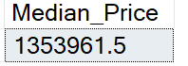

(2,019,306 − 1,353,961) / 2,019,306 * 100 % ~~ 33%
So median price is 33% less then the Average price due to high price properties like in World Islands, Palm Jumeirah, and Tecom Area

-- 2. What are the most expensive and cheapest locations?
;with filtering as
(
select
master_project_en,
AVG(actual_worth) as avg_per_location,
COUNT(*) as count_of_sale,
AVG(actual_worth) * COUNT(*) as score
from Dubai_Residential
where master_project_en is not null
group by master_project_en
)
select *
from filtering
where score = ( select MAX(score) from filtering)
or score = ( select MIN(score) from filtering)

-- Its very important what i am doing here
-- if i take only the avg by desc it would give me world island
--and Al Barari by highets avg_rate, although it wont be fair since they had only few transactions
-- where Palm Jumerah had few thousand transactions.
-- I say the Palm Jumeirah is one the most expensive locations

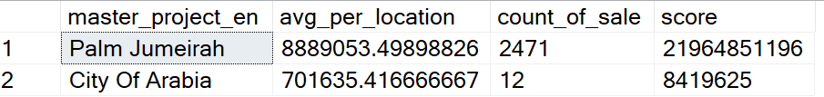

select
top 3
master_project_en,
AVG(actual_worth) as avg_per_location,
COUNT(*) as count_of_sale
from Dubai_Residential
where master_project_en is not null
group by master_project_en
order by avg_per_location

-- And where International City Phase 3 is the cheapest,
--where there were enought transactions to be judged

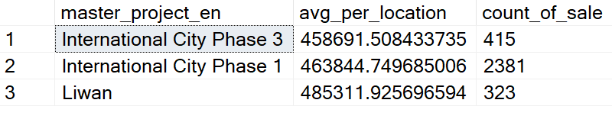

-- 3. Which projects capture the largest share of sales within each area?

;with filtering as
(
select
master_project_en,
project_name_en,
COUNT(*) as number_of_sale
from Dubai_Residential
where master_project_en is not null
and project_name_en is not null
group by master_project_en, project_name_en
), ranking as
(
select *,
ROW_NUMBER() over (partition by master_project_en order by number_of_sale desc) as rn
from filtering
)
select * from ranking
where rn =1
order by number_of_sale desc

-- it show the list of projects in each area,
--which have sold the most amount of properties

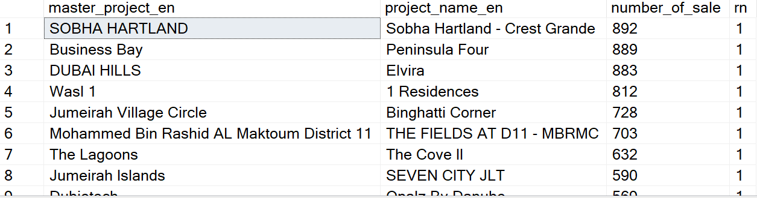
--4. How does property type affect price (apartment, villa, studio)?

select
property_sub_type_en,
AVG(meter_sale_price) as avg_price_sq_mt
from Dubai_Residential
group by property_sub_type_en
order by avg_price_sq_mt desc

-- As can be seen Apartment prices are the highest per sq.mt,
--then it followed by Villas and Townhouses, that is the way it should be actually,
-- thats how it works every where in the world

--5. Which areas are the most “liquid” (high demand vs availability)?

;with area_sales as (
select
master_project_en,
COUNT(*) AS total_sales
from Dubai_Residential
where master_project_en is not null
group by master_project_en
),total as (
select SUM(total_sales) AS total_market_sales
from area_sales
)select
top 5
a.master_project_en,
a.total_sales,
total_market_sales,
(a.total_sales * 100.0 / t.total_market_sales) AS market_share_pct
from area_sales a
cross join total t
order by total_sales desc;
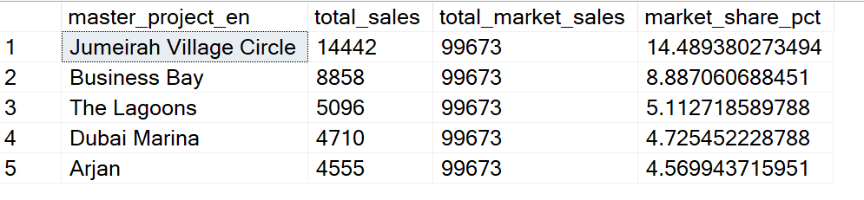
Surely Jumeirah Village Circle, Dubai Marina, Business Bay areas has been most favorite area to be invested, and its still remained the same over the decates

--6. Are property prices increasing or decreasing over time?

;with comparing as
(
select
DATEFROMPARTS(year(instance_date),month(instance_date),1) as months,
round(AVG(actual_worth), 0) as avg_price
from
Dubai_Residential
group by DATEFROMPARTS(year(instance_date),month(instance_date),1)
),
casing as
(
select *,
LAG(avg_price) over (order by months) as prv_avg
from comparing
)
select *,
case
when avg_price > prv_avg then 'Increasing'
when prv_avg is null then 'None'
else 'Decreasing' end as casing
from casing

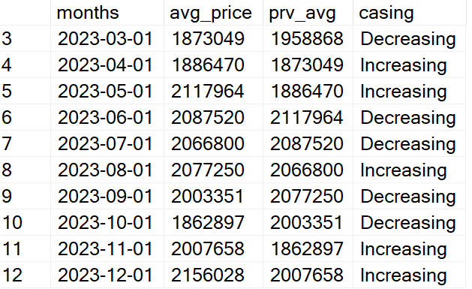

-- It shows that thougout the year prices has been slightly fluctuating,
--alghouth its remained in the same area, so significant increase or decrease has been detected.

--7. Which locations have the highest number of listings (supply)?

select
top 5
master_project_en,
COUNT(*) as number_of_listings
from Dubai_Residential
where master_project_en is not null
group by master_project_en
order by number_of_listings desc

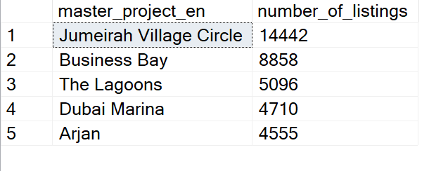

-- Jumeirah Village Circle is the winner by number of transactions

--⚖️ 8. Which areas look overvalued vs undervalued?

;with comparing as
(
select *,
AVG(actual_worth) over () as avg_price_dubai,
AVG(actual_worth) over (partition by master_project_en) as avg_price_area
from Dubai_Residential
)
select distinct master_project_en from comparing
where avg_price_area < avg_price_dubai

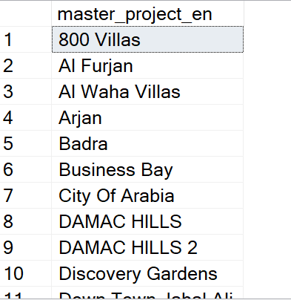

--- Areas where avg prices are below then the total dubai avg_prices

--💵 9. What is the price per square meter by location?

select
master_project_en,
AVG(meter_sale_price) as avg_price_sq_mt
from Dubai_Residential
group by master_project_en
order by avg_price_sq_mt desc

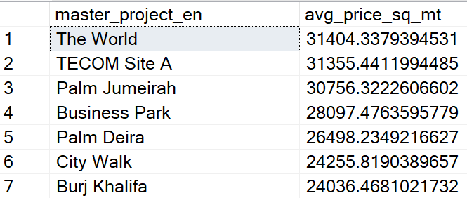

-- Again the world is wining by price per sq.mt but its very very unique peoject,
--therefore i would say Palm jumeirah is the highest

--10. Are there outliers in property prices?

--Detect luxury/extreme listings or data issues.

;with avg_prices as
(
select *,
AVG(actual_worth) over () as avg_price
from Dubai_Residential
)
select
COUNT(*) as number_of_proerties
from avg_prices
where actual_worth > 50 * avg_price

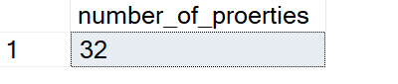

-- we have got 32 properties that are 50 times more expensive then averge price in dubai,
-- Some of them even 100 times more expensive, those are very very luxtuary and unique properties,
-- that were sold mostly in Palm Jumeirah, highest prices property worth 500 mln AED,
-- that is roughly 136 mln USD

--11. What is the distribution of property prices?

--(cheap, mid, luxury breakdown)

;with flagging as
(
SELECT
CASE
WHEN actual_worth < 1100000 THEN 'Cheap'
WHEN actual_worth BETWEEN 1100000 AND 3670000 THEN 'Mid'
ELSE 'Luxury'
END AS price_category,
COUNT(*) AS total_properties
FROM Dubai_Residential
GROUP BY
CASE
WHEN actual_worth < 1100000 THEN 'Cheap'
WHEN actual_worth BETWEEN 1100000 AND 3670000 THEN 'Mid'
ELSE 'Luxury'
END
), percentage as
(
select *,
SUM(total_properties) over () as [total properties sold]
from flagging
)
select *,
cast(total_properties *1.0 / [total properties sold] * 100 as decimal(6,2)) as percentage_contribution
from percentage

-- it shows that Cheaper properties that are below 300K$ and Mid Level priced which are
-- between 300k$ and 1 mln $ are the roughly 90% of the market,
--only 10% of properties are above 1 mln $
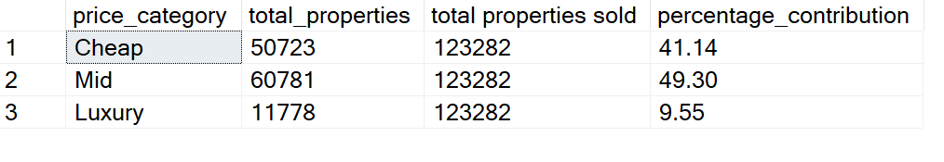
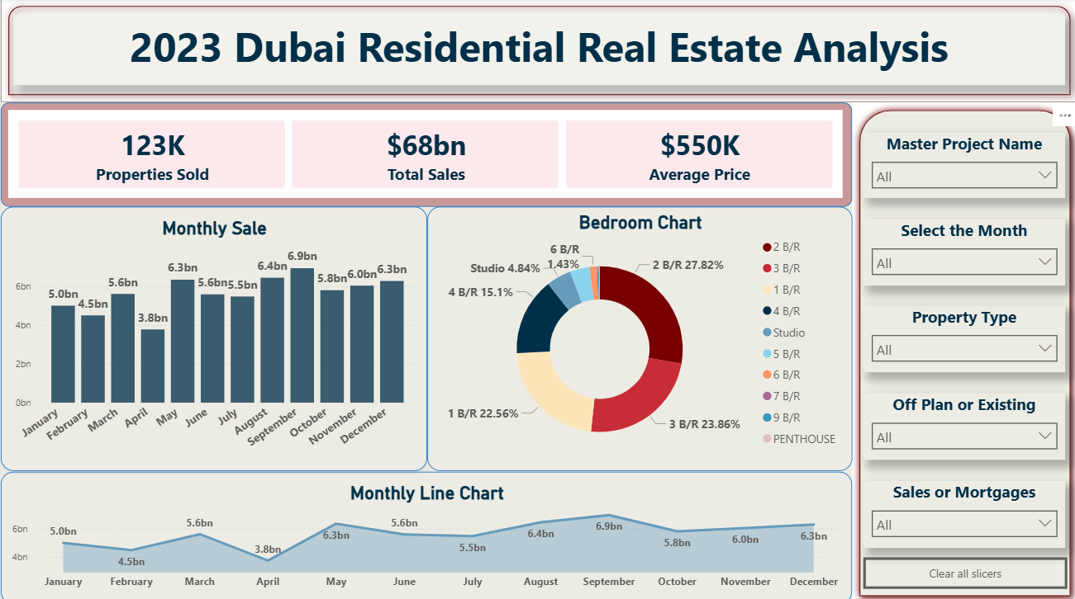

--💡 12. What are key insights or recommendations for buyers/investors?

1. Market is mid-range driven
- Cheap: 41% | Mid: 49% | Luxury: 9.5%
~90% of transactions are non-luxury
Focus on mid-range for stable demand

2. High liquidity areas
- JVC: ~14.5%
- Business Bay: ~8.9%
- Dubai Marina: ~4.7%
Highest transaction activity
Best areas for quick resale

3. Average price is misleading
- Avg: 2.02M AED
- Median: 1.35M AED (~33% lower)
Skewed by luxury deals
Use median for real market value
4. Property type pricing
- Apartments = highest price per sq.m
Driven by location & demand
Apartments = liquidity, Villas = space

5. Market stability
- Minor monthly fluctuations, no clear trend
Stable market in 2023
Suitable for medium-term investment

6. Extreme luxury outliers
- 32 properties > 50× avg price
- Max ~500M AED (~136M USD)
Mostly ultra-luxury (e.g., Palm Jumeirah)
Analyze separately

7. Undervalued opportunities
- Some areas priced below Dubai average
Potential investment zones
Combine with demand + price/sq.m

