-- Sales Analysis

-- 1. What are the total sales and total profit?

select
ROUND(SUM(sales),0) as total_sales,
ROUND(SUM(profit), 0) as total_profit
from Cleaned

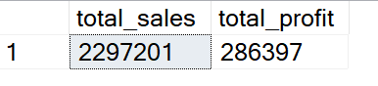

-- 2. Which region generates the highest sales?

;WITH BY_REGION AS
(
SELECT
region,
SUM(sales) as Total_sales_region
FROM Cleaned
GROUP BY region
), Tot_sales as
(
SELECT *,
SUM(Total_sales_region) over () AS Total_sales
FROM BY_REGION
)
SELECT *,
round(Total_sales_region * 1.0 /Total_sales * 100,1) as perc_of_sales
FROM Tot_sales
order by perc_of_sales desc

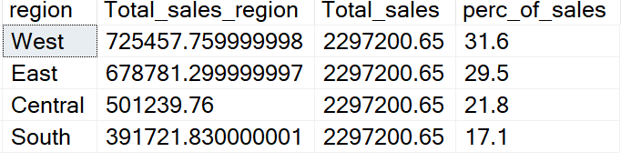

-- As can be seen West and East are making the most of the sales
--nearly 60% of total, where Central and South is followed

--3. Which top 10 products generate the most revenue?

;with revenue as
(
SELECT
product_name,
SUM(sales) as revenue
FROM Cleaned
group by product_name
), ranking as
(
select *,
ROW_NUMBER() over (order by revenue desc) as rn
from revenue
)
select * from ranking
where rn <=10

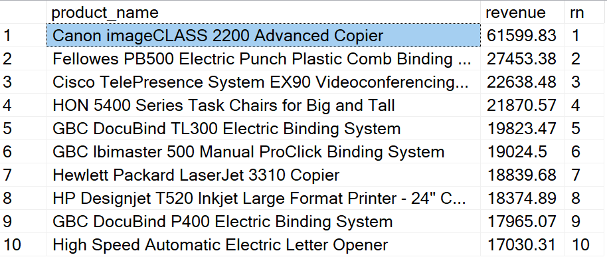

--where Canon Advanced Copier lead the sales

-- 4. Which categories are the most profitable ?

;with cat_prof as
(
SELECT
category,
SUM(profit) as category_profit
FROM Cleaned
group by category
), perc as
(
select *,
SUM(category_profit) over () as total_rev
from cat_prof
)
select *,
round(category_profit / total_rev * 100,1) as perc_share
from perc
order by perc_share desc

-- As can be noticed that Technology category is leading with nearly
--half of the revenue 51 % and Office Supplies followed by 43%
--with smallest share goes to Furnitue only around 6 %

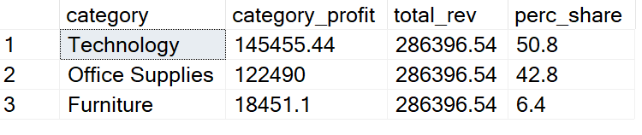

-- Customer Analysis

--5. Which customers spent the most money,
--which customers were most profitable?

SELECT top 10
customer_name,
SUM(sales) as total_spent,
SUM(profit) as cust_profit
FROM Cleaned
group by customer_name
order by total_spent desc

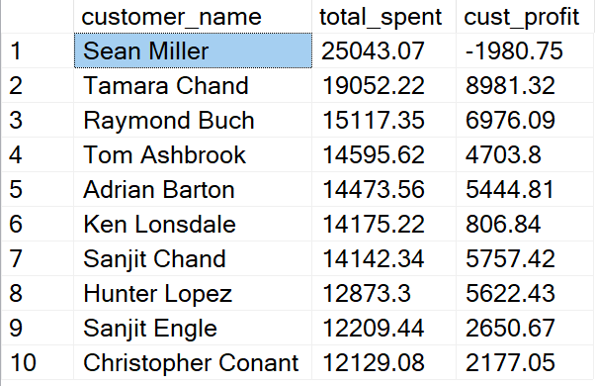

-- it seems like most spenders doesnt mean they are profitable,
--in fact it could be quite the opposite, and have negative impact.
-- The most spenders has lost money for the company
--instead of earning profit.

SELECT top 10
customer_name,
SUM(sales) as total_spent,
SUM(profit) as cust_profit
FROM Cleaned
group by customer_name
order by cust_profit desc

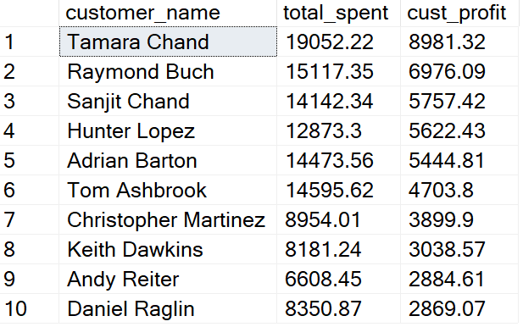

-- Above is the top 10 most profitable customers

;With spent as
(
SELECT *,
SUM(sales) over (partition by customer_id) as total_spent,
SUM(profit) over (partition by customer_id) as cust_profit
FROM Cleaned
), ranking as
(
select *,
DENSE_RANK() over
(order by total_spent desc) as rank_spent,
DENSE_RANK() over
(order by cust_profit desc) as rank_profit
from spent
), margin as
(
select *, round(cust_profit* 1.0/ total_spent *100,0) as profit_margin
from ranking
)
select
distinct customer_name, total_spent, cust_profit, profit_margin
from margin
order by profit_margin desc

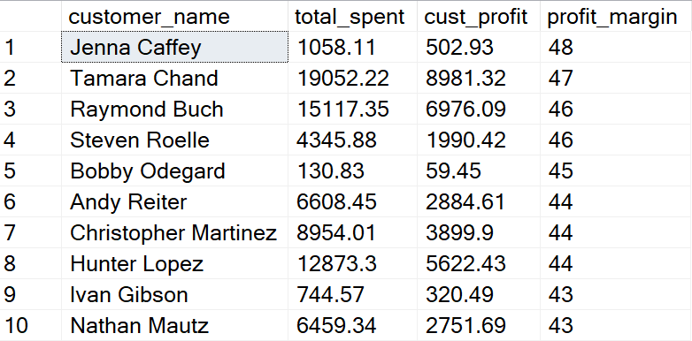

-- above is the top profitable customers by margin

-- 6. Which customer segment is the most profitable?

;with segment_total as
(
SELECT
segment,
ROUND(SUM(sales),2) as Total_per_segment
FROM Cleaned
group by segment
), tot_rev as
(
select *,
SUM(Total_per_segment) over () as total_rev
from segment_total
)
select *,
Total_per_segment / total_rev * 100 as perct_share
from tot_rev
order by perct_share desc

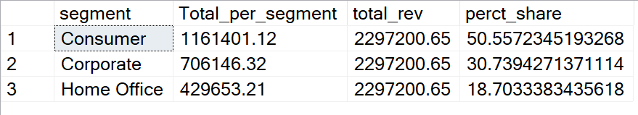

-- consumer segment is taking the half of the total revenue and becoming the
-- most profitable segment, followed by corporate 30 % and last Home Office with 18 %

-- 7. Find repeat customers (customers with multiple orders)

;with order_num as
(
SELECT
customer_name,
count(distinct order_id) as total_orders
FROM Cleaned
group by customer_name
), ranking as
(
select *,
DENSE_RANK() over (order by total_orders desc) as rn
from order_num
)
select * from ranking
where rn <= 5

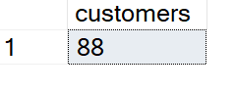

-- Above is the top 5 total order numbers which was done by 88 customers,

-- Product & Discount Analysis

-- 8. Which products have negative and positive profit, and percentage margin?

SELECT
product_name,
round(SUM(profit),2) as tot_profit
FROM Cleaned
group by product_name
having SUM(profit) > 0
order by tot_profit desc

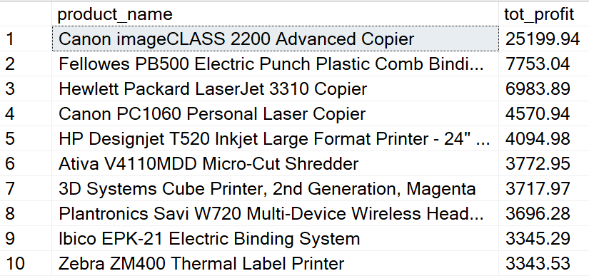

-- Again Canon Advanced Copier is the most profitable product by total profit
-- which is 25200 $

SELECT
product_name,
round(SUM(profit),2) as tot_profit
FROM Cleaned
group by product_name
having SUM(profit) < 0
order by tot_profit

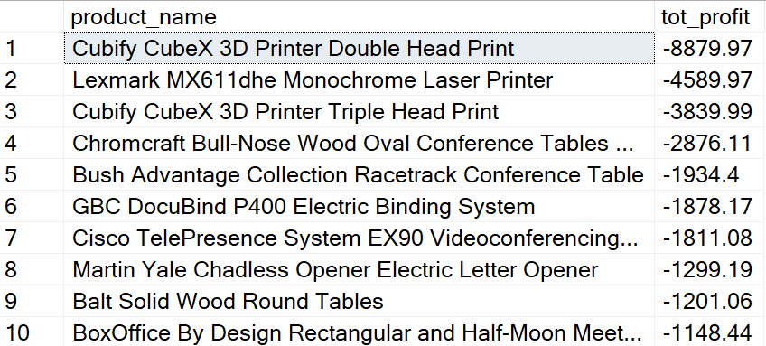

-- it turns out that Cubify CubeX 3D Printer
--has the most negative profit around -8900 $ followed by Lexmark with - 4600$ loss of profit

;with act_cost as
(
SELECT *,
sales - profit as actual_cost
FROM Cleaned
where discount = 0
), margin as
(
select *,
round(profit/actual_cost * 100,0) as margin_pers
from act_cost
)
select
count(distinct product_name) as cnt
from margin
where margin_pers = 100

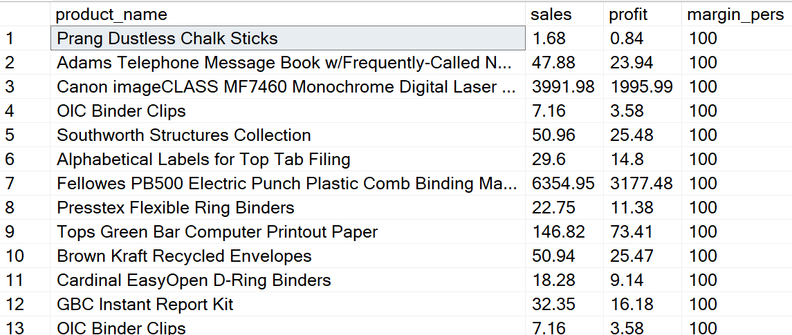

-- 53 products makes 100 margin profit from the sale,
--it means if actual cost is 100 sale price is 200

-- 9. Does higher discount reduce profit?

SELECT
discount,
AVG(profit) AS avg_profit
FROM Cleaned
GROUP BY discount
ORDER BY discount

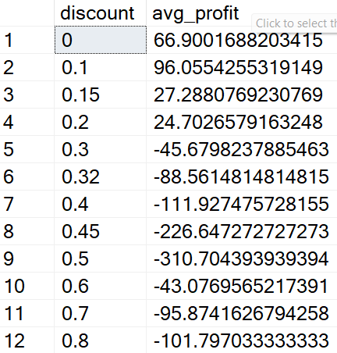

-- Yes it does, average discounts above 30 % it results on loss of profit

-- 10. Which sub-categories receive the highest average discount?

SELECT
[sub-category],
AVG(discount) as avg_discount
FROM Cleaned
group by [sub-category]
order by avg_discount desc

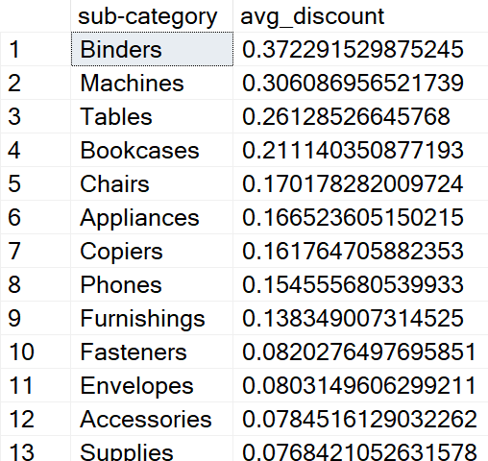

-- binders and mashine subcategories tent to receive discount above 30 %
--which results on loss

-- Time Analysis

-- 11. Monthly sales trend

SELECT
YEAR(order_date) AS year,
MONTH(order_date) AS month,
SUM(sales) AS monthly_sales
FROM Cleaned
GROUP BY YEAR(order_date), MONTH(order_date)
ORDER BY year, month

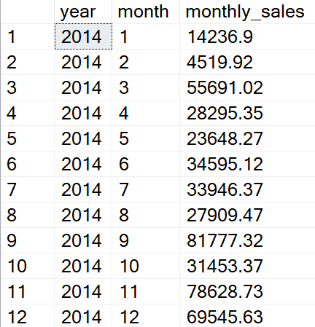

-- 12. Which month had the highest profit?

;with monthly_prof as
(
select
MONTH(order_date) as months,
SUM(profit) as monthly_profit
from Cleaned
group by MONTH(order_date)
), perc_share as
(
select *,
SUM(monthly_profit) over () as total_profit
from monthly_prof
)
select *,
round(monthly_profit / total_profit * 100,1) as percentage_share
from perc_share
order by percentage_share desc

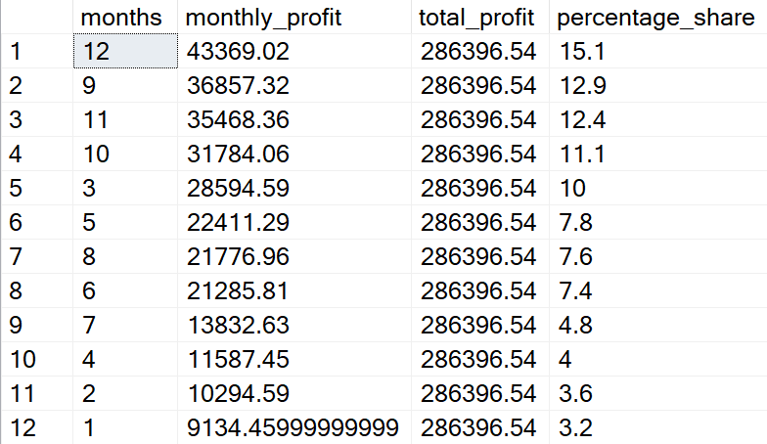

-- Last quater seems to have the highest profit share with 52% time of the year
-- leading with december 15% due to Christmas Eve and holidays

-- 13. Average shipping time by ship mode

select
ship_mode,
AVG(DATEDIFF(DAY, order_date, ship_date)) as avg_shipping_days
from Cleaned
group by ship_mode
order by avg_shipping_days

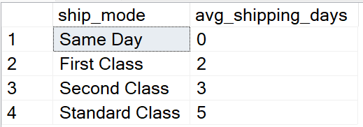

-- Second Class and Standard Class shipping modes are taking between 3-5 days
-- the quickest are Same Day and First Class up to 2 days, but normally same day shipping

-- 14. Which states generate losses?

select
state,
SUM(profit) as total_profit_state
from Cleaned
group by state
having SUM(profit) < 0
order by total_profit_state

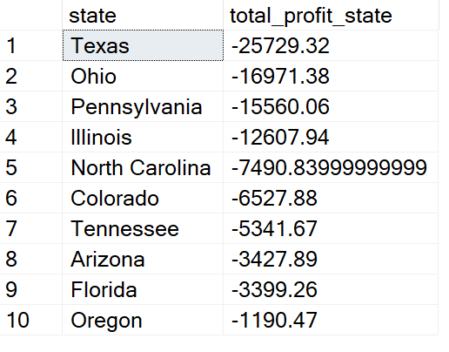

-- Unfortunately Texas with - 26,000 $and Ohio with - 17000 $
-- have experiences the most lost with no profit

-- 15. Top 3 products by sales in each category

;with top_3 as
(
select
category,
product_name,
SUM(sales) as total_sales,
ROW_NUMBER() over
(partition by category order by SUM(sales) desc) as rn
from Cleaned
group by category, product_name
)
select * from top_3
where rn <=3

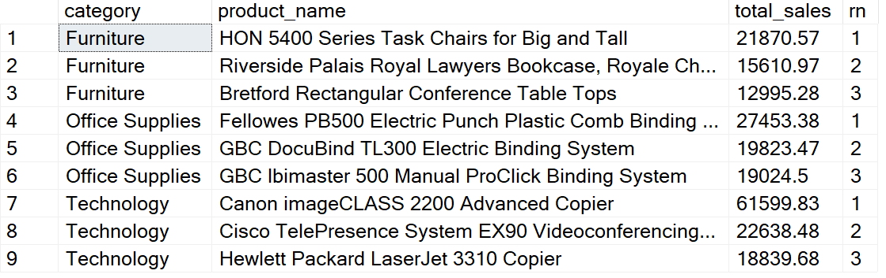

--- HON 5400 Chair is leading on sales on Furniture category,
-- Fellowes Electric Plactic Comb on Office Suppliers category
-- Canon Advanced copier on Technology category

