
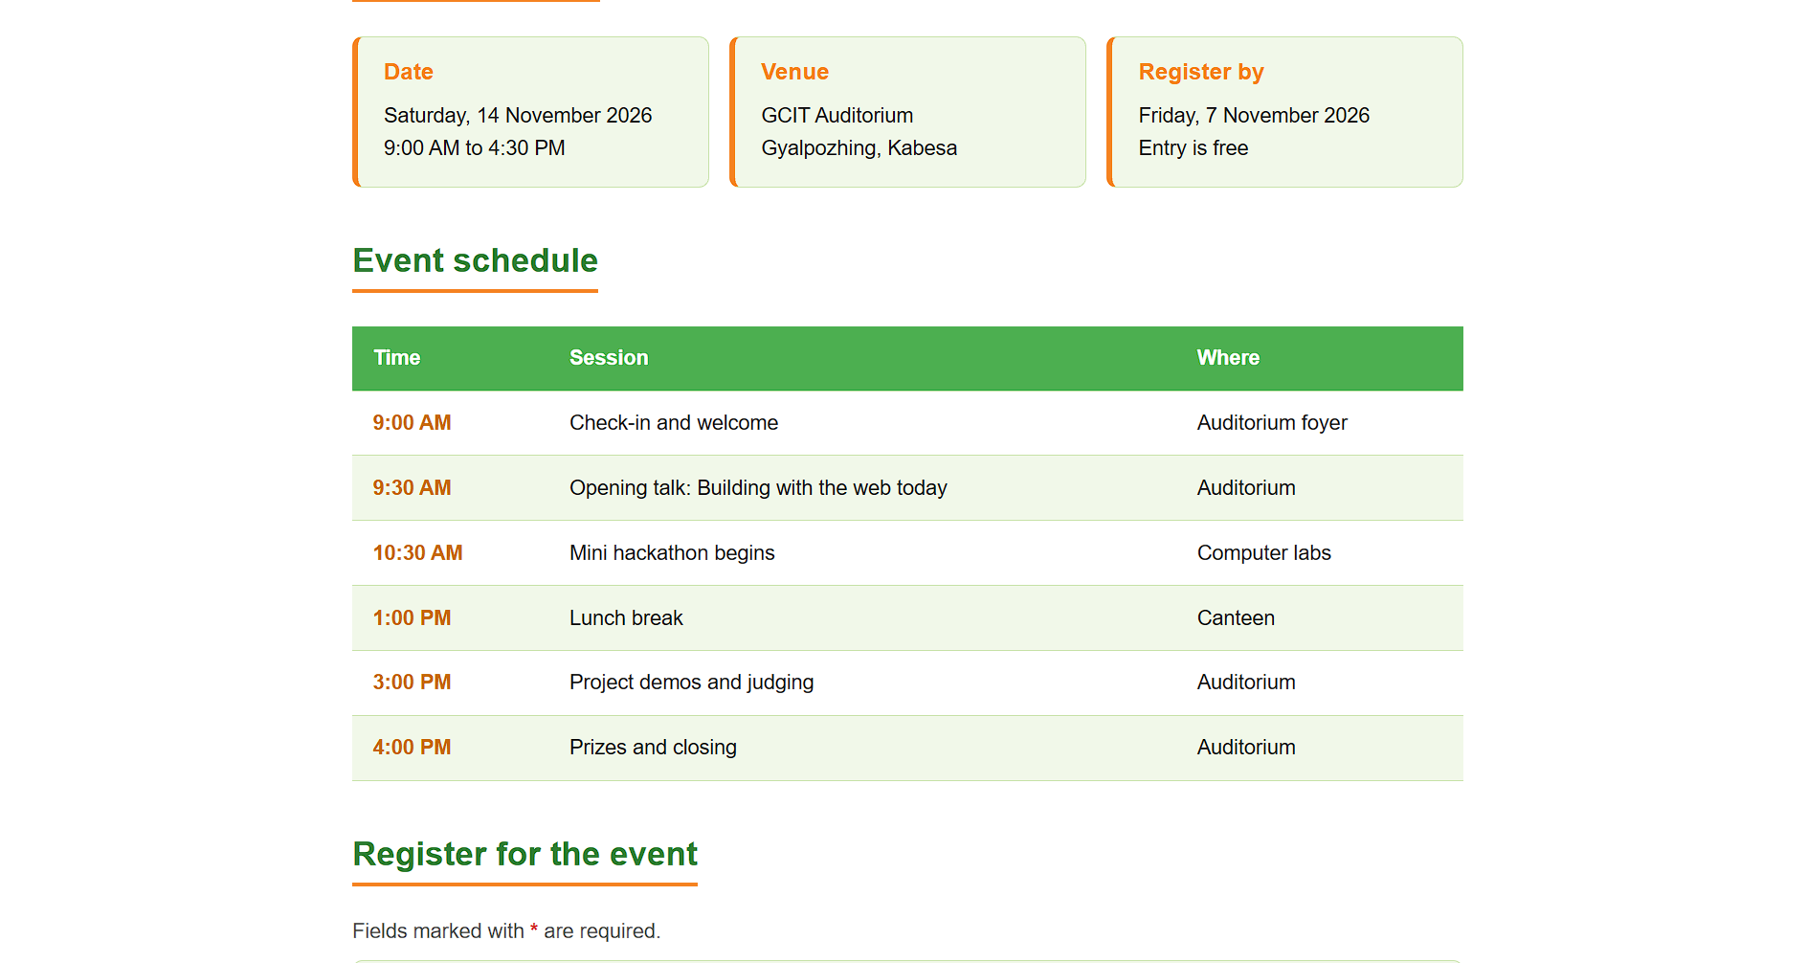
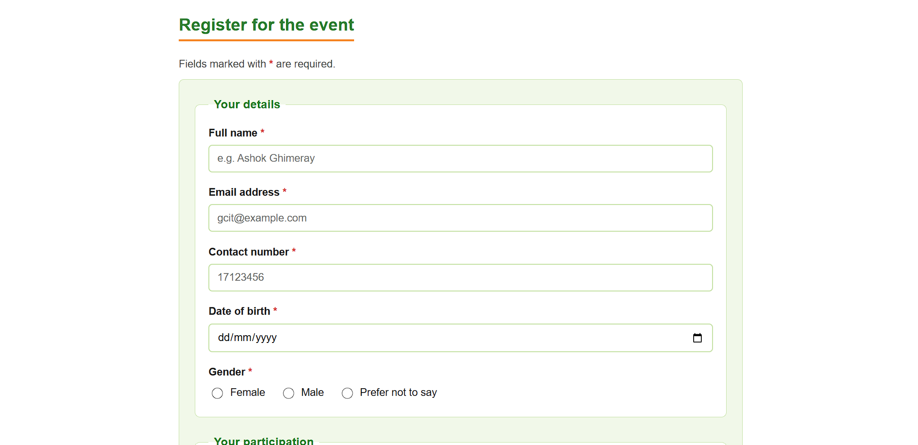
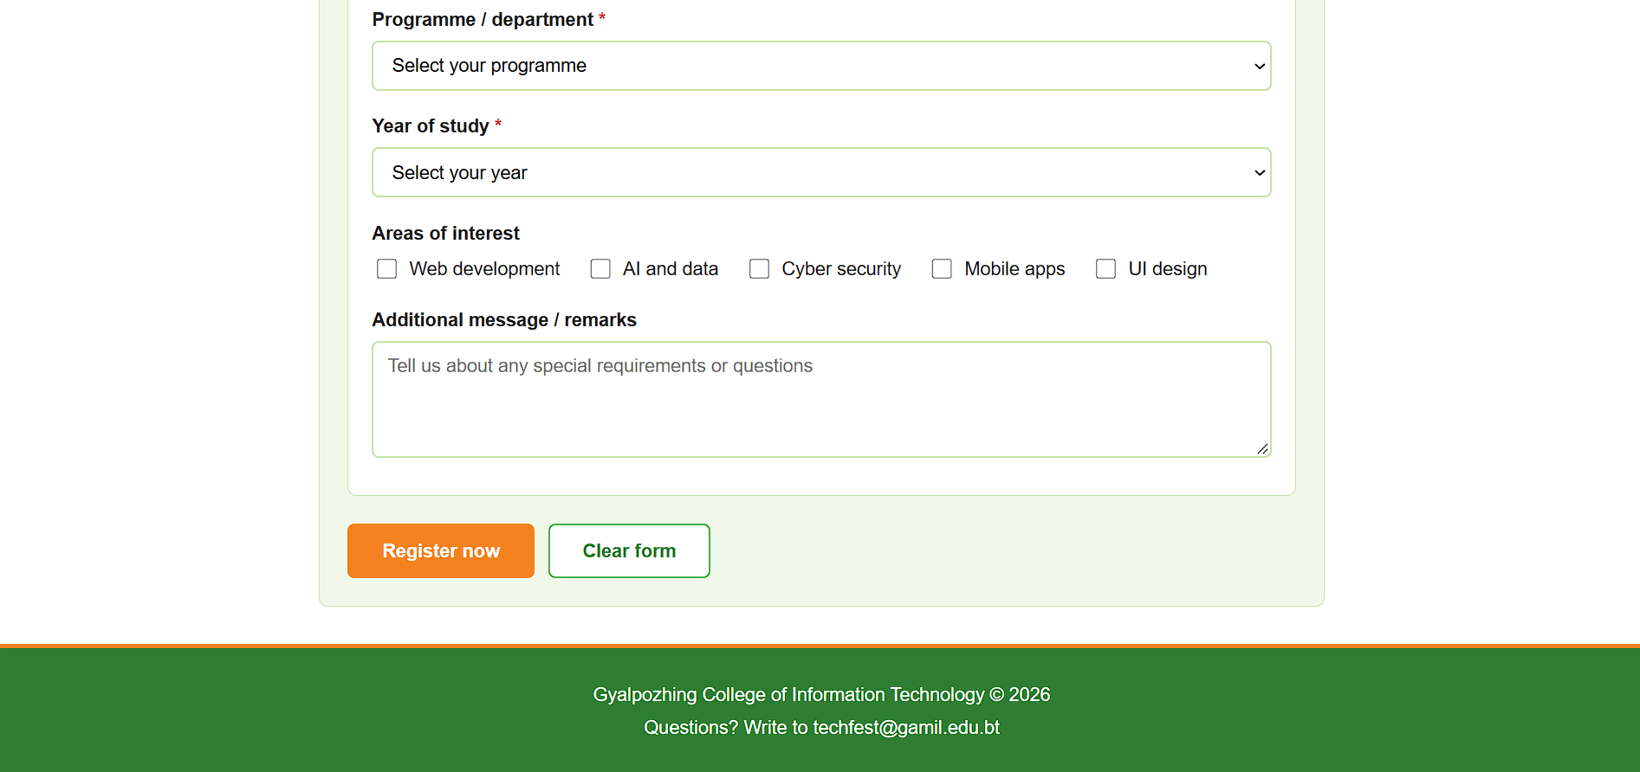
Index.html
<!DOCTYPE html>
<html lang="en">
<head>
<meta charset="UTF-8">
<meta name="viewport" content="width=device-width, initial-scale=1.0">
<title>GCIT Tech Fest 2026 | Event Registration</title>
<link rel="stylesheet" href="style.css">
</head>
<body>

<header id="site-header">
<div class="brand">
<img class="logo" src="GCIT_logo.png" alt="GCIT logo">
<span class="site-title">GCIT Tech Fest 2026</span>
</div>
<nav>
<a href="#about">About</a>
<a href="#details">Date &amp; Venue</a>
<a href="#schedule">Schedule</a>
<a href="#register">Register</a>
</nav>
</header>

<main>

<section id="hero">
<h1>GCIT Tech Fest 2026</h1>
<p class="tagline">One day of hacking, talks and demos for GCIT students.</p>
<img class="banner" src="banner.svg" alt="GCIT Tech Fest 2026 banner">
</section>

<section id="about" class="content-block">
<h2>About the event</h2>
<p>
GCIT Tech Fest brings students from every programme together for a day of
building and learning. You can join a 6-hour mini hackathon, attend short
talks from industry guests, and show your projects at the demo corner.
Beginners are welcome &ndash; no prior hackathon experience is needed.
</p>
</section>

<section id="details" class="content-block">
<h2>Date and venue</h2>
<div class="info-grid">
<article class="info-card">
<h3>Date</h3>
<p>Saturday, 14 November 2026</p>
<p>9:00 AM to 4:30 PM</p>
</article>
<article class="info-card">
<h3>Venue</h3>
<p>GCIT Auditorium</p>
<p>Gyalpozhing, Kabesa
</p>
</article>
<article class="info-card">
<h3>Register by</h3>
<p>Friday, 7 November 2026</p>
<p>Entry is free</p>
</article>
</div>
</section>

<section id="schedule" class="content-block">
<h2>Event schedule</h2>
<table class="schedule-table">
<thead>
<tr>
<th scope="col">Time</th>
<th scope="col">Session</th>
<th scope="col">Where</th>
</tr>
</thead>
<tbody>
<tr>
<td>9:00 AM</td>
<td>Check-in and welcome</td>
<td>Auditorium foyer</td>
</tr>
<tr>
<td>9:30 AM</td>
<td>Opening talk: Building with the web today</td>
<td>Auditorium</td>
</tr>
<tr>
<td>10:30 AM</td>
<td>Mini hackathon begins</td>
<td>Computer labs</td>
</tr>
<tr>
<td>1:00 PM</td>
<td>Lunch break</td>
<td>Canteen</td>
</tr>
<tr>
<td>3:00 PM</td>
<td>Project demos and judging</td>
<td>Auditorium</td>
</tr>
<tr>
<td>4:00 PM</td>
<td>Prizes and closing</td>
<td>Auditorium</td>
</tr>
</tbody>
</table>
</section>

<section id="register" class="content-block">
<h2>Register for the event</h2>
<p class="form-note">Fields marked with <span class="required-mark">*</span> are required.</p>

<form id="registration-form" action="#" method="post">

<fieldset>
<legend>Your details</legend>

<div class="form-row">
<label for="full-name">Full name <span class="required-mark">*</span></label>
<input type="text" id="full-name" name="full_name" placeholder="e.g. Ashok Ghimeray" required>
</div>

<div class="form-row">
<label for="email">Email address <span class="required-mark">*</span></label>
<input type="email" id="email" name="email" placeholder="gcit@example.com" required>
</div>

<div class="form-row">
<label for="phone">Contact number <span class="required-mark">*</span></label>
<input type="tel" id="phone" name="phone" placeholder="17123456"
pattern="(17|77)[0-9]{6}" title="Enter an 8-digit number starting with 17 or 77" required>
</div>

<div class="form-row">
<label for="dob">Date of birth <span class="required-mark">*</span></label>
<input type="date" id="dob" name="dob" required>
</div>

<div class="form-row">
<span class="field-label" id="gender-label">Gender <span class="required-mark">*</span></span>
<div class="option-group" role="radiogroup" aria-labelledby="gender-label">
<label class="option"><input type="radio" name="gender" value="female" required> Female</label>
<label class="option"><input type="radio" name="gender" value="male"> Male</label>
<label class="option"><input type="radio" name="gender" value="other"> Prefer not to say</label>
</div>
</div>
</fieldset>

<fieldset>
<legend>Your participation</legend>

<div class="form-row">
<label for="programme">Programme / department <span class="required-mark">*</span></label>
<select id="programme" name="programme" required>
<option value="">Select your programme</option>
<option value="it">Information Technology</option>
<option value="se">Software Engineering</option>
<option value="ds">Computet Science</option>
<option value="cs">Cyber Security</option>
<option value="other">Other</option>
</select>
</div>

<div class="form-row">
<label for="year">Year of study <span class="required-mark">*</span></label>
<select id="year" name="year" required>
<option value="">Select your year</option>
<option value="1">First year</option>
<option value="2">Second year</option>
<option value="3">Third year</option>
<option value="4">Fourth year</option>
</select>
</div>

<div class="form-row">
<span class="field-label" id="interest-label">Areas of interest</span>
<div class="option-group" role="group" aria-labelledby="interest-label">
<label class="option"><input type="checkbox" name="interest" value="web"> Web development</label>
<label class="option"><input type="checkbox" name="interest" value="ai"> AI and data</label>
<label class="option"><input type="checkbox" name="interest" value="security"> Cyber security</label>
<label class="option"><input type="checkbox" name="interest" value="mobile"> Mobile apps</label>
<label class="option"><input type="checkbox" name="interest" value="design"> UI design</label>
</div>
</div>

<div class="form-row">
<label for="remarks">Additional message / remarks</label>
<textarea id="remarks" name="remarks" rows="4"
placeholder="Tell us about any special requirements or questions"></textarea>
</div>
</fieldset>

<div class="button-row">
<input type="submit" class="btn btn-primary" value="Register now">
<input type="reset" class="btn btn-secondary" value="Clear form">
</div>

</form>
</section>

</main>

<footer id="site-footer">
<p>Gyalpozhing College of Information Technology &copy; 2026</p>
<p>Questions? Write to techfest@gamil.edu.bt</p>
</footer>

</body>
</html>

Style.css
* {
box-sizing: border-box;
}

body {
margin: 0;
background-color: #ffffff;
color: #222222;
font-family: Arial, Helvetica, sans-serif;
font-size: 16px;
line-height: 1.6;
}

h1, h2, h3 {
margin: 0 0 10px;
line-height: 1.25;
}

h2 {
display: inline-block;
padding-bottom: 6px;
border-bottom: 3px solid #f58220;
color: #2e7d32;
font-size: 26px;
}

h3 {
color: #f58220;
font-size: 18px;
}

p {
margin: 0 0 10px;
}

#site-header {
display: flex;
flex-wrap: wrap;
align-items: center;
justify-content: space-between;
gap: 12px;
padding: 12px 32px;
background-color: #ffffff;
border-bottom: 4px solid #4caf50;
}

.brand {
display: flex;
align-items: center;
gap: 12px;
}

.logo {
height: 48px;
width: auto;
}

.site-title {
color: #2e7d32;
font-size: 20px;
font-weight: bold;
}

#site-header nav a {
margin-left: 18px;
padding-bottom: 2px;
color: #222222;
text-decoration: none;
border-bottom: 2px solid transparent;
}

#site-header nav a:hover {
color: #f58220;
border-bottom-color: #f58220;
}

main {
max-width: 900px;
margin: 0 auto;
padding: 0 20px 32px;
}

.content-block {
margin-top: 40px;
}

#hero {
padding-top: 32px;
}

#hero h1 {
color: #2e7d32;
font-size: 42px;
}

.tagline {
color: #555555;
font-size: 19px;
}

.banner {
display: block;
width: 100%;
height: auto;
margin-top: 16px;
border: 3px solid #4caf50;
border-radius: 8px;
}

#about p {
max-width: 680px;
margin-top: 12px;
}

.info-grid {
display: grid;
grid-template-columns: repeat(auto-fit, minmax(220px, 1fr));
gap: 16px;
margin-top: 16px;
}

.info-card {
padding: 16px 20px;
background-color: #f1f8e9;
border: 1px solid #c5e1a5;
border-left: 5px solid #f58220;
border-radius: 8px;
}

.info-card p {
margin: 0;
}

.schedule-table {
width: 100%;
margin-top: 16px;
border-collapse: collapse;
}

.schedule-table th,
.schedule-table td {
padding: 12px 16px;
text-align: left;
border-bottom: 1px solid #c5e1a5;
}

.schedule-table thead th {
background-color: #4caf50;
color: #ffffff;
}

.schedule-table tbody tr:nth-child(even) {
background-color: #f1f8e9;
}

.schedule-table td:first-child {
font-weight: bold;
color: #c76a0a;
white-space: nowrap;
}

.form-note {
margin-top: 12px;
color: #555555;
}

.required-mark {
color: #d32f2f;
font-weight: bold;
}

#registration-form {
padding: 24px;
background-color: #f1f8e9;
border: 1px solid #c5e1a5;
border-radius: 8px;
}

#registration-form fieldset {
margin: 0 0 24px;
padding: 16px 20px 6px;
background-color: #ffffff;
border: 1px solid #c5e1a5;
border-radius: 8px;
}

#registration-form legend {
padding: 0 8px;
color: #2e7d32;
font-size: 18px;
font-weight: bold;
}

.form-row {
margin-bottom: 18px;
}

.form-row > label,
.field-label {
display: block;
margin-bottom: 5px;
font-weight: bold;
}

.form-row input[type="text"],
.form-row input[type="email"],
.form-row input[type="tel"],
.form-row input[type="date"],
.form-row select,
.form-row textarea {
width: 100%;
padding: 10px 12px;
font-family: inherit;
font-size: 16px;
background-color: #ffffff;
border: 2px solid #c5e1a5;
border-radius: 6px;
}

.form-row textarea {
resize: vertical;
}

.form-row input:focus,
.form-row select:focus,
.form-row textarea:focus {
outline: none;
border-color: #f58220;
}

.option-group {
display: flex;
flex-wrap: wrap;
gap: 8px 22px;
}

.option {
display: flex;
align-items: center;
gap: 7px;
cursor: pointer;
}

.option input {
width: 18px;
height: 18px;
accent-color: #4caf50;
}

.button-row {
display: flex;
flex-wrap: wrap;
gap: 12px;
}

.btn {
padding: 12px 28px;
font-family: inherit;
font-size: 16px;
font-weight: bold;
border-radius: 6px;
cursor: pointer;
}

.btn-primary {
background-color: #f58220;
color: #ffffff;
border: 2px solid #f58220;
}

.btn-primary:hover {
background-color: #d96d10;
border-color: #d96d10;
}

.btn-secondary {
background-color: #ffffff;
color: #2e7d32;
border: 2px solid #4caf50;
}

.btn-secondary:hover {
background-color: #4caf50;
color: #ffffff;
}

#site-footer {
padding: 24px 32px;
background-color: #2e7d32;
color: #ffffff;
text-align: center;
border-top: 4px solid #f58220;
}

#site-footer p {
margin: 3px 0;
}

