**Student** :Şölə Əmiyeva

**Teacher**:Şükür İbadov

**Task -1**

Not Null ,Unique ,Primary key

**1.Not Null**

By default, a column can hold NULL values.The NOT NULL constraint enforces a column to NOT accept NULL values.This enforces a field to always contain a value, which means that you cannot insert a new record, or update a record without adding a value to this field

**2.What is “Primary Key”?**

The PRIMARY KEY constraint uniquely identifies each record in a table.Primary keys must contain UNIQUE values, and cannot contain NULL values.A table can have only ONE primary key; and in the table, this primary key can consist of single or multiple columns (fields).

Unique+not null

*Unique bos qala biler primary key bos qala bilmez*

Normallasdirma qaydalarina esasen

**3.What is Unique?**

The UNIQUE constraint ensures that all values in a column are different.Both the UNIQUE and PRIMARY KEY constraints provide a guarantee for uniqueness for a column or set of columns.

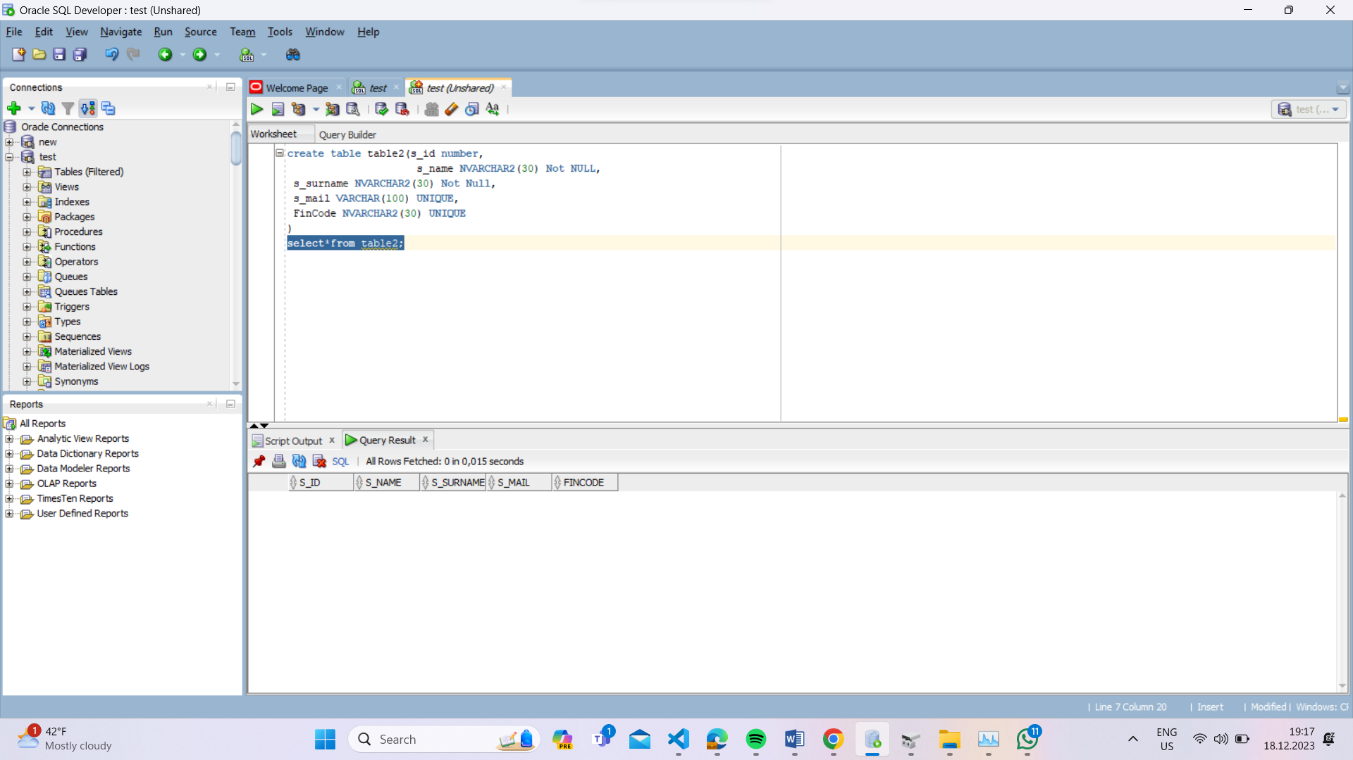

Table yaradiriq

Ve select*from u secib run edirik

**Insert vasitesi ile tableye melumat daxil edirik**

1.yazdigimiz kodu run edirik sonra select*from u

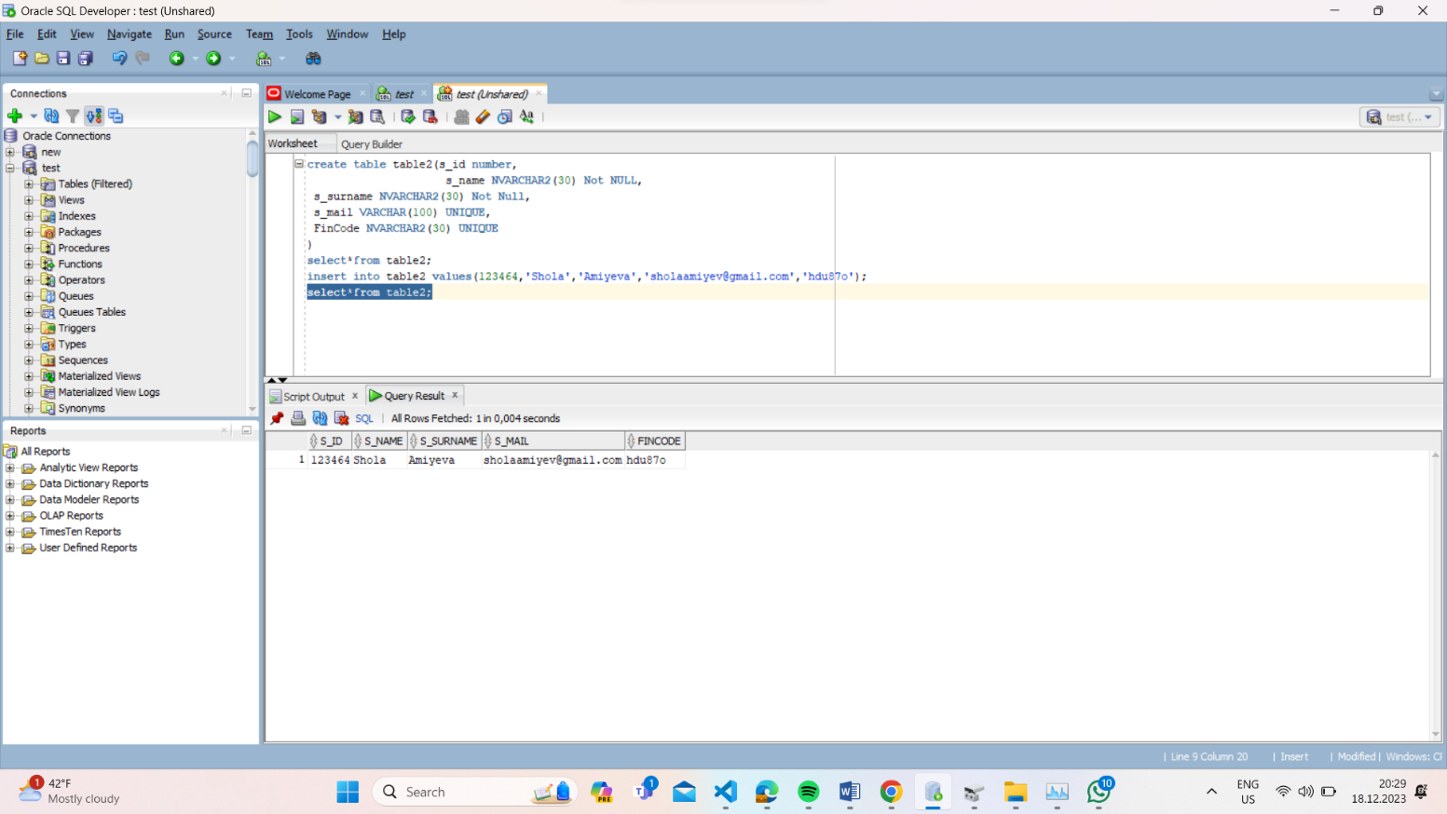

**Alter table ile xana daxil edirik**

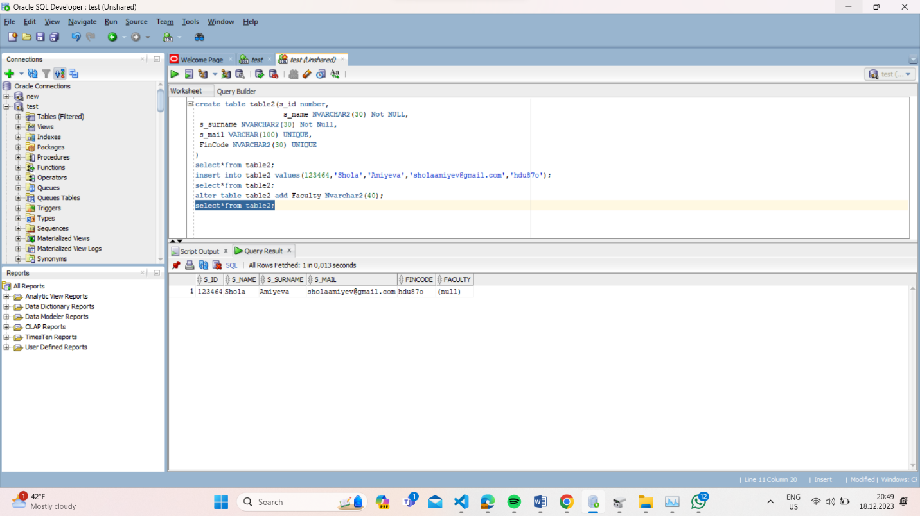

Update ile facultynin melumatini elave edirik where key sozluyunden istifade ederek tamamlayiriq

Alter table rename to ile tablenin adini deyisirik

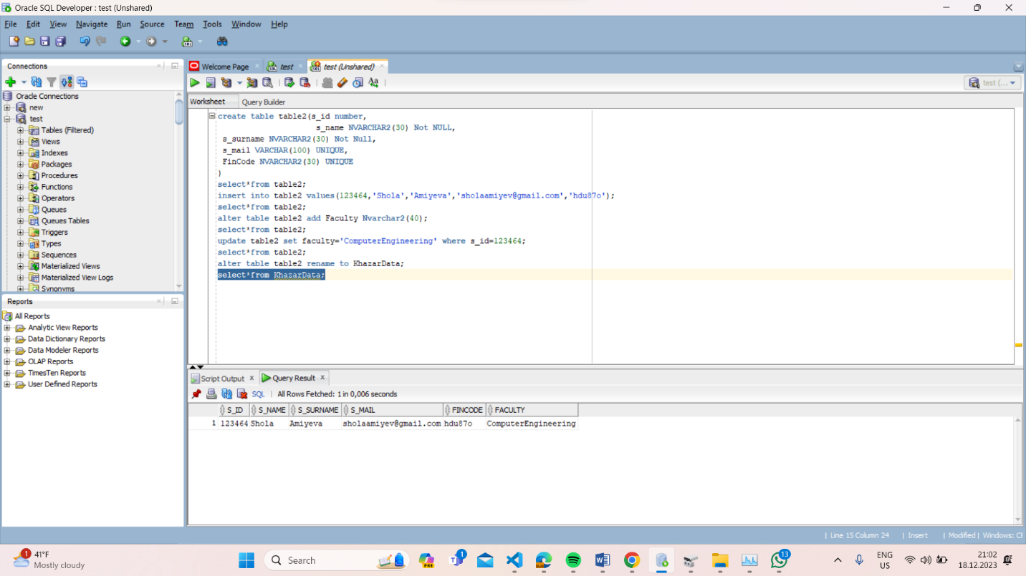

Silmek ucun dropdan istifade edirik

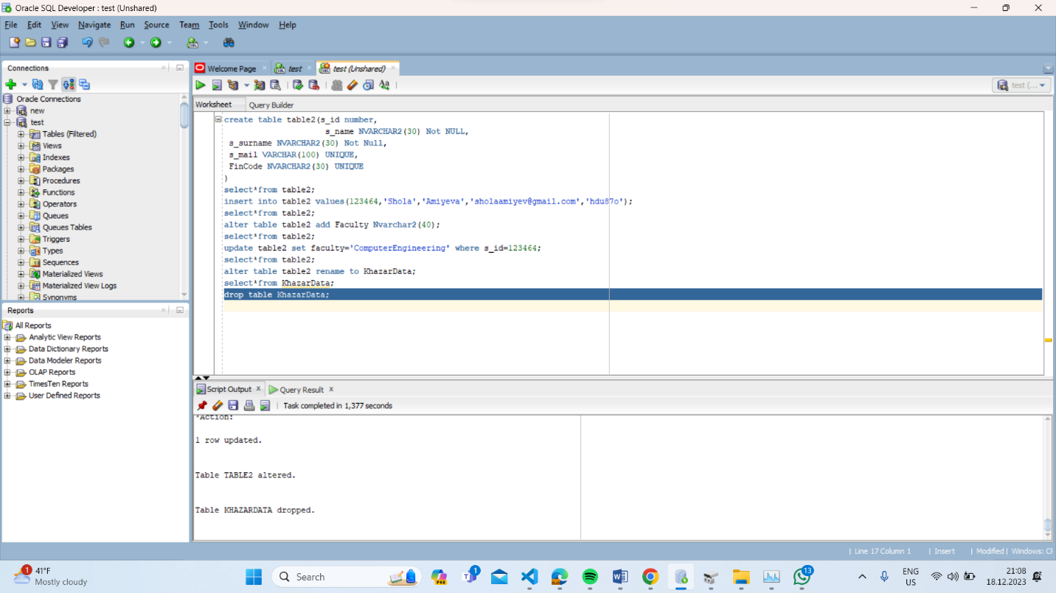

Yeniden biz bu tableni cagirsaq error verecek cunki bu table artiq silinib

