COURSE: INTRODUCTION TO DATABASE

SECTION: D

SEMESTER: FALL 20-21

PROJECT NAME: ELECTRICITY BILL MANAGEMENT SYSTEM

TEAM: **LETHAL DOTS**

|  |  |
| --- | --- |
| NAME | ID |
| SHOLAIMAN KHAN SHITOL | 18-38778-3 |
| JUBAER BIN MAHMUD MAHIM | 20-42383-1 |
| MEHADI HASAN SHOJIB | 20-42713-1 |
| MD. ARIF SULTAN | 20-43528-1 |

Er Diagram:

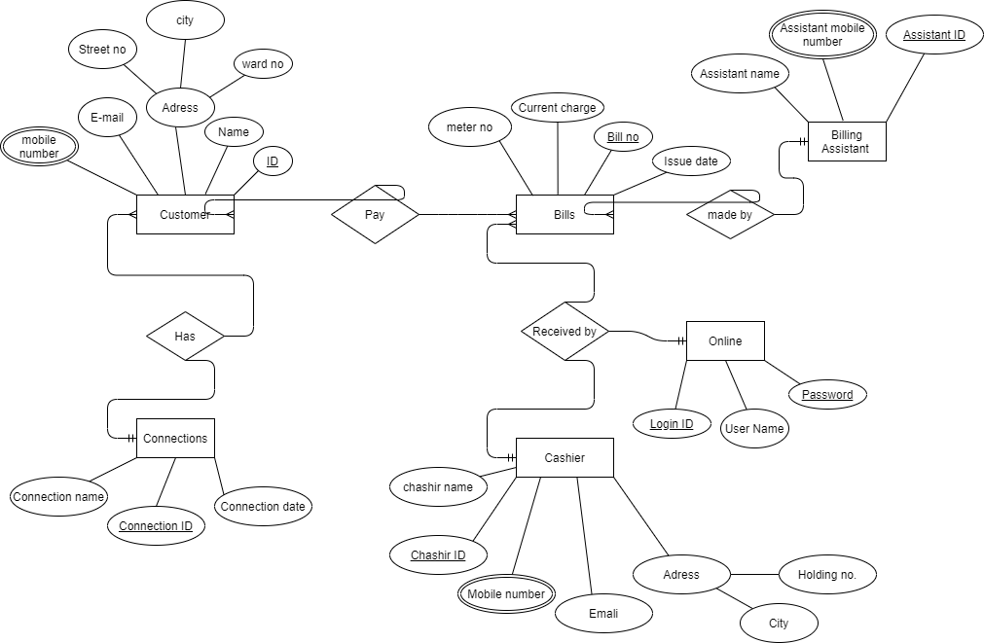

**Normalization**

**Has:**

UNF:

1st: customer-id, customer-name, customer-mobile-no,customer- email,customer-city, customer-street-no, customer-ward-no,connection-id,connection-name,connection-date

1NF:

1st: customer-id, connection-id, customer-mobile-no , customer-name, customer-email,customer-street-no,customer-city,customer-ward-no,connection-name,connection-date

2NF:

1st: customer-id, customer-mobile-no, customer-name, customer-email, customer-street-no,customer-city,customer-ward-no , connection-id

2nd: connection-id, connection-name, connection-date

3rd: Customer-id, connection-id

3NF:

1st: customer-id, customer-name, customer-mobile-no, customer-ward-no, customer-email, connection-id

2nd: customer-city, customer-street-no, customer-ward-no

3rd: connection-id, connection-name, connection-date

4th: Customer-id, connection-id

**Made By:**

UNF:

1st: assistant-id, assistant-name,assistant-mobile-no,bill-no,meter-no, current-charge,issue-date

1NF:

1st: assistant-id, bill-no, assistant mobile-no , assistant-name, meter-no , current-charge, issue-date

2NF:

1st: assistant-id , assistant-name ,assistant-mobile-no

2nd: bill-no , issue-date

3rd : bill-no, meter-no, current-charge

4th:assistant-id, bill-no

3NF:

1st: assistant-id, assistant-name, assistant-mobile-no

2nd: bill-no, issue-date

3rd : bill-no, meter-no, current-charge

4th:assistant-id, bill-no

**Pay:**

UNF:

1st: customer-id, customer-name, customer-mobile-no,customer- email,customer-address, bill-no, meter-no,customer-id,current-charge,issue-date

1NF:

1st: customer-id, bill-no, customer-name, custumer-mobile-no,customer-email,customer-street-no,customer-city,customer-ward-no, meter-no ,current-charge,issue-date

2NF:

1st: customer-id,customer-name, customer-mobile-no,customer-email,customer-street-no,customer-city,customer-ward-no,bill-no

2nd: bill-no, issue-date

3rd :  bill-no, meter-no,current-charge

4th: bill-no, customer-id

3NF:

1st: customer-id, customer-name, customer-mobile-no, customer-ward-no,customer-email

2nd: customer-street-no, customer-city, customer-ward-no

3rd: bill-no, meter-no,current-charge

4th: bill-no, issue-date

5th: bill-no, customer-id

**Received By:**

UNF:

1st:cashier-id,cashier-name,cashier-mobile-no,cashier-email,cashier-city,cashier-holding-no, bill-no, meter-no,current-charge,issue-date

1NF:

1st: cashier-id, bill-no, cashier-id,cashier-name,cashier-mobile-no,cashier-email,cashier-holding-no,cashier-city, meter-no,current-charge,issue-date

2NF:

1st: cashier-id,cashier-name,cashier-mobile-no,cashier-email,cashier-holding-no,cashier-city

2nd: bill-no, issue-date

3rd: bill-no, meter-no,current-charge

4th: bill-no, cashier-id

3NF:

1st: cashier-id, cashier-name,cashier-mobile-no, cashier-email ,cashier-holding-no,cashier-city

2nd: cashier-city, cashier-holding-no

3rd: bill-no, issue-date

4th: bill-no, meter-no,current-charge

5th: bill-no, cashier-id

**Received By:**

UNF:

1st:login-id,user-name,password, bill-no, meter-no,current-charge,issue-date

1NF:

1st: login-id, bill-no, user-name,password, meter-no,current-charge,issue-date

2NF:

1st: login-id,user-name,password,bill-no

2nd: bill-no, issue-date

3rd: bill-no, meter-no,current-charge

3th: bill-no, cashier-id

3NF:

1st: login-id,user-name,password,bill-no

2nd: bill-no, issue-date

3rd: bill-no, meter-no,current-charge

3th: bill-no, cashier-id

Final Table:

1st: customer-id, customer-name, customer-mobile-no, customer-ward-no

2nd: customer-street-no,customer-city,customer-ward-no

3rd: connection-id, customer-name, connection-name, connection-date

4th: Customer-id, connection-id

5th: assistant-id,assistant-name,assistant-mobile-no,bill-no

6th: bill-no, issue-date

7th: bill-no, meter-no,current-charge

8th: assistant-id,bill-no

9th: cashier-id, customer-id,cashier-name,cashier-mobile- no,cashier-holding-no,cashier-city,cashier-email

10th: cashier-city, cashier-holding-no

11th: bill-no,cashier-id

12th: login-id,user-name,password

**SQL Queries:**

create table customer1  
(  
customer_id int,  
customer_name varchar(255),  
customer_mobile_no int primary key,  
customer_ward_no int   
)  
Insert into customer1 values(11,'ALI',018567,6);  
Insert into customer1 values(11,'ALI',016444,6);

Insert into customer1 values(12,'KING',018566,7);

Insert into customer1 values(12,'KING',01744,7);  
Insert into customer1 values(14,'EVA',017722,8);  
Insert into customer1 values(14,'EVA',01700,8);  
Insert into customer1 values(18,'SAM',019276,1);  
Insert into customer1 values(18,'SAM',0156,1);

Insert into customer1 values(19,'RAHIM',016610,2);

Insert into customer1 values(19,'RAHIM',012847,2);  
Insert into customer1 values(22,'KARIM',017432,12);

Insert into customer1 values(22,'KARIM',0173,12);  
Select*from customer1

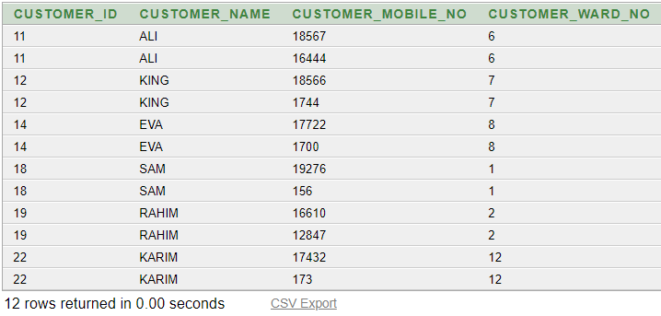

create table customer2nd  
(  
customer_street_no varchar(255),  
customer_city varchar(255),  
customer_ward_no int  
)

Insert into customer2nd values('06A','CTG',6);  
Insert into customer2nd values('8B','DHAKA',7);  
Insert into customer2nd values('9C','CTG',8);  
Insert into customer2nd values('40D','SHYLHET',1);  
Insert into customer2nd values('5F','CUMILLA',2);  
select*from customer2nd

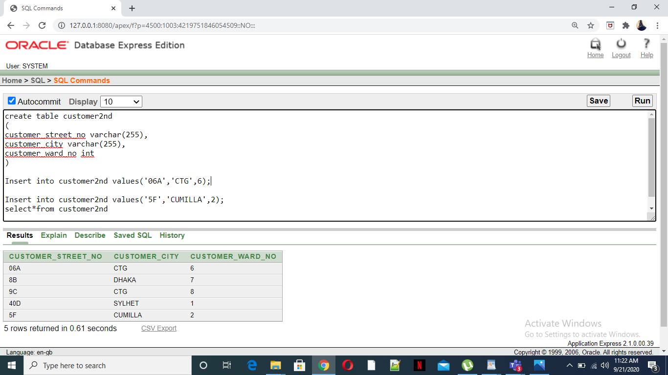

create table customer3 ( customer_ID int, customer_name varchar(225), connection_name varchar (225), connection_date varchar (225) )

insert into customer3 values (11, 'Ali', 'domestic', '02-Mar-2010' );

insert into customer3 values (12, 'King', 'industrial', '05-jan-2008' );

insert into customer3 values (14, 'Eva', 'domestic', '06-Aug-2010' );

insert into customer3 values (18, 'Sam', 'commercial', '02-Dec-2012' );

insert into customer3 values (19, 'Rahim', 'industrial', '03-Mar-2001' );

insert into customer3 values (22, 'Karim', 'domestic', '20-Nov -2013' );

select * from customer3; -------------------------------------------------------

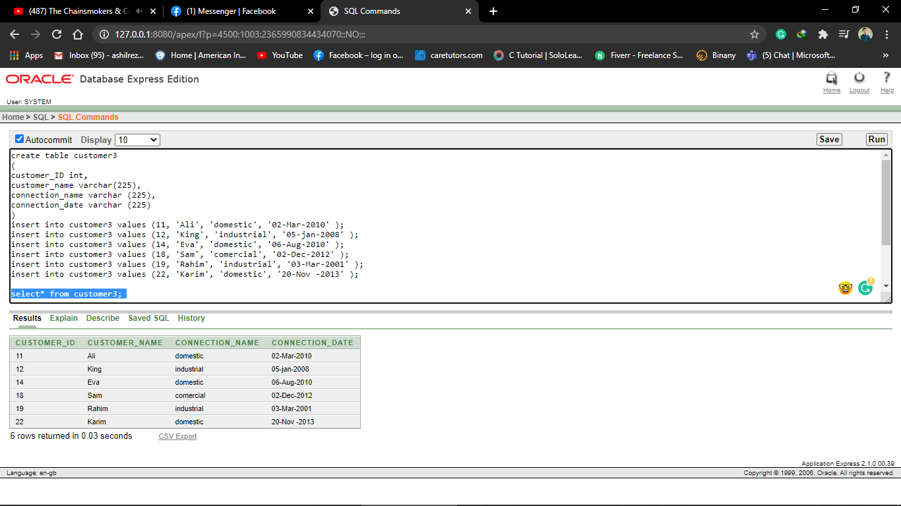

create table ID4 ( customer_ID int, connection_ID int )

insert into ID4 values (11, 92 );

insert into ID4 values (12, 56 );

insert into ID4 values (14, 92 );

insert into ID4 values (18, 33); insert into ID4 values (19, 45);

insert into ID4 values (22, 77);

select * from ID4; ----------------------------------------------------------------

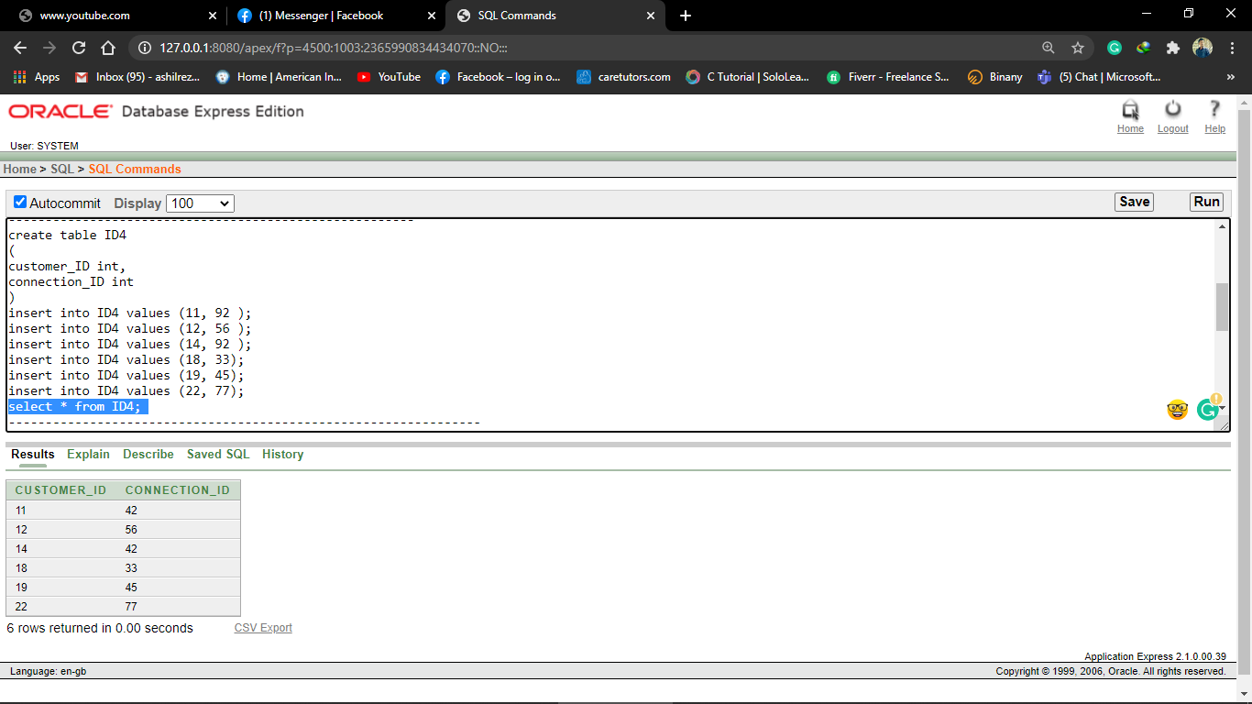

create table assistant5 ( assistant_ID int, assistant_name varchar(225), assistant_mobile_no int primary key, bill_no int )

insert into assistant5 values (101, 'Sara', 01725, 1022 );

insert into assistant5 values (101, 'Sara', 01674, 1022 );

insert into assistant5 values (103, 'Tasneem', 018839, 2034 );

insert into assistant5 values (104, 'Prapty', 019956, 3290 );

insert into assistant5 values (102, 'Sakib',01723, 7840 );

insert into assistant5 values (202, 'Mukta', 018949, 0256 );

insert into assistant5 values (300, 'Sporsho', 019923 ,5592 );

select * from assistant5;

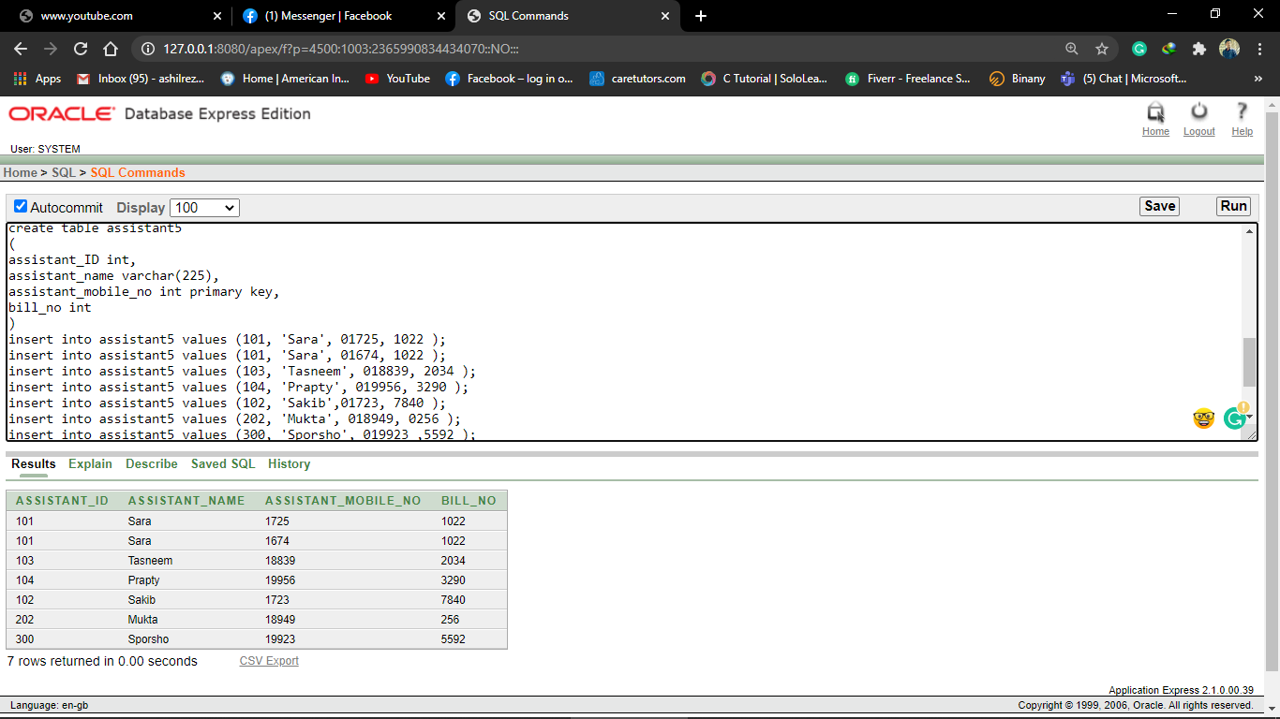

create table billdate6( bill_no int, issue_date date )

insert into billdate6 values(1022,'02-mar-2010')

insert into billdate6 values(2039,'05-jan-2008')

insert into billdate6 values(3290,'16-aug-2010')

insert into billdate6 values(7890,'02-dec-2012')

insert into billdate6 values(256,'03-mar-2001')

insert into billdate6 values(5592,'20-nov-2013')

select * from billdate6

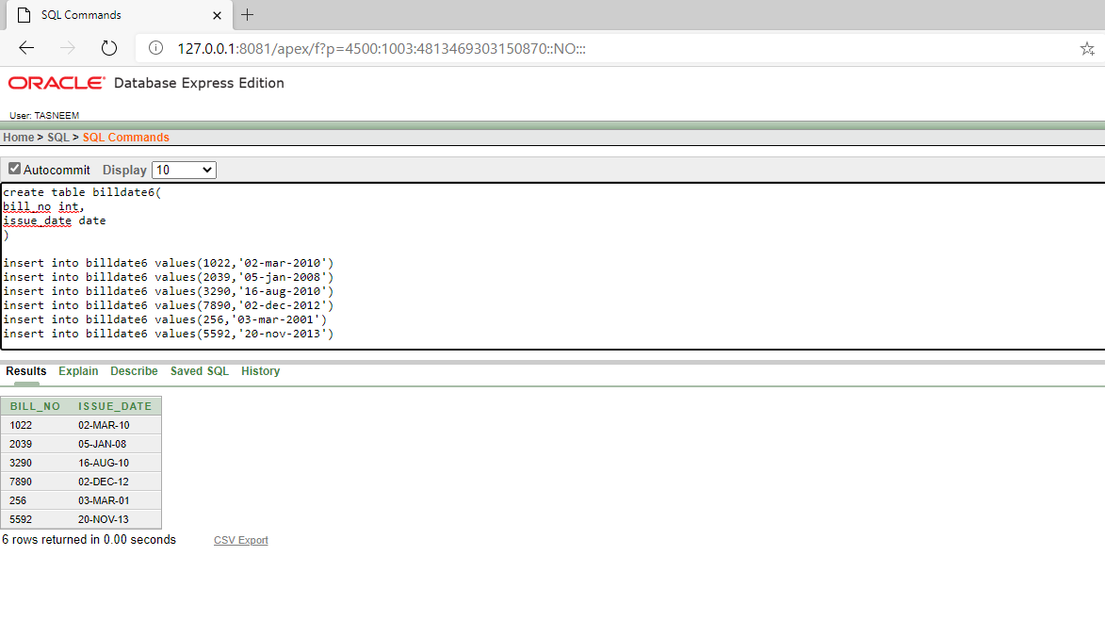

create table metercharge7( bill_no int, meter_no int, current_charge int )

insert into metercharge7 values(1022,4044,987)

insert into metercharge7 values(2039,2032,250)

insert into metercharge7 values(3290,4968,1100)

insert into metercharge7 values(7890,6667,200)

insert into metercharge7 values(0256,1004,501)

insert into metercharge7 values(5592,1256,1231)

select * from metercharge7

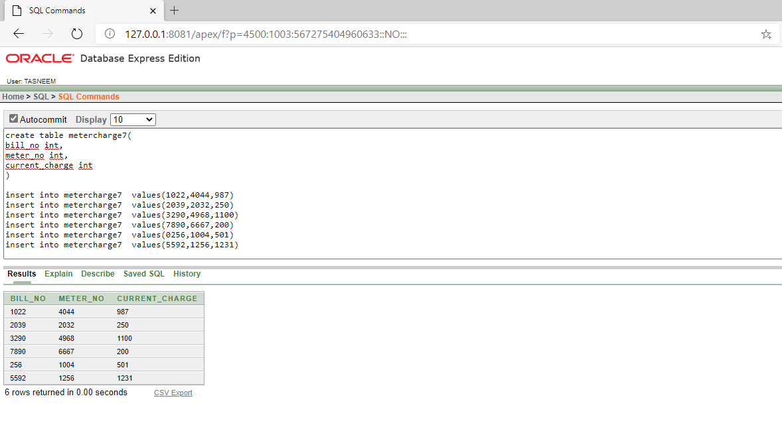

create table assistant8( assistant_id int, bill_no int )

insert into assistant8 values(101,1022)

insert into assistant8 values(103,2039)

insert into assistant8 values(104,3290)

insert into assistant8 values(102,7890)

insert into assistant8 values(202,256)

insert into assistant8 values(300,5592)

select * from assistant8;

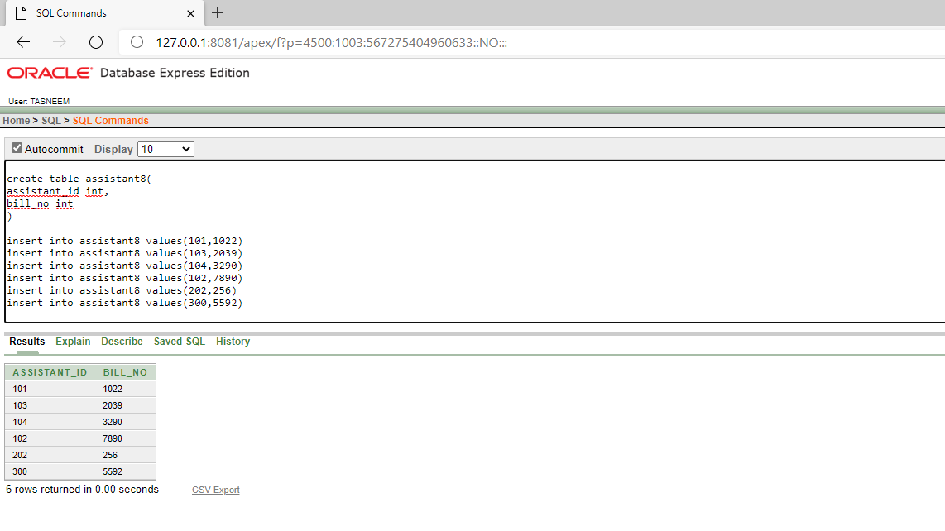

create table cashierinfo9( cashier_id int, cashier_name varchar(255), cashier_mobile_no int primary key, cashier_email varchar(255), cashier_city varchar(255) )

insert into cashierinfo9 values(222,'Arpa',012245,'arpa@gmail.com','Chittagong')

insert into cashierinfo9 values(222,'Arpa',017732,'arpa@gmail.com','Chittagong')

insert into cashierinfo9 values(453,'Rahi',01922,'rahi@gmail.com','Dhaka')

insert into cashierinfo9 values(123,'Chisty',01743,'chisty@gmail.com','Chittagong')

insert into cashierinfo9 values(772,'Mishu',01772,'mishu@gmail.com','Sylhet')

insert into cashierinfo9 values(223,'Faiza',012456,'faiza@gmail.com','Cummila')

insert into cashierinfo9 values(100,'Anik',01923,'anik@gmail.com','Feni')

select * from cashierinfo9;

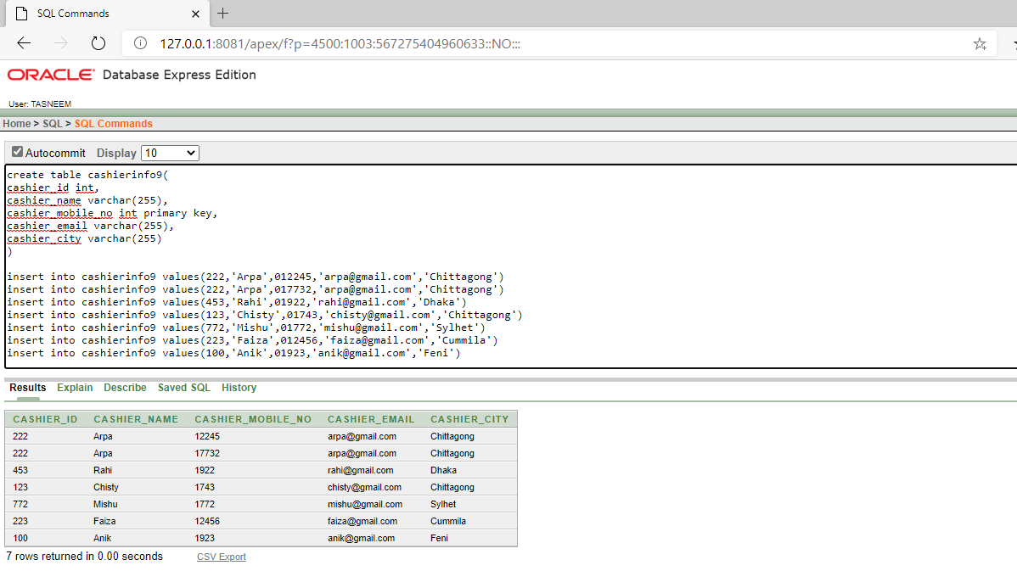

create table casadd10( cashier_city varchar(255), cashier_holding_no int )

insert into casadd10 values('Chittagong',23)

insert into casadd10 values('Dhaka',45)

insert into casadd10 values('Chittagong',67)

insert into casadd10 values('Sylhet',92)

insert into casadd10 values('Cummila',46)

insert into casadd10 values('Feni',99);

select * from casadd10;

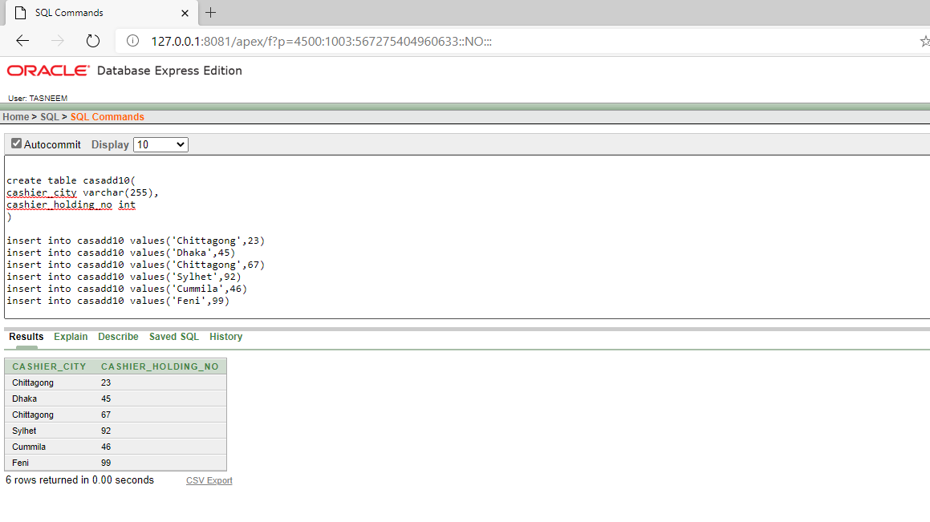

create table bill11( billno int, cashierid int );

insert into bill11 values(1022,222);

insert into bill11 values(2034,453);

insert into bill11 values(3290,123);

insert into bill11 values(7840,772);

insert into bill11 values(0256,223);

insert into bill11 values(5592,100);

select*from bill11;

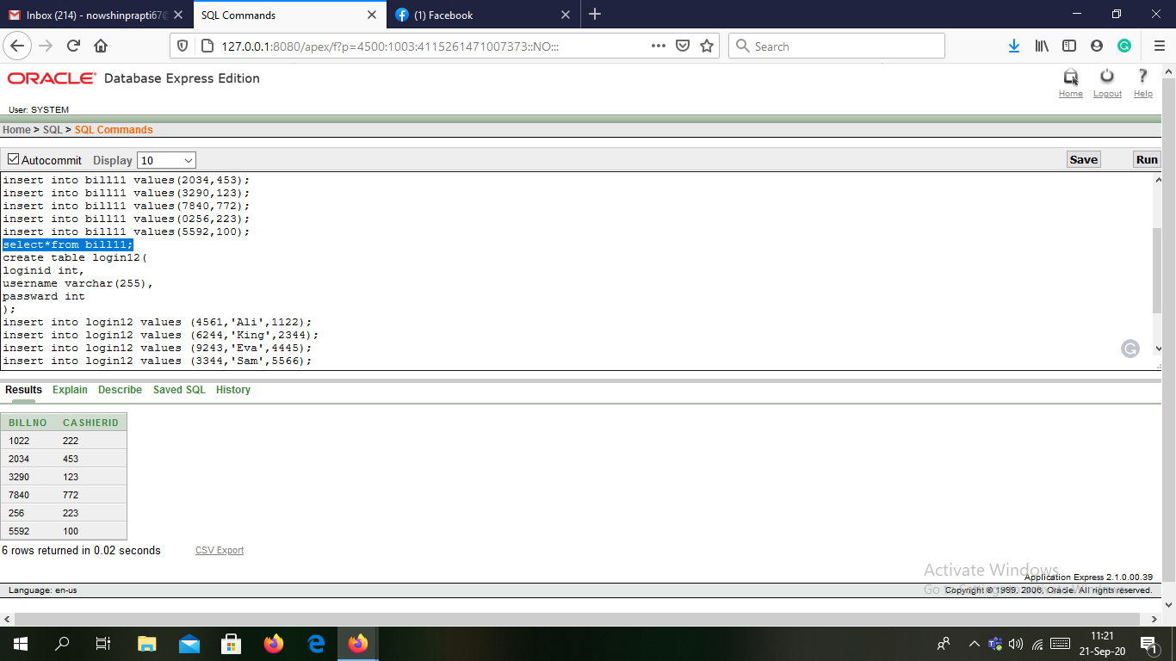

create table login12( loginid int, username varchar(255), passward int );

insert into login12 values (4561,'Ali',1122);

insert into login12 values (6244,'King',2344);

insert into login12 values (9243,'Eva',4445);

insert into login12 values (3344,'Sam',5566);

insert into login12 values (4517,'Rahim',7788);

insert into login12 values (3255,'Karim',4545);

select*from login12;

