**Aim**: To recognize emotions and facial expressions using Opencv and Stasm.

**Method and steps:**

1. Face Detection is done using HAAR features as provided in opencv
2. Landmark detection, used 5 different xml files, for eyes,nose,frontal xml. Detected 77 landmarks using stasm.
3. First generated training data using haar features.
4. Generated data for four emotions.
5. Model works fine for neutral, happy and surprised.
6. Assume: Neutral is base image , any emotion is displacement of all landmark co-ordinates.
7. For feature extraction, I used SPTS method from Lucas Kanade Extended dataset paper, I subtracted the features of first frame
8. In the confusion matrix, it shows that for SPTS feature extraction, the probability of emotion detection for happy and surprised is high.
9. Used SVM to train the model.

**Results and ScreenShots**:

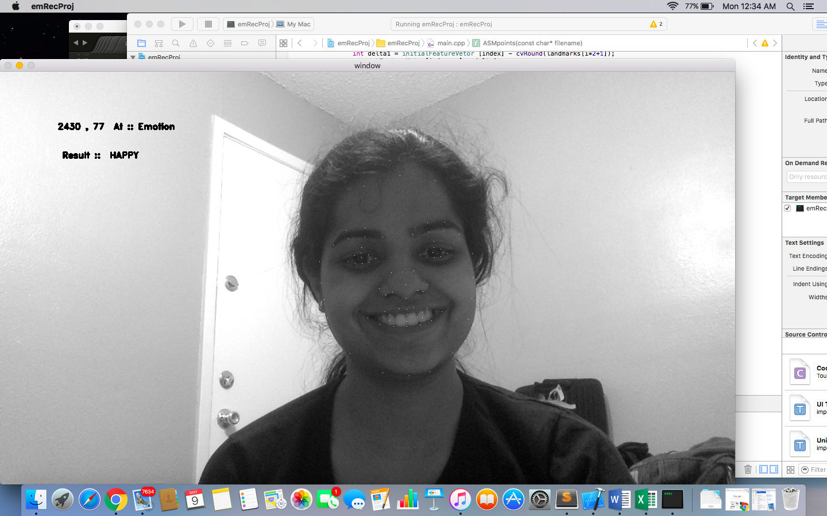



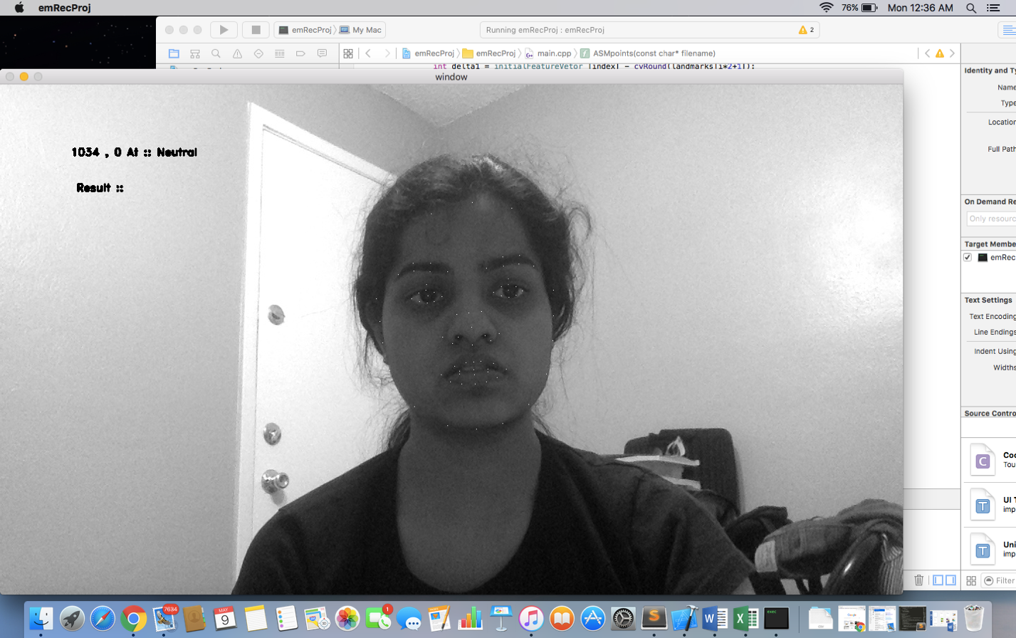

**Code**: Attached

**References**: <http://breckon.eu/toby/teaching/ml/examples/c++/speech_ex/svm.cpp>

<http://www.consortium.ri.cmu.edu/data/ck/CK+/CVPR2010_CK.pdf>

https://github.com/juan-cardelino/stasm