Portfolio Snapshot
15  Total Applications | 14  Assessed | 1  Incomplete Data | Feb–Mar 2026  Assessment Period
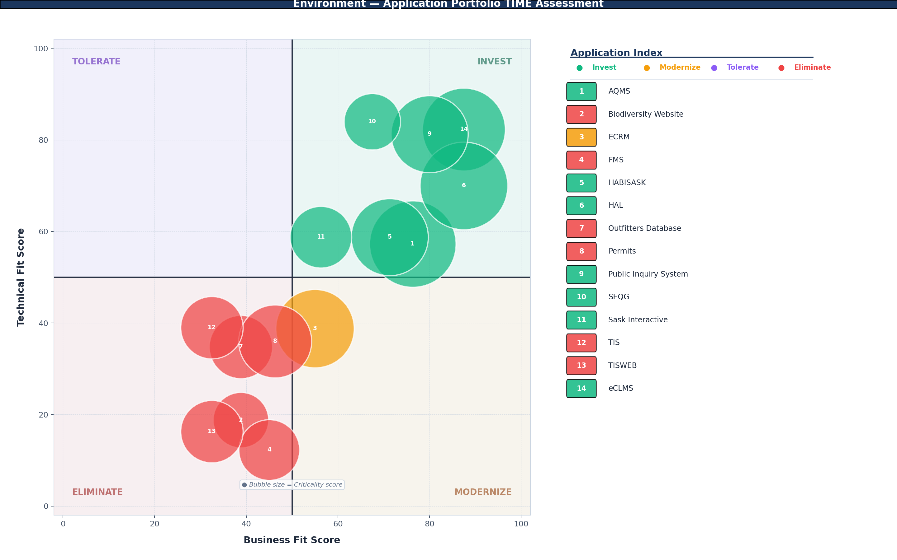
 |  | Key Portfolio Insights  - Half the portfolio (7 of 14 assessed applications) is positioned in Invest, indicating a core of high-value, technically viable systems anchored by eCLMS - Enterprise Crown Land Management System - D365, HAL - Hunting and Fishing Licence Sales, and the Public Inquiry System.  - Six applications fall in Eliminate — the largest retirement cluster in any ministry assessed to date — driven by aging platforms, non-compliant security controls, and low user satisfaction.  - Only one application (ECRM - ENV) occupies Modernize, yet it carries the highest ITSM incident volume in the portfolio (560 incidents over 24 months), signalling urgent platform risk on a business-critical system.  - No applications occupy the Tolerate quadrant, producing a polarized portfolio: applications either deliver strong value on both dimensions or fall short on both.
  TIME | # | % Assessed
  Invest | 7 | 50%
  Modernize | 1 | 7%
  Tolerate | 0 | 0%
  Eliminate | 6 | 43%
For the full visual portfolio summary, refer to the attached Application Assessment Summary.

Abstract
Between February and March 2026, the Ministry of Environment undertook an Application Portfolio Management assessment of fifteen business applications spanning environmental monitoring, wildlife and fisheries management, land administration, and public-facing information services. Each application was evaluated against ten Business Fit factors (B1–B10) and fourteen Technical Fit factors (T01–T14), producing a Business Fit Score, Technical Fit Score, and Criticality Score that together determine placement within the TIME quadrant model. Assessments were conducted by application owners and subject matter experts within the ministry, with support from Business Solutions Services (BSS).
Of the fifteen applications, fourteen received complete assessments and were positioned in a TIME quadrant. One application — Fur Program Statistics — was classified as Incomplete Data due to missing Technical Fit factor responses (T07, T08, T13). No data quality corrections were required; score distributions across applications were consistent with their assessed factor responses.
Assessment Methodology
Each application was assessed using two standardized factor sets. Scores for each factor are recorded on a 1–5 scale and normalized to 0–100.
Business Fit Factors (B1–B10) | Technical Fit Factors (T01–T14)
B1 — Strategic Contribution | T01 — Platform / Product Footprint
B2 — Regional Growth Support | T02 — Application Development Platform
B3 — Public Confidence Impact | T03 — Platform Portability
B4 — Scope of Use | T04 — Configurability & Extensibility
B5 — Business Process Criticality | T05 — Support for Modern UX
B6 — Business Interruption Tolerance | T06 — Security Controls
B7 — Essential Service Impact | T07 — Security Controls for Data Sensitivity
B8 — Current Needs Fulfillment | T08 — Identity Assurance
B9 — Future Needs Adaptability | T09 — Resilience & Recovery
B10 — User Satisfaction | T10 — Observability & Manageability
 | T11 — Vendor and Support Availability
 | T12 — Integration Capabilities
 | T13 — Integrations
 | T14 — Data Accessibility
The TIME methodology is adapted from the Gartner APM framework. SaskBuilds uses "Modernize" in place of Gartner's original "Migrate" designation to better reflect the nature of platform renewal activities within the Government of Saskatchewan context.

Contents
Portfolio Snapshot | 1
Abstract | 2
Assessment Team | 4
Invest | 5
Modernize | 6
Tolerate | 7
Eliminate | 8
Incomplete Data | 9
EA Handoff | 10

Assessment Team
Role | Name(s)
APM Program Lead | Ryan Brittner, Director, Enterprise Architecture — SaskBuilds and Procurement
Assessment Lead / Facilitator | Krista Campbell, Executive Director, Business Support Services — Environment
Assessment Participants | Shelley Bond, Manager — Environment, Bryan Chernick, Director, Business Transformation — Environment, Jarred Geiss, Manager, Service Delivery — Environment
EA / APM Advisors | Glenn Grad — SaskBuilds and Procurement, Alex Chime, Solution Architect, IT Planning — SaskBuilds and Procurement, Leanne Silzer — SaskBuilds and Procurement, Stuart Holtby — SaskBuilds and Procurement

Application Owners
Application owners were not present during the assessment sessions. They are listed here as the designated owners of record for each assessed application.
Application Owner
Krista Campbell — Environment
Andrea Benville — Environment
Travis Williams — Environment
Joann Skilnick — Environment
Robert Gillis — Environment
Vicki Gauthier — Environment
Miranda Carlberg — Environment
Katherine Mehl — Environment

INVEST
What is Invest?
Applications in the Invest quadrant demonstrate high business fit and strong technical health. They are core to operational delivery and are built on sustainable, modern platforms. Continued investment in maintenance, enhancement, and capability growth is warranted. These applications represent the portfolio's highest-value digital assets and carry the greatest risk if disrupted or allowed to decline.

Pattern Narrative
The seven Invest applications share several defining characteristics. All score highly on Strategic Contribution (B1: 3–5) and most are public-facing (B4: 4–5), reflecting the ministry’s mandate to deliver environmental monitoring and wildlife management services to citizens. Business Process Criticality (B5) is consistently elevated, with five of seven applications rated as mission-critical or critical. On the technical side, the strongest performers — eCLMS - Enterprise Crown Land Management System - D365 (82.3), SEQG - Saskatchewan Environment Quality Guidelines (84.0), and Public Inquiry System (81.3) — run on cloud-native or containerized platforms with advanced security controls (T06: 5), enforced multi-factor authentication (T08: 5), and automated resilience (T09: 5). The remaining Invest applications (AQMS - Air Quality Monitoring System, HABISASK - Hunting, Angling and Biodiversity Information, Sask Interactive, HAL - Hunting and Fishing Licence Sales) sit closer to the 50-point threshold on Technical Fit, with aging development platforms (T02: 2–3) and basic security compliance (T06: 3). These near-threshold applications are functional and business-aligned but lack the modern architecture of the top tier.
Applications — Ranked by Criticality
★ denotes Crown Jewel designation
# | Application Name | Criticality | Business Fit | Tech Fit | Lifecycle Status
7 | HAL - Hunting and Fishing Licence Sales | 93.8 | 87.5 | 70 | Business/Vendor Managed
1 | AQMS - Air Quality Monitoring System | 91.3 | 76.3 | 57.3 | Extended Support
15 | eCLMS - Enterprise Crown Land Management System - D365 ★ | 83.8 | 87.5 | 82.3 | Mainstream Support
6 | HABISASK - Hunting, Angling and Biodiversity Information | 72.5 | 71.3 | 58.8 | Extended Support
10 | Public Inquiry System | 72.5 | 80 | 81.3 | Business/Vendor Managed
12 | Sask Interactive | 46.3 | 56.3 | 58.8 | Incomplete Data
11 | SEQG - Saskatchewan Environment Quality Guidelines | 38.8 | 67.5 | 84 | Mainstream Support
Criticality-Weighted Insight
eCLMS - Enterprise Crown Land Management System - D365 carries the highest combined weight in this quadrant: a Criticality Score of 83.8 paired with Crown Jewel designation from the infrastructure lifecycle report. It is the only Crown Jewel in the portfolio. HAL - Hunting and Fishing Licence Sales (Criticality 93.8) has the highest criticality score of any application in the ministry — its role in hunting and fishing licence sales makes it revenue-generating and public-facing, with a one-hour business interruption tolerance. AQMS - Air Quality Monitoring System (Criticality 91.3) is similarly high-dependency, supporting air quality monitoring with direct public safety implications. These three applications represent the core operational assets that require investment protection and continuity planning. Sask Interactive (Criticality 46.3) and SEQG - Saskatchewan Environment Quality Guidelines (Criticality 38.8) sit at the lower end of criticality within Invest, suggesting they are important but not operationally urgent.

MODERNIZE
What is Modernize?
Applications in the Modernize quadrant deliver meaningful business value but are constrained by aging or inadequate technical foundations. The business case for continued use is present; however, the platform, infrastructure, or development environment has not kept pace with organizational needs or current standards. Re-platforming, upgrading, or transitioning to modern alternatives is indicated. SaskBuilds uses 'Modernize' in place of Gartner's original 'Migrate' designation to reflect the broader range of renewal approaches applicable in a government context.

Pattern Narrative
ECRM - ENV is the sole application in the Modernize quadrant, positioned there because its Business Fit Score (55.0) exceeds the threshold while its Technical Fit Score (38.8) falls below. The business case remains intact: ECRM - ENV is strategically aligned (B1: 4), public-facing (B4: 5), and critical to daily operations (B5: 4) with a 24-hour restoration requirement (B6: 3). However, the technical platform has reached end of support. The application runs on a legacy client-server architecture (T01: 2) with an obsolete development platform (T02: 1), non-portable infrastructure (T03: 1), non-compliant security controls (T06: 1), and manual recovery that would take over 48 hours (T09: 2). Current needs fulfillment (B8: 2) and user satisfaction (B10: 1) are both low, indicating the platform is actively constraining the business value it was built to deliver.
Applications — Ranked by Criticality
# | Application Name | Criticality | Business Fit | Tech Fit | Lifecycle Status
3 | ECRM - ENV | 75 | 55 | 38.8 | End of Support
Criticality-Weighted Insight
With a Criticality Score of 75.0, ECRM - ENV sits in the significant-dependency range, meaning sequenced delivery planning is needed for any modernization effort. The urgency is compounded by its ITSM profile: 560 incidents over 24 months — more than all other assessed applications combined. Twenty problems were also recorded, suggesting systemic rather than transactional issues. The combination of end-of-support lifecycle status, non-compliant security, high incident volume, and significant operational dependency makes ECRM - ENV the highest-priority modernization candidate in this portfolio.

TOLERATE
What is Tolerate?
Applications in the Tolerate quadrant exhibit adequate technical health but deliver limited strategic business value. These systems continue to function reliably but are not aligned with the organization's core mandate or growth priorities. The appropriate posture is to maintain as-is, limit further investment, and monitor for a natural exit or replacement opportunity. Tolerate applications are often candidates for consolidation as the broader portfolio evolves.

Pattern Narrative
No applications were positioned in the Tolerate quadrant. This is an unusual result — most ministry portfolios contain at least one or two technically sound systems that have outgrown their strategic relevance. The absence here suggests that the Ministry of Environment has not invested in platform modernization for applications where the business case has weakened; instead, those systems remain on legacy platforms and fall into Eliminate.
Applications — Ranked by Criticality
# | Application Name | Criticality | Business Fit | Tech Fit | Lifecycle Status
Criticality-Weighted Insight
With no Tolerate applications, there are no candidates for a managed phase-out where technical health would buy time. Every application below the Business Fit threshold is also technically deficient, which limits options for gradual retirement through natural attrition.

ELIMINATE
What is Eliminate?
Applications in the Eliminate quadrant provide limited business value and are built on aging or unsupported platforms. They have aged past their operational relevance on both dimensions simultaneously. Planning for retirement, consolidation, or replacement is appropriate. The Criticality score determines urgency: low-criticality applications are candidates for near-term retirement, while moderate-criticality applications require sequenced exit planning to manage operational dependencies.

Pattern Narrative
The six Eliminate applications share a consistent profile: aging or obsolete development platforms (T02: 1–3), non-portable infrastructure (T03: 1–2), and severe gaps in modern UX (T05: 1–2) and security controls. FMS - Financial Management System, TISWEB - Timber Information System Web, and Biodiversity Website all score T06: 1 (non-compliant — patches no longer available). Identity assurance is particularly weak across this group: FMS - Financial Management System (T08: 2, app-specific passwords), Outfitters Database and Permits - FWLB (T08: 1, shared credentials), and TISWEB - Timber Information System Web and Biodiversity Website (T08: 1, shared credentials). None of these applications have a disaster recovery plan (T09: 1). On the business side, current needs fulfillment (B8) and future adaptability (B9) are uniformly low (1–2), and user satisfaction (B10) ranges from dissatisfied to very dissatisfied. TIS - Timber Information System and TISWEB - Timber Information System Web are a paired system sharing identical business scores (32.5) and similar technical profiles.
Applications — Ranked by Criticality
# | Application Name | Criticality | Business Fit | Tech Fit | Lifecycle Status
9 | Permits - FWLB | 65 | 46.3 | 36 | Extended Support
8 | Outfitters Database | 48.8 | 38.8 | 34.8 | Extended Support
13 | TIS - Timber Information System | 47.5 | 32.5 | 39 | End of Support
14 | TISWEB - Timber Information System Web | 47.5 | 32.5 | 16.3 | End of Support
4 | FMS - Financial Management System | 45 | 45 | 12.3 | End of Support
2 | Biodiversity Website | 37.5 | 38.8 | 18.8 | Extended Support
Criticality-Weighted Insight
Permits - FWLB stands out within this quadrant. Its Criticality Score of 65.0 places it in the significant-dependency range, yet it sits firmly in Eliminate with a Business Fit of 46.3 and Technical Fit of 36.0. The application supports cross-organizational permit management (B4: 4), is critical to daily operations (B5: 4), and directly supports public services (B7: 4). Its retirement cannot be treated as a simple decommission — the business functions it supports will need to be absorbed by another system first. FMS - Financial Management System (Criticality 45.0) presents a similar tension: it is strategically aligned (B1: 4) and cross-organizational (B4: 4), but its technical platform is the weakest in the portfolio (Tech Fit 12.3) with legacy monolith architecture, green-screen UI, no disaster recovery, and unmonitored integrations. The Outfitters Database (Criticality 48.8) also carries moderate dependency with shared-credential access (T08: 1) and no data sensitivity controls (T07: 1), creating a security exposure that warrants attention independent of retirement timing.

Incomplete Data
1 application could not be fully positioned in the TIME model due to incomplete assessment data. This application is not included in the quadrant analysis above and requires a follow-up assessment session before it can be incorporated into portfolio planning.

Fur Program Statistics
Business Fit Score | 17.5
Criticality Score | 11.3
Technical Fit Score | Not assessed
Lifecycle Status | Business/Vendor Managed
TIME Position | Eliminate based on available scores (Business Fit 17.5, Criticality 11.3), though Technical Fit is missing
Action Required | Complete the Technical Fit assessment (T07, T08, T13 are missing) to confirm quadrant placement. Low criticality and business fit suggest Eliminate, but vendor-managed lifecycle status warrants confirmation that the ministry still uses this application.

EA Handoff — Open Questions
The following questions are surfaced by the assessment data. They are portfolio-wide observations intended to frame the EA team's planning conversations. APM collects data and provides insights — it does not make decisions or prescribe outcomes.
- What is the ministry’s modernization plan for ECRM - ENV, given its end-of-support lifecycle status, 560 incidents over 24 months, and non-compliant security controls? Is there a funded initiative or is the ministry absorbing the operational risk?
- TIS - Timber Information System and TISWEB - Timber Information System Web share identical business scores and similar technical profiles. Are these being treated as a single retirement candidate, and has the forestry data they manage been identified for migration to a successor system?
- Permits - FWLB carries significant operational dependency (Criticality 65.0) but sits in Eliminate. Which system is intended to absorb its permit management functions, and is there a sequencing dependency with other retirements in this cluster?
- Four Eliminate applications (Outfitters Database, Permits - FWLB, TISWEB - Timber Information System Web, Biodiversity Website) use shared credentials with no individual user tracking. Has the ministry assessed the audit and compliance exposure this creates, particularly for systems handling public-facing or sensitive data?
- AQMS - Air Quality Monitoring System and HABISASK - Hunting, Angling and Biodiversity Information are positioned in Invest but sit near the Technical Fit threshold (57.3 and 58.8 respectively) with aging development platforms. Is there a planned investment cycle to prevent these from drifting into Modernize as their platforms age further?
Suggested Next Assessment Trigger
A follow-up assessment is indicated after the ministry confirms a modernization path for ECRM - ENV and a retirement sequence for the six Eliminate applications, or within twelve months of this assessment, whichever comes first.

