Portfolio Snapshot
22  Total Applications | 20  Assessed | 2  Incomplete Data | Feb–Mar 2026  Assessment Period
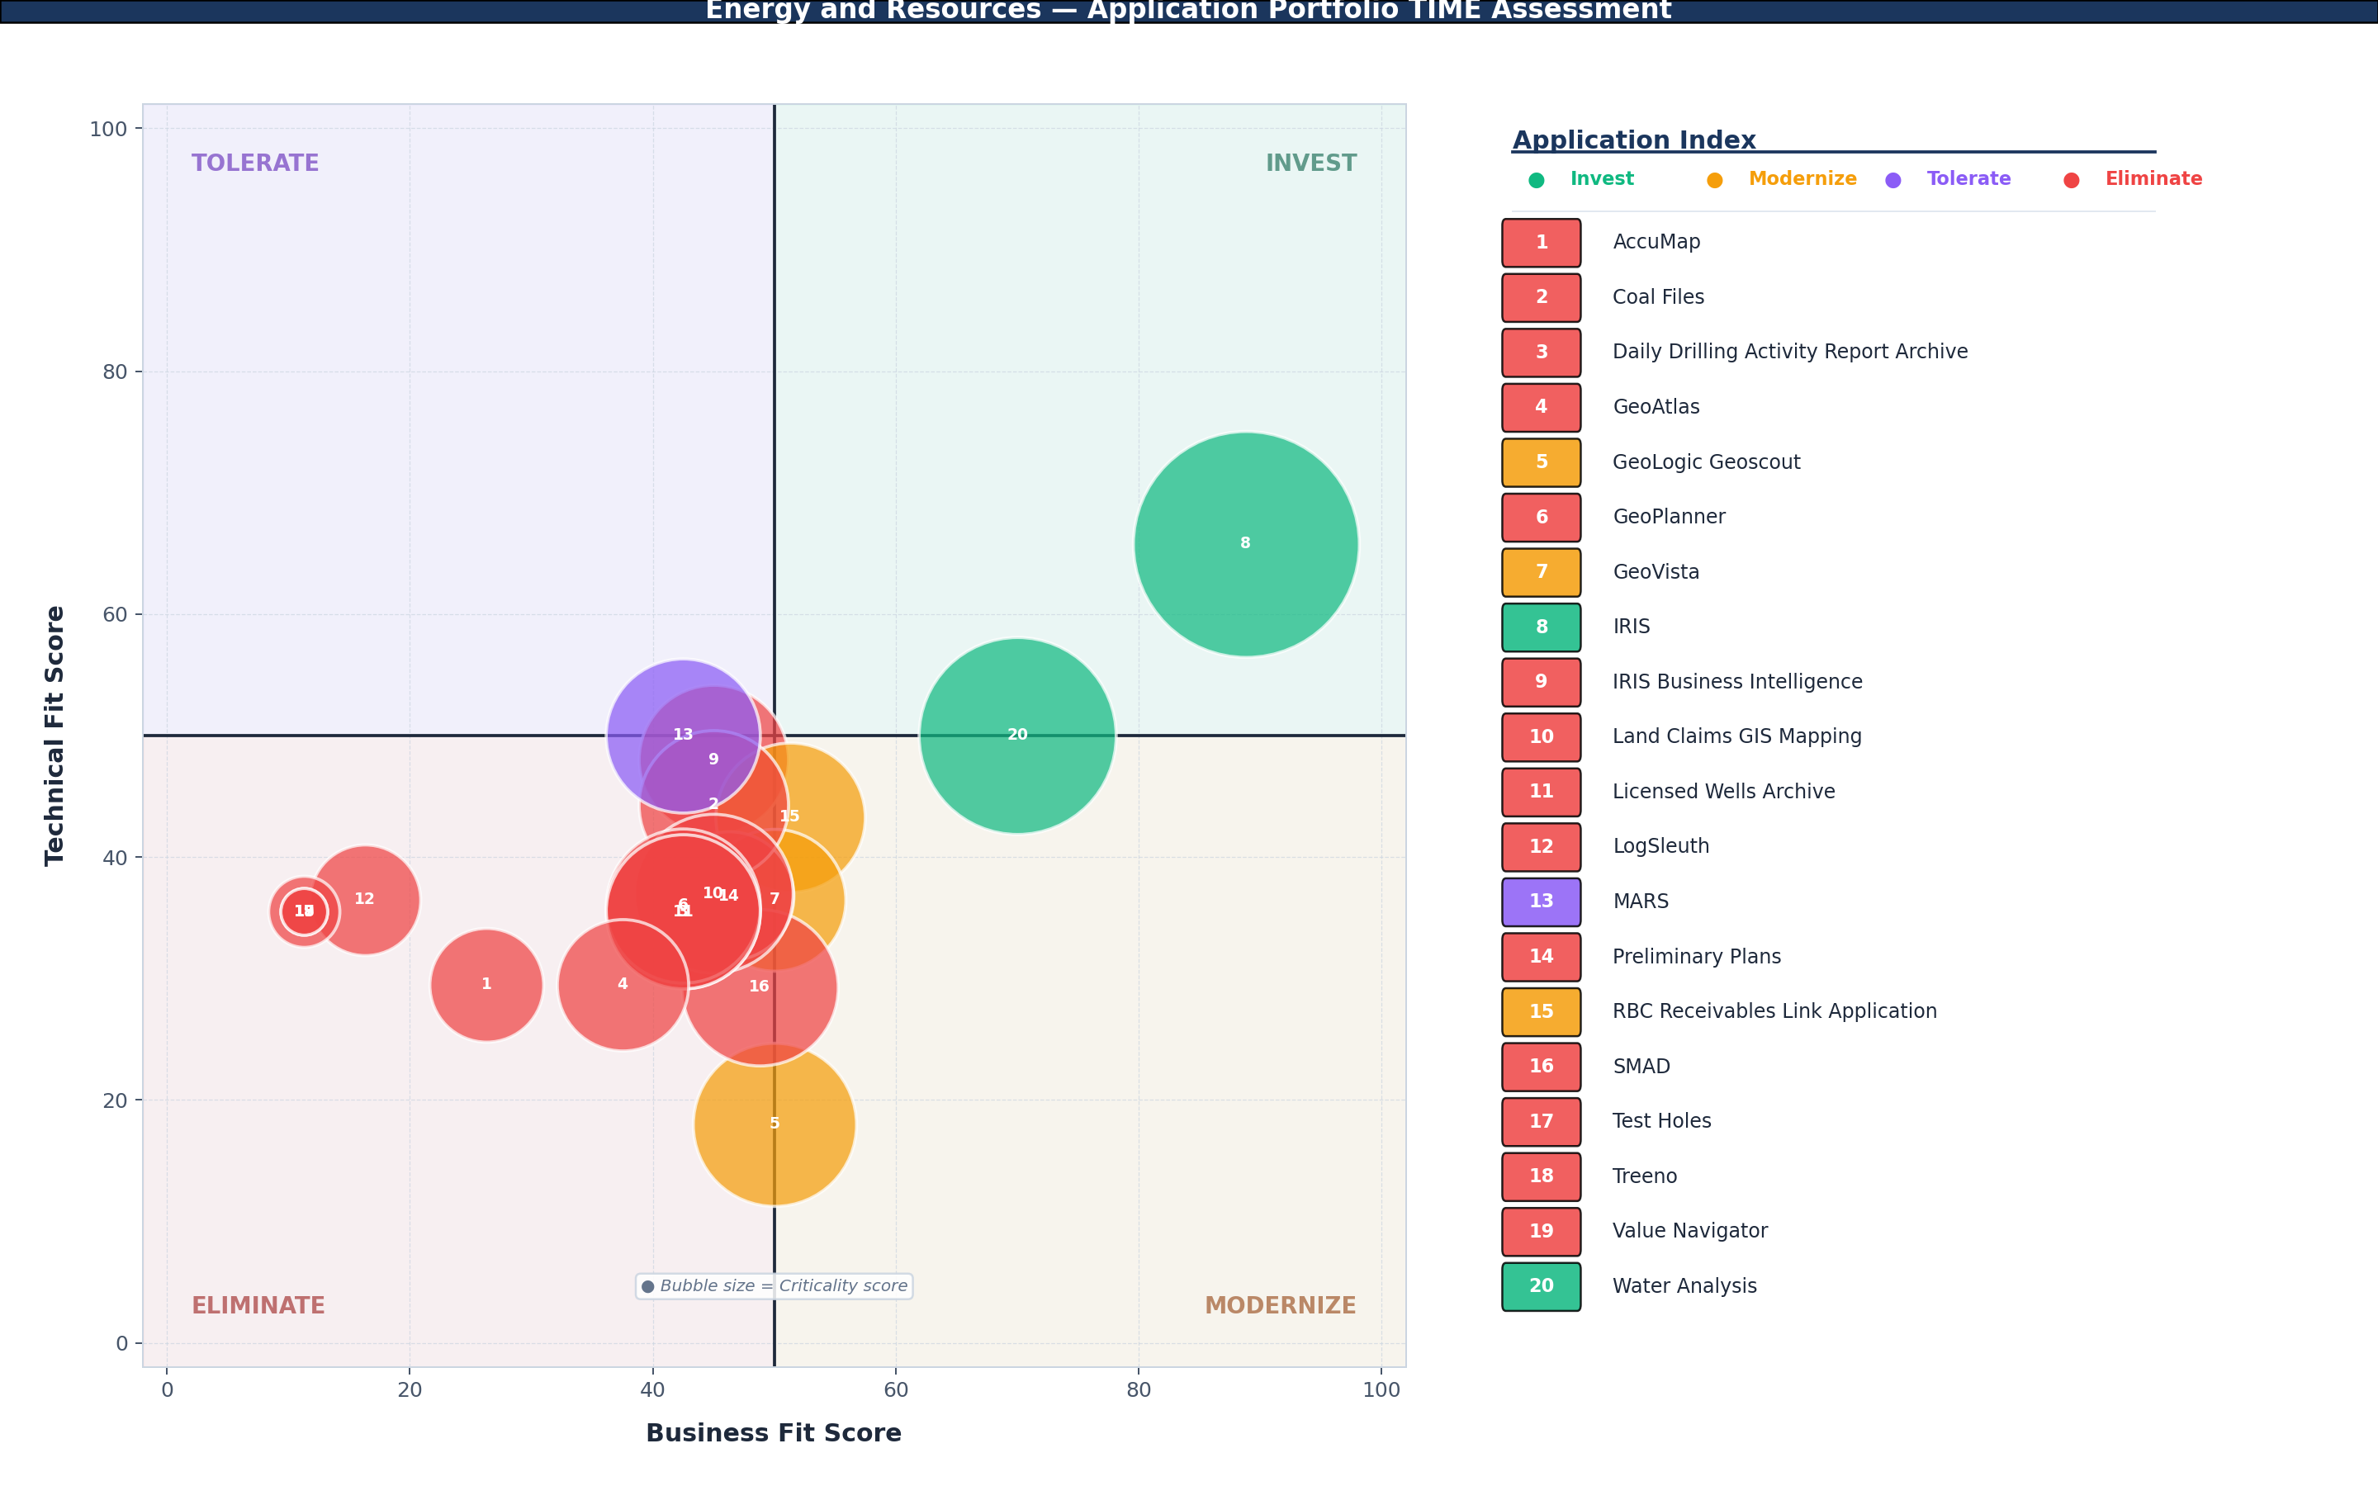
TIME Category Count % of Assessed  Invest 2 10%  Modernize 3 15%  Tolerate 1 5%  Eliminate 14 70% |  | Key Portfolio Insights  - 70% of the assessed portfolio (14 of 20 applications) is positioned in Eliminate, reflecting accumulated technical legacy against declining business relevance across a large portion of the ministry’s application inventory.  - IRIS - Integrated Resource Information System is the portfolio’s highest-criticality asset (88.8), correctly positioned in Invest with Crown Jewel designation. Its scores were found to be inverted with IRIS Business Intelligence in the source data and have been corrected in this report.  - GeoLogic Geoscout represents the most time-pressured Modernize application — the lowest technical fit score in the portfolio (18.0) combined with ITDNAS-End-Of-Life infrastructure status.  - Geoscience Data Management carries the highest criticality (60.0) of the two incomplete-data applications and warrants priority follow-up before the next portfolio planning cycle.
For the full visual portfolio summary, refer to the attached Application Assessment Summary.

Abstract
This report presents the findings of the Application Portfolio TIME Assessment conducted for the Ministry of Energy and Resources, Government of Saskatchewan. The assessment was administered across 22 business applications using the TIME methodology, adapted from the Gartner Application Portfolio Management framework. Each application was evaluated against ten business fit factors (B1–B10) and fourteen technical fit factors (T01–T14), yielding normalized scores on a 0–100 scale for Business Fit, Technical Fit, and Criticality. Applications were subsequently positioned within one of four strategic quadrants — Invest, Tolerate, Modernize, or Eliminate — based on the intersection of their Business Fit and Technical Fit scores. Bubble size in the portfolio visualization represents the Criticality score, providing a risk-weighted view of each application’s portfolio position.
The assessment was conducted by the APM Team, Ministry of Energy and Resources, in collaboration with application owners, technical architects, and subject matter experts across the ministry. Assessment sessions were facilitated between February and March 2026. Two applications — Geoscience Data Management and SMDI - Saskatchewan Mineral Deposits Index — could not be fully assessed due to incomplete data and are excluded from quadrant analysis pending follow-up assessment sessions. One data quality issue was identified during report preparation: the assessment records for IRIS - Integrated Resource Information System and IRIS Business Intelligence were found to have been recorded with inverted scores. This error has been corrected in the present report; the source data should be updated accordingly.
Assessment Methodology
Each application was assessed using two standardized factor sets. Scores for each factor are recorded on a 1–5 scale and normalized to 0–100.
Business Fit Factors (B1–B10) | Technical Fit Factors (T01–T14)
B1 — Strategic Contribution | T01 — Platform / Product Footprint
B2 — Regional Growth Support | T02 — Application Development Platform
B3 — Public Confidence Impact | T03 — Platform Portability
B4 — Scope of Use | T04 — Configurability & Extensibility
B5 — Business Process Criticality | T05 — Support for Modern UX
B6 — Business Interruption Tolerance | T06 — Security Controls
B7 — Essential Service Impact | T07 — Security Controls for Data Sensitivity
B8 — Current Needs Fulfillment | T08 — Identity Assurance
B9 — Future Needs Adaptability | T09 — Resilience & Recovery
B10 — User Satisfaction | T10 — Observability & Manageability
 | T11 — Vendor and Support Availability
 | T12 — Integration Capabilities
 | T13 — Integrations
 | T14 — Data Accessibility
The TIME methodology is adapted from the Gartner APM framework. SaskBuilds uses "Modernize" in place of Gartner's original "Migrate" designation to better reflect the nature of platform renewal activities within the Government of Saskatchewan context.

Contents
Portfolio Snapshot | 1
Abstract | 2
Assessment Team | 4
Invest | 5
Modernize | 6
Tolerate | 7
Eliminate | 8
Incomplete Data | 10
EA Handoff | 11

Assessment Team
Role | Name(s)
APM Program Lead | Ryan Brittner, Director, Enterprise Architecture — SaskBuilds and Procurement
Assessment Lead / Facilitator | Emma Zhou — Energy and Resources
Assessment Participants | He Tian — Energy and Resources, Trushil Patel, Manager, Systems Integration — Energy and Resources, Michele Wyatt — SaskBuilds and Procurement
EA / APM Advisors | Glenn Grad — SaskBuilds and Procurement, Leanne Silzer — SaskBuilds and Procurement, Stuart Holtby, Allstar Technologies

Application Owners
Application owners were not present during the assessment sessions. They are listed here as the designated owners of record for each assessed application.
Application Owner
Jenni Gasson — Energy and Resources
Colin Card — Energy and Resources
Emma Zhou — Energy and Resources
Jane McLeod — Energy and Resources
Marilyn Lolacher — Energy and Resources
Scott Weaver — Energy and Resources
Kim Olyowsky — Energy and Resources
Bruce Wilhelm — Energy and Resources
Yanyan Han — Energy and Resources

INVEST
What is Invest?
Applications in the Invest quadrant demonstrate high business fit and strong technical health. They are core to operational delivery and are built on sustainable, modern platforms. Continued investment in maintenance, enhancement, and capability growth is warranted. These applications represent the portfolio's highest-value digital assets and carry the greatest risk if disrupted or allowed to decline.

Pattern Narrative
IRIS - Integrated Resource Information System and Water Analysis are the only applications positioned in Invest, distinguishing them from the rest of the Energy and Resources portfolio. IRIS - Integrated Resource Information System carries Crown Jewel designation and the highest criticality score in the ministry (88.8). Its B-factor profile reflects strong strategic alignment (B1: 5), mission-critical process dependency (B5: 5), and direct relevance to mandate delivery (B7: 5). On the technical side, IRIS - Integrated Resource Information System scores adequately but not exceptionally (Tech Fit 65.8), with a legacy client-server platform (T01: 2) and an obsolete development environment (T02: 1) offset by strong integration capabilities (T12: 4) and modern data accessibility (T14: 5). Water Analysis serves a clear operational mandate with strong strategic contribution (B1: 5) and regional growth alignment (B2: 5), but sits precisely at the 50-point technical fit threshold with a transitional development platform (T02: 3) and basic security compliance (T06: 3).
Applications — Ranked by Criticality
★ denotes Crown Jewel designation
# | Application Name | Criticality | Business Fit | Tech Fit | Lifecycle Status
9 | IRIS - Integrated Resource Information System ★ | 88.8 | 88.8 | 65.8 | Mainstream Support
22 | Water Analysis | 67.5 | 70 | 50 | Mainstream Support
Criticality-Weighted Insight
IRIS - Integrated Resource Information System at 88.8 criticality is the single most operationally significant application in the portfolio. Its technical fit of 65.8 is adequate but not exceptional — sufficient to remain in Invest, but not so strong that the platform can be taken for granted. The legacy client-server architecture (T01: 2) and obsolete development platform (T02: 1) represent ongoing technical debt that, if left unaddressed, could push this application toward Modernize at a future assessment cycle. Water Analysis sits precisely at the 50-point technical fit threshold; any further decline in technical health without corresponding investment would shift this application into Modernize territory at the next assessment cycle.

MODERNIZE
What is Modernize?
Applications in the Modernize quadrant deliver meaningful business value but are constrained by aging or inadequate technical foundations. The business case for continued use is present; however, the platform, infrastructure, or development environment has not kept pace with organizational needs or current standards. Re-platforming, upgrading, or transitioning to modern alternatives is indicated. SaskBuilds uses 'Modernize' in place of Gartner's original 'Migrate' designation to reflect the broader range of renewal approaches applicable in a government context.

Pattern Narrative
The three Modernize applications share a business fit cluster at or just above the 50-point threshold, each retaining sufficient organizational relevance to justify continued investment. What distinguishes this group most sharply is the severity of their technical positions. GeoLogic Geoscout carries a technical fit score of 18.0 — the lowest in the entire assessed portfolio — while running on ITDNAS-End-Of-Life infrastructure. GeoVista and RBC Receivables Link Application sit in Extended Support with moderate technical scores, suggesting they are aging but not yet in crisis. B-factor assessments across the group reflect applications that support visible operational functions — resource management workflows, geoscience data visualization, and financial receivables processing — but have not kept pace with user expectations or organizational growth.
Applications — Ranked by Criticality
# | Application Name | Criticality | Business Fit | Tech Fit | Lifecycle Status
5 | GeoLogic Geoscout | 46.3 | 50 | 18 | ITDNAS-End-Of-Life
16 | RBC Receivables Link Application | 38.8 | 51.3 | 43.3 | Extended Support
7 | GeoVista | 35 | 50 | 36.5 | Extended Support
Criticality-Weighted Insight
GeoLogic Geoscout demands the most immediate EA attention in this quadrant. A technical fit score of 18.0 on ITDNAS-End-Of-Life infrastructure, combined with a criticality of 46.3 and recorded ITSM activity (7 incidents, 3 requests, 1 problem over 24 months), signals a platform under active operational stress. The infrastructure lifecycle status alone — ITDNAS-End-Of-Life — constitutes an active planning trigger. RBC Receivables Link Application and GeoVista carry Extended Support status and more moderate technical scores, providing more runway, but both sit close enough to the Eliminate boundary on business fit that a further decline in organizational relevance could shift their quadrant position at the next assessment cycle.

TOLERATE
What is Tolerate?
Applications in the Tolerate quadrant exhibit adequate technical health but deliver limited strategic business value. These systems continue to function reliably but are not aligned with the organization's core mandate or growth priorities. The appropriate posture is to maintain as-is, limit further investment, and monitor for a natural exit or replacement opportunity. Tolerate applications are often candidates for consolidation as the broader portfolio evolves.

Pattern Narrative
MARS - Mineral Administration Registration System is the sole application in the Tolerate quadrant, with a business fit of 42.5 paired with a technical fit of exactly 50.0. Its Business/Vendor Managed lifecycle status indicates the application is maintained and supported externally, limiting the ministry’s direct control over its technical trajectory and roadmap. The criticality score of 41.3 places MARS - Mineral Administration Registration System in the moderate dependency range — present enough to require a managed approach if the vendor relationship changes, but not so critical that disruption poses immediate operational risk.
Applications — Ranked by Criticality
# | Application Name | Criticality | Business Fit | Tech Fit | Lifecycle Status
14 | MARS - Mineral Administration Registration System | 41.3 | 42.5 | 50 | Business/Vendor Managed
Criticality-Weighted Insight
The key question MARS - Mineral Administration Registration System surfaces for the EA team is one of ownership and control. Given that it is vendor-managed, what visibility does the ministry have into its technical roadmap and contract renewal timeline? A change in the vendor relationship — price increase, product discontinuation, or acquisition — could force a repositioning decision without the lead time a ministry-managed application would afford. The combination of moderate criticality and external control makes this application’s status worth including in any contract review or vendor management process.

ELIMINATE
What is Eliminate?
Applications in the Eliminate quadrant provide limited business value and are built on aging or unsupported platforms. They have aged past their operational relevance on both dimensions simultaneously. Planning for retirement, consolidation, or replacement is appropriate. The Criticality score determines urgency: low-criticality applications are candidates for near-term retirement, while moderate-criticality applications require sequenced exit planning to manage operational dependencies.

Pattern Narrative
The 14 Eliminate applications share consistent patterns across their assessment data. On the business side, most scored low on strategic contribution, organizational scope, and user satisfaction, indicating they serve narrow, non-strategic functions within specific branches or units. Process criticality ratings are predominantly low to moderate, suggesting these applications support work that has viable workarounds or could be absorbed through other means. Several applications were assessed with limited stakeholder participation, which may itself reflect limited organizational awareness of the application. On the technical side, the group shows a concentration of legacy client-server architectures, limited platform portability, and minimal disaster recovery posture. Many run on infrastructure that is either at end-of-life or on the ITDNAS-managed file share network, with no active vendor support path. The overall profile is a group of applications that have been maintained but not modernized — functional enough to keep running, but carrying accumulating technical debt on both dimensions.
Applications — Ranked by Criticality
# | Application Name | Criticality | Business Fit | Tech Fit | Lifecycle Status
11 | Land Claims GIS Mapping | 43.8 | 45 | 37 | Incomplete Data
17 | SMAD - Saskatchewan Mineral Assessment Data | 42.5 | 48.8 | 29.3 | Extended Support
3 | Daily Drilling Activity Report Archive | 41.3 | 42.5 | 35.5 | Extended Support
6 | GeoPlanner | 41.3 | 42.5 | 36 | End of Support
12 | Licensed Wells Archive | 41.3 | 42.5 | 35.5 | Extended Support
10 | IRIS Business Intelligence | 38.8 | 45 | 48 | Incomplete Data
2 | Coal Files | 38.8 | 45 | 44.3 | Mainstream Support
4 | GeoAtlas | 30 | 37.5 | 29.5 | End of Support

Applications — Ranked by Criticality (continued)
# | Application Name | Criticality | Business Fit | Tech Fit | Lifecycle Status
15 | Preliminary Plans | 28.8 | 46.3 | 36.8 | Mainstream Support
1 | AccuMap | 22.5 | 26.3 | 29.5 | Extended Support
13 | LogSleuth | 21.3 | 16.3 | 36.5 | ITDNAS-End-Of-Life
19 | Test Holes | 8.8 | 11.3 | 35.5 | Mainstream Support
20 | Treeno | 3.8 | 11.3 | 35.5 | End of Support
21 | Value Navigator | 3.8 | 11.3 | 35.5 | Extended Support
Criticality-Weighted Insight
Despite sharing an Eliminate position, the criticality scores within this group vary enough to warrant differentiated EA attention. Five applications cluster between 38 and 44 on the criticality scale — Land Claims GIS Mapping (43.8), SMAD - Saskatchewan Mineral Assessment Data (42.5), Daily Drilling Activity Report Archive (41.3), GeoPlanner (41.3), and Licensed Wells Archive (41.3). These represent moderate-dependency applications requiring sequenced exit planning rather than straightforward retirement. Their lifecycle statuses — a mix of Extended Support, End of Support, and Incomplete Data — add complexity to any planning effort. IRIS Business Intelligence (38.8) sits close to the Eliminate/Invest boundary on both dimensions (Business Fit 45.0, Tech Fit 48.0) and has a functional relationship to IRIS - Integrated Resource Information System that must be considered in any exit or consolidation planning. At the lower end of the criticality scale, Test Holes (8.8), Treeno (3.8), and Value Navigator (3.8) represent the clearest candidates for near-term retirement with minimal organizational disruption. LogSleuth, on ITDNAS-End-Of-Life infrastructure with a criticality of 21.3, also presents a low-risk retirement opportunity, though its active incident history (3 incidents over 24 months) warrants a brief operational check before exit.

Incomplete Data
2 applications could not be fully positioned in the TIME model due to incomplete assessment data. These applications are not included in the quadrant analysis above and require a follow-up assessment session before they can be incorporated into portfolio planning.

Geoscience Data Management
Business Fit Score | 55
Criticality Score | 60
Technical Fit Score | Not assessed
Lifecycle Status | Incomplete Data
TIME Position | Cannot be determined. Scores suggest Invest or Modernize. Priority follow-up recommended.
Action Required | Complete technical assessment before the next portfolio planning cycle.

SMDI - Saskatchewan Mineral Deposits Index
Business Fit Score | 33.8
Criticality Score | 28.8
Technical Fit Score | Not assessed
Lifecycle Status | Incomplete Data
TIME Position | Cannot be determined. Scores suggest Eliminate or Tolerate.
Action Required | Determine whether a full technical assessment is warranted given low business fit and criticality scores.

EA Handoff — Open Questions
The following questions are surfaced by the assessment data. They are portfolio-wide observations intended to frame the EA team's planning conversations. APM collects data and provides insights — it does not make decisions or prescribe outcomes.
- IRIS Business Intelligence is positioned in Eliminate with scores close to the quadrant boundary (Business Fit 45.0, Tech Fit 48.0). Given its functional relationship to IRIS - Integrated Resource Information System — the core operational system — what downstream reporting or operational dependencies exist that would affect how any exit or consolidation of the BI layer is planned?
- Geoscience Data Management carries the highest criticality score (60.0) of any application without a confirmed TIME position, and its technical assessment is described as in progress. What is the expected completion timeline, and what governance path exists to incorporate it into portfolio planning once complete?
- Five Eliminate applications cluster between 38 and 44 on the criticality scale. What data flows, shared infrastructure, or operational dependencies exist between these applications that would affect how any exit or consolidation effort is sequenced?
- GeoLogic Geoscout sits on ITDNAS-End-Of-Life infrastructure with the lowest technical fit score in the portfolio (18.0) and active ITSM history. Is there a current infrastructure exit plan for this application, and if not, at what point does the infrastructure end-of-life status become a forcing function for the modernization decision?
- IRIS - Integrated Resource Information System is the highest-value asset in the portfolio with a criticality of 88.8 and Crown Jewel designation. What governance mechanism exists to ensure this application’s technical currency, platform roadmap, and lifecycle status are actively maintained and visible to the EA team?
Suggested Next Assessment Trigger
Review this portfolio assessment when any Eliminate-quadrant application reaches an infrastructure end-of-life event, contract renewal, or sustained ITSM activity threshold — or when the Geoscience Data Management technical assessment is completed.

