GetInSync NextGen
Demo Guide

A guided walkthrough of the platform

February 2026
nextgen.getinsync.ca

Contents
[Right-click and select "Update Field" to generate Table of Contents]

Getting Started
Welcome to GetInSync NextGen. This guide walks you through the key features of the platform using the demo environment pre-loaded with sample data from a fictional City of Riverside Police Department.

Logging In
Navigate to nextgen.getinsync.ca and sign in with the credentials provided. The platform supports email/password, Google, and Microsoft SSO authentication.
After signing in, you'll land on your default workspace — the portfolio dashboard showing your application inventory at a glance.

Stop 1: Portfolio Dashboard
The portfolio dashboard is your home base. It gives you an immediate read on the health, cost, and composition of your application portfolio.
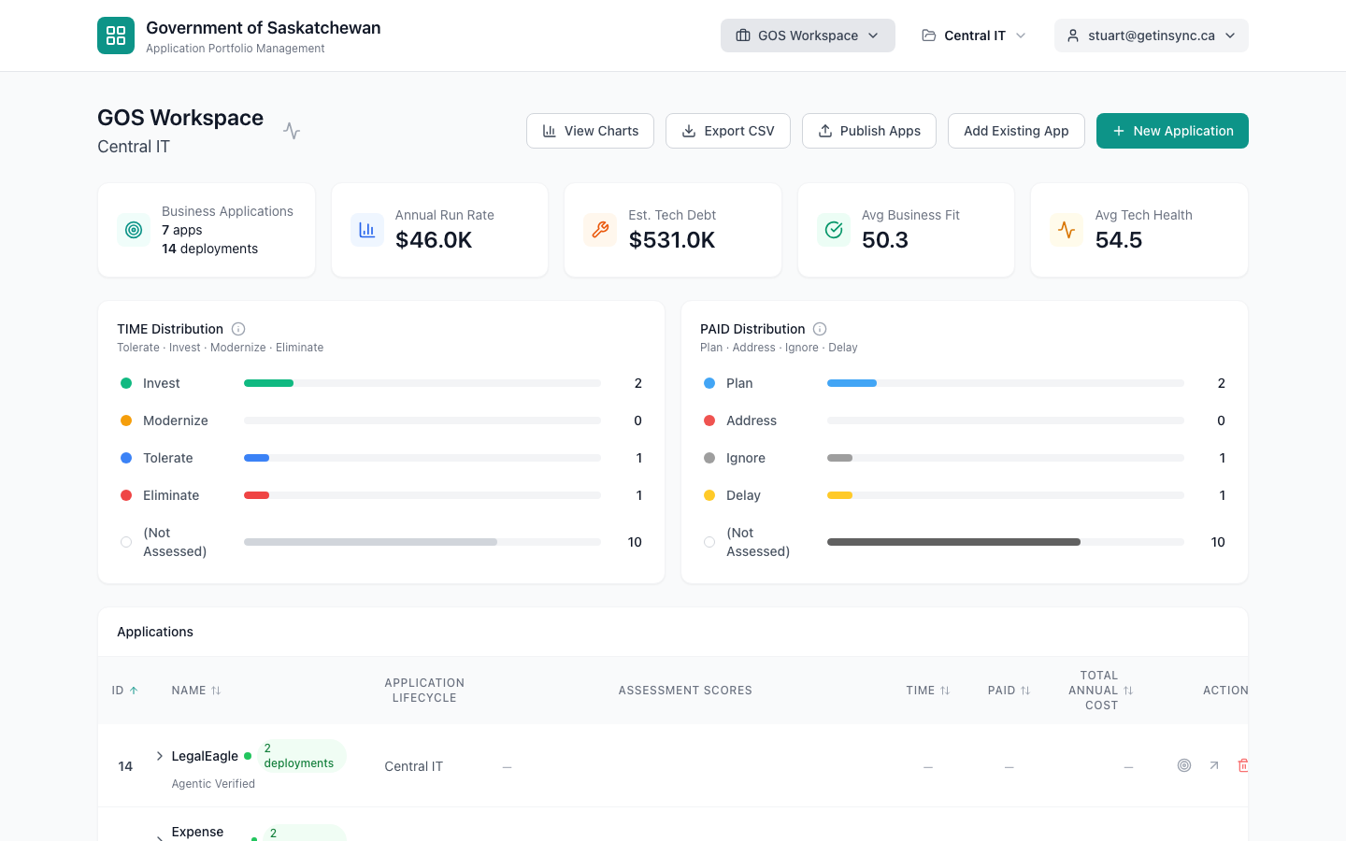
Portfolio dashboard with KPIs, TIME/PAID distribution, and application list

What You're Looking At
KPI Bar — Across the top, five summary metrics give you the portfolio pulse: total applications and deployments, annual run rate, estimated technical debt, average business fit score, and average technology health score.
TIME Distribution — Shows how your applications score on the Tolerate/Invest/Modernize/Eliminate framework. This tells you at a glance what proportion of your portfolio needs action.
PAID Distribution — The complementary business-action view: Plan/Address/Ignore/Delay. Together with TIME, these two charts answer "what condition are we in?" and "what are we doing about it?"
TIP: Use the workspace selector in the header to switch between departments. Each workspace is isolated — users only see what they have access to.

Stop 2: Applications List
Below the dashboard charts, you'll find the full applications table. This is your portfolio inventory — every application with its assessment scores, TIME/PAID recommendations, and total annual cost at a glance.
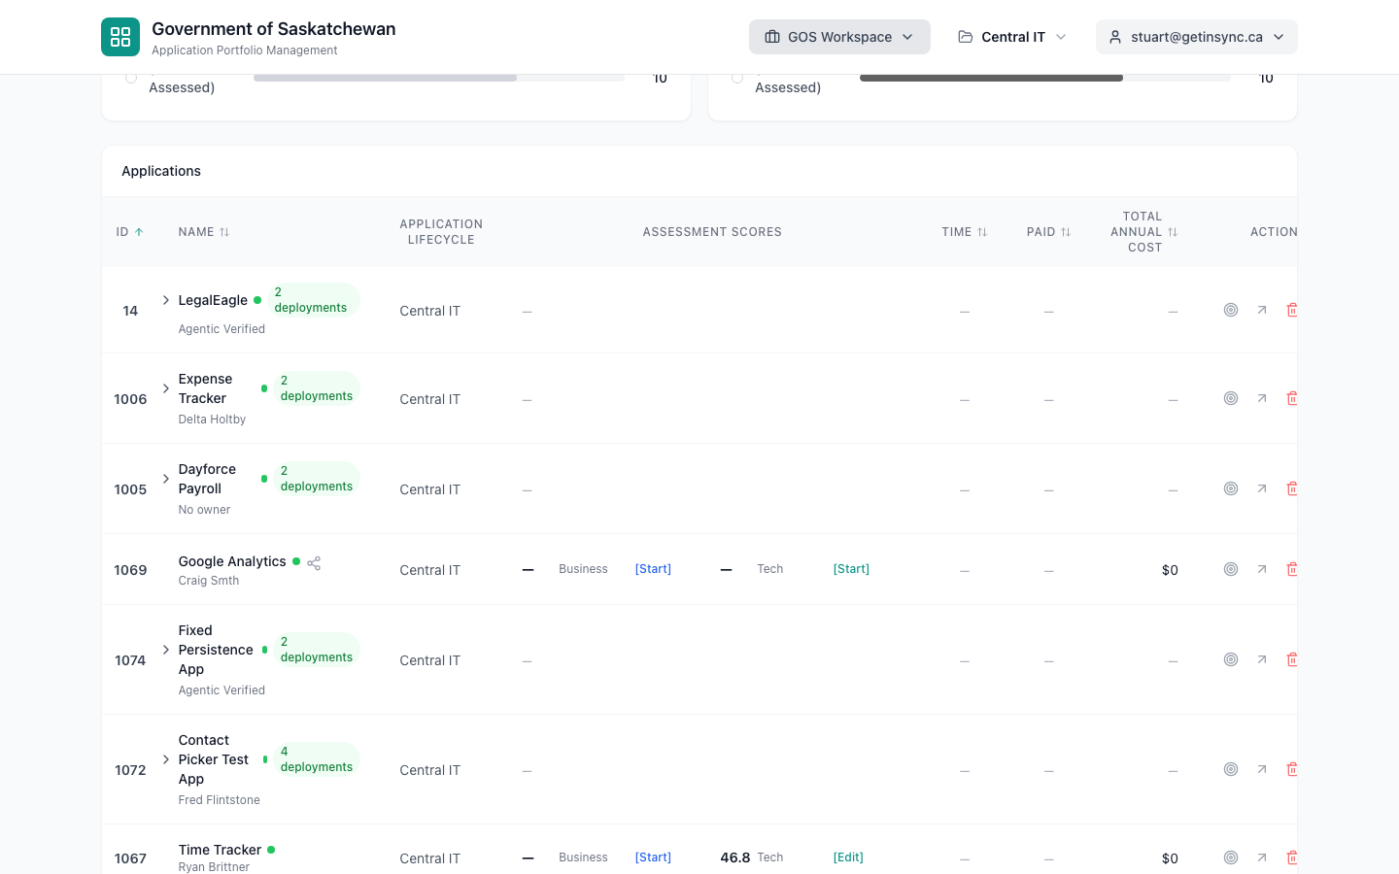
Applications table with scores, TIME/PAID badges, and costs

Key Columns
- Name — The application name, owner, and deployment count
- Application Lifecycle — Which portfolio this application belongs to
- Assessment Scores — Business fit and technical health scores with quick-edit links
- TIME / PAID — Color-coded badges showing the assessment recommendation
- Total Annual Cost — Rolled up from all cost channels across all deployments
TIP: Click "View Charts" to see visual analytics. Click "Export CSV" to download the full portfolio for offline analysis or board reporting.

Stop 3: Application Detail
Click "View Details" on any application to open its full profile. The application detail page is organized into tabs: General, Deployments, Costs, Integrations, Visual, and Assessment.
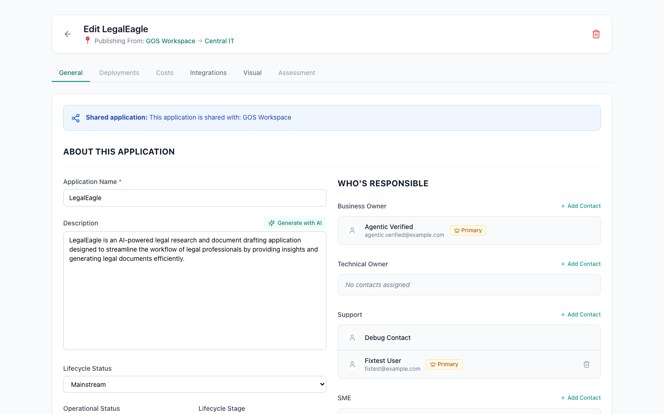
Application detail — General tab with ownership and deployment profiles

General Tab
The General tab shows the application's identity and ownership:
- Name, description (with AI generation), lifecycle status, and operational status
- Contact roles: Business Owner, Technical Owner, Support, and Subject Matter Expert
- Deployment profiles listed at the bottom — each representing a distinct environment (Production, Development, DR) with its own assessment and cost data
TIP: The "Generate with AI" button on the description field uses AI to create a concise application description from the application name and metadata.

Stop 4: Deployment Profile
Click on a deployment profile to expand it. This is the atomic unit of assessment and cost in GetInSync — because the same application deployed in Production vs. Development has fundamentally different risk, cost, and ownership characteristics.
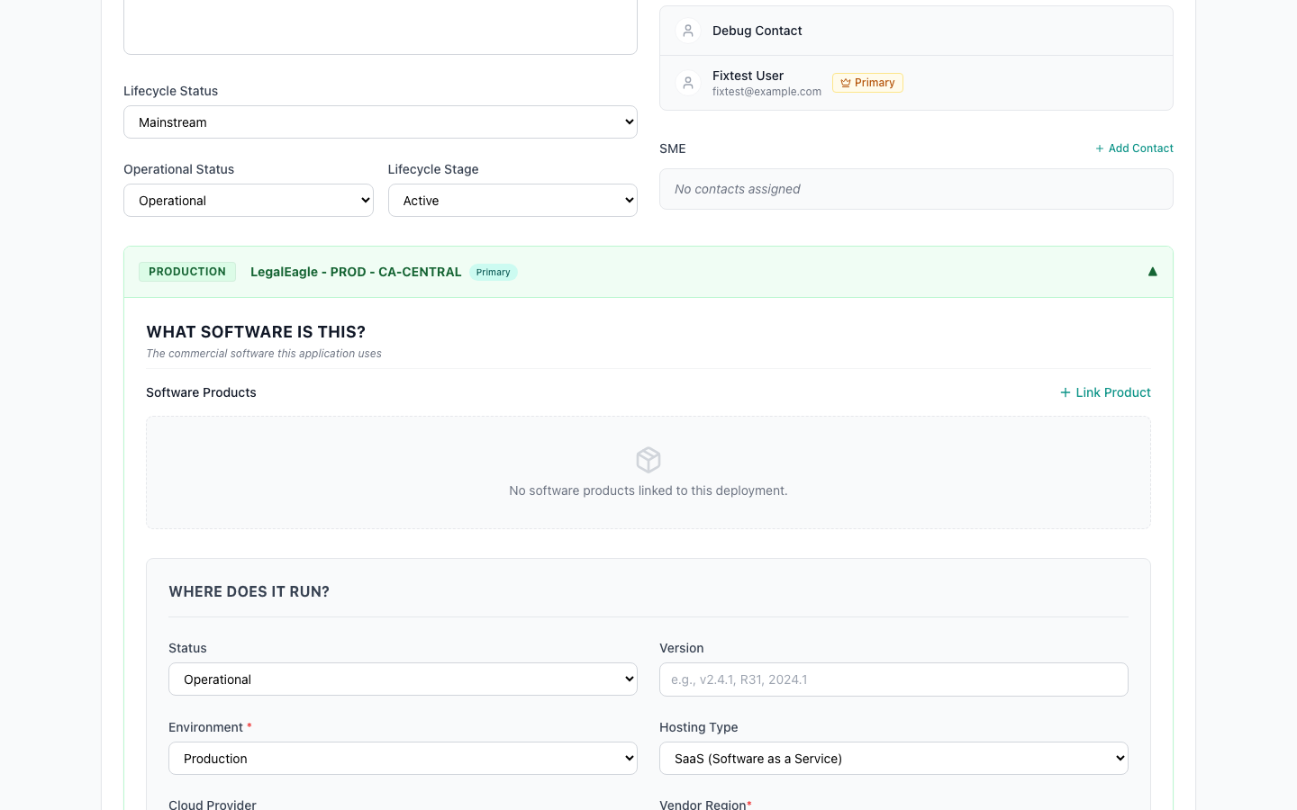
Deployment profile — software products linked to this deployment

Software Products
Each deployment can be linked to the software products it runs on. In this example, the Hexagon OnCall CAD/RMS production deployment uses Oracle Database, VMware vSphere, and Commvault. These links power the Technology Health dashboard — when Oracle announces an end-of-life date, every affected deployment surfaces automatically.
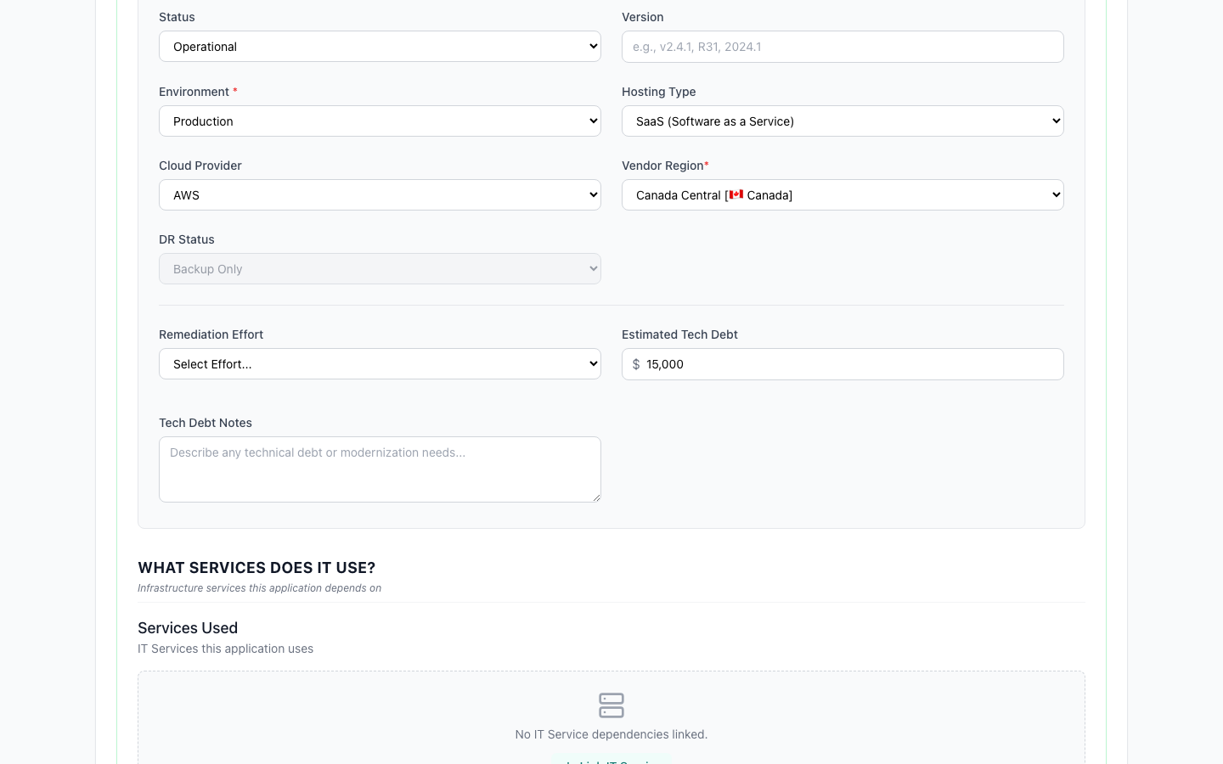
Deployment profile — hosting, cloud provider, region, and tech debt

Hosting & Technical Debt
The "Where Does It Run?" section captures hosting type, cloud provider, region, environment, and DR status. Below that, remediation effort (t-shirt sizing) and estimated technical debt give you the financial picture of deferred maintenance.
TIP: Technical debt notes are free-text — use them to capture specific remediation items (e.g., "Windows Server 2012 EOL, Oracle 11g upgrade required").

Stop 5: Technology Health Dashboard
Navigate to Technology Health from the main menu. This dashboard replaces the spreadsheets your team maintains to track technology lifecycle status across the portfolio.
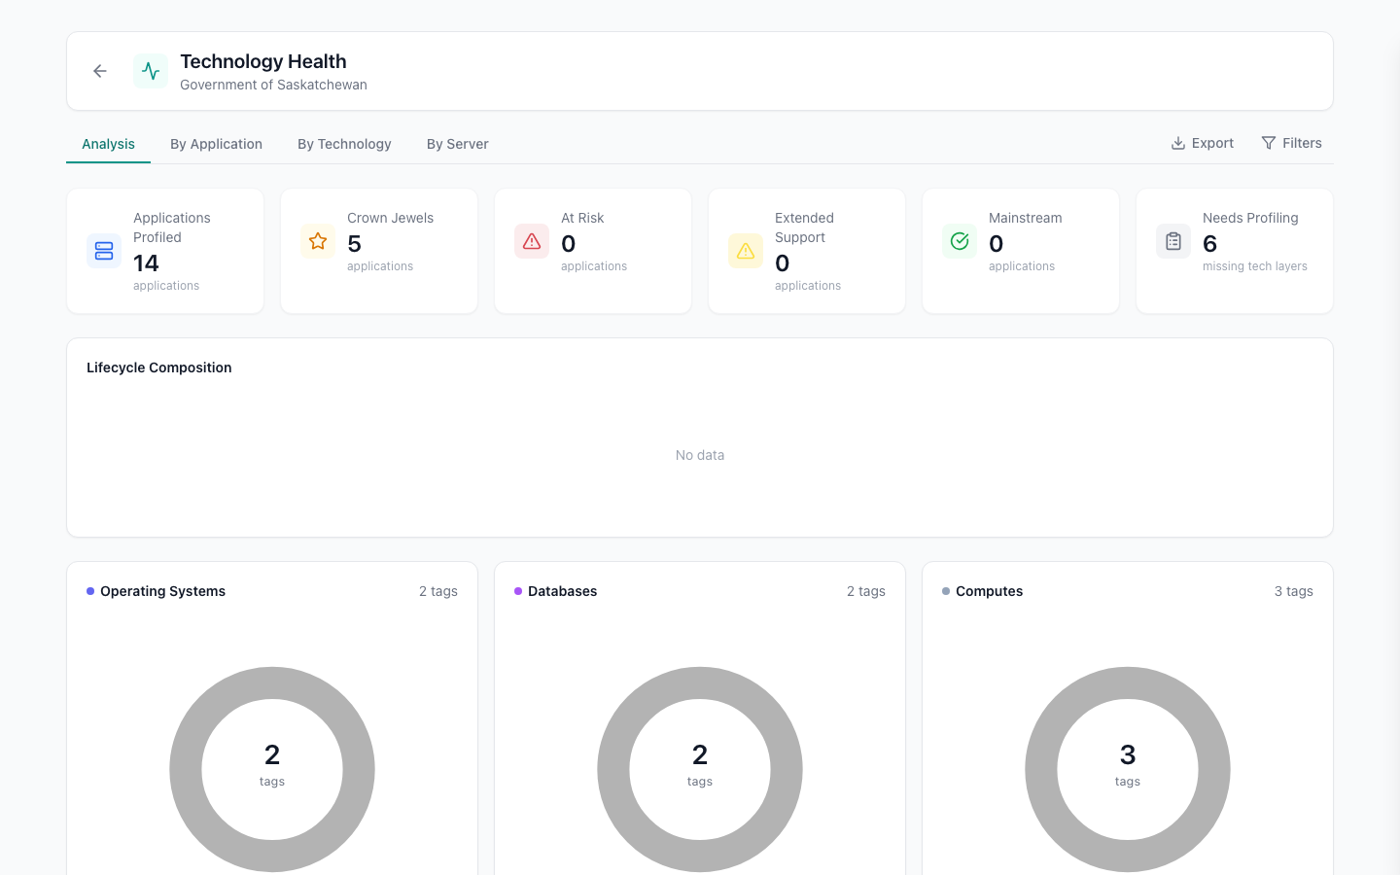
Technology Health dashboard — lifecycle KPIs, composition, and breakdown by category

What You're Looking At
KPI Bar — Applications profiled, crown jewels (your most critical apps), at-risk count, extended support, mainstream, and those needing profiling.
Lifecycle Composition — Stacked bars showing the distribution of technology across End of Support (red), Extended Support (yellow), and Mainstream (green), broken down by Operating System, Database, and Web Server.
Category Donuts — Operating Systems, Databases, and Web Servers each get a donut chart showing the lifecycle breakdown. In this demo, 71% of OS tags are in Extended Support — a clear signal that upgrades are needed.
Risk Alert — "13 Applications at Risk in 12 months" — click to expand and see exactly which applications are affected and what technology is driving the risk.
TIP: Switch between Analysis, By Application, By Technology, and By Server tabs to slice the data from different angles. Use Filters to narrow by workspace.

Stop 6: IT Value Creation
This is where GetInSync goes beyond traditional APM. Navigate to IT Value Creation to see the findings-to-roadmap pipeline that turns assessment observations into strategic action.

Initiatives — Grid View
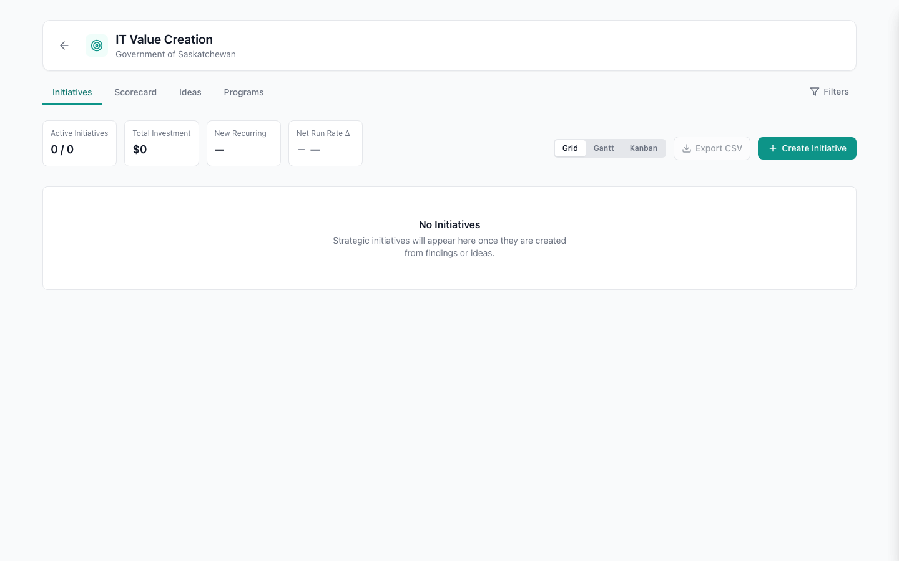
Initiatives grid — status, timeline, theme, cost, and run-rate impact
The Initiatives tab shows all strategic recommendations in a sortable table. Each initiative has:
- Status — Planned, In Progress, Identified, Completed, or On Hold
- When — Which quarter the work is targeted
- Theme — Risk, Optimize, or Growth — why this work matters
- Cost — Total investment required
- Run Rate Delta — The ongoing annual cost impact (positive = savings, negative = new spend)

Initiatives — Gantt Timeline
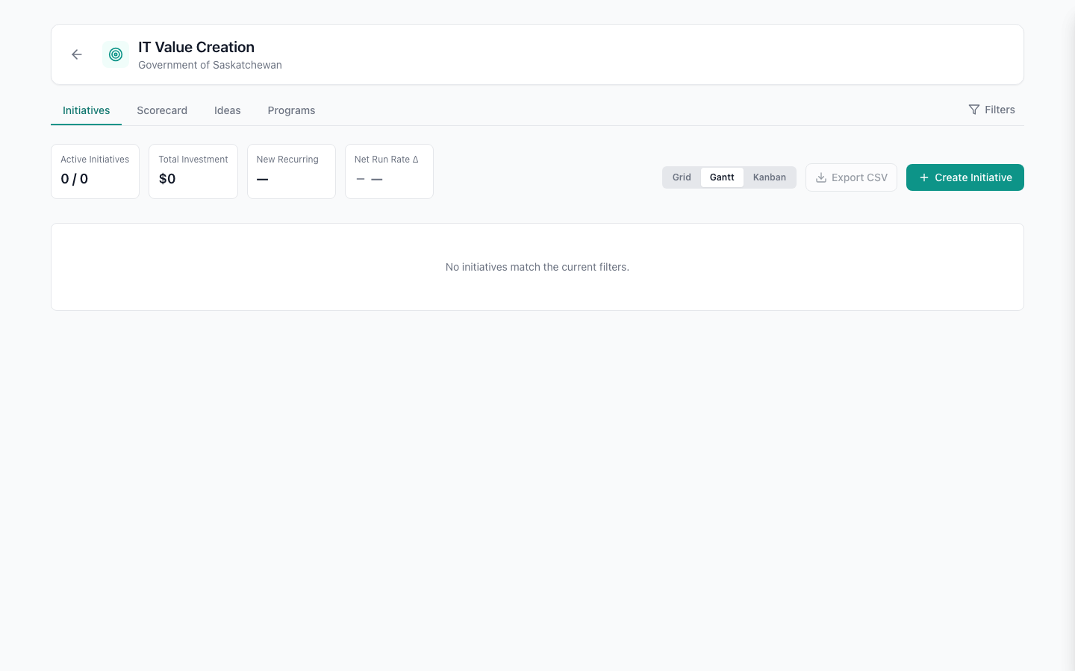
Gantt timeline — initiatives color-coded by theme with quarterly cost totals
Switch to Gantt view for a visual timeline. Initiatives are color-coded by theme (red = Risk, green = Optimize, blue = Growth) and positioned in their target quarter. Quarter totals at the bottom show investment distribution across the planning horizon.
TIP: The Gantt view supports drag-and-drop scheduling — drag an initiative to a different quarter to explore what-if scenarios.

Stop 7: Findings Scorecard
Click the Scorecard tab to see assessment findings organized by domain. These are the observations that drive initiative creation.
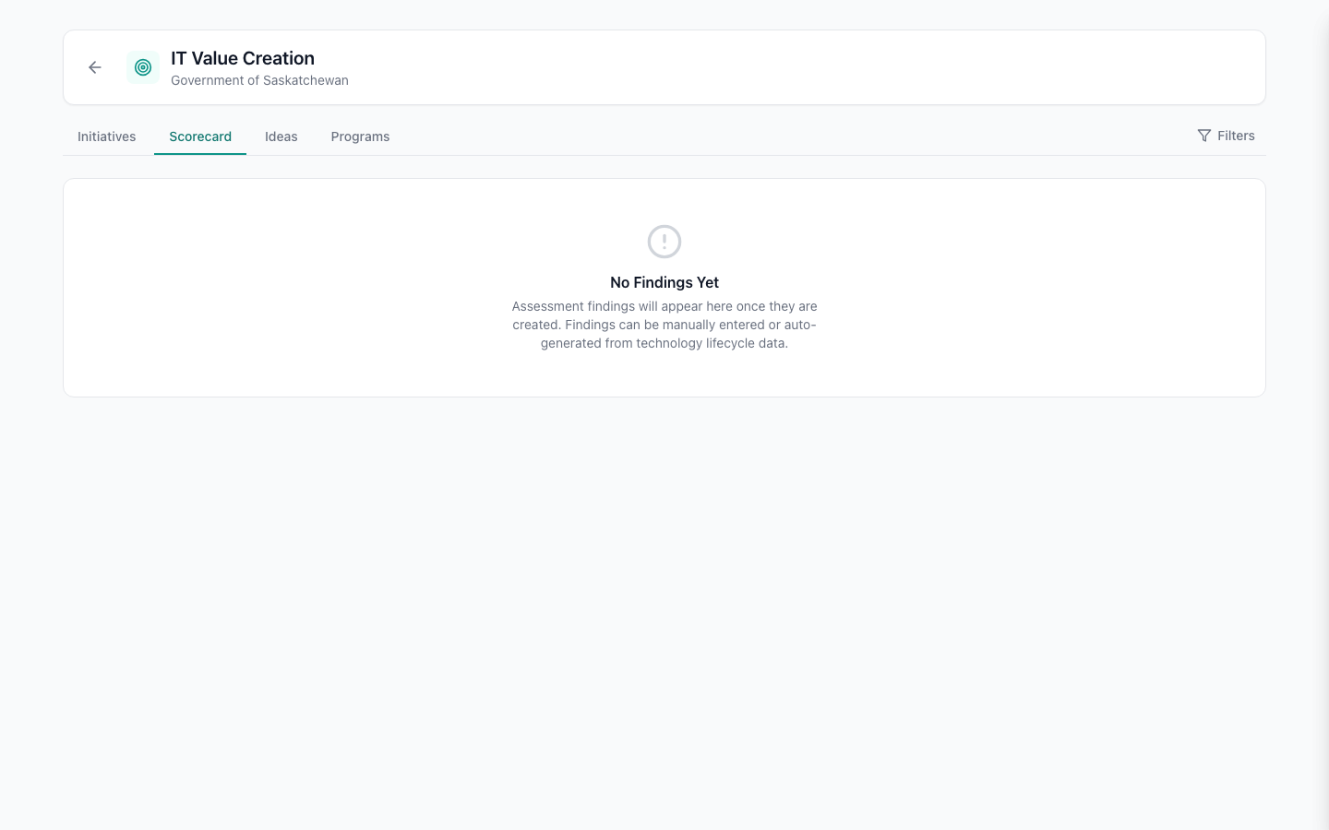
Findings scorecard — 8 findings across 5 domains with severity levels
Each domain card shows the number of findings, severity (high/medium/low), impact distribution bar, and whether findings were manually entered or auto-detected from Technology Health data. Click any card to drill into the individual findings.
TIP: Technology Infrastructure findings are auto-generated from your Technology Health data. When a technology approaches end-of-life, a finding is created automatically — no manual entry needed.

Stop 8: Ideas & Programs

Ideas — Bottom-Up Intake
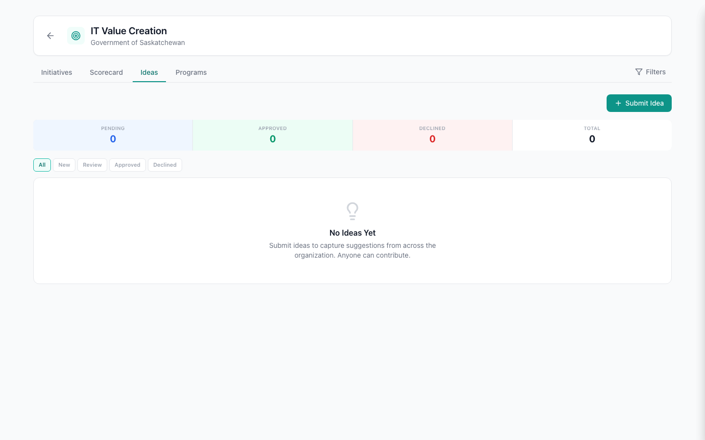
Ideas tab — crowd-sourced suggestions from across the organization
The Ideas tab is the crowd-sourced intake channel. Anyone in the organization can submit an idea — "We should consolidate our three HR systems" or "The payroll batch job takes 6 hours and should be modernized." Reviewers assess ideas and can promote them to full initiatives.

Programs — Strategic Grouping
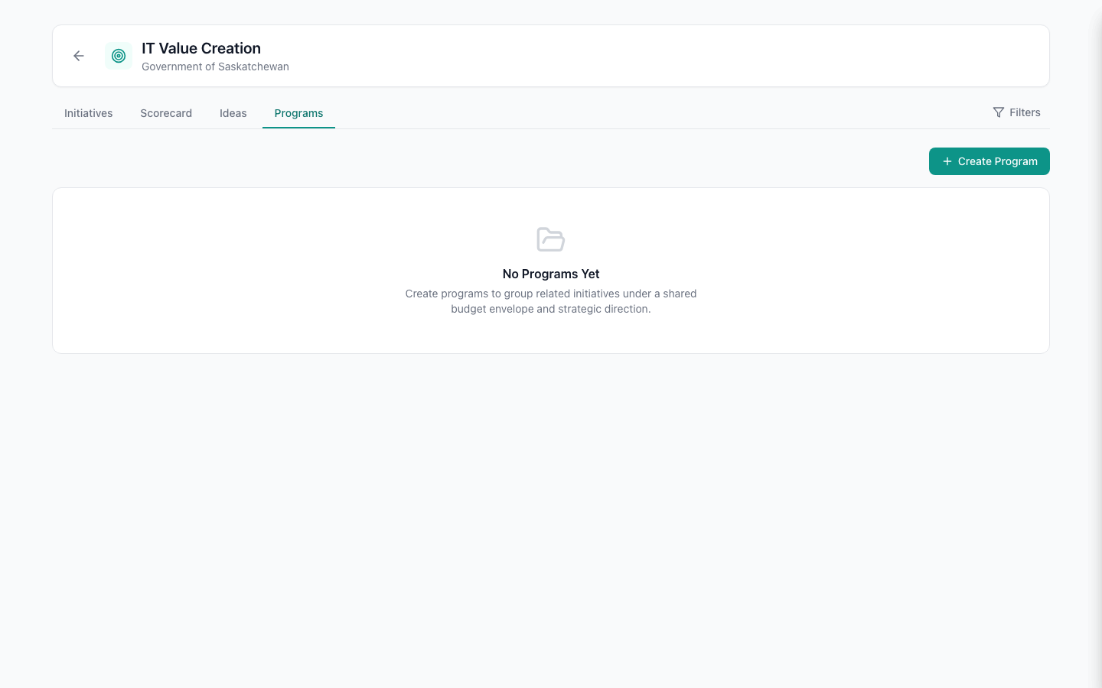
Programs tab — strategic groupings with budget envelopes
Programs group related initiatives under a strategic umbrella with a budget envelope and business driver. For example, a "Technology Debt Remediation" program might contain the SQL Server migration, Oracle upgrade, and Windows Server modernization initiatives.

What to Explore Next
This guide covers the main workflow: Inventory → Assess → Discover Health → Plan Action. Here are additional features to explore in your trial:
- Cost Management — See how cost flows from contracts and IT services to deployments, with automatic stranded-cost detection.
- Integration Mapping — Map upstream and downstream dependencies between applications with criticality, frequency, and data sensitivity.
- Multi-Workspace — Use the workspace selector to switch between departments. Each workspace is fully isolated with its own roles and data.
- Shared Catalog — Browse applications shared by other workspaces through the federated catalog.
- Export & Reporting — Download portfolio data as CSV for board reporting or further analysis.

Need Help?
We're here to help you get the most from your trial. Whether you want a guided walkthrough with your own data, help configuring workspaces for your organization, or a deeper dive into any feature — reach out.
- Platform: nextgen.getinsync.ca
- Website: getinsync.ca

GetInSync NextGen — Demo Guide — February 2026

