Study1

Dr. Gemini

2025-07-26

# Abstract

This is the abstract for Study1. It summarizes the key findings of the report.

# Introduction

This is the introduction for Study1.

# 

# Results

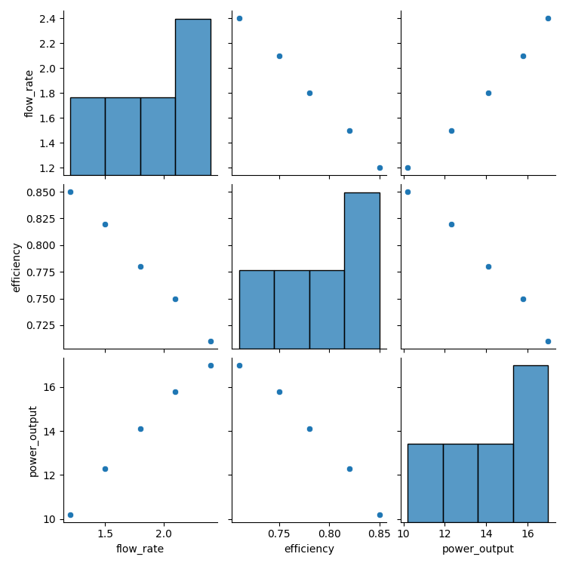

## Performance Metrics

The key performance indicators are as follows:

* Average Flow Rate: 1.8 m³/s

* Maximum Efficiency: 85.0%

* Calculated Power Output: 13.88 kW

The results indicate a strong correlation between flow rate and power output. The efficiency peaks at a flow rate of 1.8 m³/s.

# Discussion

This is the discussion for Study1.

Conclusion  
This is the conclusion for Study1.