Study2

Dr. Gemini

2025-07-26

# Abstract

This is the abstract for Study2. This study explores alternative bucket designs.

# Introduction

This is the introduction for Study2.

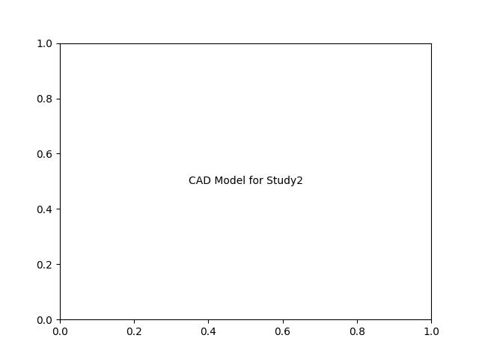

# Results

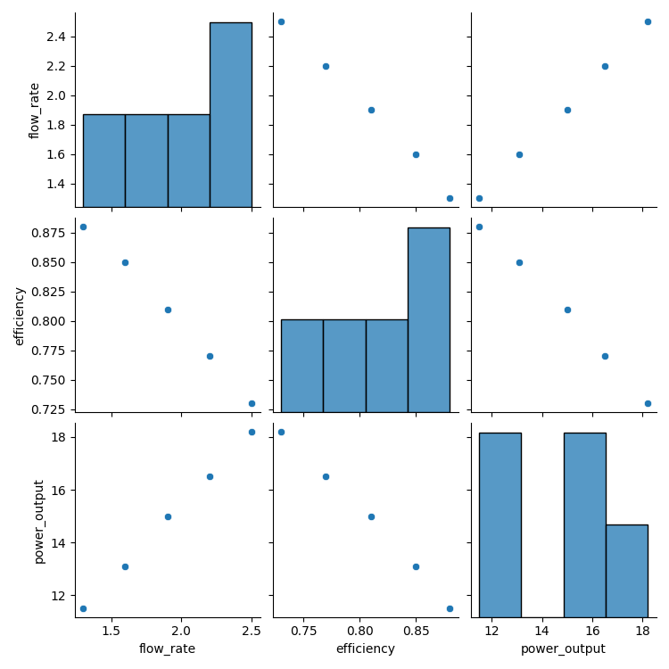

## Performance Metrics

The key performance indicators are as follows:

* Average Flow Rate: 1.9 m³/s

* Maximum Efficiency: 88.0%

* Calculated Power Output: 14.86 kW

The results from Study2 show a marked improvement in efficiency with the new bucket design.

# Discussion

This is the discussion for Study2.

Conclusion  
This is the conclusion for Study2.