**MICROSERVICES**

* **Creating Microservices for account and loan**

**🡺**solution:

Account.java

package com.cognizant.account.model;

public class Account {

private String number;

private String type;

private int balance;

public Account(String number, String type, int balance) {

this.number = number;

this.type = type;

this.balance = balance;

}

public String getNumber() {

return number;

}

public void setNumber(String number) {

this.number = number;

}

public String getType() {

return type;

}

public void setType(String type) {

this.type = type;

}

public int getBalance() {

return balance;

}

public void setBalance(int balance) {

this.balance = balance;

}

}

AccountController.java

package com.cognizant.account.controller;

import org.springframework.web.bind.annotation.GetMapping;

import org.springframework.web.bind.annotation.PathVariable;

import org.springframework.web.bind.annotation.RestController;

import com.cognizant.account.model.Account;

@RestController

public class AccountController {

@GetMapping("/accounts/{number}")

public Account getAccountDetails(@PathVariable String number) {

return new Account(number, "savings", 234343);

}

}

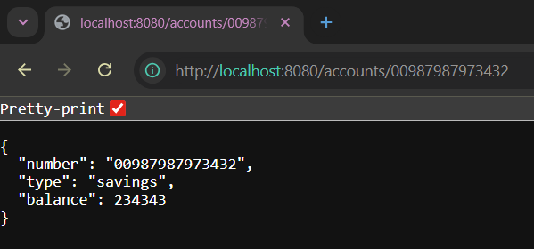

Loan.java

package com.cognizant.loan.model;

public class Loan {

private String number;

private String type;

private int loan;

private int emi;

private int tenure;

public Loan(String number, String type, int loan, int emi, int tenure) {

this.number = number;

this.type = type;

this.loan = loan;

this.emi = emi;

this.tenure = tenure;

}

public String getNumber() {

return number;

}

public void setNumber(String number) {

this.number = number;

}

public String getType() {

return type;

}

public void setType(String type) {

this.type = type;

}

public int getLoan() {

return loan;

}

public void setLoan(int loan) {

this.loan = loan;

}

public int getEmi() {

return emi;

}

public void setEmi(int emi) {

this.emi = emi;

}

public int getTenure() {

return tenure;

}

public void setTenure(int tenure) {

this.tenure = tenure;

}

}

LoanController.java

package com.cognizant.loan.controller;

import org.springframework.web.bind.annotation.GetMapping;

import org.springframework.web.bind.annotation.PathVariable;

import org.springframework.web.bind.annotation.RestController;

import com.cognizant.loan.model.Loan;

@RestController

public class LoanController {

@GetMapping("loans/{number}")

public Loan getLoanDetails(@PathVariable String number) {

return new Loan(number, "car", 400000, 3258, 18);

}

}

