**React-js(wk-06)**

***1st HandsON***

* **Set up a react environment**
* **Use create-react-app**

**=>solution:**

$ npx create-react-app myfirstreact

$ cd myfirstreact

$ npm start

App.js

function App() {

  return (

    <h1>Welcome to the first session of react.</h1>

  );

}

export default App;

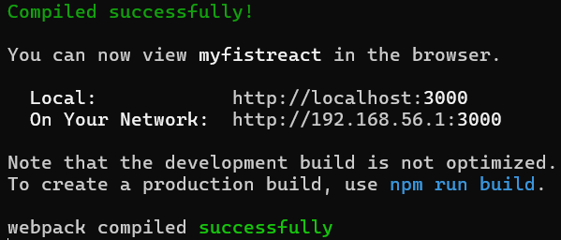

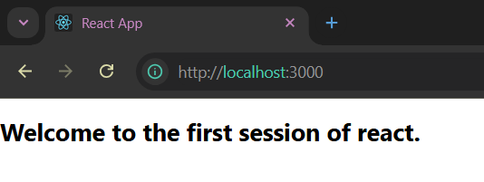

***2nd HandsOn***

* **Create a class component**
* **Create multiple components**
* **Render a component**

**=>solution:**

App.js

import './App.css';

import About from './components/About';

import Contact from './components/Contact';

import Home from './components/Home';

function App() {

  return (

    <div className="App">

      <Home/>

      <About/>

      <Contact/>

    </div>

  );

}

export default App;

Home.js

function Home(){

    return(

        <h1>Welcome to Home Page of Student Management Portal</h1>

    )

}

export default Home;

About.js

function About() {

  return <h1>Welcome to About Page of Student Management Portal</h1>

}

export default About

Contact.js

function Contact() {

  return <h1>Welcome to Contact Page of Student Management Portal</h1>

}

export default Contact

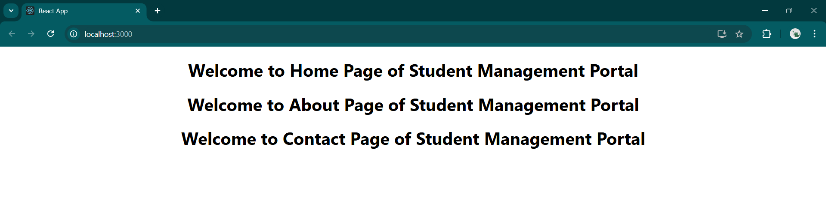

------------------------------------------------------------------------------------------------------------------------------------

***3rd HandsOn***

* **Create a react app for Student Management Portal named scorecalculatorapp and create a function component named “CalculateScore” which will accept Name, School, Total and goal in order to calculate the average score of a student and display the same**

**=>solution:**

CalculateScore.js

import '../Stylesheets/mystyle.css';

const percentToDec = (decimal) => {

    return decimal.toFixed(2) + '%';

}

const calcScore = (total, goal) => {

    return percentToDec(total/goal);

}

export const CalculateScore = ({name, school, total, goal}) =>(

    <div className="formatstyle">

      <h1>

        <font color="Brown">Student Details:</font>

      </h1>

      <div className="Name">

        <b>

          <span>Name: </span>

        </b>

        <span>{name}</span>

      </div>

      <div className="School">

        <b>

          <span>School: </span>

        </b>

        <span>{school}</span>

      </div>

      <div className="Total">

        <b>

          <span>Total: </span>

        </b>

        <span>{total} </span>

        <span>Marks</span>

      </div>

      <div className="Score">

        <b>Score:</b>

        <span>

            {calcScore(total,goal)}

        </span>

      </div>

    </div>

);

mystyle.css

.Name{

    font-weight:300;

    color:blue;

}

.School{

    color:crimson;

}

.Total{

    color:darkmagenta;

}

.formatstyle{

    text-align: center;

    font-size: large;

}

.Score{

    color:forestgreen;

}

App.js

import { CalculateScore } from "./Component/CalculateScore";

function App() {

  return (

    <div className="App">

      <CalculateScore name="Steeve" school="DNV Public Scool" total={284} goal={3}/>

    </div>

  );

}

export default App;

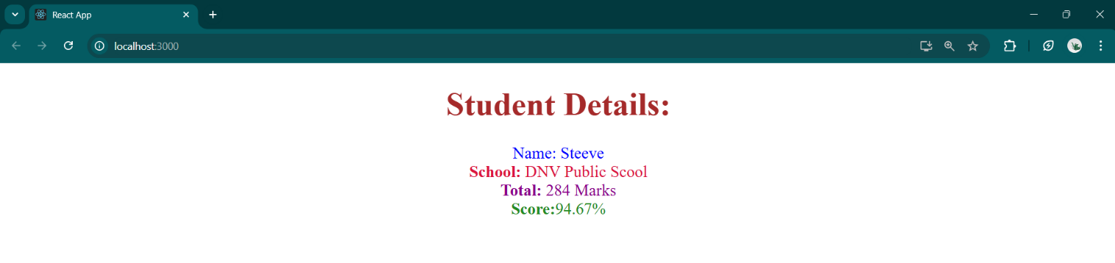

------------------------------------------------------------------------------------------------------------------------------------

**HandsOn-4**

* **Implement componentDidMount() hook**
* **Implementing componentDidCatch() life cycle hook.**

🡺 solution:

Posts.js

import React, { Component } from 'react';

import Post from './Post';

class Posts extends Component {

    constructor(props) {

        super(props);

        this.state = {

            posts: []

        };

    }

    loadPosts() {

        fetch('https://jsonplaceholder.typicode.com/posts')

            .then(response => response.json())

            .then(data => {

                const posts = data.map(postData =>

                    new Post(postData.id, postData.title, postData.body)

                );

                this.setState({ posts: posts });

            })

            .catch(error => {

                console.error('Error: ', error);

                throw error;

            });

    }

    componentDidMount() {

        console.log('calling loadPosts()');

        this.loadPosts();

    }

    componentDidCatch(error, errorInfo) {

        console.error('Error: ', error, errorInfo);

        alert(`error: ${error.message}`);

    }

    render() {

        const { posts } = this.state;

        return (

            <div>

                <h1>Blog Posts</h1>

                {posts.map(post => (

                    <div key={post.id}>

                        <h2>{post.title}</h2>

                        <p>{post.body}</p>

                    </div>

                ))}

            </div>

        );

    }

}

export default Posts;

Post.js

class Post {

    constructor(id, title, body) {

        this.id = id;

        this.title = title;

        this.body = body;

    }

}

export default Post;

App.js

import './App.css';

import Posts from './Posts';

function App() {

  return (

    <div>

      <header>

        <h1 style={{textDecoration:"underline"}}>React Component Lifecycle Demo</h1>

        <Posts />

      </header>

    </div>

  );

}

export default App;

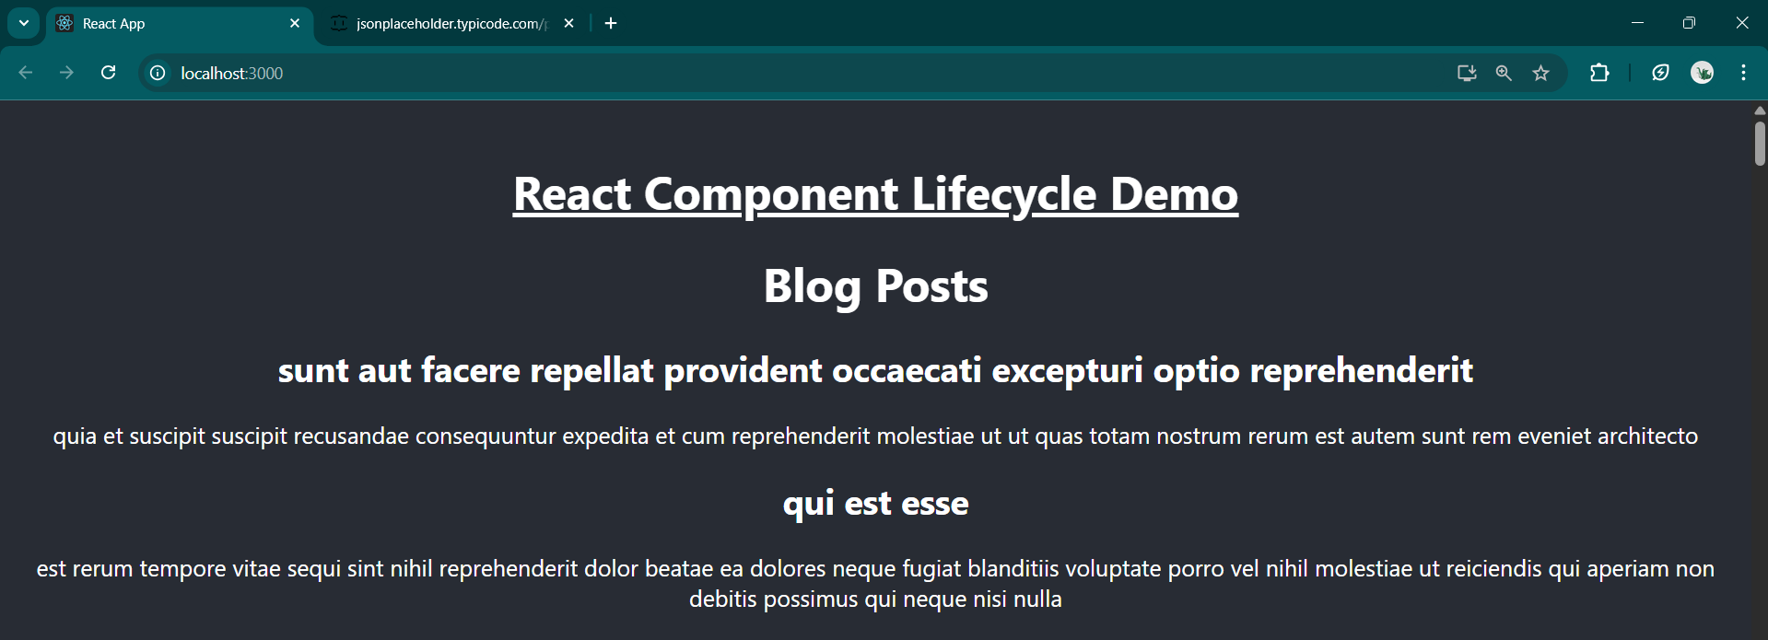

**HandsOn-5**

* **Style a react component**
* **Define styles using the CSS Module**
* **Apply styles to components using className and style properties**

**🡺solution**

CohortDetails.module.css

.box {

  width: 300px;

  display: inline-block;

  margin: 10px;

  padding: 10px 20px;

  border: 1px solid black;

  border-radius: 10px;

}

dt {

  font-weight: 500;

}

CohortDetails.js

import styles from './CohortDetails.module.css'

function CohortDetails(props) {

  const h3Style = {

    color: props.cohort.currentStatus === 'Ongoing' ? 'green' : 'blue',

  }

  return (

    <div className={styles.box}>

      <h3 style={h3Style}>

        {props.cohort.cohortCode} -<span>{props.cohort.technology}</span>

      </h3>

      <dl>

        <dt>Started On</dt>

        <dd>{props.cohort.startDate}</dd>

        <dt>Current Status</dt>

        <dd>{props.cohort.currentStatus}</dd>

        <dt>Coach</dt>

        <dd>{props.cohort.coachName}</dd>

        <dt>Trainer</dt>

        <dd>{props.cohort.trainerName}</dd>

      </dl>

    </div>

  )

}

export default CohortDetails;

App.js

import './App.css';

import { CohortsData} from './Cohort'

import CohortDetails from './CohortDetails';

function App() {

  return (

  <div>

    <h1>Cohorts Details</h1>

    {CohortsData.map(cohort => <CohortDetails cohort={cohort}/>)}

  </div>

  );

}

export default App;

