# Interpolación Simple

**Matlab**

InterpolacionSimple.m

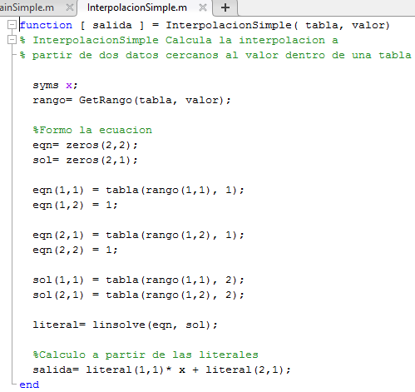

GetRango.m

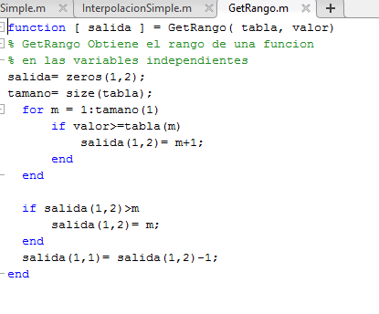

InterpolacionSimpleCompleta.m

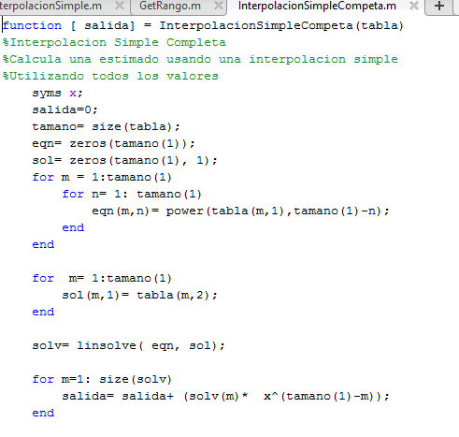

**Excel**

**Ejercicio 1**

Datos

|  |  |
| --- | --- |
| **X** | **y** |
| 1 | 1 |
| 1.5 | 1.6487 |
| 2 | 2.7182 |
| 2.5 | 7.3891 |

Polinomio propuesto:

|  |  |
| --- | --- |
| f(x)= | 4.2408x^3- 18.2420x^2+ 26.7586x^x- 11.7574 |

|  |  |
| --- | --- |
| **x** | **f(x)** |
| 1 | 1 |
| 1.5 | 1.6487 |
| 2 | 2.7182 |
| 2.5 | 7.3891 |

Grafica.

**Matlab**

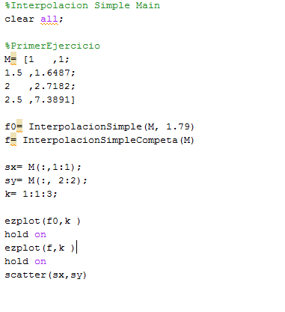

**Ejecución**

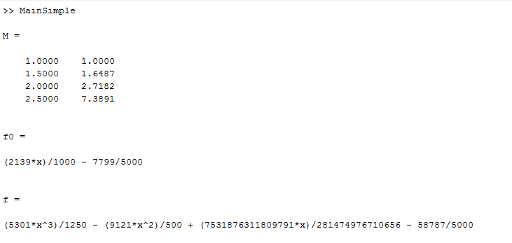

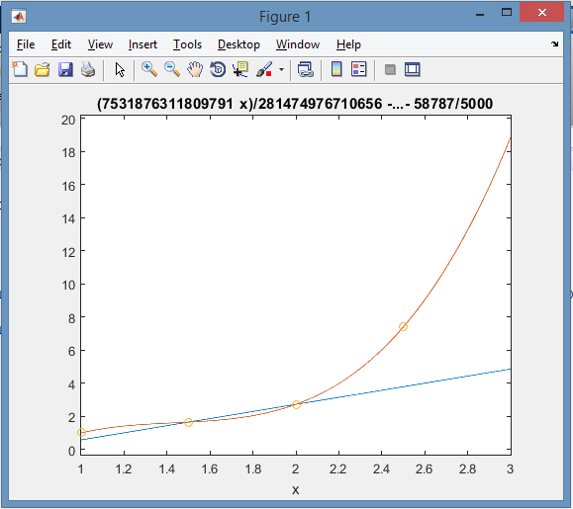

**Ejercicio 2**

|  |  |
| --- | --- |
| **x** | **y** |
| 1 | 63 |
| 2 | 75 |
| 4 | 97 |
| 8 | 128 |

Polinomio propuesto:

|  |  |
| --- | --- |
| f(x)= | (-0.0298x^3)- .125 x^2+ 12.583x + 50.571 |

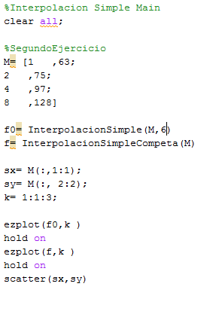

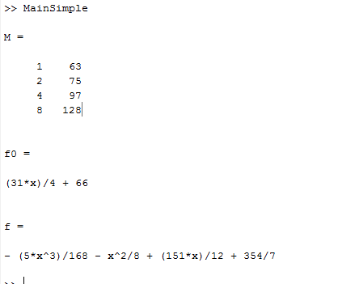

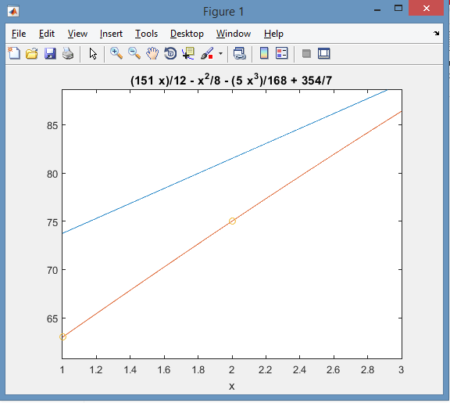

**Practica 3**

|  |  |
| --- | --- |
| **x** | **y** |
| 14 | 68.7 |
| 17 | 64.2 |
| 31 | 44.1 |
| 35 | 38.9 |

|  |  |
| --- | --- |
| f(x)= | 0.00017896x^3- 0.0073x^2- 1.4026x+ 89.30 |

|  |  |
| --- | --- |
| **x** | **f(x)** |
| 14 | 68.7238662 |
| 17 | 64.2253305 |
| 31 | 44.1354974 |
| 35 | 38.93941 |

**Matlab**

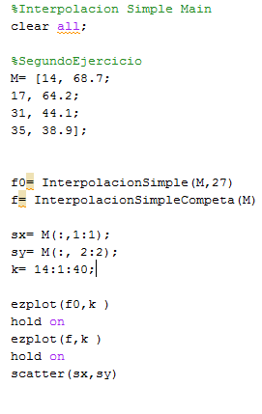

**Ejecución**

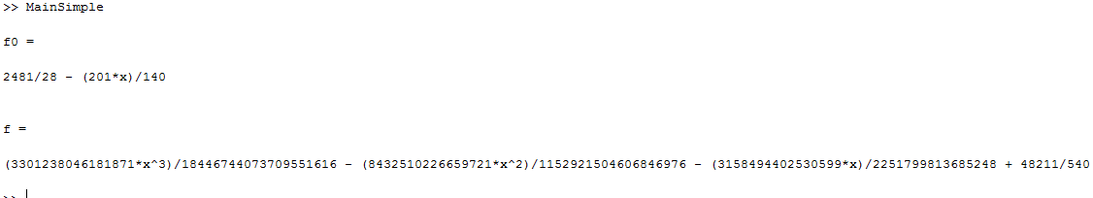

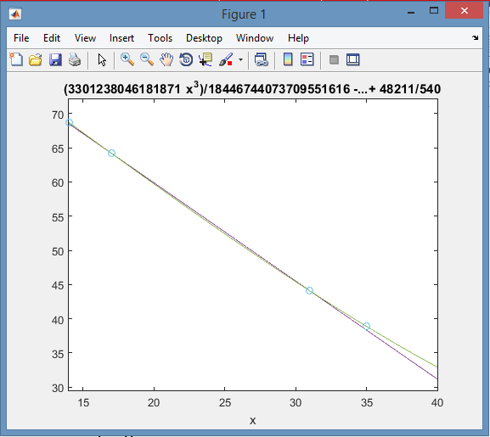

# Interpolacion Lagrange

Matlab

InterporlacionLagrange.m

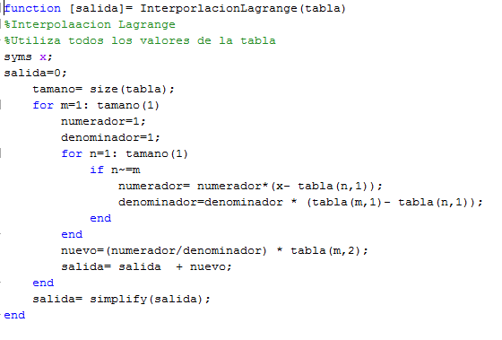

**Excel.**

|  |  |
| --- | --- |
| **X** | **y** |
| 14 | 68.7 |
| 17 | 64.2 |
| 31 | 44.1 |
| 35 | 38.9 |

Para x= 27

|  |  |  |
| --- | --- | --- |
| **X** | **y** | **Orden** |
| 14 | 68.7 | X0 |
| 17 | 64.2 | X1 |
| 31 | 44.1 | X2 |

Y= 49.6915966

Para x=53

|  |  |  |
| --- | --- | --- |
| **X** | **y** | **Orden** |
| 17 | 64.2 | X2 |
| 31 | 44.1 | X0 |
| 35 | 38.9 | X1 |

Y= 18.4857143

MatLab

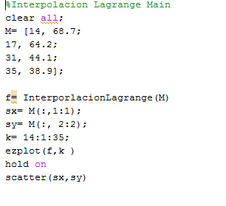

Ejecución

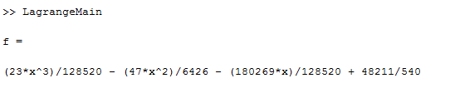

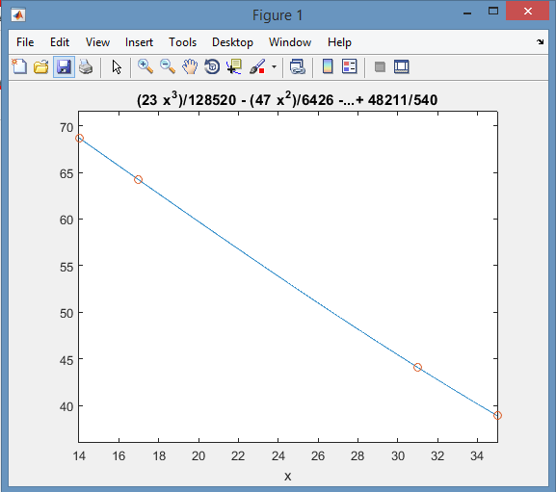

# Mínimos cuadrados

**Matlab**

InterpolacionMinimosCuadrados.m

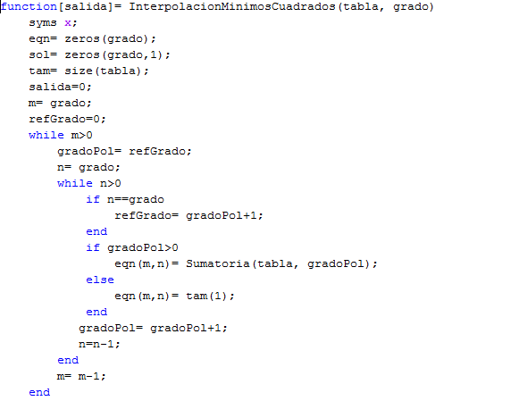

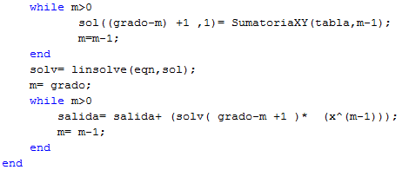

SumatoriaXY.m

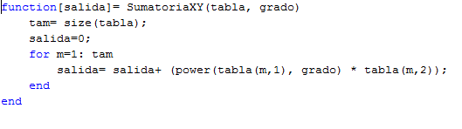

**Excel**

|  |  |  |  |  |  |  |
| --- | --- | --- | --- | --- | --- | --- |
| **x** | **y** | **x^2** | **XY** | **x^3** | **x^2 y** | **x^4** |
| -5 | 0.4 | 25 | -2 | -125 | 10 | 625 |
| -3 | -0.1 | 9 | 0.3 | -27 | -0.9 | 81 |
| -1 | -0.2 | 1 | 0.2 | -1 | -0.2 | 1 |
| 0 | -0.3 | 0 | 0 | 0 | 0 | 0 |
| 1 | -0.3 | 1 | -0.3 | 1 | -0.3 | 1 |
| 2 | 0.1 | 4 | 0.2 | 8 | 0.4 | 16 |
| 4 | 0.4 | 16 | 1.6 | 64 | 6.4 | 256 |
| -2 | 0 | 56 | 0 | -80 | 15.4 | 980 |

**Sistema propuesto.**

|  |  |  |
| --- | --- | --- |
| 980a2-80a1+56a0 | = | 15.4 |
| (-80 a2 + 56 a1 - 2 ao) | = | 0 |
| 56a2+ 2ai+7a0 | = | 0 |

**Solucion.**

**Ao= -.26**

**A1= .04**

**A2=.03**

MatLab

Ejecucion.



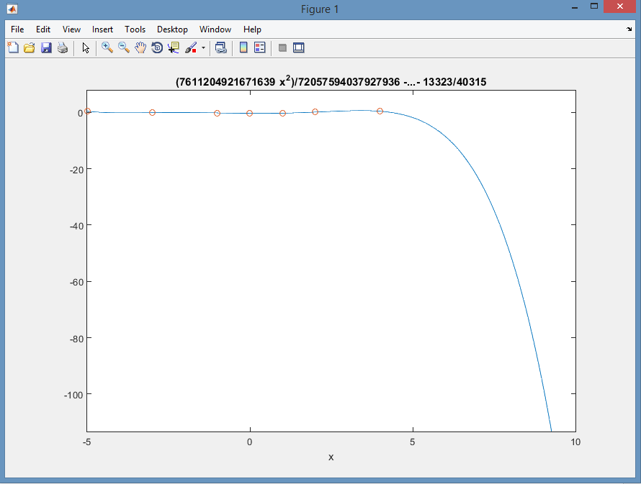

Newton

MatLab

Newtonmain.m

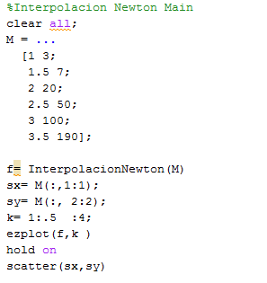

InterpolacionNewton.m

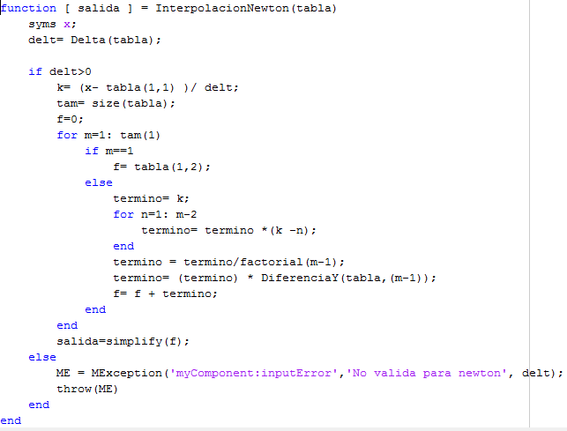

DiferenciaY.m

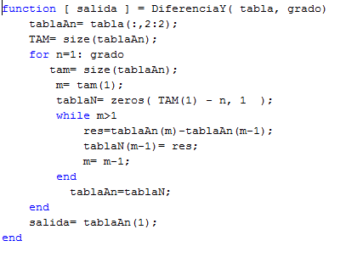

Ejecucion.

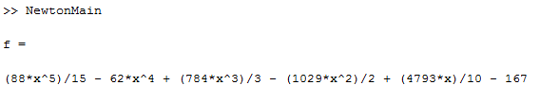

MinimosCuadradosMain.m

