**Expiriment NO: 3**

**1 pwd (Print Working Directory)**

To find out the path of the current working directory (folder) you’re in.

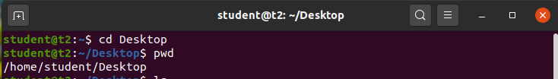

**2 history**

To review the commands you have entered before. command number to run a command from history.

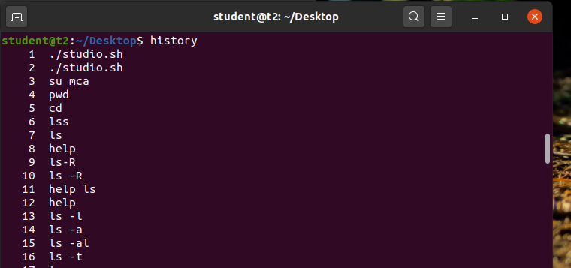

**3 man**

This will show the manual instruction of the command.

*man ls

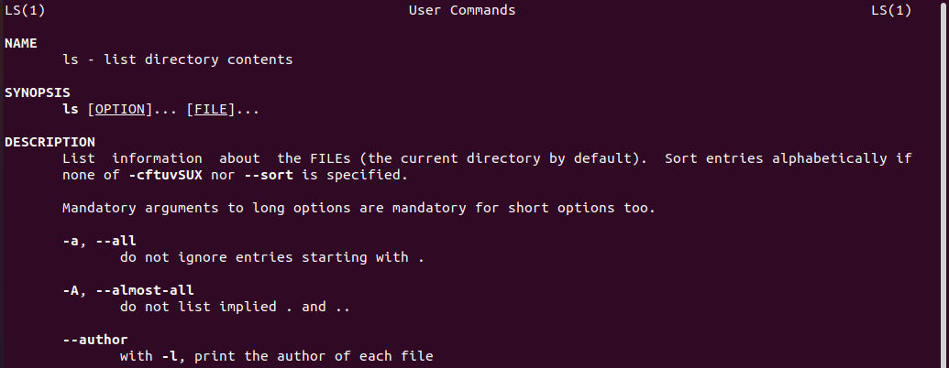

**ls**

The ls command is used to view the contents of a directory. By default, this command will display the contents of your current working directory.



**\*ls -a**

This will show the hidden files

**\*ls -R**

This will list all the files in the sub-directories as well

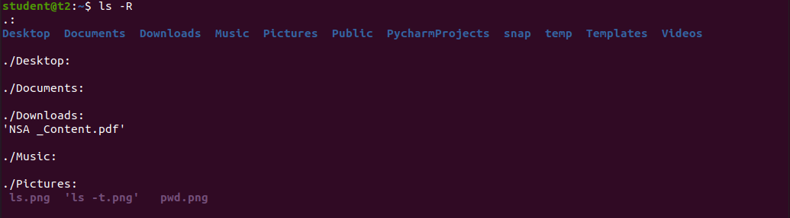

**\*ls –l (Long listing)**

This command displays the contents of the current directory in a long listing format, one per line

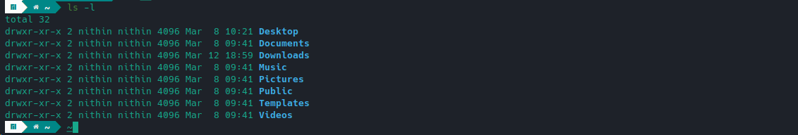

**\*ls -al**

It will list the files and directories with detailed information like the permissions, size, owner, etc.

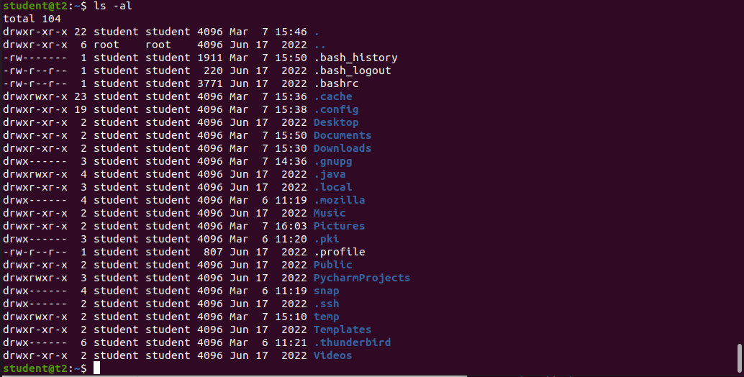

**\*ls -t**

It will lists files sorted in the order of “last modified”



**\*ls -r**

It will reverse the natural sorting order. Usually used in combination with other switches such as ls -tr. This will reverse the time-wise listing.



**touch**

The touch command allows you to create a blank new file through the Linux command line.

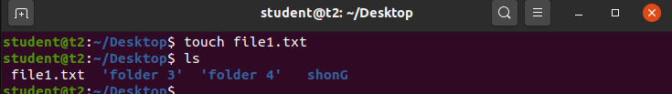

**mkdir**

Use mkdir command to make a new directory. Use the p (parents) option to create a directory in between two existing directories.

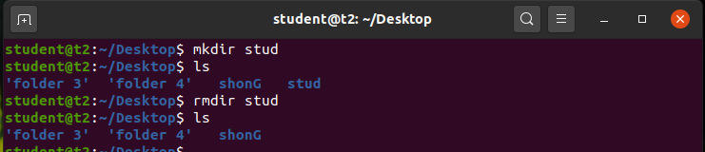

**cd**

To navigate through the Linux files and directories.

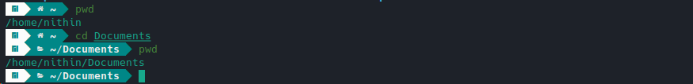

**\*cd ..** (with two dots) to move one directory up

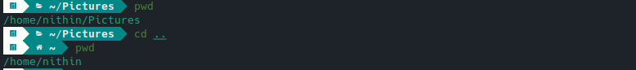

**\*cd** to go straight to the home folder

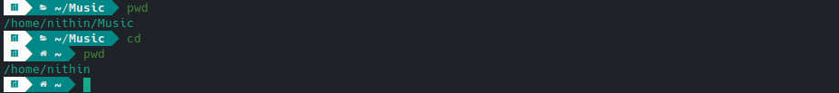

**\*cd-** (with a hyphen) to move to your previous directory

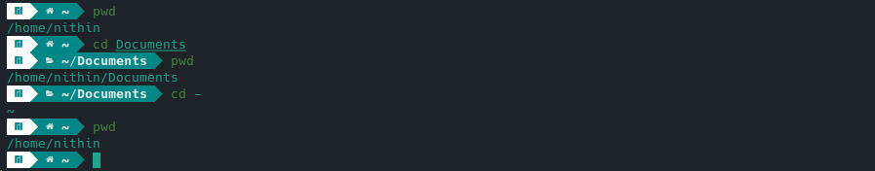

cp file1 file2

This command is used to copy files from the current directory to a different directory.

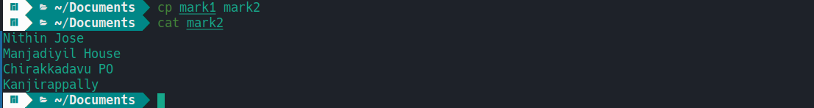

cp -r

This command will copy directories recursively.

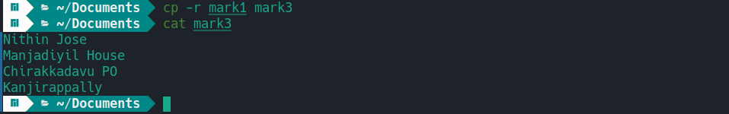

Cat >

To create a file.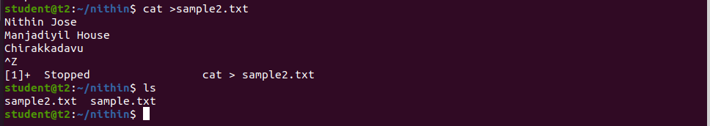

cat>>

This command will append (add something in the last of a file) something in your already existing file.

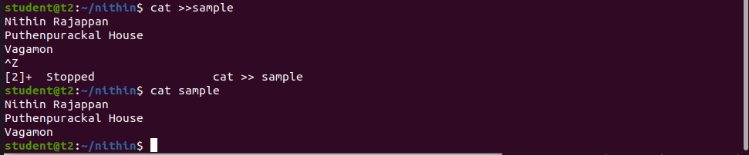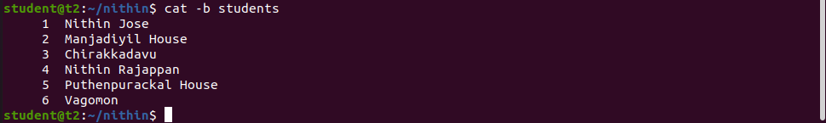

cat -e

The cat -e command displays the contents of a file with special characters and line endings shown visibly. 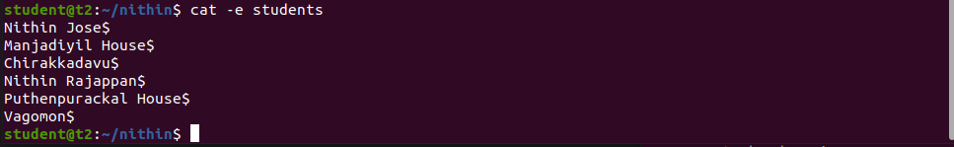

cat filename

This command will displays the contents of a file in the terminal.

cat -n

This command will display the contents of a file in the terminal, with line numbers displayed before each line. 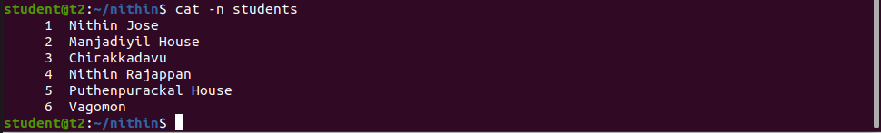

cat a b

This command displays the contents of both files in the terminal, with the contents of file "a" displayed first, followed by the contents of file "b".

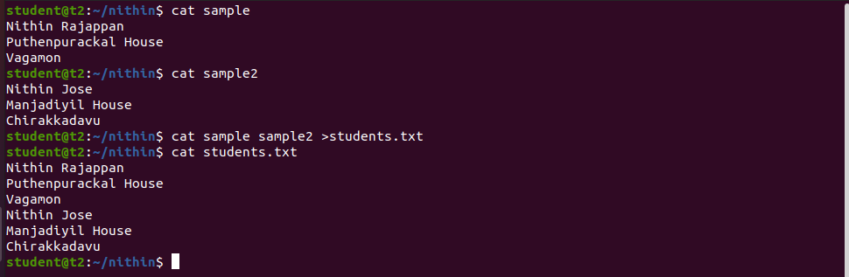

cd

This command is used to change the current working directory to a specified directory.



cut -b1

This command is used to extract the first byte or character of each line from a file or output, where "b" stands for "byte" and "1" refers to the first byte or character position.

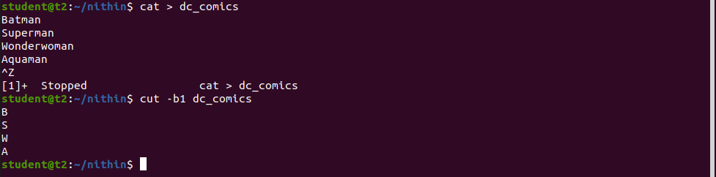

cut -b2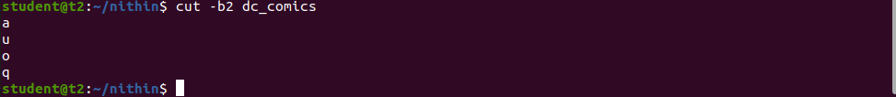

cut -c3

This command is used to extract the third character or column of each line from a file or output, where "c" stands for "character" and "3" refers to the third character or column position.

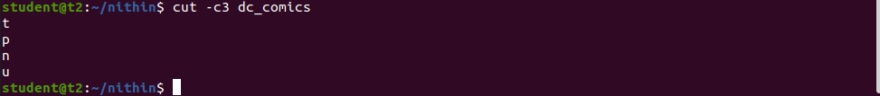

ls -b

The command "ls -b" is used to list the files and directories in a directory, displaying their names in a way that special characters are shown in a format that is suitable for printing and human-readable representation.



ls -man

The command "ls -man" is used to list the files and directories in a directory, displaying their names in a comma-separated list with information about their permissions, owner, group, size, and modification time in a human-readable format. 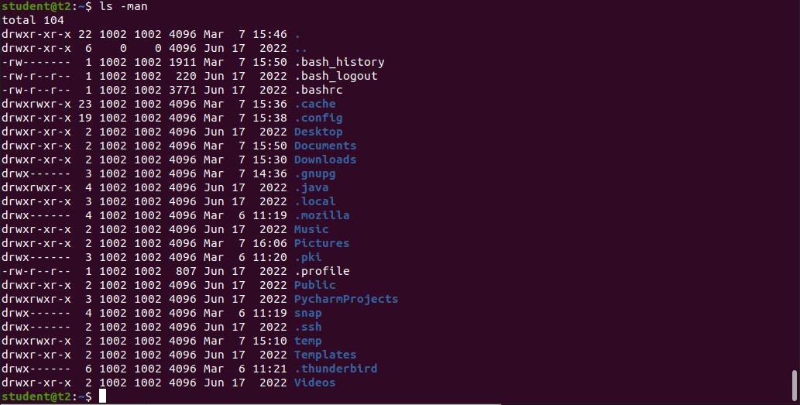

rmdir

The "rmdir" command is used to remove or delete an empty directory in a file system from the command line or terminal.



tr a-z

To convert the content into Capital Letters

