# Sahlgrenska Sjukhus

Sahlgrenska sjukhus

1. Introduction

1.1. Description

1.2. Basic requirements

1.3. User stories

1.4. Technologies and tools

2. Model

3. Project plan

4. Problems

## Introduction

### Description

This project aims to create a hospital app in Java.

The Hospital app should be able to hold and information about patients, doctors, medicine, rums, equipment and stuff members.

### Basic requirements

* Classes
  + Main
  + Avdelning
  + Doctor
  + Lab
  + Medical
  + Patient
  + Staff
* Main

Prints list of all available options

Allows the user to choose between options and computes the data

* Avdelning

Print list of available departments and its costs

* Doctor

Select and show information about a doctors

Id

Name

Speciality

Working hours

Qualification

Room number

* Lab

Print list of available labs and costs of the available tests

* Medical

Print and show information about a medicine

Name

Manufacturer

Exp date

Cost

Number

* Patient

Print and show information about the patients

Id

Name

Disease

Sex

Admittance

Age

* Staff

Print and show information about the staff

Id

Name

Designation

Sex

Salary

### User stories

|  |  |  |  |  |  |
| --- | --- | --- | --- | --- | --- |
| Story | As a <user> | I want to <perform a task> | so that I can <achieve a goal> | Acceptance criteria | Status |
| 0 | Doctor/medical worker/ user | see all options in the UI | select functions for | * see all options in the UI, at least:   + list of doctors   + add a new doctor   + list of departnments   + add a departnment   + list of labs and test costs   + add a new lab/test   + list of medicines   + add a new medicine   + read lowest grade   + <home> |  |
| 1 | Doctor/medical worker/ user | Add a doctor | Setup new doctor |  |  |
| 1 | Doctor/medical worker/ user | Print all available doctors | Get id, name, specialty, qualifications, working hours, rums |  |  |
| 2 | Doctor/medical worker/ user | Add a patient | Setup new patient |  |  |
| 2 | Doctor/medical worker/ user | Print all available patients | Get id, name, disease, sex, admittance, age |  |  |
| 3 | Doctor/medical worker/ user | Add a new medicine to the list of the available meds | Setup a new medicine |  |  |
| 3 | Doctor/medical worker/ user | Print all available  medicine | Get name, manufacturer, exp-date, cost, number |  |  |
| 4 | Doctor/medical worker/ user | Add a new lab/test | Setup a new lab |  |  |
| 4 | Doctor/medical worker/ user | Print all available  Labs/tests | Get name of the lab and the cost |  |  |
| 5 | Doctor/medical worker/ | Add a new departnment | Setup a new departnment |  |  |
| 5 | Doctor/medical worker/ user | Print all available  departments | Get name of the department |  |  |
| 6 | Doctor/medical worker/HR | Add a new stuff member | Set up a new stuff member |  |  |
| 6 | Doctor/medical worker/HR | Print all available  Staff members | Get id, name, designation, sex, salary |  |  |

### Technologies and tools

IDE - IntelliJ

Programming language - Java

Version control system - Git

Source code repository service - Github

Documentation – Trello, GoogleDocs, drawIO

## Model

* 1. Classes
     1. Main

Handles the UI and runs the tasks

* + 1. Avdelning

Print list of available departments and its costs

* + 1. Doctor

Prints available doctors Id, Name, Specialty, Working hours, Qualification, Room number

It must be possible to

* + - * Add a new doctor

* + 1. Lab

List with available labs.

It must be possible to

* + - * Add a new lab

2.1.5 Medical

Print and show information about a medicine

Name

Manufacturer

Exp date

Cost

Number

It must be possible to

* + - * Add a new medicine

UML

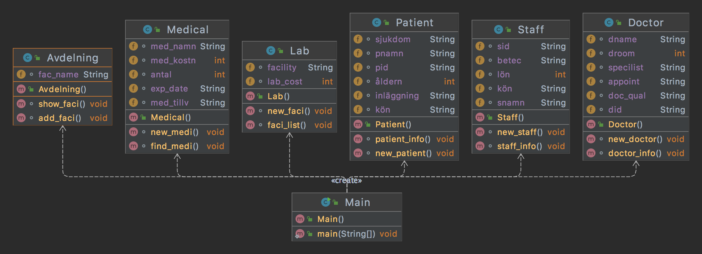

## Project plan

Milestones

* 1. Startup

Deadline 2022-03-04

* Read requirements
* Create documents
* Create project plan
* Setup environment
  1. Design

Deadline 2022-03-03

* Implement class models and interfaces
* Discuss design with the team
  1. Implementation

Deadline 2022-03-

* Implement user stories
  1. Release

Deadline 2022-03-04

* Publish on GitHub
* Presentation one time per week for tree week period for the teacher
* Handing in

## Problems

* Prestudy
* Planning
  + How to work with AGIL development with the team?
* Implementing