Name : Shone Sajan
College : Saintgits College of Engineering
- connection screenshot :
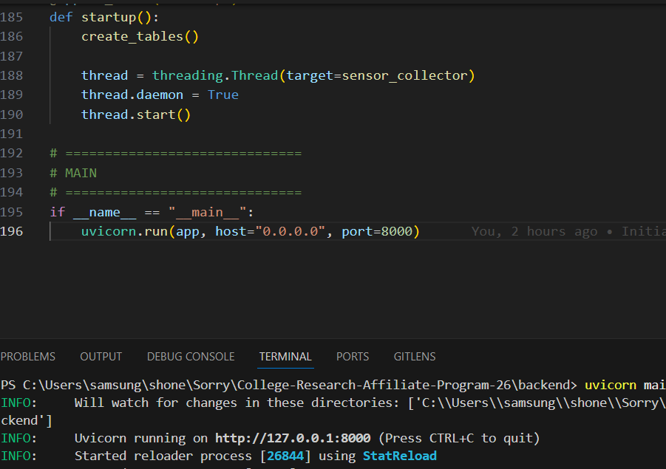
- Updated GitHub repository link : https://github.com/shonesjn/iot_test/
- Working deployed app screenshot
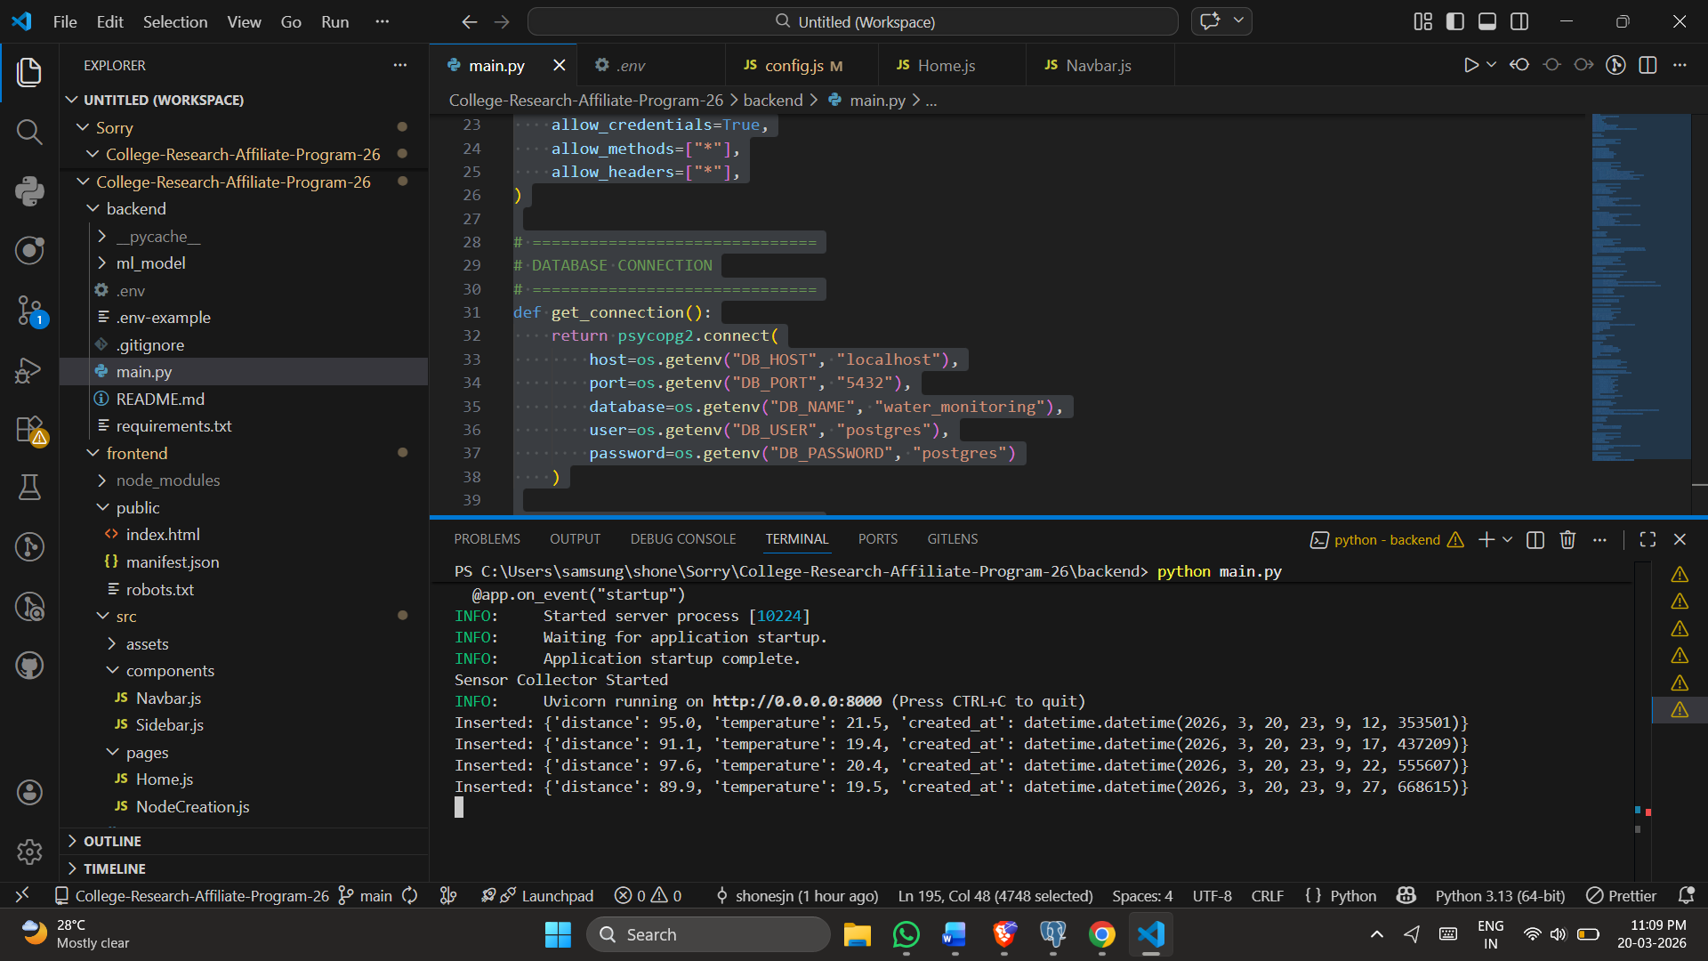
- Deployed frontend URL : https://vercel.com/shonesjns-projects/iot-test-py9n/3egM5ZnQLD6FRrELb8hHBgSgXmZj
- Deployed backend URL : https://back-dorp.onrender.com

- Dashboard with college branding screenshot
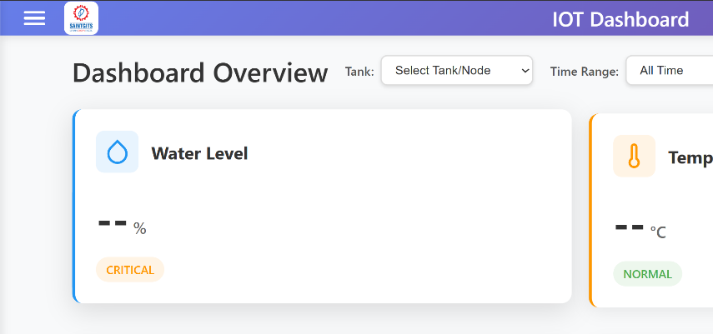
ML Improvements and Accuracy
The system uses a rule-based approach to classify water usage based on distance and temperature. The logic was refined by adjusting thresholds and defining clear categories such as shower, faucet, toilet, and no activity. With simulated data, the system achieved an approximate accuracy of 75–85%. This can be improved further by integrating trained machine learning models.

- API Endpoints Added
The backend includes three main endpoints. The root endpoint checks database connectivity. The /sensor-data endpoint retrieves recent sensor readings. The /api/v1/predict endpoint processes input data, returns predictions with confidence, and stores results in the database.

Frontend Features Added
The frontend provides a dashboard to display real-time sensor data and trends. It includes graphs, filtering options, a data table with pagination, and a responsive design. The interface was styled using a consistent color theme.

- Challenges and Solutions
There were issues with database connection and environment configuration, which were resolved by correcting credentials and using environment variables properly. Import errors were fixed by organizing the project structure. Integration between frontend and backend required enabling CORS. Since real sensor data was unavailable, a background process was used to simulate data.

