Laboratory work 7
Database: Indexes (PostgreSQL)

Student: Nabi Nurdaulet

Task 1
Create an index on the actual_departure column in the flights table.
Screenshot 1.1
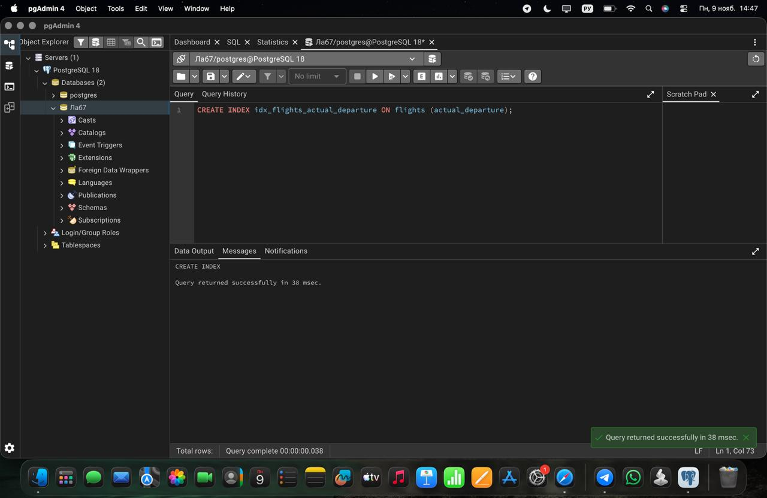

Task 2
Create a unique index to ensure flight_no and scheduled_departure combinations are unique.
Screenshot 2.1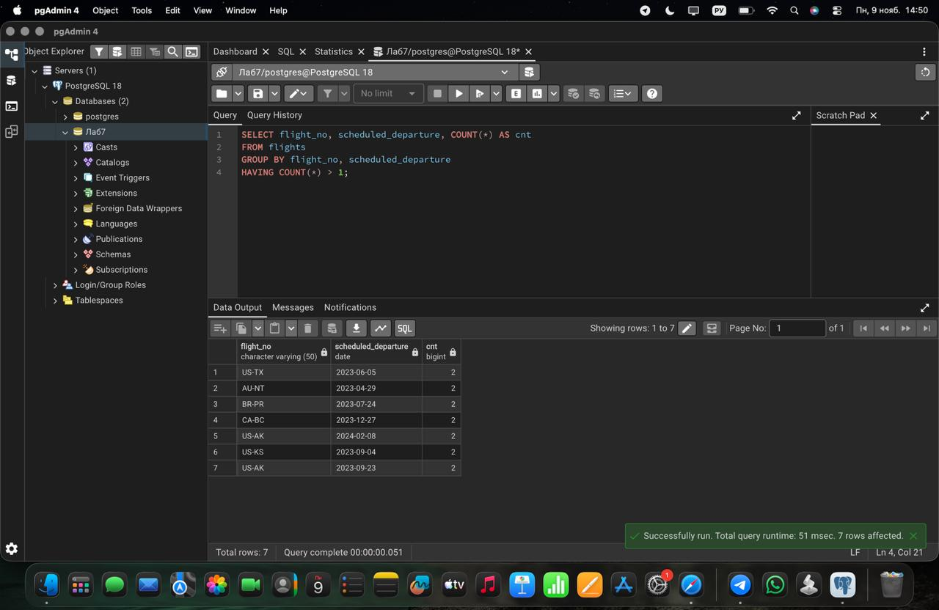

Screenshot 2.2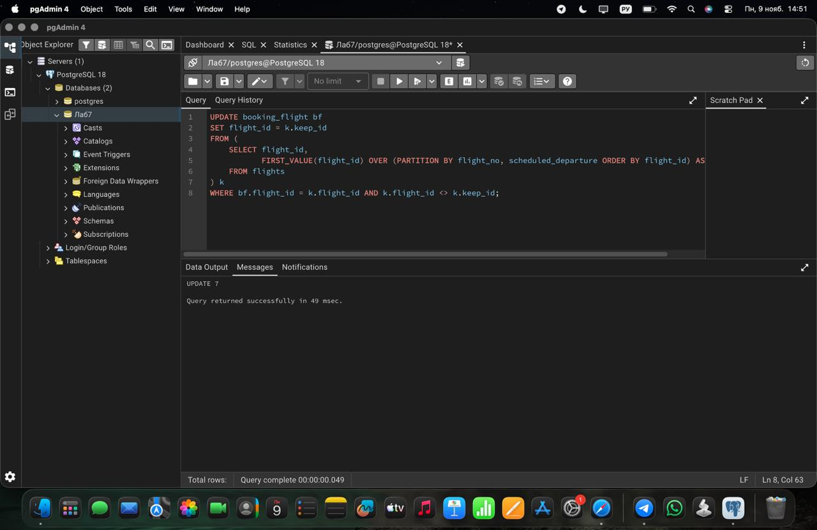

Screenshot 2.3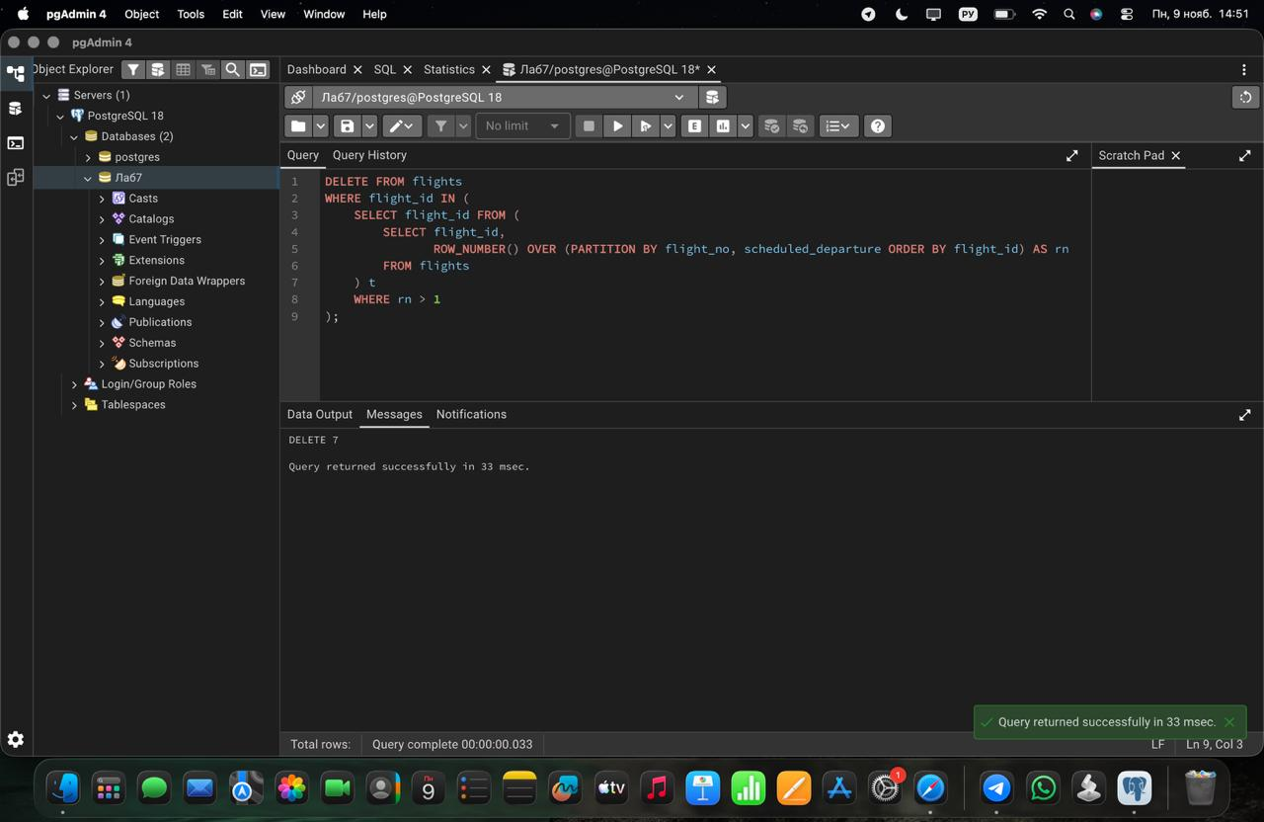

Task 3
Create a composite index on the departure_airport_id and arrival_airport_id columns.
Screenshot 3.1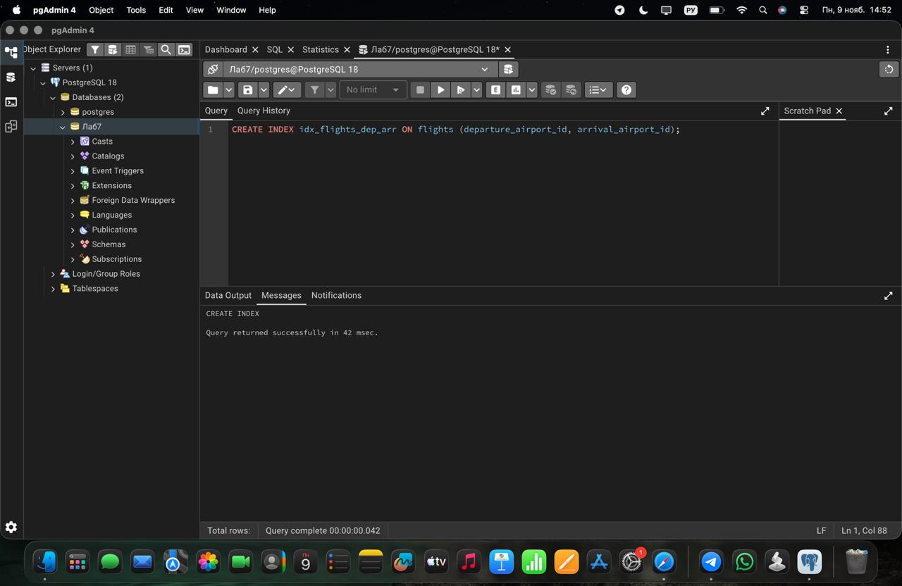

Task 4
Evaluate the difference in query performance with and without indexes. Measure performance differences.
Screenshot 4.1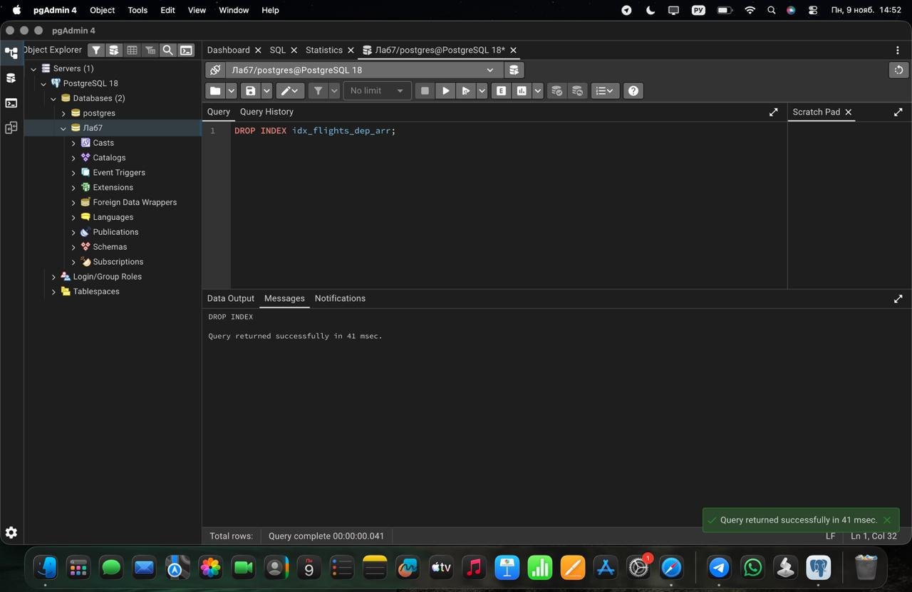

Screenshot 4.2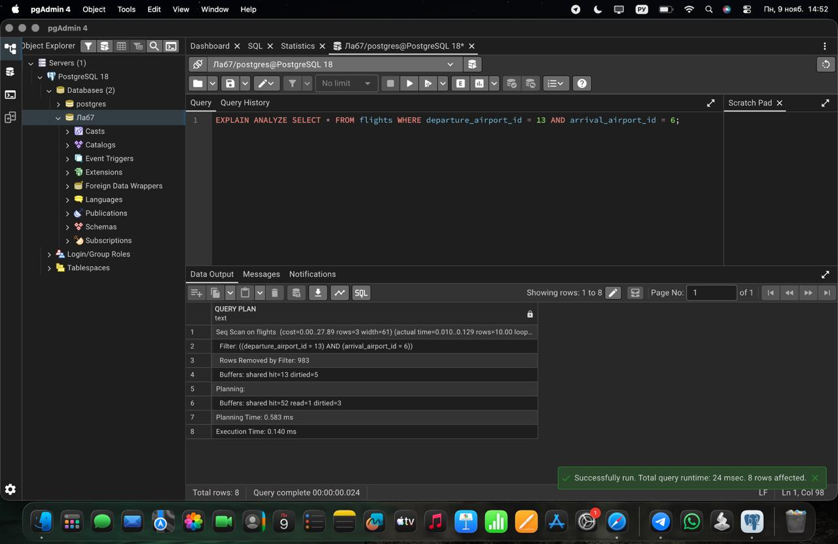

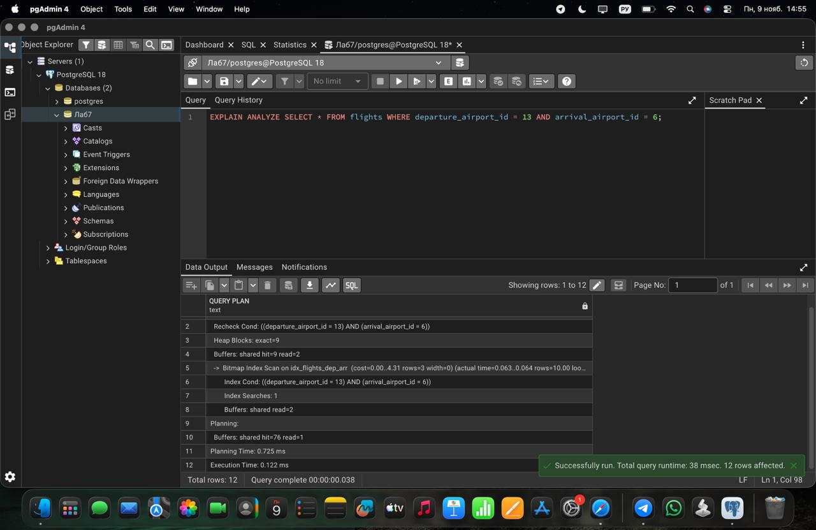

Task 5
Use EXPLAIN ANALYZE to check index usage in a query filtering by departure_airport and arrival_airport.
Screenshot 5.1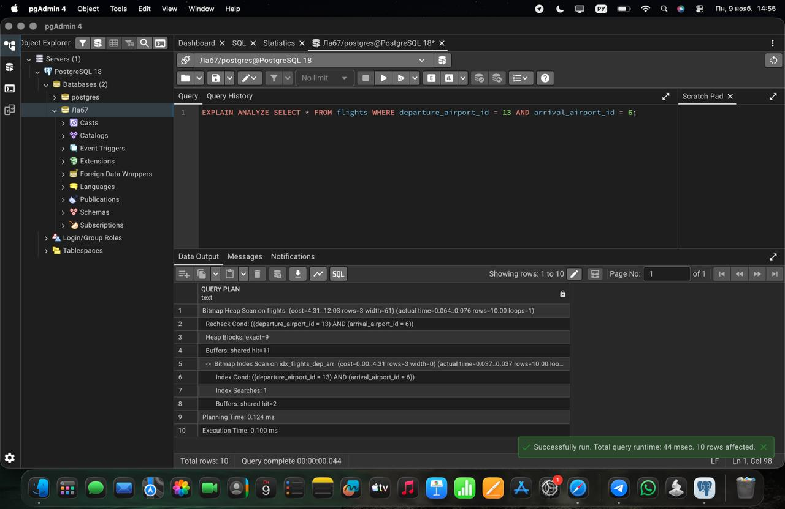

Task 6
Create a unique index for the passport_number of the Passengers table. Check if the index was created or not. Insert into the table two new passengers. Explain in your own words what is going on in the output.
Screenshot 6.1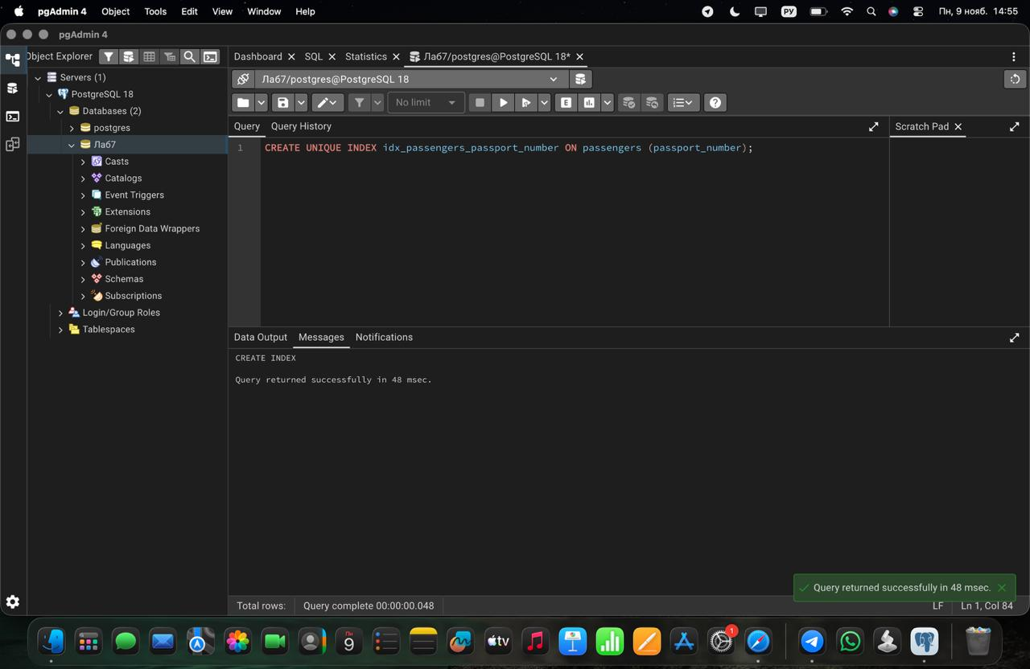

Screenshot 6.2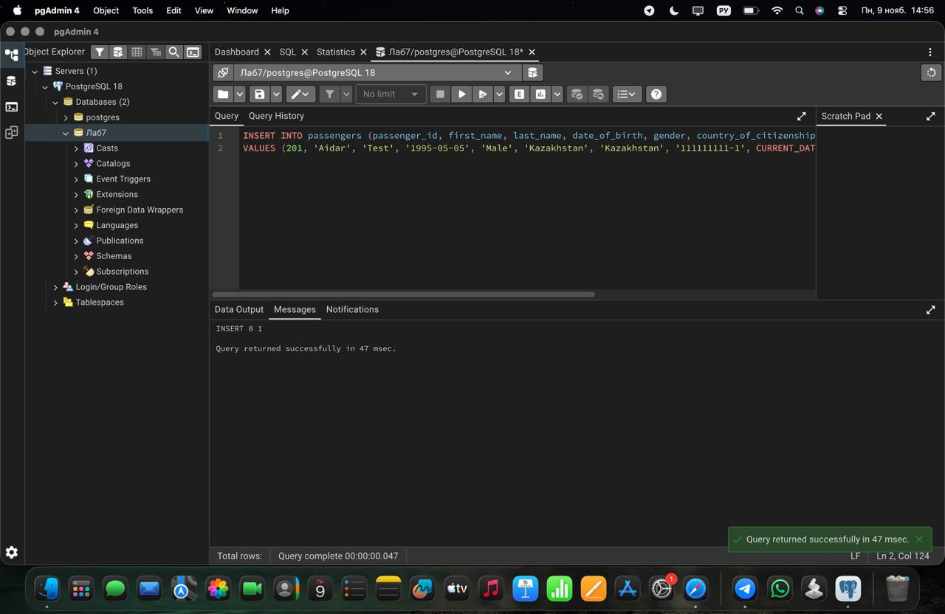

Task 7
Create an index for the Passengers table using first name, last name, date of birth and country of citizenship. Then, write a SQL query to find a passenger who was born in Philippines and was born in 1984 and check if the query uses indexes or not. Give the explanation of the results.
Screenshot 7.1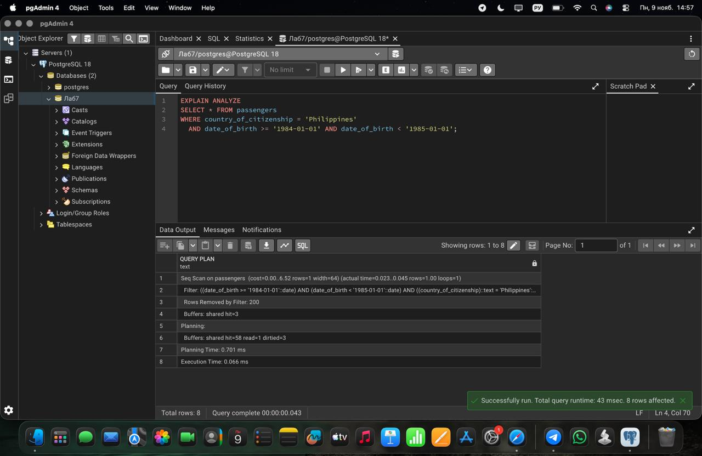

Screenshot 7.2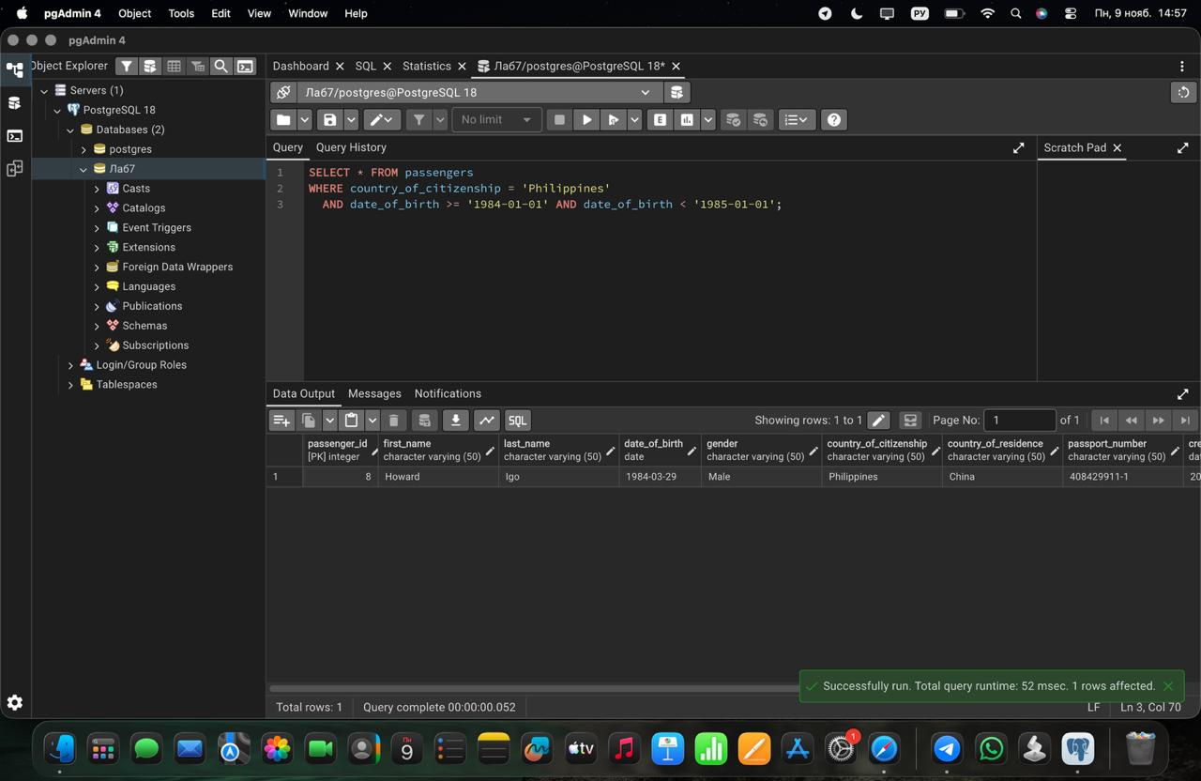

Task 8
Write a SQL query to list indexes for table Passengers. After delete the created indexes.
Screenshot 8.1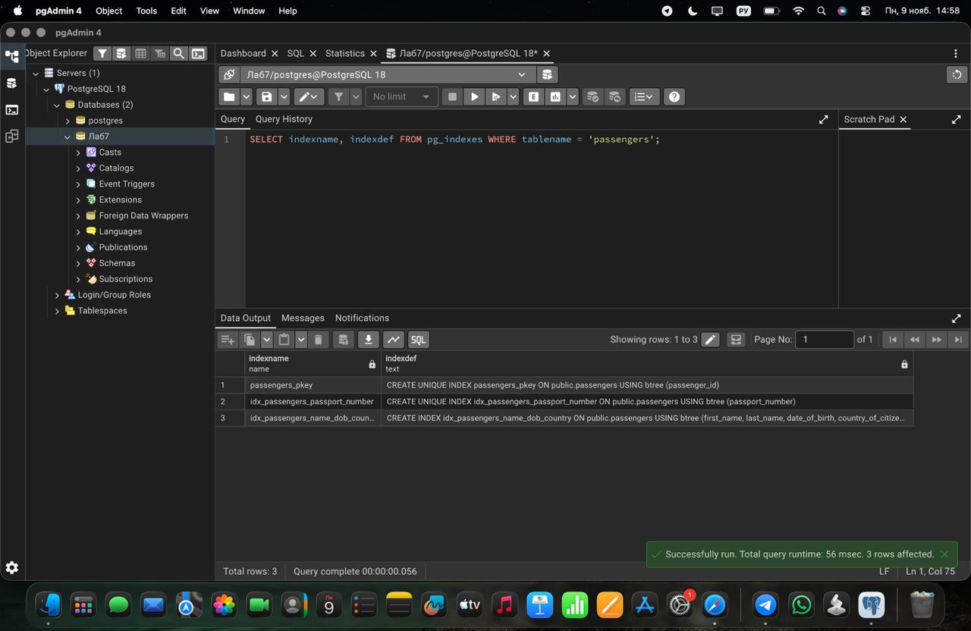

Screenshot 8.2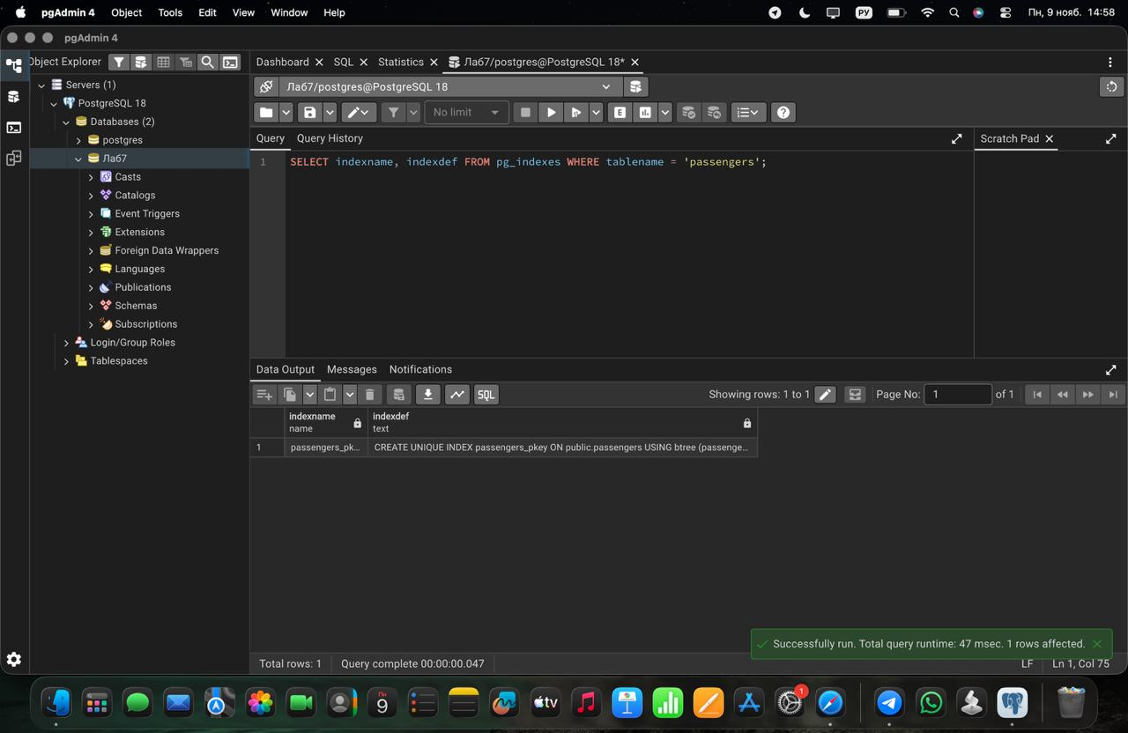

Task 9
Create an index on the passenger_id column of the booking table. Using EXPLAIN ANALYZE, compare the execution plan and execution time of a query that selects all bookings of one passenger (passenger_id = 100) before and after creating the index. Explain what changed in the plan.
Screenshot 9.1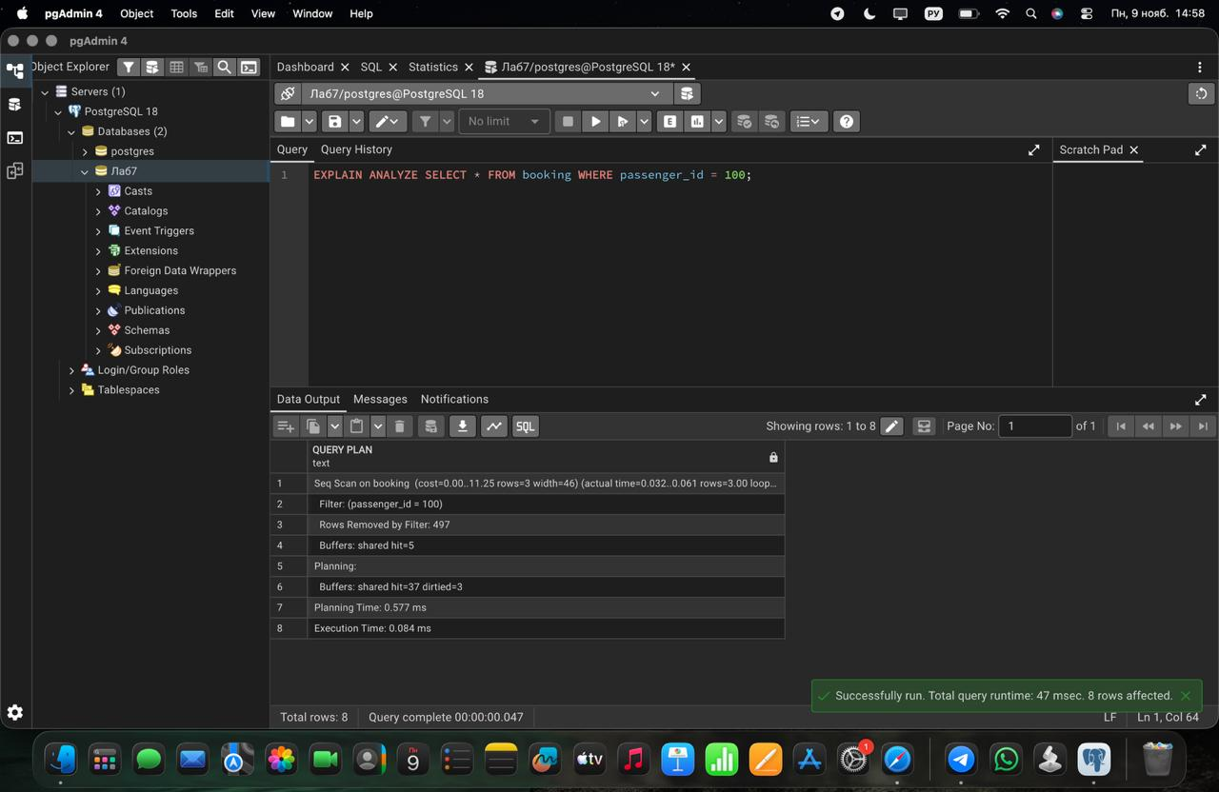

Screenshot 9.2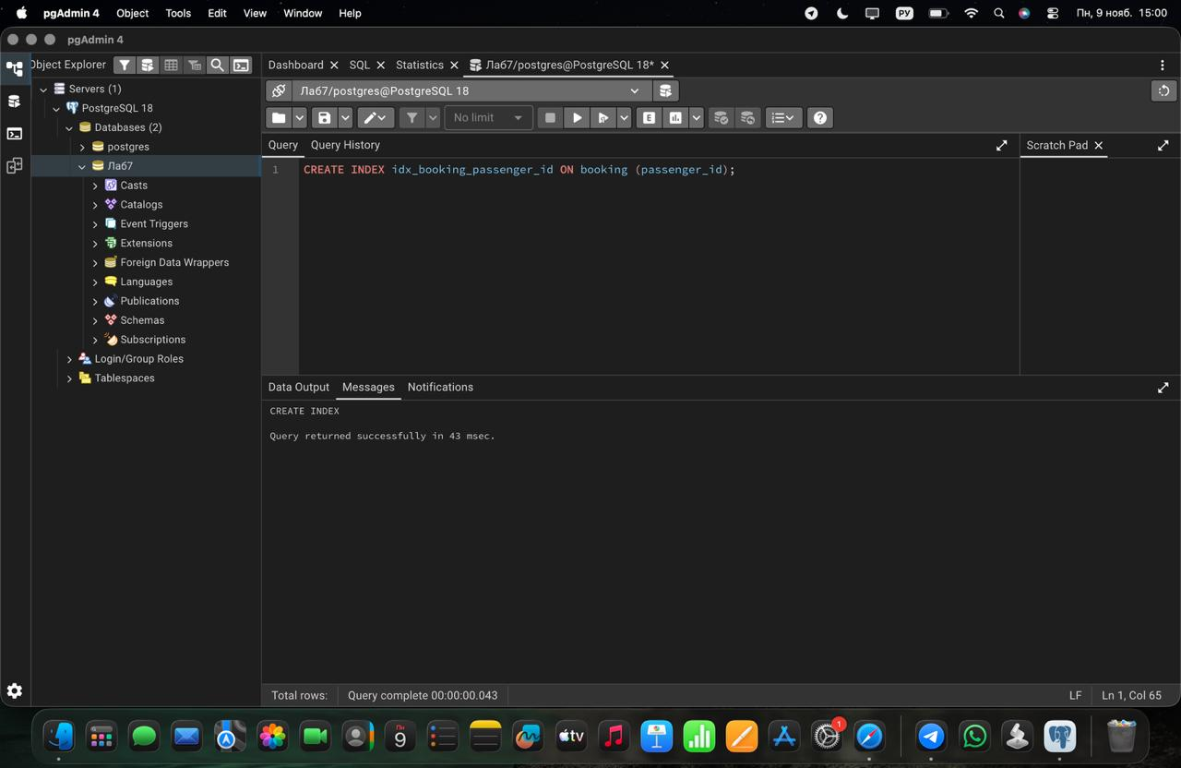

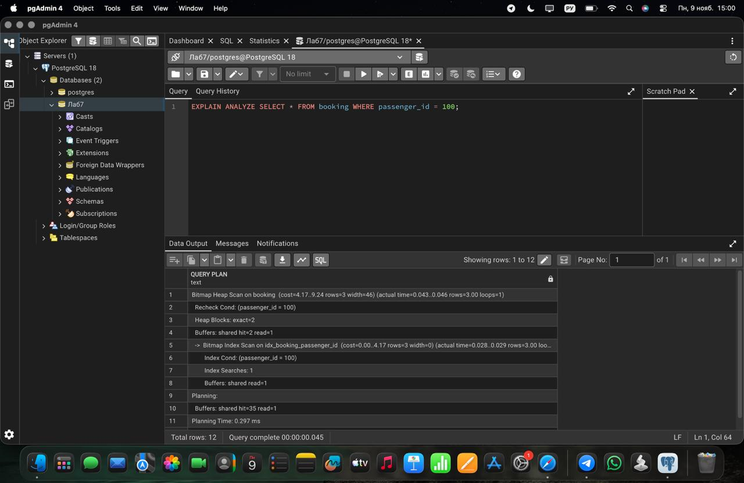

Task 10
Create a composite index on the booking_flight table using the booking_id and flight_id columns. Write a query that joins booking, booking_flight and flights and returns the flight_no and price for bookings with a price greater than 9000. Check with EXPLAIN ANALYZE which indexes are used in each step of the join.
Screenshot 10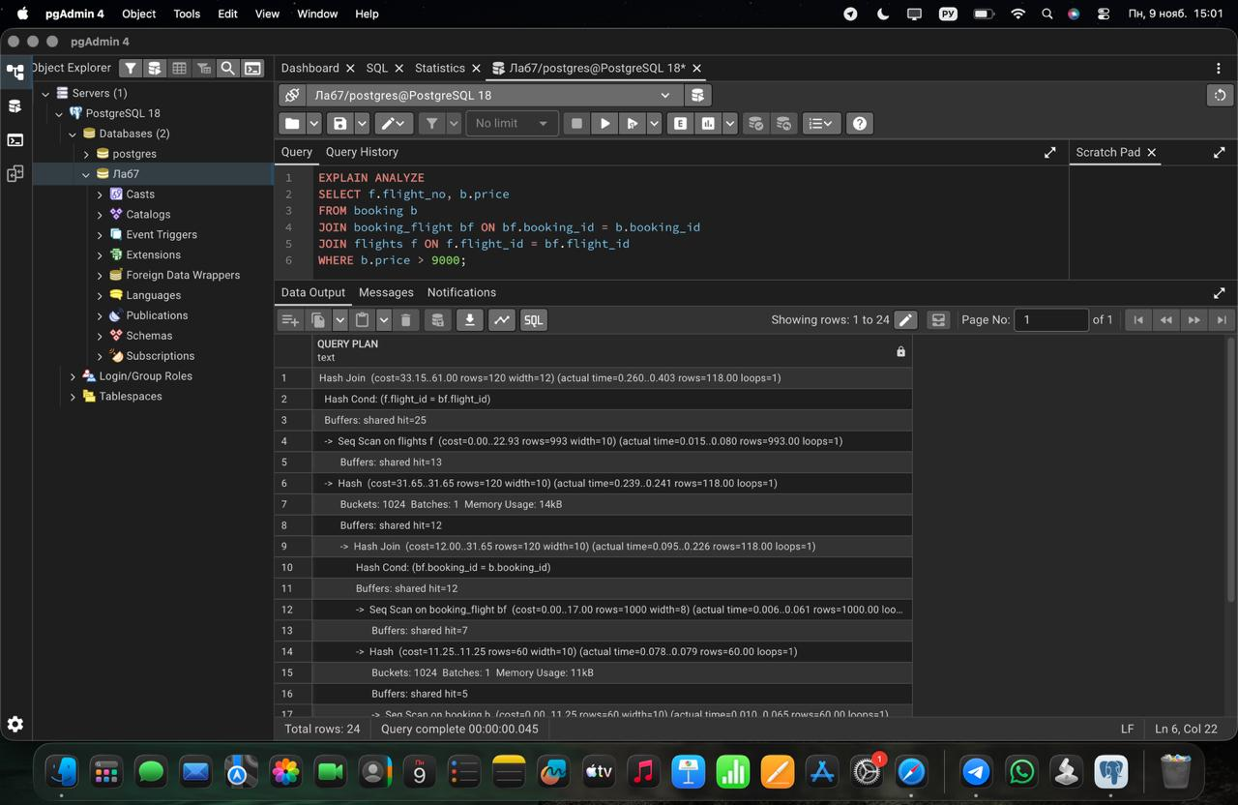

Task 11
Create an index on the status column of the flights table. Run EXPLAIN ANALYZE for the query with status = 'Departed' and for the query with status = 'Boarding'. Compare the plans and explain why the optimizer may ignore the index for one of the values (hint: selectivity).
Screenshot 11.1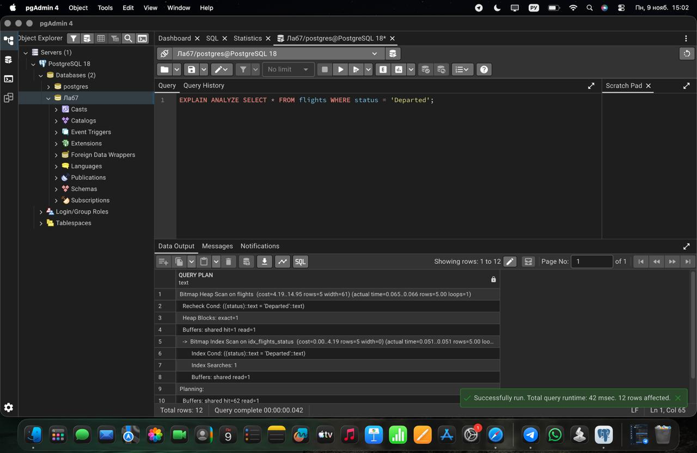

Screenshot 11.2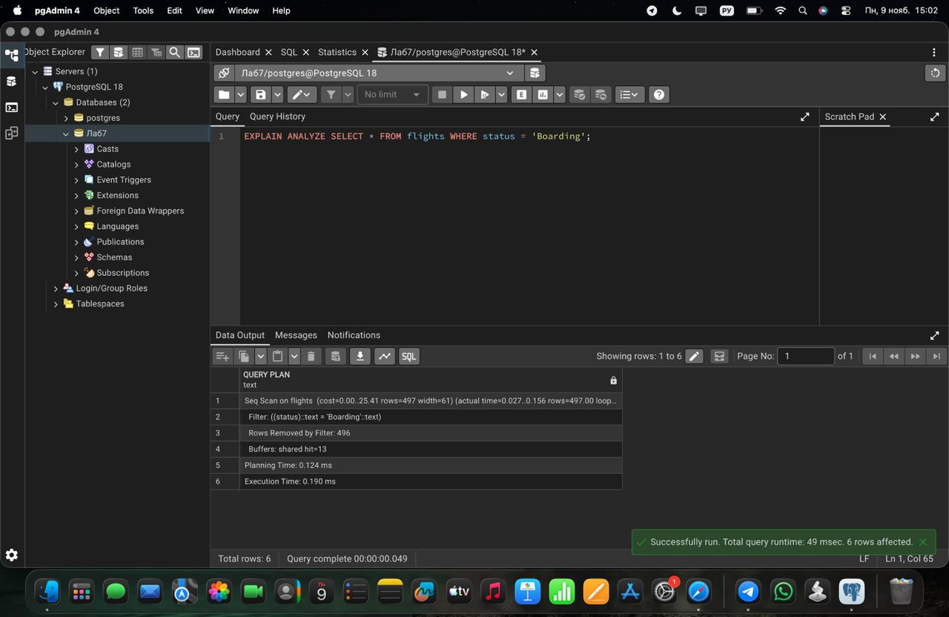

Task 12
Create an index on the weight_in_kg column of the baggage table. Compare the plans of two range queries: weight_in_kg > 49 and weight_in_kg > 5. Explain the difference in index usage.
Screenshot 12.1
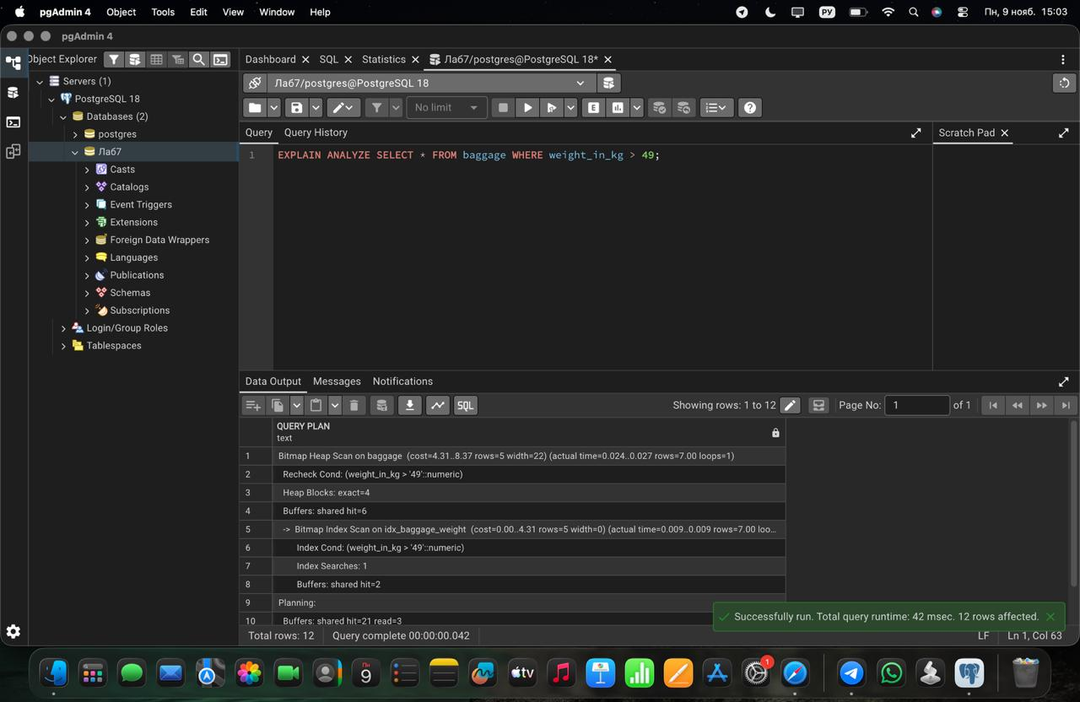
Screenshot 12.2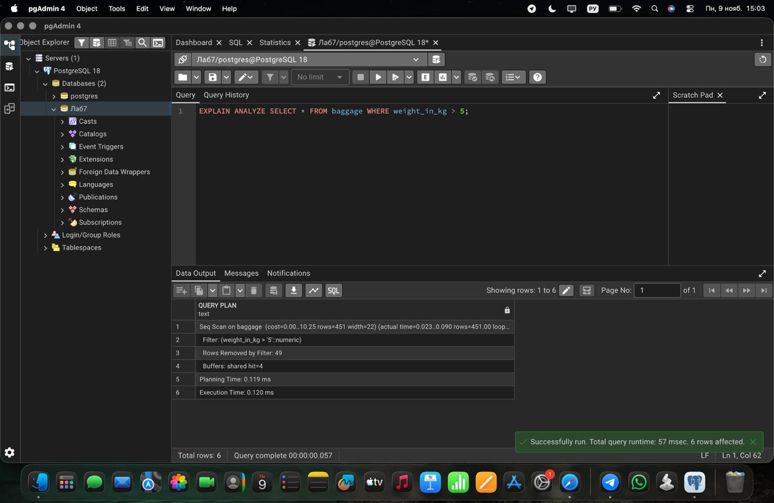

Task 13
Create an index on the airport_name column of the airport table. Check with EXPLAIN ANALYZE whether it is used by the queries LIKE 'A%' and LIKE '%Airport'. Explain why the results are different.
Screenshot 13.1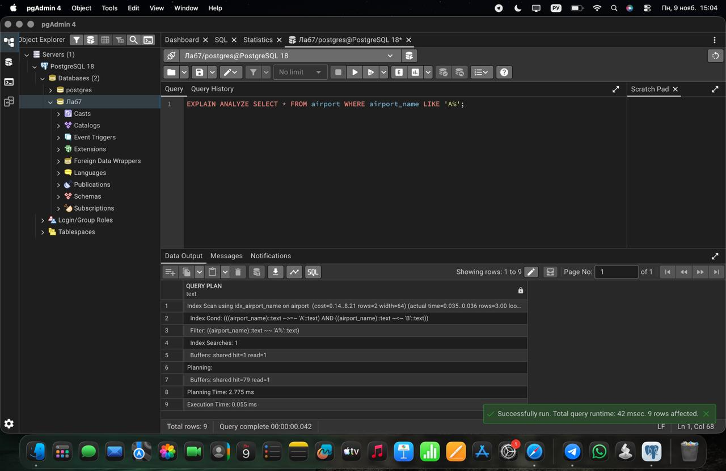

Screenshot 13.2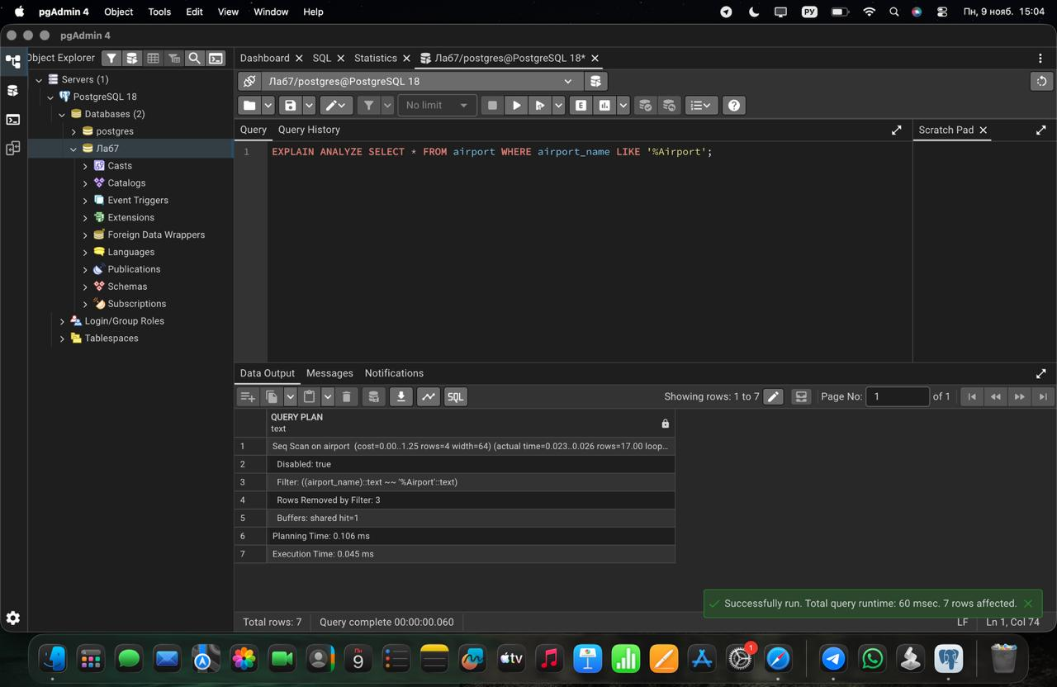

Task 14
Create a composite index on the country and city columns of the airport table. Run three queries: filtering by country only, by city only, and by both columns. Check which of them use the index and explain the leftmost prefix rule using your results.
Screenshot 14.1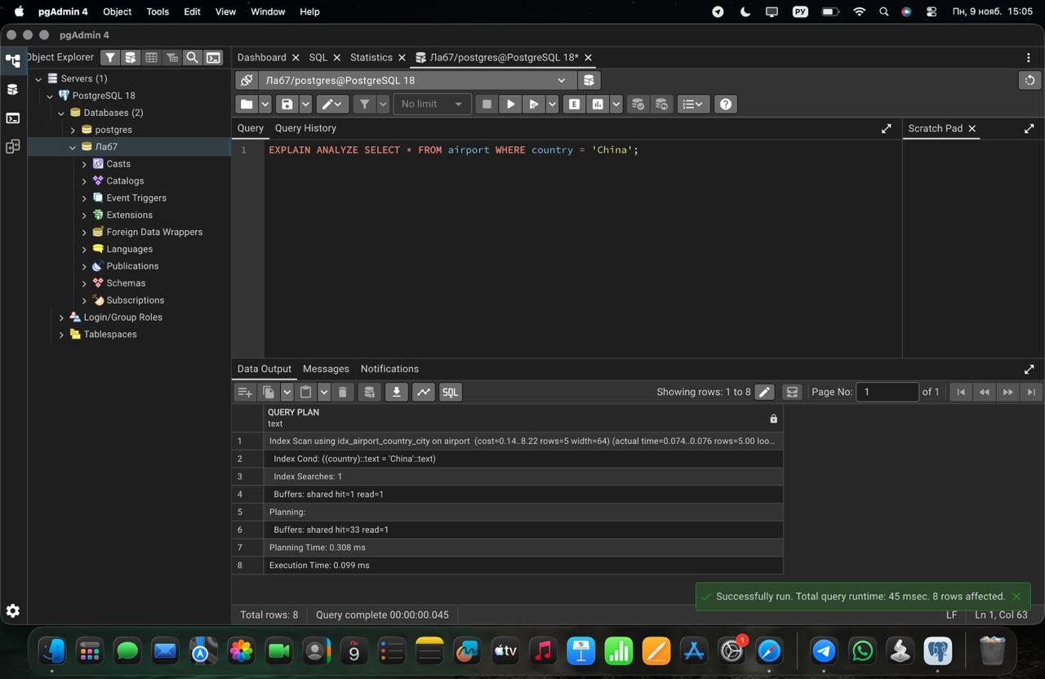

Screenshot 14.2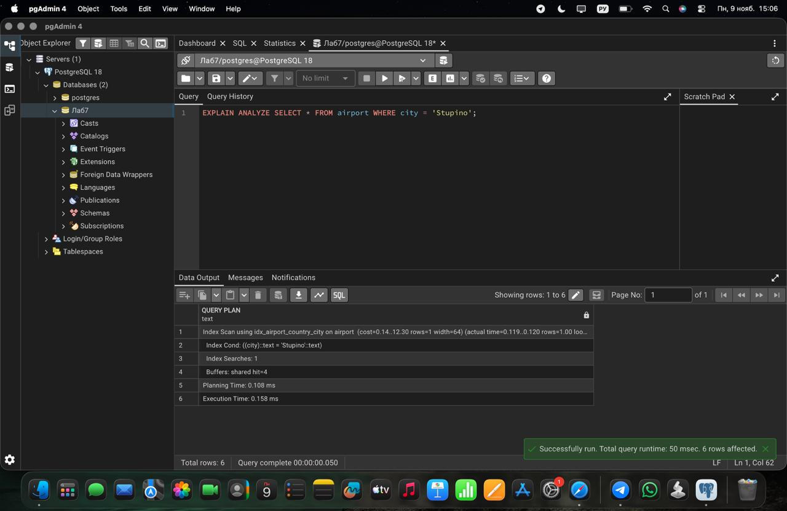

Screenshot 14.3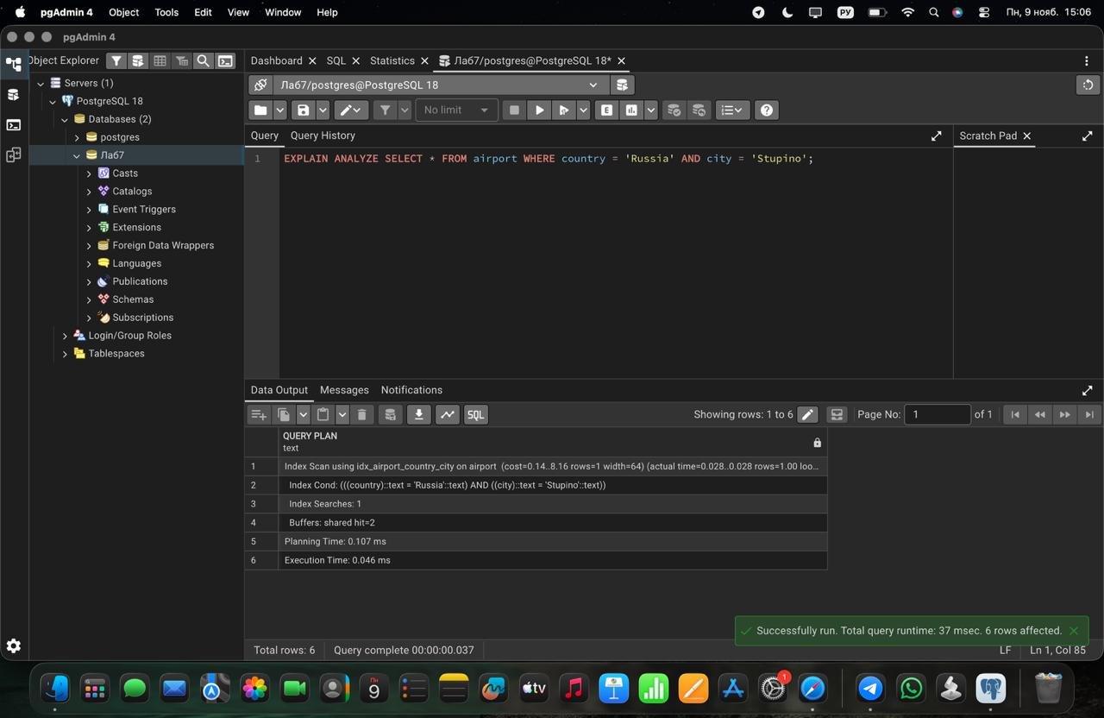

Task 15
Create an expression (functional) index on the lower-case last_name of the Passengers table (LOWER(last_name)). Compare the plans of a query written as WHERE LOWER(last_name) = 'irnis' and a query written as WHERE last_name = 'Irnis'. Explain which query can use the index and why.
Screenshot 15.1
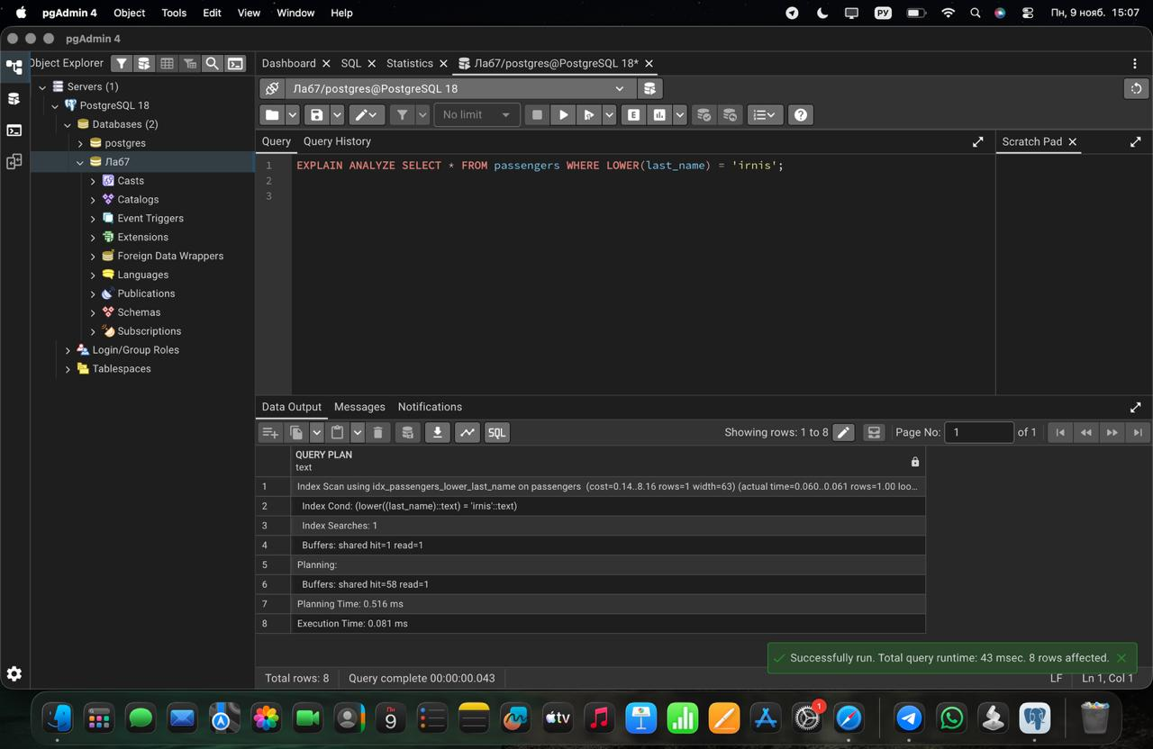
Screenshot 15.2
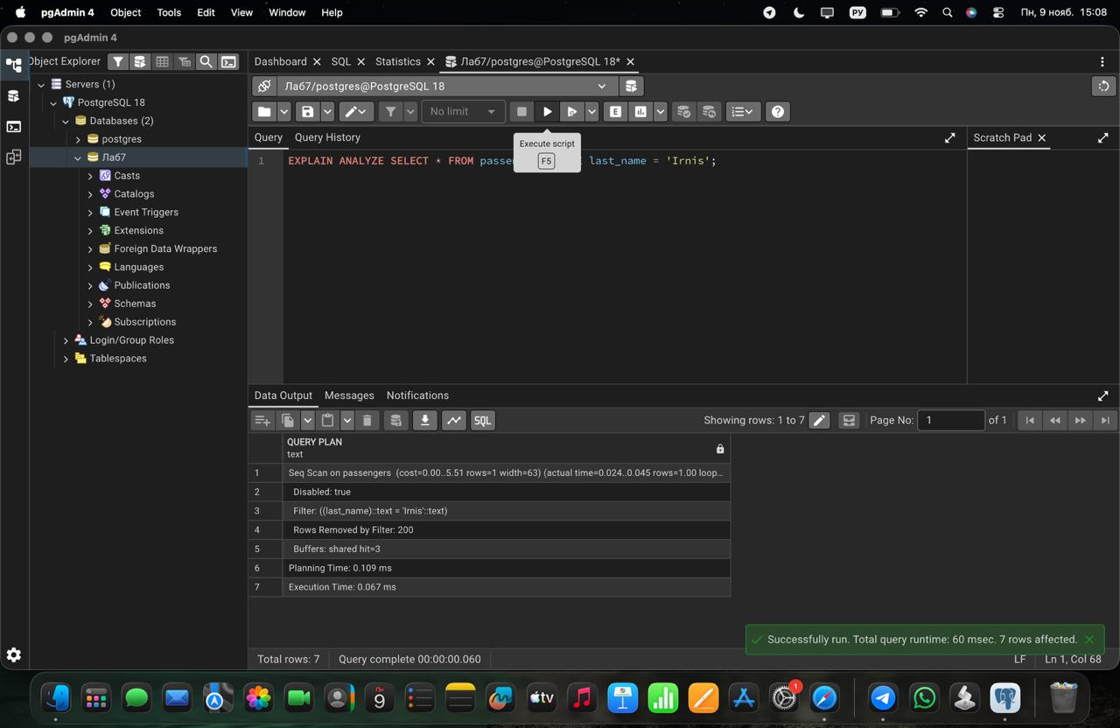

Task 16
Create a covering index on the booking table for the columns passenger_id and price. Write a query that returns only price for a given passenger_id and check with EXPLAIN ANALYZE whether an index-only scan is used. Explain the benefit of a covering index.
Screenshot 16.1
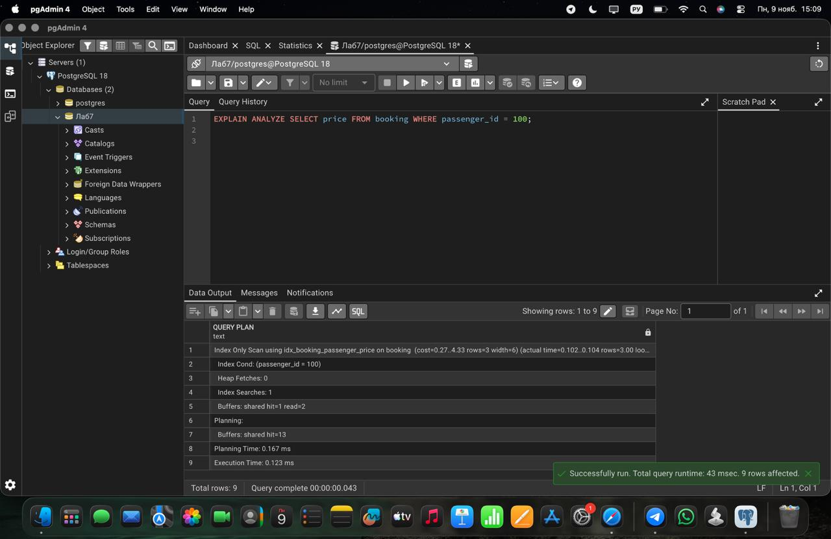

Task 17
Try to create a unique index on the airline_code column of the airline table. If an error occurs, explain what caused it and find the problematic rows with a GROUP BY ... HAVING COUNT(*) > 1 query. Then create the unique index in a way that works for the current data, or after fixing the data.
Screenshot 17.1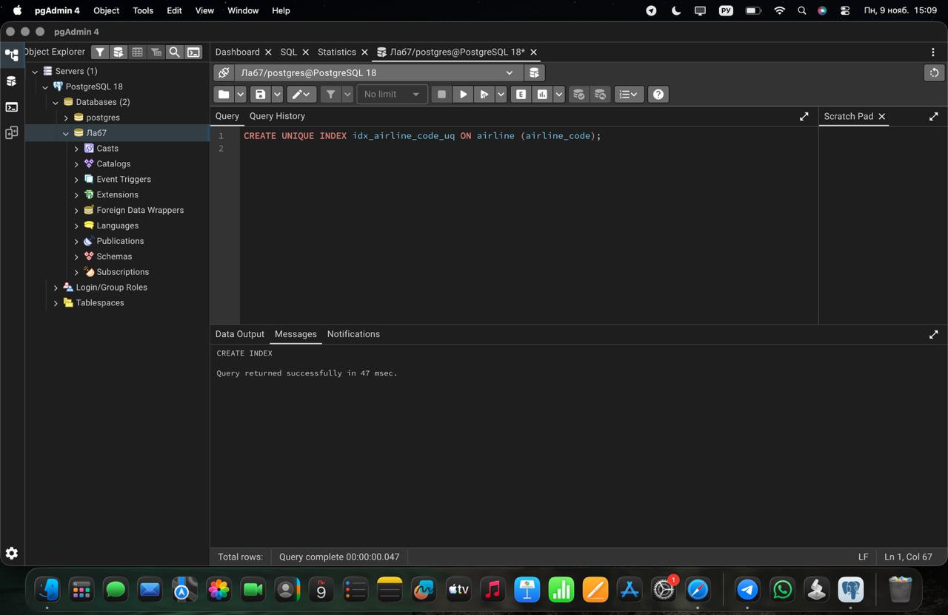

Screenshot 17.2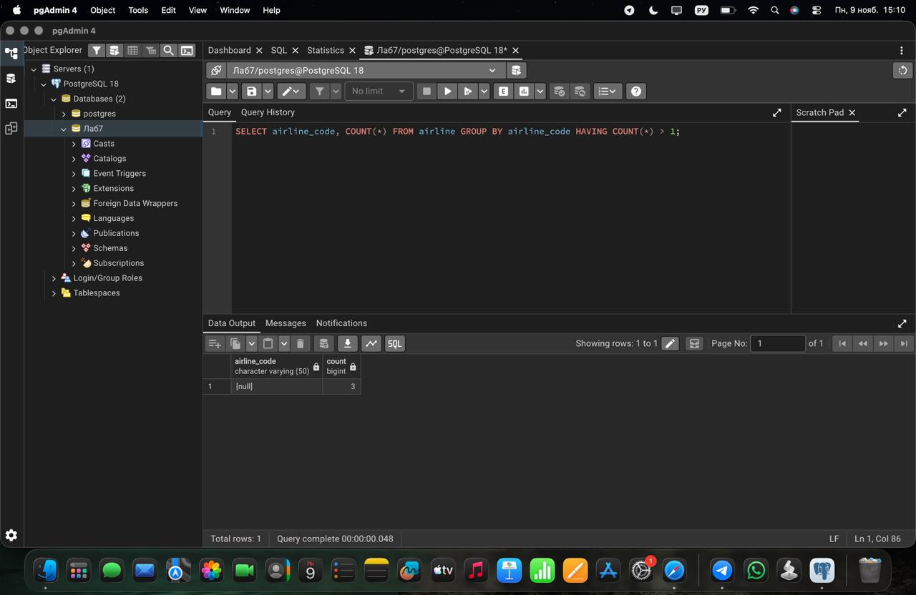

Screenshot 17.3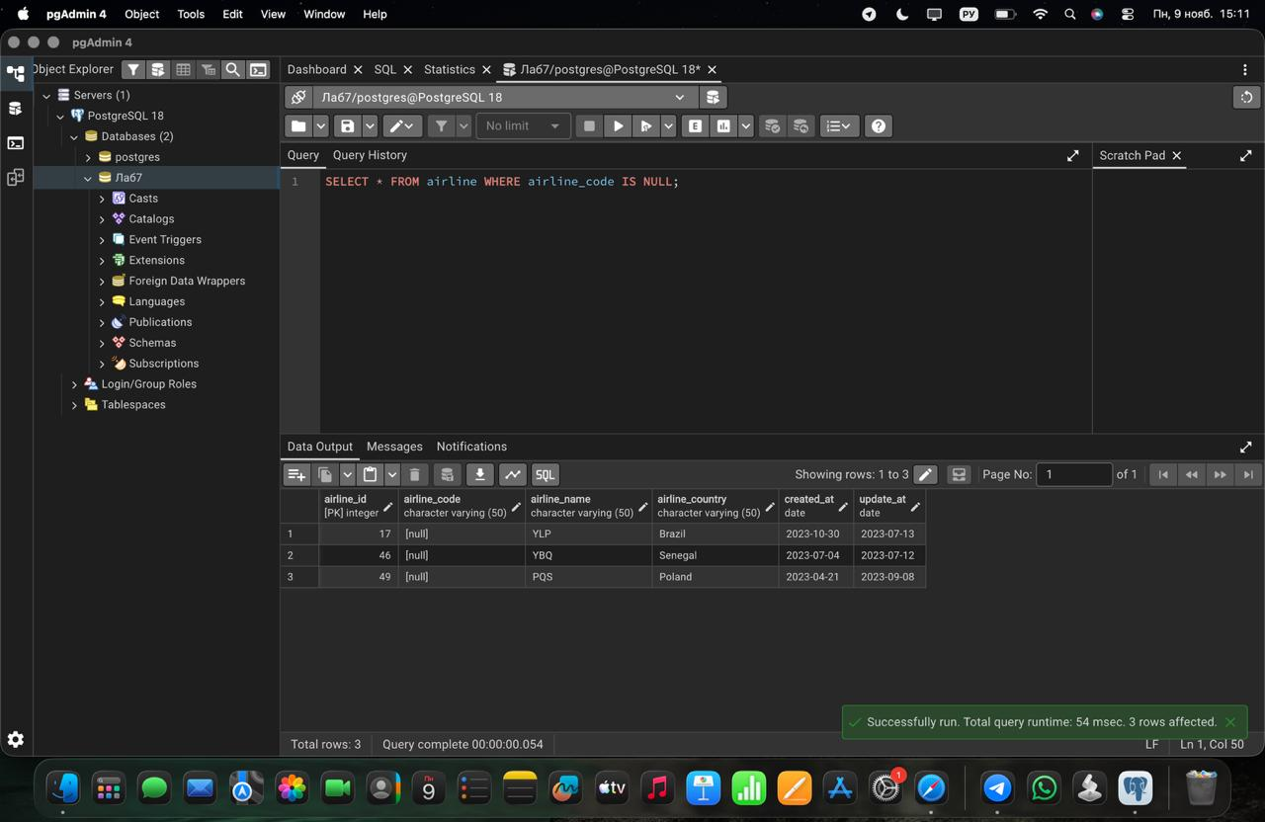

Screenshot 17.4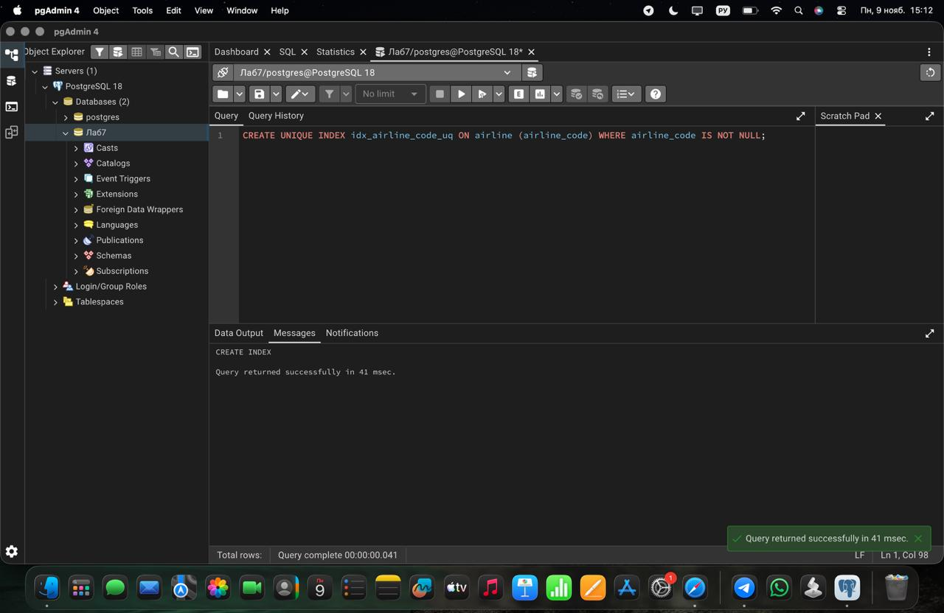

Conclusion

In this laboratory work I learned how indexes work in PostgreSQL. I created single, composite, unique, expression, partial and covering indexes and checked their usage with EXPLAIN ANALYZE.

The results showed that an index speeds up a query only when it fits the query: composite indexes follow the leftmost prefix rule, LIKE '%text' cannot use a regular index, and an expression index works only with the same expression. The optimizer also ignores an index when a query returns a large part of the table (low selectivity), as with status = 'Boarding' and weight_in_kg > 5. Unique indexes protect data from duplicates, and a covering index allows an Index Only Scan without reading the table.

In general, indexes make reading faster, but they use extra space and slow down INSERT, UPDATE and DELETE, so they should be created only for columns that are often used in filtering and joining.

