|  |
| --- |
| Fontys Hogescholen ICT |
| User Requirements Specifications |
| Waterfall |

|  |
| --- |
| Dynamic service  Supervisor: Chung, Kuah W.C.  Eindhoven, 2-16-2020 |

Document Change Record

|  |  |  |  |
| --- | --- | --- | --- |
| *Date* | *Version* | *Author* | *Comments* |
| 16-02-2020 | 0.1 | Dynamic service | First version of the document. |
|  |  |  |  |

# Definitions, Acronyms and Abbreviations

|  |  |
| --- | --- |
| *Term* | *Description* |
| Employee | In the context of this document the Employee is a worker in the company with restricted rights and access to information |
| Manager | In the context of this document the Manager is an Employee with more rights, access to information |
|  |  |

Table of Contents

Definitions, Acronyms and Abbreviations 3

1 Introduction 5

1.1 Document Purpose 5

1.2 Document Overview 5

2 Background 6

2.1 Scope and Objectives 6

3 Stakeholder and User Analysis 7

4 User Requirements 8

4.1 Functional Requirements 8

4.2 Non-Functional Requirements 8

5 Assumptions/Constraints 9

6 Functionalities 10

7 Use Cases 11

1. GUI 19
2. **Introduction**

## Document Purpose

This document is the definitive specification of the user requirements for management application of the store “Media Bazaar” developed by Dynamic service.

## Document Overview

## In the first chapter named “Background” we are going to give a brief explanation about the project and its requirements.

## In stakeholder and user analysis will be described who will be the users of the system.

## In the user requirements as it is saying, it’s going to be explained the functionalities and non-functionalities of the application.

## In assumption/constraints we talk about the things that control what we do by keeping us within limits and the things that we accept as true without question or proof.

## In use case models we describe the more ‘technical’ part about how a user interacts with the system.

## In GUI is shown sample version of the system design.

## In website wireframe will be included the design of the website.

# Background

We, Dynamic service are hired by Media Bazaar to help them with administrative system. The project will help with software solution for a hardware shop which is struggling with management of the company. The main requirements are keeping track of their employees and products.

## Scope and Objectives

Our main objective is to deliver an application that will help Media Bazaar in solving the following problems:

* Managers can’t keep track of their employees. They didn’t know who is really working for the company, when the employees are working.
* Managers can’t assign work shifts properly. They need something like calendar schedule working hours. They do not want to be google calendar.
* Managers don’t have a clean view over attendance and work hours of their employees.
* Managers don’t have a registry of people who have worked in the company before. Why their contract has ended.
* Shelves in store don’t get restocked because there is no system that tracks how much of the stock is left in the storage.

* The shop doesn’t have departments. The products are not separated correctly. They must be settled on different floors.

1. **Stakeholder and User Analysis**

Our stakeholders are the administration, employees and customers. Administration includes the managers of the company.

One of our stakeholders is the administration of the company, for which we are making the software solution of the managing problem. The general characteristics of the users affecting the requirements are a user-friendly system in which the administration can know everything about them at first place. And then everything about the products in the market.

Employees are also important part of our stakeholders. We need to provide easily accessible platform in which they can see a clean view of their work hours, schedule vacations, etc.

They do want a positive impact on their business. Part of the success is a happy customer. All the problems that are planned to be fixed is going to provide better service of their client, which can improve the store’s rating.

Their success is directly affected by the success of our future system. So, we should aim a successful problem-solving system, which will cover all the client’s requirements.

# User Requirements

**Functional Requirements:**

* **FR-01: Administration should be able to store credentials and information about employees of the company in a database**

*All of the following must be stored in the database: First name, last name, gender, birthdate, birthplace, nationality, languages, BSN number, home address, FTE, start day of working contract, last day of working contract, vacations taken, position, when did they stop working and why, how much they worked compared to how much they were scheduled to work*

* **FR-02: Administration should be able to assign work shifts to all employees**
* **FR-03: Administration should be able to hire new employees**
* **FR-04: Administration should be able to end contracts of employees**
* **FR-05: Administration should be able to keep track of the attendance of employees**
* **FR-06: Administration should be able to log in**
* **FR-07: Administration should be able to keep track of products in store**
* **FR-08: Work shifts should be automatically assigned**
* **FR-09: Administration should be able to promote and demote employees**
* **FR-10: Employees should be able to log on the website**
* **FR-11: Employees should be able to preview their work shifts on the website**
* **FR-12: Administration should be able to keep track of the salaries of employees**

Non-Functional Requirements:

* Software should be Simplified- User friendly.
* Software should be easily maintainable.
* Software should be extendable

# Assumptions/Constraints

We think the biggest constrains in our Waterfall Project are that the period is exactly six weeks for the first version of the application and 18 weeks for the final version. That forces us to be very strict with the deadlines and pushes us to work harder in the given period in order to complete everything on time.

The usage of git is a must, which can be observed as a constraint because sometimes sending files and information between each other can happen faster with another platform.

Another constraint is the customer satisfaction in some cases finishing all the deliverables on time won’t be enough to satisfy the customer. For example, the design – sometimes customer’s and company’s views for the design can be different, misunderstanding the functionalities – not implementing some of them or adding them but not with the exact purpose. That’s why the earlier we begin looking for clues to answer that question, the better we will be able to deliver a product meeting all the requirements. That’s why our meetings with the customer must be as comprehensive as possible in order to get the job done. Keep track of data can also be part of the constrains. There are couple of ways to save data. For example, the data can be saved as lists which is no so useful way because it’s going to be saved temporary. We came to the decision for saving data is databases.

# Functionalities

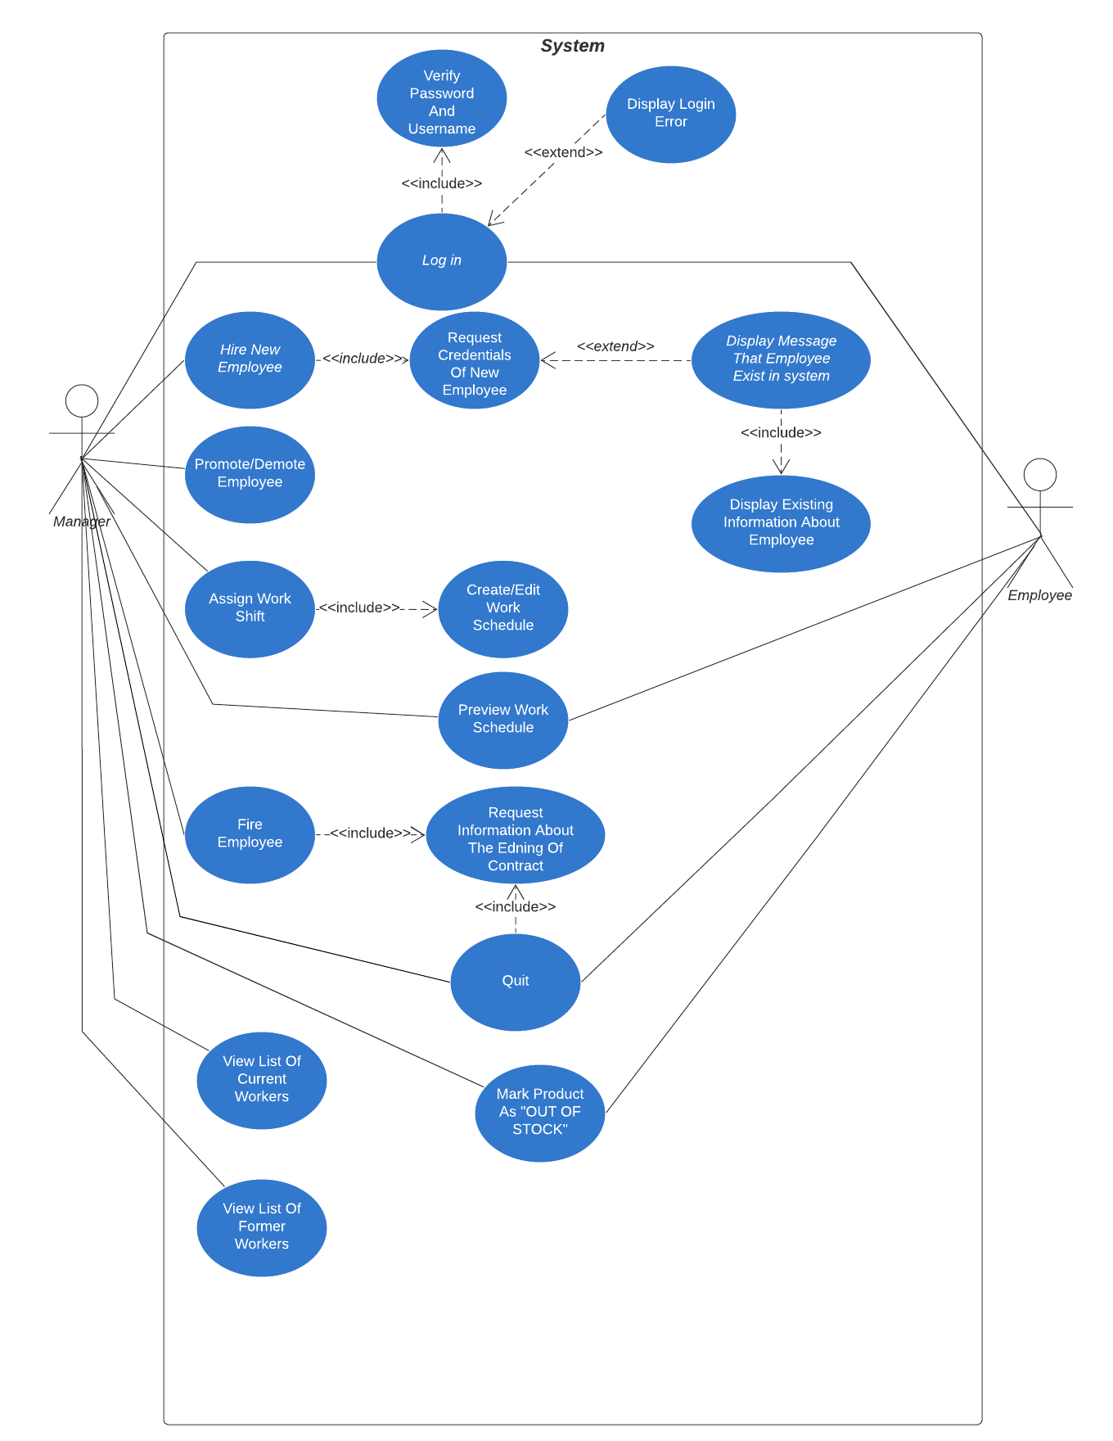

# Use cases

UC-01: Login Application

Actor: Manager, employee, CEO

Main Success Scenario:

1. User opens application.
2. Login Form appears and requests e-mail and password.
3. User fills in requested details.
4. System searches for a person with e-mail and password matching the given ones.
5. System marks the user as “logged in” and shows the welcome screen

Extensions:

4a: Entered e-mail and/or password don’t match with anyone in the database

1. System shows a message that the entered e-mail and password are either wrong or not registered
2. End of Use case

4b: The user is a normal employee not from the depot or sales departments

1. System displays a message to the user that normal employees can only log in on the website
2. System doesn’t log the user in
3. End of Use case

4c: The user is a manager not from the depot or sales departments

1. System marks the manager as “logged in” and shows the welcome screen, while giving permission to access every tab in the application except those concerning specially the depot and sales departments
2. End of Use case

4d: The user is a normal employee from the sales department

1. System displays the welcome screen and gives access to the “Products” tab to the employee excluding the “Restock requests” section
2. End of Use case

4e: The user is a manager from the sales department

1. System displays the welcome screen and gives access to every section except “Request history:
2. End of Use case

4f: The user is a normal employee from the depot department

1. System displays the welcome screen and gives access to the “Products” tab to the employee while disabling and hiding the options to mark products as sold and making restock requests
2. End of Use case

4g: The user is a manager from the depot department

1. System displays welcome screen and gives access to every section while disabling and hiding the options to mark products as sold and making restock requests
2. End of Use case

4h: The user is the CEO

1. System displays welcome screen and gives full access to all functionalities of the application
2. End of Use case

UC-02: Hiring an employee

Actor: Manager

Pre-condition: Manager is logged in

Main Success Scenario:

1. Manager clicks on the “Employees” tab in the application, and then on the “Hire new” button.
2. System displays the registration form, requesting for the credentials of the employee.
3. Manager fills in the required information and clicks on “Register”
4. System checks if the person exists in the system and if not adds the person to the list of employees and shows a confirmation message to the manager

Extensions:

4a: Person already exists in the system

1. System displays a message that the person has been hired in the company before
2. Manager goes to “Former employees” section in “Employees” tab
3. System displays a list of all the ended contracts of people form this company
4. Manager chooses the person he wants to rehire and clicks on “Retrieve employee"
5. System displays all information concerning the reasons of firing/quitting
6. Manager decides whether he should hire the person again or not and clicks on “ok”
7. System displays a dialog asking whether the person should be rehired
   1. Manager decides to hire the person again
      1. Manager clicks on “Yes”
      2. System returns person to the list of current employees
      3. End of use case
   2. Manager decides not to rehire the person
      1. Manager clicks on “No”
      2. End of Use case

UC-03: Promotion/Demotion

Actor: Manager

Pre-condition: Manager is logged in

Main Success Scenario:

1. Manager goes to the “Current employees” section in the “Employees” tab
2. System displays a list containing information about all the employees currently working in the company
3. Manager clicks on the employee he wishes to promote/demote
4. System displays a window containing more info about the chosen employee and a few buttons
5. Manager clicks on the button Promote/Demote
6. System displays a message whether promotion was successful

UC-04: End contract of the employee

Actor: Manager

Pre-condition: Manager is logged in

Main Success Scenario:

1. Manager goes to the “Current employees” section in the “Employees” tab
2. System displays a list containing information about all the employees currently working in the company
3. Manager selects the employee whose contract he wishes to end and clicks on “Manage”
4. System displays a window containing more info about the chosen employee and a few buttons
5. Manager clicks on the button “End contract”
6. System requests information about why the contract is being ended
7. Manager writes about the situation and clicks on the button “Confirm”
8. System removes the person from the list of current employees and adds him to the list of former employees, while saving the information which was provided

UC-05: Viewing details of an employee

Actor: Manager

Pre-condition: Manager is logged in

Main Success Scenario:

1. Manager goes to the “Current employees” section of the “Employees” tab
2. System displays a list of all currently hired employees
3. Manager selects the person whose details he wishes to know and clicks on “Manage”
4. System displays a window containing all details it has about the chosen employee

UC-06: Managing work shifts assignment

Actor: Manager

Pre-condition: Manager is logged in

Main Success Scenario:

1. Manager goes to the “Work shifts” section in the “Management” tab
2. System displays a calendar displaying the work schedule and showing to which days and shifts an employee could be assigned
3. Manager clicks on “Manage” under the day to which he would like to assign an employee
4. System displays two lists, one that contains all unassigned for the day employees from the department of the manager and one that contains all assigned employees for the day
5. Manager decides that he wants to assign a shift to a worker
6. Manager selects the worker and chooses the shift he wishes to assign to him, then clicks on “Assign”
7. System assigns Works shift to selected worker for the selected day
8. System refreshes both lists, providing the user with the updated information
9. End of Use case

Extensions:

5a: Manager decides that he wants to unassign a shift from a worker

1. Manager selects the worker he wishes to unassign from the “Assigned employees” list and clicks on “Unassign”
2. System removes the shift assigned to the person and refreshes both lists, providing the user with the updated information
3. End of Use case

UC-07: Login Website

Actor: Employee

Main Success Scenario:

1. Employee opens website.
2. Login Form appears and requests e-mail and password.
3. Employee fills in requested details.
4. System searches for a person with e-mail and password matching the given ones.
5. System marks the employee as “logged in” and shows the Home Page

Extensions:

4a: Entered e-mail and/or password don’t match with anyone in the database

1. System shows a message that the entered e-mail and password are either wrong or not registered
2. End of Use case

UC-08: Preview work shift on website

Actor: Employee

Pre-condition: Employee is logged in

Main Success Scenario:

1. Website homepage displays only his/her own schedule for the week
2. End of Use case

UC-9: Searching for a specific product

Actor: Manager

Pre-condition: Manager is logged in

Main Success Scenario:

1. Manager goes to the “Search” section of the “Products” tab
2. System displays a list of all products added to the system with their stocks
3. Manager types in the name of the product which details he wishes to preview and clicks on “Search”
4. System finds the product with the given name
5. System displays the details which it stores about this product
6. End of Use case

Extensions:

4a: System is unable to find the specified product

1. System displays a message informing the user that no such product has been registered
2. End of Use case

UC-10: Tracking the sales of a product

Actor: Manager/Employee of sales department

Pre-condition: User is logged in

Main Success Scenario:

1. User goes to “Products”
2. System displays a list of all the products which have been registered
3. User selects the product whose sale count he wishes to change and types in how many purchases of this product have been made and clicks on “Update sales”
4. System decreases the count of items it has in store for the product and refreshes the list
5. End of use case

Extensions:

3a: User doesn’t select a product

1. System displays a message informing the user that a product must be selected in order to run the operation
2. End of Use case

4a: Product doesn’t have enough stock compared to the entered amount of sales

1. System displays a warning that there aren’t enough copies of the product in stock and that the operation cannot be processed.
2. End of Use case

4b: Product count is already 0

1. System displays a warning message informing the user that this product was already sold out
2. End of Use case

UC-11: Tracking the sales of a product

Actor: Manager/Employee of sales department

Pre-condition: User is logged in

Main Success Scenario:

1. User goes to “Products”
2. System displays a list of all the products which have been registered
3. User selects the product which he wishes to restock and clicks on restock
4. System displays a prompt asking for how much of the selected product should be requested from the depot department
5. User fills in the requested information
6. System sends the data to the depot department
7. End of Use case

Extensions:

5a: User doesn’t fill the requested information

1. System displays a message insisting that the information is needed
2. End of Use Case

UC-12: Adding products

Actor: Manager/Employee of either sales or depot departments

Pre-condition: User is logged in

Main Success Scenario:

1. User goes to “Add new product” of the “Products” section
2. System displays a couple of fields requesting information about the product that will be registered in the system
3. User fills in the required information and clicks on “Register product”
4. System check if the product exists in the database and if it doesn’t it adds the product to it
5. End of Use case

Extensions:

3a: User doesn’t fill the required information and clicks on “Register product”

1. System displays a message insisting that the information is needed
2. End of Use Case

4a: Product exists in the system

1. System displays a message notifying the user that a product with this data already exists in the system
2. End of Use Case

UC-13: Restocking

Actor: Manager/Employee from depot department

Pre-condition: User is logged in

Main Success Scenario:

1. User goes to “Restock requests” of the “Products” section
2. System displays a list containing all the requested products alongside information about from which floor of the sales department they were requested
3. User fulfils the request physically and then selects the item which he has restocked then clicks on “Confirm restock”
4. System updates the information in the database and refreshes all lists within the “Products” section
5. End of Use case

UC-14: Change password from website

Actor: Employee

Pre-condition: User is logged in

Main success scenario:

1. User click on change password.
2. Website redirect to page where you enter the old password, new password.
3. Confirm changing password.
4. End of use case.

UC-15: Forgot password and retrieve from website

Actor: Employee

Pre-condition: User is not logged in

Main success scenario:

1. User open the site
2. User click forgot password.
3. Enters email.
4. Confirm email.
5. End of use case.

# GUI

[Add app screenshots and describe each view]

