

SmartFusion2 MSS

Reset Controller Configuration



SmartFusion2 MSS Reset Controller Configuration

Table of Contents

Configuration Options 3
Configuration Options 3
A Product Support 4
Customer Service 4
Customer Technical Support Center 4
Technical Support 4
Website 4
Contacting the Customer Technical Support Center 4
ITAR Technical Support 5

The reset controller manages the SmartFusion2 MSS reset resources. For complete details please refer to the Microsemi SmartFusion2 User's Guide.

Configuration Options

- Enabling FPGA Fabric to MSS Reset (MSS_RESET_N_F2M) - You can reset the entire MSS by asserting the FPGA fabric to MSS reset signal MSS_RESET_N_F2M. On the assertion of MSS_RESET_N_F2M reset the reset controller generates SYSRESET_N which resets the MSS. Refer to the Microsemi SmartFusion2 User's Guide for more details. You can enable the MSS_RESET_N_F2M signal in this configurator. The MSS_RESET_N_F2M signal is then available to be used in the design (Figure 1).
- Enabling FPGA Fabric to Cortex-M3 Reset (M3_RESET_N) - The M3_RESET_N is an active low reset input from FPGA fabric and if this is set to '0' the ARM® Cortex™-M3 microcontroller will be reset. It is only usable in order to extend the duration of system reset to the ARM® Cortex™- M3 microcontroller after the rest of the MSS has been released from reset. This allows you to perform a secure hardware based code shadowing function, thereby minimizing boot time. When released from this extended reset, the ARM® Cortex™-M3 microcontroller starts to execute a minimalist boot loader from the eNVM block. If not performing code shadowing, M3_RESET_N may be tied statically high in the FPGA fabric allowing you access to the rest of the MSS. Refer to the Microsemi SmartFusion2 User's Guide for more details. You can enable the MSS_RESET_N_F2M signal in this configurator. The MSS_RESET_N_F2M signal is then available to be used in the design.
- Enabling MSS to FPGA Fabric reset (MSS_RESET_N_M2F) - The MSS_RESET_N_M2F drives the synchronized system reset signal (SYSRESET_N) to the FPGA Fabric Interface. Refer to the Microsemi SmartFusion2 User's Guide for more details. You can enable the M3_RESET_N signal in this configurator. The M3_RESET_N signal is then available to be used in the design.

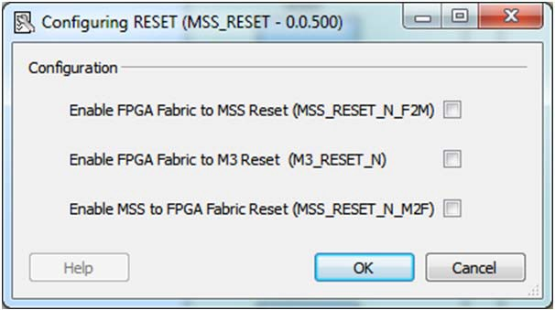

Figure 1 • MSS RESET Controller Configurator

Microsemi SoC Products Group backs its products with various support services, including Customer Service, Customer Technical Support Center, a website, electronic mail, and worldwide sales offices. This appendix contains information about contacting Microsemi SoC Products Group and using these support services.

Customer Service

Contact Customer Service for non-technical product support, such as product pricing, product upgrades, update information, order status, and authorization.
From North America, call 800.262.1060 From the rest of the world, call 650.318.4460
Fax, from anywhere in the world, 408.643.6913

Customer Technical Support Center

Microsemi SoC Products Group staffs its Customer Technical Support Center with highly skilled engineers who can help answer your hardware, software, and design questions about Microsemi SoC Products. The Customer Technical Support Center spends a great deal of time creating application notes, answers to common design cycle questions, documentation of known issues, and various FAQs. So, before you contact us, please visit our online resources. It is very likely we have already answered your questions.

Technical Support

Visit the Customer Support website (www.microsemi.com/soc/support/search/default.aspx) for more information and support. Many answers available on the searchable web resource include diagrams, illustrations, and links to other resources on the website.

Website

You can browse a variety of technical and non-technical information on the SoC home page, at
www.microsemi.com/soc.

Contacting the Customer Technical Support Center

Highly skilled engineers staff the Technical Support Center. The Technical Support Center can be contacted by email or through the Microsemi SoC Products Group website.

Email

You can communicate your technical questions to our email address and receive answers back by email, fax, or phone. Also, if you have design problems, you can email your design files to receive assistance. We constantly monitor the email account throughout the day. When sending your request to us, please be sure to include your full name, company name, and your contact information for efficient processing of your request.
The technical support email address is soc_tech@microsemi.com.

My Cases

Microsemi SoC Products Group customers may submit and track technical cases online by going to My Cases.

Outside the U.S.

Customers needing assistance outside the US time zones can either contact technical support via email (soc_tech@microsemi.com) or contact a local sales office. Sales office listings can be found at www.microsemi.com/soc/company/contact/default.aspx.

ITAR Technical Support

For technical support on RH and RT FPGAs that are regulated by International Traffic in Arms Regulations (ITAR), contact us via soc_tech_itar@microsemi.com. Alternatively, within My Cases, select Yes in the ITAR drop-down list. For a complete list of ITAR-regulated Microsemi FPGAs, visit the ITAR web page.

Microsemi Corporate Headquarters
One Enterprise, Aliso Viejo CA 92656 USA Within the USA: +1 (949) 380-6100
Sales: +1 (949) 380-6136
Fax: +1 (949) 215-4996
Microsemi Corporation (NASDAQ: MSCC) offers a comprehensive portfolio of semiconductor solutions for: aerospace, defense and security; enterprise and communications; and industrial and alternative energy markets. Products include high-performance, high-reliability analog and RF devices, mixed signal and RF integrated circuits, customizable SoCs, FPGAs, and complete subsystems. Microsemi is headquartered in Aliso Viejo, Calif. Learn more at www.microsemi.com.

© 2012 Microsemi Corporation. All rights reserved. Microsemi and the Microsemi logo are trademarks of Microsemi Corporation. All other trademarks and service marks are the property of their respective owners.

5-02-00352-0/09.12

