GB ENHANCED+ USER MANUAL



Version 1.10
D.S. Baxter
April 1st, 2026
0. Table of Contents GB Enhanced+ Manual - 2

1. Foreword 4

2. Getting Started 5
2.1 :: Obtaining, Compiling, & Installing GBE+ 6
2.2 :: Command-Line Options 7

3. Configuration 11 3.1 :: General Settings 11
3.2 :: Display Settings 20
3.3 :: Sound Settings 22
3.4 :: Controls Settings 24
3.5 :: Netplay Settings 32
3.6 :: Paths Settings 34
3.7 ::The .ini File 36
3.8 :: The Cheat File 37

4. Debugging 38
4.1 :: Memory Mapped I/O Registers 38
4.2 :: Palettes 39
4.3 :: Memory Viewer 40
4.4 :: Disassembly 41
4.5 :: OBJ Tiles 43
4.6 :: BG Tiles 44
4.7 :: The Command-Line Debugger 45

5. Netplay 53
5.1 :: Netplay Guide 53
5.2 :: DMG-07 Setup 54
5.3 :: Net Gate 55
5.4 :: Pokemon Mini IR 56
5.5 :: Campho Advance 58
5.6 :: HuC-1 and HuC-3 IR Connectivity 59

6. Game Specific Instructions 60
6.1 :: Advance Movie Adapter 60
6.2 :: Agatsuma TV Tuner 60
6.3 :: Barcode Boy Games 60
6.4 :: Barcode Taisen Bardigun 61
6.5 :: Battle Chip Gate Games 61
6.6 :: Bayer Didget 61
6.7 :: Boktai Games 61
6.8 :: Bomberman Max Red/Blue, Mission Impossible 61
6.9 :: Bouken Yuuki Pluster World Games 62
0. Table of Contents GB Enhanced+ Manual - 3

6.10 :: Campho Advance 62
6.11 :: Carrera Go Powerslide 62
6.12 :: Chee Chai Alien 62
6.13 :: Cyber Drive Zoids 62
6.14 :: Drill Dozer 62
6.15 :: GBA Music Recorder / Jukebox 63
6.16 :: GBA Wireless Adapter 63
6.17 :: GBC Infrared Games 63
6.18 :: GB KISS Games 63
6.19 :: GB KISS LINK 64
6.20 :: GB Memory Cartridge 64
6.21 :: Glucoboy 64
6.22 :: Gyogun Tanchiki: Pocket Sonar 64
6.23 :: Joy Carry Cartridge 65
6.24 :: Juushinden: Ultimate Beast Battlers 65
6.25 :: Kirby Tilt ‘n’ Tumble 65
6.26 :: Koro Koro Puzzle 65
6.27 :: Legendz: Isle of Trial/Sign of Nekrom 65
6.28 :: Magical Watch 65
6.29 :: Mobile Adapter GB Games 66
6.30 :: My Weight Loss Coach/My Health Coach: Manage Your Weight 66
6.31 :: NDS Rumble Pak Games 66
6.32 :: Play-Yan & Play-Yan Micro & Nintendo MP3 Player 66
6.33 :: Pokemon Gold, Silver, and Crystal 66
6.34 :: Pokemon Ruby, Sapphire, and Emerald 67
6.35 :: Sakura Taisen GB 67
6.36 :: Sega Card Reader Games 67
6.37 :: Singer Izek 1500/Jaguar JN-2000/Jaguar JN-100 Software 68
6.38 :: Telefang/Network Adventure Bugsite Games 68
6.39 :: Turbo File GB/Turbo File Advance Games 68
6.40 :: Vaus Controller 69
6.41 :: Wantame Card Scanner 69
6.42 :: Wave Scanner 69
6.43 :: WarioWare: Twisted 69
6.44 :: WorkBoy 69
6.45 :: Yoshi Topsy Turvy/Yoshi’s Universal Gravitation 70
6.46 :: Zok Zok Heroes 70
6.47 :: Encoding and Playing Video 70

7. FAQ 71

8. Credits & Acknowledgments 74
1. Foreword GB Enhanced+ Manual - 4

1. Foreword

This manual will attempt to cover all the functions users may encounter while operating GB Enhanced+. The information contained herein doubles as both an operating guide and reference to the emulator’s various features.

GB Enhanced+ is the successor to the original GB Enhanced project (note the shiny “+”). It is a Game Boy, Game Boy Color, Game Boy Advance, NDS, and Pokemon Mini emulator that aims to be at the forefront of video game preservation by emulating a vast array of the Game Boy’s many accessories. From the widely-known Game Boy Camera and Printer, to the exotic and obscure Barcode Boy, one of GBE+’s primary goals is to recreate all of these devices through software. History deserves to be documented and remembered, and to that end, GBE+ plays all sorts of games that used specialty hardware or weird features. With any luck, eventually every crazy add-on imaginable will added to the project.

What started as an idle dream to make my own NDS emulator has become something much more than the humble project I founded in 2012. There is still a lot more to go through before I can see my vision completed, however, I believe this project is on the right path. In the coming years, we’ll see where the road takes this emulator. In the meantime, I hope this manual will give users an insight to how the programs works, what it’s capable of, and where it’s going.

D.S. Baxter - aka Shonumi
2. Getting Started GB Enhanced+ Manual - 5

2. Getting Started

Getting started with GBE+ is relatively simple. The emulator does not have many requirements to build from source, and installation should be simple for most operating systems. Please consider, however, that GBE+ has not been tested on OS X/macOS in any way, shape, or form. This is due to the lack of access to the operating system. Users can still build it themselves on OS X/macOS.

Currently, GBE+ has minimal hardware requirements. Any recent computer should be able to run the emulator just fine. It should be noted, however, that as of 1.8, GBA games in general may eat up a lot of CPU resources. This is due to inefficiencies in the GBA core that will be addressed at some point. Most mid-range computers and above won’t notice anything performance-wise, but weaker computers, particularly those with Ultra-Low Voltage CPUs, may experience slowdowns with the GBA core. The NDS core is similarly unoptimized at the moment. Otherwise GBE+ is not a demanding emulator.

GBE+ aims to build and run with minimal software dependencies. The recommended minimum version of OpenGL is 3.3. Any computer released in the past decade should support this without any trouble. Future versions of GBE+ may add support for Vulkan.

Currently, GBE+ supports both 32-bit and 64-bit systems. For the foreseeable future, this will remain the case. For CPU emulation, any dynamic recompilers added to later releases, will only target x64 systems. Nevertheless, GBE+ will technically continue to support 32-bit systems at that time through CPU interpreters.

For a general roadmap of where GBE+ will go from here, please see the FAQ in Section 7 for more details.
2.1 Obtaining, Compiling, & Installing GBE+ GB Enhanced+ Manual - 6

2.1 Obtaining, Compiling, & Installing GBE+

For Windows users who do not want to build from source code, please visit the project’s GitHub page and check out the 1.9 release on the Release page. Download the zip file and extract it. Simply double-click the executable file gbe_plus_qt.exe to run the GUI version of the emulator. For those interested in the command-line version of GBE+, run the gbe_plus.exe file from the command prompt. The majority of this manual focuses on the Qt version of GBE+, however, please refer to Section 2.2 for more details about running the command-line version.

Linux users have to compile the source code themselves. The build process on Windows is virtually unchanged when using the MSYS2 toolchain and msysgit. Compiling from source requires prior installation of the following programs and libraries:

- GIT
- CMake
- SDL 2.0
- SDL_net 2.0 (optional, for netplay support)
- SDL_image 2.0 (optional, for video playback)
- OpenGL
- Qt5 (optional, for the GUI)
- GLEW (Windows only)

CMake will check to make sure it can find all of the necessary dependencies before the build process begins. Before that happens, however, GIT must retrieve the source, or the source tarball from the Release page must be downloaded and extracted. The following terminal instructions detail how to download the source code through GIT, compile it, and install the emulator:

git clone https://github.com/shonumi/gbe-plus.git
cd gbe-plus
mkdir build && cd build
cmake ..
make && make install

Note that this will install the very latest source code. GIT can check out specific revisions based on the hash of that commit. Consult the GIT documentation for checking out revisions and the GBE+ GitHub repository for the appropriate hash. Once CMake installs GBE+, the emulator can be called via gbe_plus for the command-line version, or gbe_plus_qt for the Qt version.
2.2 Command-Line Options GB Enhanced+ Manual - 7

2.2 Command-Line Options

The command-line version of GBE+ accepts several parameters. Below are all the valid arguments for the emulator along with a short description of what they do:

-b or --bios [FILE]:
This instructs GBE+ to boot a system’s BIOS or Boot ROM with the provided file when loading a game. The second argument is the exact path for the BIOS or Boot ROM on the user’s computer.

-fw or --firmware [FILE]:
This instructs GBE+ to boot the NDS firmware with the provided file. NDS firmware does not currently run in GBE+.

-d or --debug:
This starts GBE+ in debug mode. It will pull up the command-line debugger. See Section 5.7 for details on how to use properly use this version of the debugger.

--opengl:
This forces GBE+ to use OpenGL for all drawing/blitting operations instead of SDL.

--2x, --3x, --4x, --5x, --6x:
Scales the screen by a given factor. Only applicable when OpenGL is enabled.

--sys-auto:
Sets the emulated system type to AUTO. In this mode, GBE+ will automatically determine what system to emulate based on the game.

--sys-dmg:
Sets the emulated system type to DMG (old black and white Gameboy). This option is not valid when running GBA games and is ignored by the emulator.

--sys-gbc:
Sets the emulated system type to GBC. This option is not valid when running GBA games and is ignored by the emulator. DMG games will run as if on a GBC.

--sys-gba:
Sets the emulated system type to GBA. DMG/GBC games will run as if on a GBC, however, like a real GBA, the screen can be stretched horizontally by pressing the L and R triggers.

--sys-nds:
Sets the emulated system type to NDS.

--sys-sgb:
Sets the emulated system type to SGB. Allows GBE+ to display Super Game Boy borders. Borders can be toggled by pressing the L and R triggers.

--sys-sgb2:
Sets the emulated system type to SGB2. Allows GBE+ to display Super Game Boy and Super Game Boy 2 borders. Borders can be toggled by pressing the L and R triggers.
2.2 Command-Line Options GB Enhanced+ Manual - 8

--sys-min:
Sets the emulated system type to Pokemon Mini.

--mbc1m:
Forcibly emulates MBC1 games as MBC1M variants. Use this option for games like Mortal Kombat I & II, or Bomberman Collection.

--mm01:
Forcibly emulates an MM01 multicart.

--mbc1s:
Forcibly emulates an MBC1S cartridge used for the Pocket Sonar.

--mbc30:
Forcibly emulates an MBC30 cartridge. Used for Japanese version of Pokemon Crystal to access online mobile features.

--m161:
Forcibly emulates an M161 multicart. Used for the Mani 4-in-1 cartridge.

--gbmem:
Forcibly emulates a GB Memory Cartridge.

--huc-ir:
Forcibly emulates a HuC-1 or HuC-3 cartridge with infrared connectivity enabled.

--agb-rtc:
Forcibly emulates a GBA cart with an real-time clock.

--agb-rumble:
Forcibly emulates a GBA cart with rumble. Used for Drill Dozer.

--agb-solar-sensor:
Forcibly emulates a GBA cart with a solar sensor. Used for the Boktai games.

--agb-tilt-sensor:
Forcibly emulates a GBA cart with a tilt sensor. Used for Yoshi Topsy Turvy/Universal Gravitation

--agb-gyro-sensor:
Forcibly emulates a GBA cart with a gyro sensor. Used for WarioWare: Twisted.

--agb-dacs
Forcibly emulates a GBA cart with an 8M DACS. Used for Hikaru no Go and the Joy Carry Cartridge.

--agb-jukebox
Forcibly emulates a GBA Music Recorder/Jukebox cartridge.

--agb-am3
Forcibly emulates an Advance Movie Adapter along with AM3 files.
2.2 Command-Line Options GB Enhanced+ Manual - 9

--agb-play-yan:
Forcibly emulates the original Play-Yan or Play-Yan Micro cartridge.

--agb-campho:
Forcibly emulates the Campho Advance cartridge.

--agb-glucoboy:
Forcibly emulates the Glucoboy cartridge.

--agb-tv-tuner:
Forcibly emulates the Agatsuma TV Tuner.

--slot2-gba:
Specifies a file to use when emulating NDS games that access GBA ROM via Slot-2.

--cheats:
Enables Game Shark and Game Genie cheats.

--patch:
Enables patching for the current ROM.

--turbo-file-memcard:
Enables the memory card for the Turbo File GB or Turbo File Advance.

--turbo-file-protect:
Enables write protection for the Turbo File GB or Turbo File Advance.

--ignore-illegal-opcodes:
Continue running a core when the emulated CPU encounters and unknown or illegal CPU instruction. May be useful in some debugging instances.

--auto-gen-smid
Automatically generate a 16-byte DES key (also known as an SMID file) for a given AM3 file.

--dump-am3-files
Extracts all files from an AM3 SmartMedia disc image.

--min-disable-colors
Disables 3-Color mode (color blending) for the Pokemon Mini core.

--min-disable-rtc
Disables the RTC for the Pokemon Mini core.

--min-shared-eeprom
Enables using a single shared EEPROM file for all Pokemon Mini games (like real hardware).

-mf, or --max-fps
Caps the maximum frames-per second to the value passed to GBE+.

2.2 Command-Line Options GB Enhanced+ Manual - 10

-ad, or --audio-driver
Manually selects an audio driver for SDL2 to use

--save-auto:
Automatically detects GBA save type.

--save-none:
Disables all GBA game saves.

--save-sram:
Forces GBA save type to SRAM.

--save-eeprom:
Forces GBA save type to EEPROM.

--save-flash64:
Forces GBA save type to FLASH RAM (64KB).

--save-flash128:
Forces GBA save type to FLASH RAM (128KB).

--save-import:
Specifies a save file that GBE+ will read from instead of automatically selecting one.

--save-export:
Specifies a save file that GBE+ will write to instead of automatically selecting one.

--am3-folder:
Specifies a folder containing AM3 files that GBE+ will use when emulating the Advance Movie Adapter. GBE+ will use this instead of a SmartMedia card image.

--use-legacy-save-size:
Use the old 128KB save size that GBE+ formerly set for DMG/GBC games.

--f, or --fullscreen:
Boots GBE+ into fullscreen mode.

--h, or --help:
Displays a brief help message explaining all of the above options.

NOCART:
Forces GBE+ to emulate a system booting up with no cartridge inserted. This option replaces the filename typically passed to GBE+. Only applicable to the DMG/GBC, GBA, and Pokemon Mini cores.

3. Configuration GB Enhanced+ Manual - 11

3. Configuration

GBE+ has many options that will affect how the program runs games. There are 6 major areas of configuration: General Settings, Display Settings, Sound Settings, Control Settings, Netplay, and Paths. The following sections detail what these options do for the Qt version of the emulator.

3.1 General Settings

This section deals with miscellaneous settings that don’t belong to any particular category.

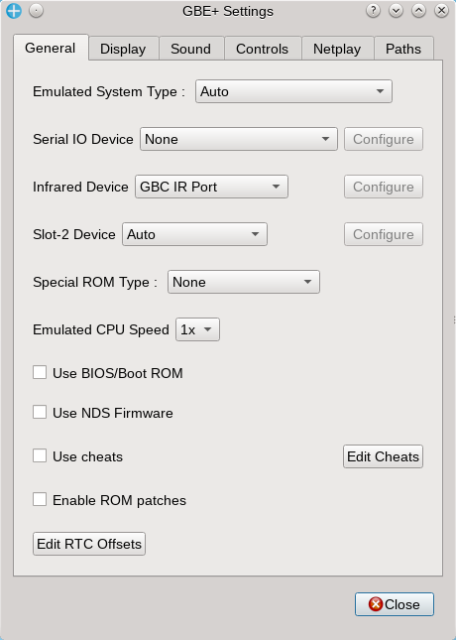

Emulated System Type:
Forces GBE+ to emulate a certain system. The following options are:

Auto: In this mode, GBE+ will automatically determine what system to emulate based on the game.

Game Boy [DMG]: Emulates the DMG (old black and white Gameboy). This option is not valid when running GBA games and is ignored by the emulator.

3. Configuration GB Enhanced+ Manual - 12

Game Boy Color [GBC]: Emulates the GBC. This option is not valid when running GBA games and is ignored by the emulator. DMG games will run as if on a GBC.

Game Boy Advance [GBA]: Emulates the GBA. DMG/GBC games will run as if on a GBC, however, like a real GBA, the screen can be stretched horizontally by pressing the L and R triggers.

Nintendo DS [NDS]: Emulates the NDS. Most NDS games are detected automatically, so this setting does not need to be explicitly changed. NDS emulation is a work-in-progress.

Super Game Boy [SGB]: Emulates the Super Game Boy. The border can be disabled by pressing the input assigned to the R trigger, and disabled by pressing the input assigned to the L trigger.

Super Game Boy 2 [SGB2]: Emulates the Super Game Boy 2. The is basically the same as the Super Game Boy, except some games such as Tetris DX will show different borders.

Pokemon Mini: Emulates the Pokemon Mini. This core requires the appropriate BIOS to run.

Serial IO Device:
Specifies the type of device that should be connected to the emulated Game Boy. The following options are:

None: Emulates a regular Game Boy with nothing attached to it.

GB Link Cable: Emulates the GB Link Cable used for GB and GBC games. This option is necessary for netplay to work. See Section 5.1 for more details on setting up netplay.

GB Printer: Emulates the GB Printer. Images generated by the GB Printer are automatically saved to the screenshot directory. See Section 3.6 for more details on setting up the screenshot directory.

GB Mobile Adapter: Emulates the GB Mobile Adapter used in a limited number of Japan-only games. Support is currently limited to booting GB Mobile Trainer.

Bardigun Barcode Scanner: Emulates the card scanner for Barcode Taisen Bardigun. See Section 6 for more details.

Barcode Boy: Emulates the Barcode Boy card scanner. See Section 6 for more details.

DMG-07: Emulates the DMG-07 4-player adapter. See Section 5.1 for general netplay configuration and specifically Section 5.2 for configuring netplay for the DMG-07.

GBA Link Cable: Emulates the GBA Link Cable used for GBA games. This option is still experimental and not currently functional.

GB Player Rumble: Emulates the special rumble feature some GBA games unlock when using the Game Boy Player. The rumble feature must also be enabled in the controller settings. See Sections 3.4 for more details.

Soul Doll Adapter: Emulates the Soul Doll Adapter for the GBA games Legendz: Isle of Trial and Legendz: Sign of Nekrom. See Section 6 for more details.
3. Configuration GB Enhanced+ Manual - 13

Battle Chip Gate: Emulates the Battle Chip Gate used in various Mega Man games on the GBA. See Section 3.4 and Section 6 for more details.

Progress Chip Gate: Emulates the Progress Chip Gate used for Megaman Battle Network 5/Rockman.EXE 5. See Section 6 for more details.

Beast Link Gate: Emulates the Beast Link Gate used for Megaman Battle Network 6/Rockman.EXE 6. See Section 6 for more details.

Power Antenna: Emulates all versions of the Power Antenna/Bug Sensor for the Telefang games. See Section 6 for more details.

Sewing Machine: Emulates the IZEK 1500, Jaguar JN-100, and Jaguar JN-2000 sewing machines. This feature very experimental. See Section 6 for more details.

Multi Plust On System: Emulates the Multi Plust On System accessory used for the Bouken Yuuki Pluster World franchise games. See Section 6 for more details.

Turbo File GB/Advance: Emulates both the Turbo File GB and Turbo File Advance external storage devices. See Section 6 for more details.

AGB-006: Emulates GBA Infrared Adapter, used for the game Cyber Drive Zoids. See Section 6 for more details.

V.R.S: Emulates the Virtureal Racing System, used with Carrera Go Powerslide. See Section 6 for more details.

Magical Watch: Emulates the Magical Watch, used with Wagamama Fairy Mirumo de Pon! - 8 Nin no Toki no Yousei. See Section 6 for more details.

GBA Wireless Adapter: Emulates the GBA Wireless Adapter used with a limited number of GBA titles. See Section 6 for more details.

Vaus Controller: Emulates the unreleased Vaus Controller for Alleyway on the Game Boy. See Section 6 for more details.

WorkBoy: Emulates the unreleased WorkBoy accessory. See Section 6 for more details.

Please note that when changing the Serial IO Device option during gameplay, it will only take effect when resetting or booting a new game.

Infrared Device:
Specifies the type of infrared device that should be connected to the emulated Game Boy Color. The following options are:

None: Emulates a regular system connected to no infrared devices.

GBC IR Port: Emulates the standard GBC IR port, used in various GBC-to-GBC communications. If a game does not use the GBC IR port (e.g. older DMG games) this option has no effect.
3. Configuration GB Enhanced+ Manual - 14

Full Changer: Emulates the Full Changer accessory used with Zok Zok Heroes. Click the Configure button for more options. See Section 6 for more details.

Pokemon Pikachu 2: Emulates IR communications with the Pokemon Pikachu 2. Click the Configure button for more options. See Section 6 for more details.

Pocket Sakura: Emulates IR communications with the Pocket Sakura. Click the Configure button for more options. See Section 6 for more details.

TV Remote: Emulates random IR signals as if from a TV remote. See Section 6 for more details.

Constant IR Light: Emulates a constant IR light in Chee Chai Alien. See Section 6 for more details.

Zoids CDZ Model: Emulates a generic robotic model, used for the game Cyber Drive Zoids. See Section 6 for more details.

NTR-027: Partially emulates the Activity Meter, used with the games Personal Trainer: Walking/Walk With Me and Active Health. See Section 6 for more details.

IR Noise: Generates random ON/OFF signals for the GBC infrared port. Used for some games. See Section 6 for more details.

GB KISS LINK: Emulates the GB KISS LINK infrared modem, used to transfer files to and from certain Game Boy Games. This is separate from the Game Boy-to-Game Boy HuC-1 or HuC-3 infrared communications (see Special ROM Type for more details in this section). See Section 6 for more details.

Slot-2 Device:
Specifies the type of Slot-2 device inserted into the emulated NDS. The following options are:

Auto: GBE+ will automatically set the Slot-2 device to PassMe if required by homebrew software, otherwise it acts as if set to None.

None: Emulates an empty Slot-2 on the NDS with nothing inserted.

PassMe: Emulates the PassMe device necessary for some homebrew.

Rumble Cart: Emulates the Rumble Pak. The rumble feature must also be enabled in the controller settings. See Sections 3.4 and Section 6 for more details.

GBA Cart: Emulates inserting a GBA game into Slot-2. Currently does not work.

Ubisoft Thrustmaster Pedometer: Emulates a pedometer used for the game My Weight Loss Coach / My Health Coach: Manage Your Weight. See Section 6 for more details.

HCV-1000: Emulates the HCV-1000 card reader. See Section 6 for more details.

Magic Reader: Emulates the Magic Reader card reader. See Section 6 for more details.
3. Configuration GB Enhanced+ Manual - 15

Memory Expansion Pak: Emulates the 8MB RAM expansion pak used for the Opera Browser. Currently not usable aside from booting the browser.

Motion Pack: Partially emulates the Motion Pack used for the game Tony Hawk's Motion. Currently not usable aside from booting the game.

Facening Scan: Partially emulates the Facening Scan / NTR-014. Currently not usable.

Bayer Didget: Emulates the Bayer Didget glucose meter. See Section 6 for more details.

Microphone Device:
Specifies the type of microphone device to be used for the emulated NDS. The following options are:

None: Emulates a regular NDS with no microphone input.

NDS Microphone: Emulates NDS microphone input by accessing the user's own microphone. Currently not implemented.

WAV File: Emulates NDS microphone input by reading and using a WAV file. Currently not implemented.

Noise: Emulates NDS microphone input with random values.

Wantame Card Scanner: Emulates the Wantame Card Scanner connected to the DS' microphone port. See Section 6 for more details.

Wave Scanner: Emulates the Wave Scanner connected to the DS' microphone port. See Section 6 for more details.

Special ROM Type:
Some games have unique cartridges that are not easily detected automatically. In these cases, GBE+ can manually specify what type of cartridge to emulate. The following options are:

None: GBE+ will not emulate any of the supported special cartridge types. If unsure, leave this as the default option.

DMG - MBC1M: Emulates MBC1 multicart variants known as MBC1M. Use this for games like Mortal Kombat I & II or Bomberman Collection.

DMG - MBC1S: Emulates the MBC1S cartridge used for Pocket Sonar. See Section 6 for more details.

DMG - MMM01: Emulates MMM01 multicarts. Use this for games like Taito Variety Pack or Momotarou Collection 2.

DMG - M161: Emulates the Chinese Mani-4-in-1 multicart.

DMG - MBC30: Emulates the MBC30. Use this for Pocket Monsters Crystal, especially when trying to unlock Mobile Adapter functionality.
3. Configuration GB Enhanced+ Manual - 16

DMG - GB Memory: Emulates the GB Memory cartridge. See Section 6 for more details.

DMG - HuC IR Cart: Emulates the HuC-1/HuC-3 infrared diodes. See Sections 5.6 and 6 for more details.

AGB - Solar Sensor: Emulates the Solar Sensor found in the Boktai games. The intensity of the sunlight can be controlled dynamically via Context Up and Context Down controls. See Sections 3.4 and Section 6 for more details.

AGB - Rumble: Emulates the rumble found in Drill Dozer. This is not to be confused with the rumble feature used for Game Boy Player games like Pokemon Pinball: Ruby & Sapphire or Mario & Luigi: Superstar Saga (which is mostly unsupported in GBE+). The rumble feature must also be enabled in the controller settings. See Sections 3.4 and Section 6 for more details.

AGB - Gyro Sensor: Emulates the gyroscope sensor in WarioWare: Twisted. The game can be played with Context Left and Context Right controls. See Sections 3.4 and Section 6 for more details.

AGB - Tilt Sensor: Emulates the tilt sensor in Yoshi Topsy-Turvy / Universal Gravitation and Koro Koro Puzzle. These game can be played with Context Up, Context Down, Context Left, and Context Right controls. See Sections 3.4 and Section 6 for more details.

AGB - RTC: Emulates the Real-Time Clock found on some GBA games. Use this for games like Pokemon Ruby, Sapphire, and Emerald, as well a The RTC can be artificially manipulated via RTC offsets. See more about that option further down in the section.

AGB - 8M DACS: Emulates the 8M DACS used in the Joy Carry Cartridge. See Section 6 for more details.

AGB - AM3: Emulates the Advance Movie Adapter used for watching movies on SmartMedia cards. See Section 6 for more details.

AGB - Jukebox: Emulates the GBA Music Recorder/Jukebox used for playing and recording music files. See Section 7 for more details.

AGB - Play-Yan: Emulates the original Play-Yan, Play-Yan Micro, and Nintendo MP3 Player. See Section 6 for more details.

AGB - Campho: Emulates the Campho Advance. See Section 6 for more details.

AGB - Glucoboy: Emulates the Glucboy. See Section 6 for more details.

AGB - TV Tuner: Emulates the Agatsuma TV Tuner. See Section 6 for more details.

NDS - IR Cart: Partially emulates the NTR-031 cartridge with infrared functionality.

Emulated CPU Speed:
Alters the CPU’s speed by 1x, 2x, 4x, or 8x. Only works for the DMG/GBC/SGB core!
3. Configuration GB Enhanced+ Manual - 17

Use BIOS/Boot ROM:
This instructs GBE+ to boot a system’s BIOS or Boot ROM. When checking this option, users must ensure that the proper paths to the DMG, GBC, or GBA files are configured. See Section 3.6 for more details on configuring BIOS and Boot ROM files.

User NDS Firmware:
This instructs GBE+ to load and boot the NDS core using a given firmware file. Currently not working.

3. Configuration GB Enhanced+ Manual - 18

Use cheats:
Enables cheats for DMG and GBC games via GameShark and Game Genie codes. Both code types can be used simultaneously. To add, delete, and modify cheats, click on the Edit Cheats button to enter the following menu:

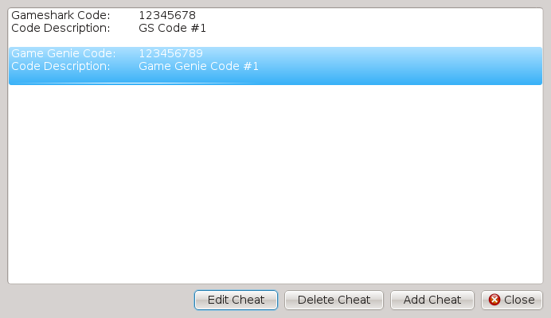

Current cheats are displayed in a list like such. To edit or delete a specific cheat, click on it and highlight it as the screenshot above demonstrates, then click the Edit Cheat or Delete Cheat button. Add Cheat will bring up a menu such as this:

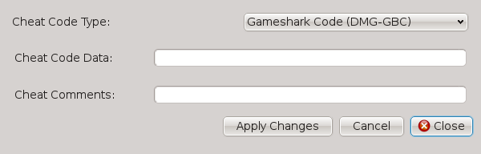

Select the cheat code type, then enter the cheat code data. Comments can be added to each cheat. If cheat code data format is incorrect, GBE+ will set it to 0, in which case, please edit the cheat to correct it. Cheats are loaded from and saved to the specified cheat file if available. See Section 3.8 for more info.

For the GBA, GBE+ supports V1 and V2 GameShark/Action Replay codes.
3.1 General Settings GB Enhanced+ Manual - 19

Use ROM patches:
Applies IPS or UPS patches when booting a game. The patch must match the ROM filename, except for the extension. For example, the patch file for Super_Mario.gb would be Super_Mario.ips or Super_Mario.ups. Note that BPS files are not yet supported.

Edit RTC Offsets:
Some games - such as Pokemon Gold, Silver, Crystal, Ruby, Sapphire, and Emerald - take advantage of special cartridges that have real-time clocks in them. It can also somewhat adjust the system clock on the Pokemon Mini. GBE+ will use the current system time for this feature, however, users can manually adjust the clock without having to change their system clock. GBE+ will add values to the current time; this makes it possible to jump from day to night and back again in the Pokemon games with minimal effort. The following screen is used for editing RTC offsets:

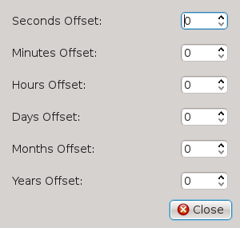

3.2 Display Settings GB Enhanced+ Manual - 20

3.2 Display Settings

Display settings deal with how GBE+ draws things on screen.

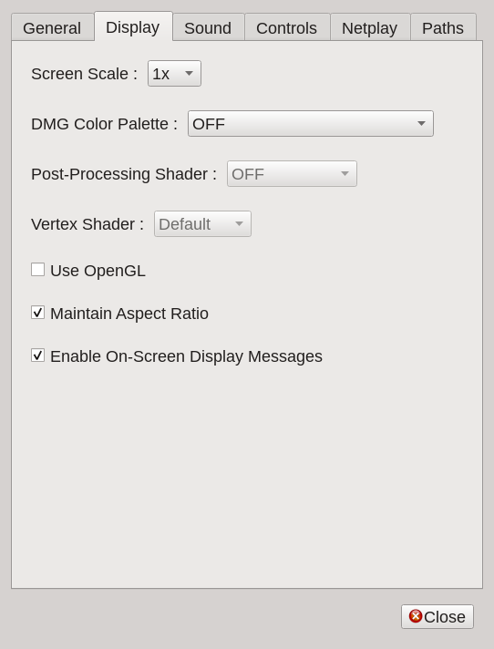

Screen Scale:
Determines what factor to scale the original game screen. Factors of 1x to 10x are applicable. Unlike the command-line version, the Qt version can scale the image regardless of whether OpenGL is used or not.

DMG Color Palette:
DMG games can be colorized with special palettes. OFF emulates standard grayscale colors. DMG - Classic Green emulates the old-school green LCD. The other options emulate palettes from the GBC Boot ROM.

Post-Processing Shader:
Applies various shaders (if any) to the final output image. Used to create different special effects or for scaling algorithms. OpenGL must be selected to use this option. Changing this option during gameplay takes effect immediately.

3.2 Display Settings GB Enhanced+ Manual - 21

Vertex Shader:
Applies a vertex shader to the final output image. Used for unique transformations, such as inverting the image on the X-axis.

Use OpenGL:
Use OpenGL for all drawing/blitting operations. This option is faster than using software, especially when increasing the Screen Scale.

Maintain Aspect Ratio:
Forces GBE+ to maintain the same aspect ratio as the original system regardless of the window size. Leaving this option unchecked will let GBE+ fill in the available window space.

Enable On-Screen Display Messages:
Allows GBE+ to draw brief text messages on-screen when certain actions occur, such as loading/saving save states or taking a screenshot.
3.3 Sound Settings GB Enhanced+ Manual - 22

3.3 Sound Settings

Sound settings determine how GBE+ will process audio.

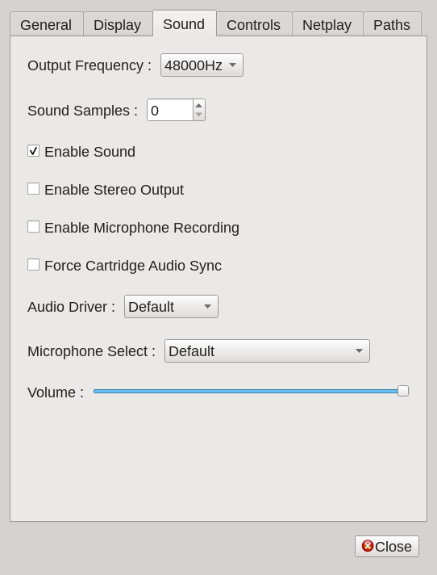

Output Frequency:
Determines the final output frequency of all sound. The available options are 11025Hz, 22050Hz, 44100Hz, and 48000Hz. With higher frequencies, GBE+ will produce better audio quality. Please note, changing this option only takes effect when booting or resetting a game. If unsure, please leave this option at its default setting.

Enable Sound:
Checking this option enables sound output. Unchecking this option will mute any sounds from GBE+.

Enable Stereo Output:
Checking this option enabled stereo output for DMG/GBC/SGB games. Currently not supported for the GBA and NDS cores.

Enable Microphone Recording:
Checking this option will enable microphone input. This feature is currently exclusive for emulating the GBA Music Recorder / Jukebox or the Campho Advance. Refer to Section 6 for more details.
3.3 Sound Settings GB Enhanced+ Manual - 23

Force Cartridge Audio Sync:
This option forcibly syncs audio playback speed to GBE+'s current framerate. It prevents audio from playing faster than the actual system is being emulated. This option only applies to special cartridges that handle their own audio processing (Play-Yan, Nintendo MP3 Player, and the Agatsuma TV Tuner). It is highly recommended to enable for these cartridges.

Audio Driver:
This option allows GBE+ to manually set SDL2's audio driver. This may be necessary under some operating systems in conjunction with microphone recording. If unsure, please leave this option at its default setting. The menu is automatically populated with any available audio drivers detected on a system.

Microphone Select:
This option allows users to manually select which audio device to use for microphone input, if any devices are available. Changing this option while requires the emulator to reset to take effect.

Volume:
This slider controls the master volume for all sound output from GBE+. Turning it all the way down to zero will effectively mute the emulator.
3.4 Controls Settings GB Enhanced+ Manual - 24

3.4 Controls Settings

Controls settings allow users to configure input for the emulator via the keyboard or joysticks. There are two sections for input configuration, Standard Controls, Advanced Controls, and Virtual Cursor Controls. Featured below are settings for the Standard Controls.

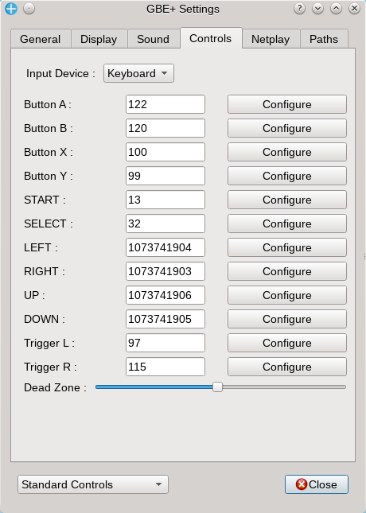

Input Device:
Selects the input device to configure. Both keyboards and joysticks can be configured. This option will contain a list of all available joysticks GBE+ can detect. Please note that both keyboard and joysticks can be used at the same time, regardless of what this option is set to.

Buttons:
These are the individual buttons that can be configured. Press the Configure button for GBE+ to map input from a device. For joysticks, there is a 3 second delay before configuration is processed. During this time, please continue holding down on the joystick for GBE+ to finish mapping.

Dead Zone:
Configures the dead zone for joystick axes. A smaller dead zone means less tilt on an axis is needed to trigger an input. A larger dead zone means more tilt on an axis is needed to trigger an input. If unsure, please leave this option at its default setting.
3.4 Controls Settings GB Enhanced+ Manual - 25

These controls apply to all cores within GBE+. While most of these labels are straightforward for the Game Boy all the way through the NDS, the Pokemon Mini uses slightly different button layout. The following represents how to properly map controls for the Pokemon Mini.

GBE+
___________________________________________
Button A

Button B

Button X

Button Y

Select
Pokemon Mini
___________________________________________
Button A

Button B

Button C

Shock Sensor

Power Button

3.4 Controls Settings GB Enhanced+ Manual - 26

Advanced Controls cover areas like enabling rumble and the Context Buttons.

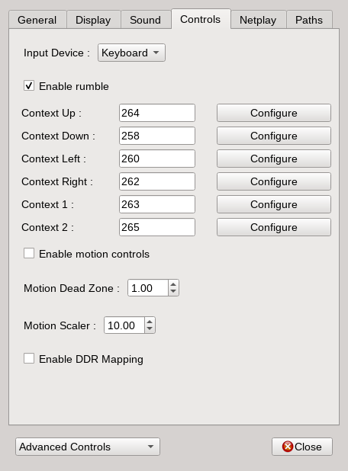

Enable rumble:
Turns on haptic feedback (rumble support) for various games that use rumble carts such as GBC titles like Pokemon Pinball or GBA titles like Drill Dozer or GBA software designed for the Game Boy Player. This option only works for joysticks that support some sort of haptic feedback.

Context Buttons:
Context buttons are meta-buttons that serve different roles depending on certain games. For example, in Kirby Tilt ‘n’ Tumble, the context buttons are used to move “tilt” the emulated GBC up, down, left or right. For WarioWare: Twisted, Context Left and Context Right determine which direction to spin the emulated GBA. For the Boktai games, Context Up and Context Down dynamically control the level of sunlight hitting the sensor. Context Left, Right, Up, and Down are used for the Battle Chip Gate controls on the following page. These buttons are configured exactly like the buttons in Standard Controls.

The Conext buttons have special meanings for the secondary screens used for the sewing machines supported in GBE+ as well as the V.R.S. See Section 6 for more details. The Context buttons are also used for the Virtual Cursor described in the following pages.

3.4 Controls Settings GB Enhanced+ Manual - 27

Enable motion controls:
This option allows GBE+ to take advantage of motion controls found in modern game controllers. This is useful for games that use the MBC7, GBA Tilt Cartridge, or for WarioWare: Twisted. Depending on the game, GBE+ will automatically enable and use gyroscopes or accelerometers. Note that in order for motion controls to work, SDL2 must be able to use the controller's hardware. Additionally, the operating system needs the appropriate drivers installed for that controller.

Motion Dead Zone:
Specifies the minimum amount of movement necessary to activate motion-based input. Smaller dead- zone values require less movement to trigger motion control while larger dead-zones require more movement to trigger motion controls. The value set here will be dependent on the game played, the user's controller, and the user's own preferences.

Motion Scaler:
Specifies the sensitivity of motion controls. Smaller number are smoother, slower, and more sensitive. Larger numbers are rougher, faster, and less sensitive. Users will have to adjust this as needed depending on the game played, the user's controller, and their own preferences.

Enable DDR Mapping:
Switches GBC controls to work with Dance Dance Revolution games and the Finger Pad. When enabled, the Up/Down/Left/Right inputs will correctly correspond with arrows found in DDR games. With this option, it's best to map Up/Down/Left/Right to input other than joysticks or directional pads, such as keyboard arrows. This is due to the fact that sometimes Left/Right and Up/Down inputs need to be pressed at the same time. Be sure to select the correct mode in-game when emulating DDR titles.
3.4 Controls Settings GB Enhanced+ Manual - 28

Hotkey Controls cover certain configurable shortcuts to different actions within GBE+. Currently, hotkeys only apply to keyboard input.

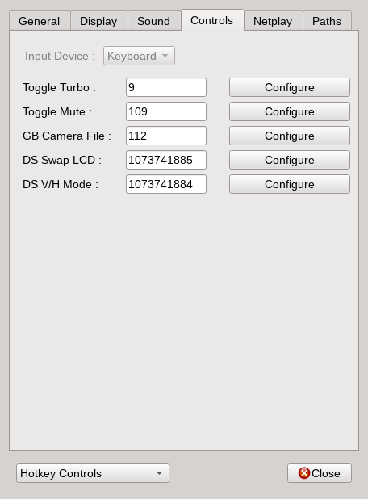

Toggle Turbo:
Lets GBE+ run at maximum speed while this key is held down. Defaults to the TAB key. It should be noted that many OpenGL drivers limit the FPS in some way. Properly configure the OpenGL to allow higher FPS, or simply disable OpenGL in GBE+.

Toggle Mute:
Disables/enables all sound coming from GBE+. Defaults to the M key.

GB Camera File:
Loads an arbitrary BMP file from the user’s computer into VRAM while GBE+ emulates the GB Camera. Defaults to the P key. This basically inserts any image into the GB Camera to take pictures with.

DS Swap LCD:
Switches the top and bottom screens for the NDS core. Defaults to F4.

3.4 Controls Settings GB Enhanced+ Manual - 29

DS V/H Mode:
Switches between vertical and horizon display modes for the NDS core. Defaults to F3.
3.4 Controls Settings GB Enhanced+ Manual - 30

Battle Chip Gate Controls allow players to map specific Battle Chips to the Context Buttons.

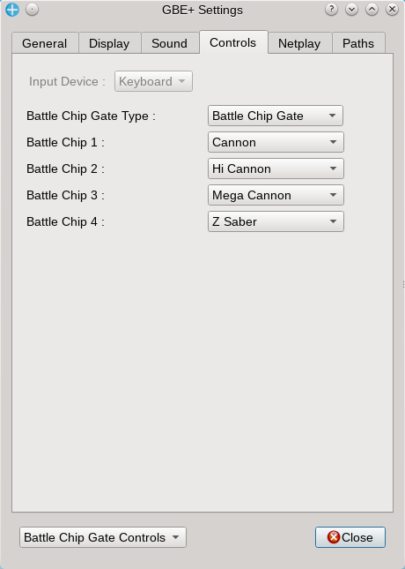

Battle Chip Gate Type:
Chooses between Battle Chip Gate (the original model), Progress Chip Gate, and Beast Link Gate. Changing this option updates the list of available Battle Chips specific to each model. This option does not enable emulation of the Battle Chip Gate accessory. Enabling the Battle Chip Gate must be done through the Serial IO Device option. See Section 3.1 for more details.

Battle Chip 1-4:
Chooses the Battle Chip to use. Battle Chips 1 through 4 are mapped directly to the Context Left, Right, Up, and Down buttons respectively. See Section 6 for details on using the Battle Chip Gate in-game.
3.4 Controls Settings GB Enhanced+ Manual - 31

In GBE+, the NDS core features a "Virtual Cursor", an 8x8 icon that can optionally appear on the emulated touchscreen. This allows users to control the cursor via keyboard or joystick and emulate touchscreen input without having to use the mouse at all.

The Virtual Cursor is moved horizontally and vertically by the Context Left, Right, Up, and Down inputs. Context 1 emulates pressing the stylus down on the touchscreen. These inputs must be configured properly before using the Virtual Cursor. See the previous pages for more details.

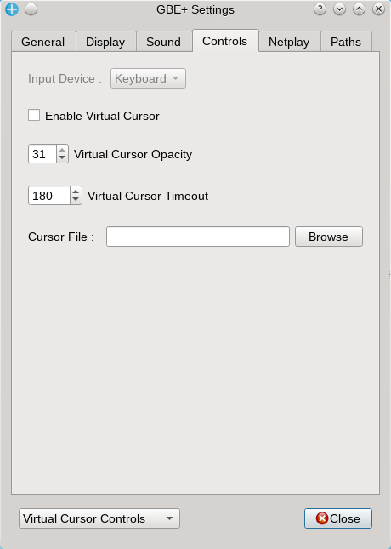

Enable Virtual Cursor:
Checking this option will allow GBE+ to draw the Virtual Cursor when emulating NDS games.

Virtual Cursor Opacity:
Sets the level of alpha-blending to make the Virtual Cursor transparent. Accepts values of 0 (fully transparent) to 31 (fully opaque).

Virtual Cursor Timeout:
Sets the amount of frames to display the Virtual Cursor on-screen until it disappears.

Cursor File:
File path to an 8x8 BMP used for the Virtual Cursor. If blank, GBE+ uses data/misc/vc_default.bmp.
3.5 Netplay Settings GB Enhanced+ Manual - 32

3.5 Netplay Settings

Netplay settings configure networking information necessary for two instances of GBE+ to connect with one another for multiplayer games. For a guide on setting up netplay in GBE+, refer to Section 5.

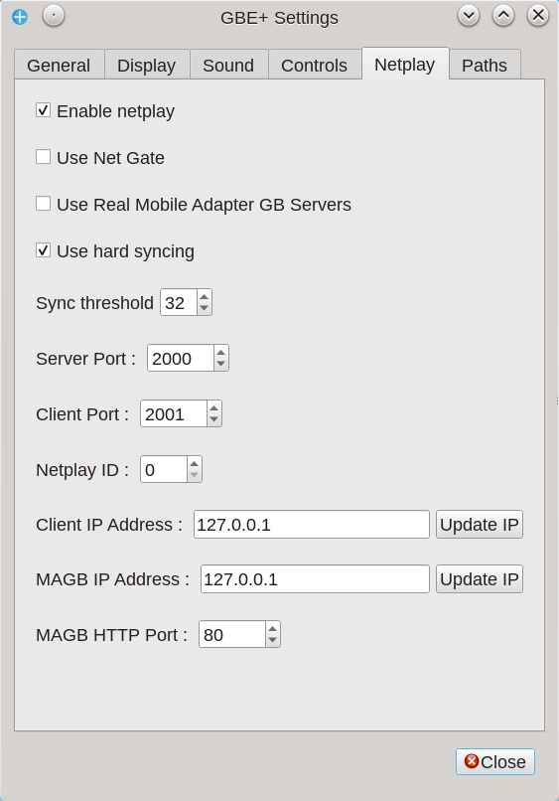

Enable netplay:
Turns on netplay in GBE+.

Use Net Gate:
Allows an external program to connect to GBE+ to send Battle Chips when emulating one of the Battle Chip Gates. See Section 6.3 for more details.

Use Real Mobile Adapter GB Servers:
Allows GBE+ to connect to a custom-made live server that reproduces the functionality of the now defunct Mobile Adapter GB servers. Used in conjunction with something like the REON project.

Sync threshold:
Sets the number of CPU cycles before two instances of GBE+ are synchronized. Used only when hard syncing is enabled. Anywhere from 256 to 32 cycles is recommended for most DMG and GBC games, and lower values of 32 to 4 cycles may be necessary for IR communications. Use 40 for HuC-1/HuC-3.
3.5 Netplay Settings GB Enhanced+ Manual - 33

Use hard syncing:
Forces two instances of GBE+ to synchronize periodically. This may cause slowdowns, but it is also necessary for some games. If this option is unchecked, GBE+ may de-sync or fail to connect properly. If unsure, leave checked.

Server Port:
The port of GBE+ will send data to. This must match the Client Port of another instance of GBE+.

Client Port:
The port GBE+ will receive data from. This must match the Server Port of another instance of GBE+.

Netplay ID:
The current users "Player Number" when using certain netplay modes such as the Pokemon Mini's IR communications or the HuC-1/HuC-3 infrared connectivity.

Client IP Address:
The IPv4 address of the client, a.k.a, the other instance/player GBE+ will connect to.

MAGB IP Address:
The IPv4 address of the custom-made server that Mobile Adapter GB server.

MAGB HTTP Port:
The port GBE+ will use for HTTP transfers when communicating with custom-made Mobile Adapter GB servers. Varies depending on the server, but typically most will use port 80.
3.6 Paths Settings GB Enhanced+ Manual - 34

3.6 Paths Settings

Paths settings determine the location GBE+ will look to for important files such a screenshot directories, or the location of BIOS or Boot ROMs. To set a location, click the Browse button and choose a folder or file from the pop-up.

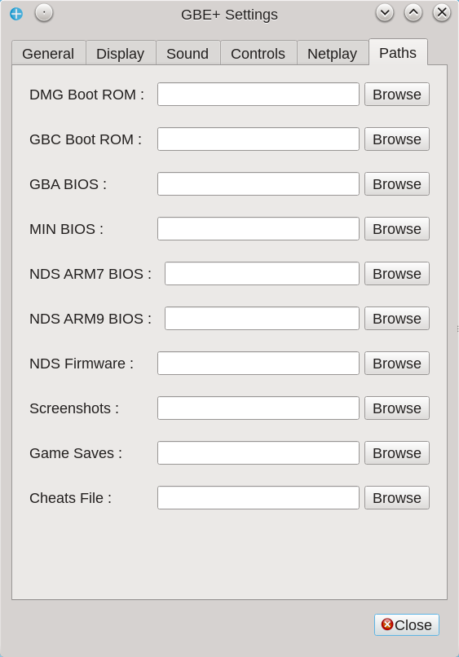

DMG Boot ROM:
This is the original Game Boy’s Boot ROM file. Although booting this will have no effect on overall emulation, this is will let users see the scrolling “Nintendo” logo.

GBC Boot ROM:
This is the Game Boy Color Boot ROM file. Booting up this will let users choose color palettes when running DMG games, and some DMG games (like Metroid II: Return of Samus) will have custom palettes.

GBA BIOS:
This is the Game Boy Advance BIOS file. Booting this up will let users see the GBA’s “Nintendo” logo and the boot animation. Allows for low-level emulation of the GBA BIOS, necessary for some games that use certain sound functions (such as Cyber Drive Zoids).
3.6 Paths Settings GB Enhanced+ Manual - 35

NDS ARM7 BIOS:
This is the ARM7 BIOS of the DS. Currently, all BIOS functions are high-level emulated, so GBE+ does not actually run the code from the ARM7 BIOS. In the future, low-level emulation of the BIOS will be possible.

NDS ARM7 BIOS:
This is the ARM9 BIOS of the DS. Currently, all BIOS functions are high-level emulated, so GBE+ does not actually run the code from the ARM9 BIOS. In the future, low-level emulation of the BIOS will be possible.

MIN BIOS:
This is the Pokemon Mini BIOS file. Booting any Pokemon Mini title requires this file to be present.

NDS Firmware:
This is the firmware file GBE+ will use when booting up the NDS core. Booting from firmware is not possible yet.

Screenshots:
This is the folder GBE+ will use to store screenshots.

Game Saves:
This is the folder GBE+ will use for all game saves. If nothing is specified for this path, GBE+ will look for the save file in the same directory as the ROM.

Cheats File:
This is the file GBE+ will use to look up cheats. If nothing is specified for this path, cheats can still be used (by adding them through Edit Cheats in the General tab, see Section 3.1), however GBE+ will not be able to save them. For more details about the format of the cheat file itself, see Section 3.8.

When using BIOS and Boot ROMs, if no specific files have been specified in the above paths, GBE+ can automatically grab them from the data folder if they are placed within the bin/firmware directory. It does not matter how the files in bin/firmware are named, as GBE+ will try to detect the best BIOS or Boot ROM available for the emulated system. Make sure the BIOS or Boot ROM files are valid; it is recommended to verify your dumps against a database or list using its hash (CRC32, MD5, or SHA256).
3.7 The .ini File GB Enhanced+ Manual - 36

3.7 The .ini File

GBE+ can be configured through a .ini text file. This file includes nearly all of the same options as the Qt options previously described. For both the SDL and Qt versions of GBE+, the .ini file will be loaded and automatically set up any options. The .ini file and its format are self-documented, so please refer to the default .ini file to see how it works and how to edit it.

GBE+ will always search for a .ini file in the same folder as the emulator itself. If no such file exists, GBE+ will search in the data folder for its .ini file. If no .ini file exists in the data folder either, GBE+ will use its default settings.

For the Qt version, GBE+ will always update and save the .ini file. This way, changes to settings are remembered during the next play session.
3.8 The Cheat File GB Enhanced+ Manual - 37

3.8 The Cheat File

Below is the format for the cheat file. While user can manage cheats exclusively through the GUI, they can also edit the cheat file manually. Each cheat code has three components:

Cheat Type:
This is a simple ID, either “GG” for Game Genie or “GS” for GameShark on the DMG/GBC or “GSA1” for GameShark/Action Replay V1 and V2 on the GBA.

Cheat Code Data:
This is the actual cheat code (with no spaces).

Comment:
Any comments about the cheat.

The following is an example of what a cheat code file looks like as a text file:

[GG:123456789:Test Code]
[GG:DEADBEEEF:Test Code 2]
[GS:FEEEEEED:Another Test]
[GS:00000001:More]
[GG:111111111:This had better work]
[GSA1:0123456789ABCDEF:Game Shark Advance Code]

4. Debugging GB Enhanced+ Manual - 38

4. Debugging

GBE+ offers a wide range of debugging options for those interested in what makes games run. Currently, GBE+ supports command-line debugging features for both the DMG and GBA cores. Additionally, GBE+ has a specific interface for debugging DMG/GBC games through the Qt GUI. Below the GUI version is detailed first. To access this, run a DMG or GBC game and go to Advanced -> Debugger. When opening the debugger, the game will automatically pause; it will resume when the window is closed.

4.1 Memory Mapped I/O Registers

This is the first tab of the debugger. It shows the current state of various MMIO registers.

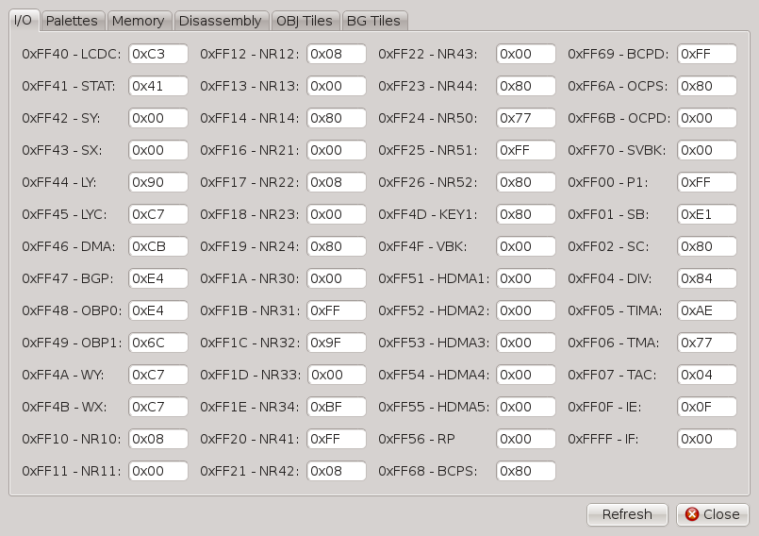
4.2 Palettes GB Enhanced+ Manual - 39

4.2 Palettes

!! THIS DEBUG MENU IS CURRENTLY BROKEN IN 1.9 !!

The Palettes tab displays the current Background and Object palettes. On DMG games, there is only 1 BG palette, and 2 OBJ palettes, however on the GBC there are 8 for both. The relative RGB values for each color (0 - 31) will be displayed when clicking on a color. An enlarged preview of the color will appear on the right-hand side as well.

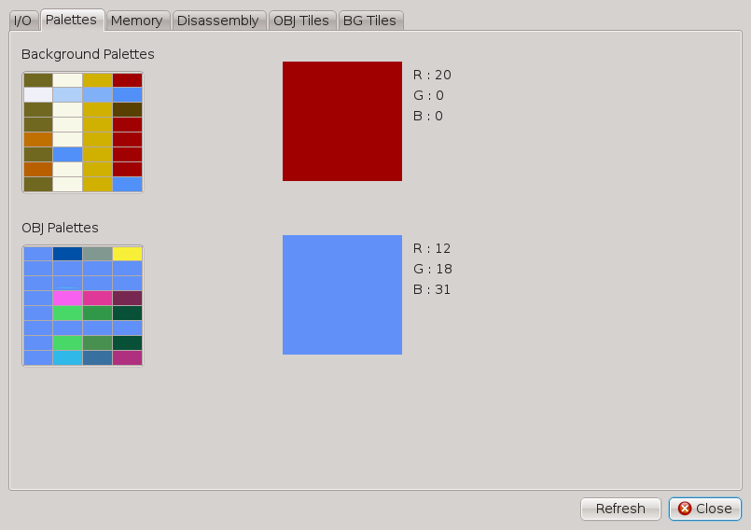
4.3 Memory GB Enhanced+ Manual - 40

4.3 Memory

The Memory tab will display the entire contents of the memory map (0x0 through 0xFFFF on the DMG/GBC). All the values can be scrolled through and examined in detail. Additionally, as a convenience, the memory contents are also displayed as ASCII characters on the right-hand side.

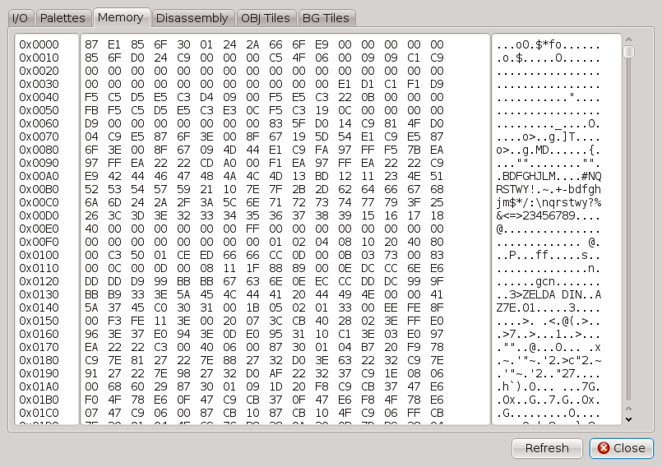
4.4 Disassembly GB Enhanced+ Manual - 41

4.4 Disassembly

The Disassembly tab shows instructions and allows the user to step through game code in real-time. Below are descriptions of all of the functions in this tab:

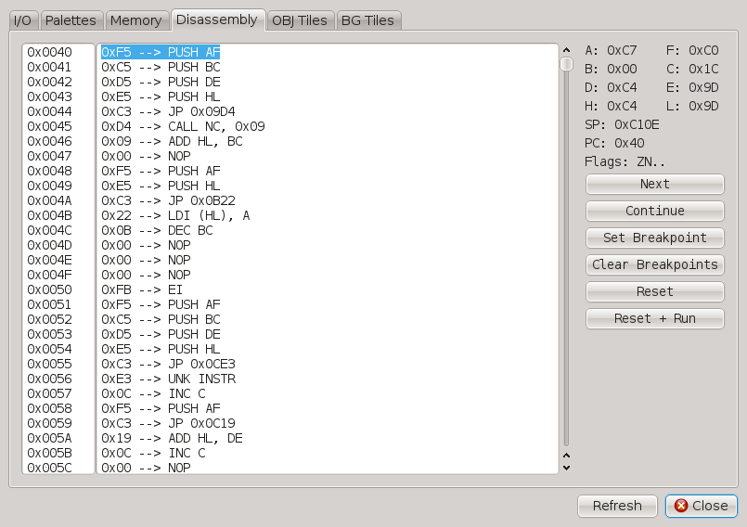
Next:
Jumps to the next instruction and waits for further input. When running in Continue mode, this will pause the emulator and resume debugging.

Continue:
Runs the emulator normally until it hits a breakpoint or the Next button is pressed. In either case, the emulator will pause and resume debugging.

Set Breakpoint:
Creates a break point on the current PC. Any breakpoints are highlighted in yellow. A breakpoint will force the emulator to stop when running in Continue mode.

Clear Breakpoints:
Erases all existing breakpoints from the debugger.

4.4 Disassembly GB Enhanced+ Manual - 42

Reset:
Resets emulation back to the beginning and pauses.

Reset + Run:
Resets emulation back to the beginning and runs in Continue mode.
4.5 OBJ Tiles GB Enhanced+ Manual - 43

4.5 OBJ Tiles

!! THIS DEBUG MENU IS CURRENTLY BROKEN IN 1.10 !!

The OBJ Tiles tab displays all of the sprites currently in use by a game. Each sprite can be clicked on, and then GBE+ will displayed an enlarged preview on the right-hand side along with detailed information about the sprite’s OAM data.

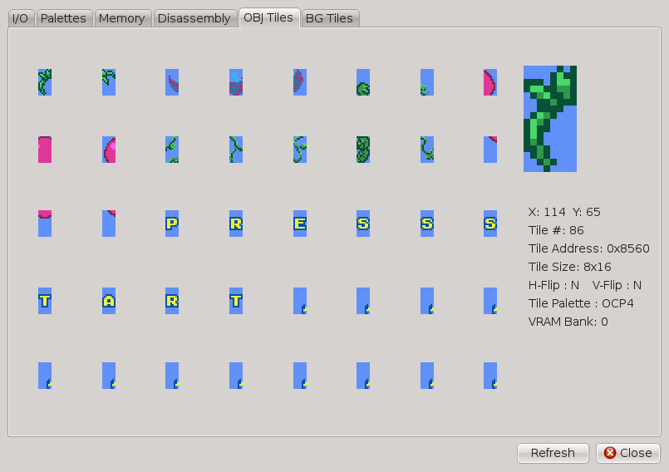
4.6 BG Tiles GB Enhanced+ Manual - 44

4.6 BG Tiles

!! THIS DEBUG MENU IS CURRENTLY BROKEN IN 1.10 !!

The BG Tiles tab displays the background tiles currently in use by a game. Each BG tile can be clicked on, and then GBE+ will displayed an enlarged preview on the right-hand side. Please note that this feature is not complete at this time and may experience issues for some GBC games.

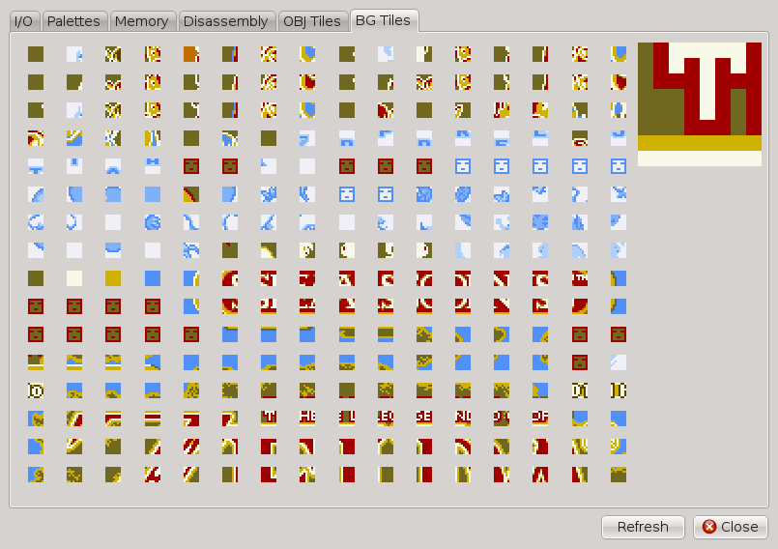
4.7 The Command-Line Debugger GB Enhanced+ Manual - 45

4.7 The Command-Line Debugger

GBE+ offers another debugger for the SDL version. Although not as powerful as the Qt GUI version, it offers many of the features found in the disassembler such as breakpoints and viewing instructions. To enter into debugging mode use the -d or --debug arguments when running GBE+ from the command-line.

GBE+ will start off paused, and from the command-line, debugging commands are entered. GBE+ will print information to the command-line console as necessary. All of GBE+'s cores have this debugging functionality, unlike the Qt version which currently only works with DMG and GBC games. The debugging commands vary slightly between all cores, although the majority are consistent. Below are the all the commands for the DMG core:

n:
Run next Fetch-Decode-Execute stage.

c:
Continue until next breakpoint.

bp:
Set breakpoint, format 0x1234ABCD.

bc:
Set breakpoint when a specific memory address equals a certain value. format 0x1234 for addr, 0x12 for value.

bw:
Set breakpoint when any value is written to the specified address, format 0x1234. Only available when setting the ADVANCED_DEBUG CMake flag when building GBE+ from source code.

br:
Set breakpoint when any value is read from the specified address, format 0x1234. Only available when setting the ADVANCED_DEBUG CMake flag when building GBE+ from source code.

del:
Delete all current breakpoints.

u8:
Show BYTE @ memory, format 0x1234.

u16:
Show WORD @ memory, format 0x1234.

w8:
Write BYTE @ memory, format 0x1234. Prompts for address first, then value to write.

w16:
Write HALFWORD @ memory, format 0x1234. Prompts for address first, then value to write.

4.7 The Command-Line Debugger GB Enhanced+ Manual - 46

reg:
Alters the value of a register. Prompts for an index (0 - 9) first, then the value. Index values of 0 - 6 correspond to registers A - L. Index values of 7 - 9 correspond to the CPU Flags, SP, and PC registers respectively.

rom:
Displays current MBC ROM bank, if any.

ram:
Displays current MBC RAM bank, if any.

dz:
Disassembles 16 GBZ80 instructions from the specified address, format 0x1234.

dq:
Quit the debugger, return to normal emulation.

dc:
Toggle CPU cycle display.

cr:
Reset CPU cycle counter.

rs:
Reset emulation.

pa:
Toggles printing all instructions to the screen.

pc:
Toggles printing the all Program Counter values to the screen.

ls:
Loads a given save state (0-9)

ss:
Saves a given save state (0-9)

ri:
Runs emulation for a given number of instruction before halting back into the debugger, format 0x1234ABCD

q:
Quit GBE+.

h:
Display the above help messages.
4.7 The Command-Line Debugger GB Enhanced+ Manual - 47

Below are all the commands for the GBA core:

n:
Run next Fetch-Decode-Execute stage.

c:
Continue until next breakpoint.

bp:
Set breakpoint, format 0x1234ABCD.

bc:
Set breakpoint when a specific memory address equals a certain value. format 0x1234 for addr, 0x12 for value.

bw:
Set breakpoint when any value is written to the specified address, format 0x1234. Only available when setting the ADVANCED_DEBUG CMake flag when building GBE+ from source code.

br:
Set breakpoint when any value is read from the specified address, format 0x1234. Only available when setting the ADVANCED_DEBUG CMake flag when building GBE+ from source code.

del:
Delete all current breakpoints.

u8:
Show BYTE @ memory, format 0x1234ABCD.

u16:
Show HALFWORD @ memory, format 0x1234ABCD.

u32:
Show WORD @ memory, format 0x1234ABCD.

w8:
Write BYTE @ memory, format 0x1234ABCD. Prompts for address first, then value to write.

w16:
Write HALFWORD @ memory, format 0x1234ABCD. Prompts for address first, then value to write.

w32:
Write WORD @ memory, format 0x1234ABCD. Prompts for address first, then value to write.

reg:
Alters the value of a register. Prompts for an index (0 - 36) first, then the value. Index values 0 - 15 correspond to r0 - r15 (User Mode), 16 for CPSR, and 17 - 36 the rest of the registers for FIQ, SVC, ABT, IRQ, and UND modes
4.7 The Command-Line Debugger GB Enhanced+ Manual - 48

dq:
Quit the debugger, return to normal emulation.

dc:
Toggle CPU cycle display.

cr:
Reset CPU cycle counter.

rs:
Reset emulation.

pa:
Toggles printing all instructions to the screen.

pc:
Toggles printing the all Program Counter values to the screen.

ls:
Loads a given save state (0-9).

ss:
Saves a given save state (0-9).

ri:
Runs emulation for a given number of instruction before halting back into the debugger, format 0x1234ABCD

q:
Quit GBE+.

h:
Display the above help messages.
4.7 The Command-Line Debugger GB Enhanced+ Manual - 49

Below are all the commands for the NDS core:

n:
Run next Fetch-Decode-Execute stage.

c:
Continue until next breakpoint.

sc:
Switch current CPU core to debug (NDS7 or NDS9).

bp:
Set breakpoint, format 0x1234ABCD.

bc:
Set breakpoint when a specific memory address equals a certain value. format 0x1234 for addr, 0x12 for value.

bw:
Set breakpoint when any value is written to the specified address, format 0x1234. Only available when setting the ADVANCED_DEBUG CMake flag when building GBE+ from source code.

br:
Set breakpoint when any value is read from the specified address, format 0x1234. Only available when setting the ADVANCED_DEBUG CMake flag when building GBE+ from source code.

del:
Delete all current breakpoints.

u8:
Show BYTE @ memory, format 0x1234ABCD.

u16:
Show HALFWORD @ memory, format 0x1234ABCD.

u32:
Show WORD @ memory, format 0x1234ABCD.

w8:
Write BYTE @ memory, format 0x1234ABCD. Prompts for address first, then value to write.

w16:
Write HALFWORD @ memory, format 0x1234ABCD. Prompts for address first, then value to write.

w32:
Write WORD @ memory, format 0x1234ABCD. Prompts for address first, then value to write.

dq:
Quit the debugger, return to normal emulation.
4.7 The Command-Line Debugger GB Enhanced+ Manual - 50

da:
Disassembles 16 ARM instructions from the specified address, format 0x1234ABCD.

dt:
Disassembles 16 THUMB instructions from the specified address, format 0x1234ABCD.

rs:
Reset emulation.

pa:
Toggles printing all instructions to the screen.

pc:
Toggles printing the all Program Counter values to the screen.

ri:
Runs emulation for a given number of instruction before halting back into the debugger, format 0x1234ABCD

q:
Quit GBE+.

h:
Display the above help messages.
4.7 The Command-Line Debugger GB Enhanced+ Manual - 51

Below are all the commands for the Pokemon Mini core:

n:
Run next Fetch-Decode-Execute stage.

c:
Continue until next breakpoint.

bp:
Set breakpoint, format 0x1234ABCD.

bc:
Set breakpoint when a specific memory address equals a certain value. format 0x1234 for addr, 0x12 for value.

bw:
Set breakpoint when any value is written to the specified address, format 0x1234. Only available when setting the ADVANCED_DEBUG CMake flag when building GBE+ from source code.

br:
Set breakpoint when any value is read from the specified address, format 0x1234. Only available when setting the ADVANCED_DEBUG CMake flag when building GBE+ from source code.

del:
Delete all current breakpoints.

u8:
Show BYTE @ memory, format 0x1234ABCD.

u16:
Show HALFWORD @ memory, format 0x1234ABCD.

w8:
Write BYTE @ memory, format 0x1234ABCD. Prompts for address first, then value to write.

w16:
Write HALFWORD @ memory, format 0x1234ABCD. Prompts for address first, then value to write.

reg:
Alters the value of a register. Prompts for an index (0 - 15) first, then the value. Index values correspond to the following registers: A, B, L, H, IX, IY, SP, PC, BR, SC, CC, NB, CB, XP, YP, EP.

rs:
Reset emulation.

dq:
Quit the debugger, return to normal emulation.

4.7 The Command-Line Debugger GB Enhanced+ Manual - 52

dc:
Toggle CPU cycle display.

cr:
Reset CPU cycle counter.

pa:
Toggles printing all instructions to the screen.

pc:
Toggles printing the all Program Counter values to the screen.

ls:
Loads a given save state (0-9).

ss:
Saves a given save state (0-9).

ri:
Runs emulation for a given number of instruction before halting back into the debugger, format 0x1234ABCD

vb:
Runs emulation until the next VBlank.

q:
Quit GBE+.

h:
Display the above help messages.

5 Netplay Guide GB Enhanced+ Manual - 53

5.1 Netplay Guide

GBE+ supports netplay for the DMG and GBC systems only. GBA and SGB support are not functional at this time. Standard linking between two Game Boys is emulated. The 4-player adapter - used for games like Wave Race or Faceball 2000 - is also supported (see Section 5.2 for more details). Additionally the GBC’s infrared port is emulated with only a few minor incompatibilities (see Section 6 for more details). This section will go over the basics of configuring netplay.

First, gather the necessary network information. Each player must have the IPv4 address of the other to correctly connect. If netplay will only involve one machine (connecting two instances of GBE+ on the same computer), only that machine’s current IPv4 address is needed. In that case, it is recommended that the localhost address (127.0.0.1) be used.

Next, all players must agree the use the same ports. Player A’s Server Port must match the Player B’s Client Port, Player A’s Client Port must match Player B’s Server Port. Effectively, only 2 ports are necessary, but they must be configured correctly like such:

Player A Player B
Server Port 2000 Server Port 2001
Client Port 2001 Client Port 2000

Additionally, both players must agree whether or not to turn on hard syncing. For most network connections outside of the same machine, the latency is far too high and will desync netplay without hard syncing. Although it is very slow, hard syncing is recommended. Due note that the real-world latency outside of LAN or small networks makes hard syncing unbearably slow, so netplay across the internet is a bit impractical. For local networks, however, the speed should be fine.

To start netplay, the emulated SIO device should be set to GB Link Cable for both players for linked gameplay. For the GBC IR port, this step is unnecessary. Each player must then start a netplay session while running the game by pressing hotkey F5. GBE+ will pause for 10 seconds and wait to establish a connection. If no connection is detected, GBE+ will unpause and users can try again. Once connected, both instances of GBE+ will continuously communicate with each other.

To suspend a netplay session, press the F6 hotkey. To resume a netplay session, both sides must press the F5. GBE+ will use another 10 second delay to make sure both players are connected. Any disconnection caused by a network error, however, requires GBE+ to restart the game in order to properly reconnect. Currently there are no GUI indications of netplay connection status, but there are messages printed to the terminal when launch the SDL or Qt version from the command-line.
5.2 DMG-07 Setup GB Enhanced+ Manual - 54

5.2 DMG-07 Setup

To emulate the DMG-07, first make sure every instance of GBE+ has selected DMG-07 as the option in Serial IO Device from General Settings (see Section 3.1 for more details). After that, adjust the netplay settings as described in the previous section. The only difference now is that 3 or 4 players must now be configured as such:

Player A Player B Player C Player D
Server Port 2000 Server Port 2001 Server Port 2001 Server Port 2001
Client Port 2001 Client Port 2000 Client Port 2000 Client Port 2000

Player A’s Server Port must match the other players’ Client Ports, and Players A’s Client Port must match the other players’ Server Port. Player A’s Server Port must be lower than any other players in order for GBE+ to detect it as the DMG-07 host. Additionally, ensure that all instances of GBE+ have access to following ports:

Player A Server Port
Player A Server Port + 2
Player A Server Port + 4
Player A Client Port
Player A Client Port + 2
Player A Client Port + 4

Finally, hard syncing is required for GBE+ to properly emulate DMG-07. Make sure every instance of GBE+ has this options turned on and that they use the same threshold value. Currently, GBE+ only supports localhost for the DMG-07, so all instances of GBE+ need to be running on the same IP address, i.e. the same computer.

To begin connecting instances of GBE+, let Player A begin the netplay session by pressing the F5 key. Afterwards, other instances of GBE+ can connect to Player A by pressing F5 as well. Player IDs are assigned based on whoever connects first (e.g. Player B is the 1st to connect, Player C is 2nd, and Player D is 3rd). If any instance of GBE+ disconnects, all others will also exit netplay.
5.3 Net Gate GB Enhanced+ Manual - 55

5.3 Net Gate

The Net Gate is a simple protocol that allows an external application to communicate with GBE+ when emulating the Battle Chip Gate, Progress Chip Gate, or Beast Link Gate accessories. GBE+ will wait on a network to receive a specific Battle Chip ID to emulate inserting the chip into the slot. The chip is automatically removed after a brief period of time, so the external application only deals with sending data back to the emulator. The protocol is only 3 bytes sent over TCP and is as follows:

Byte 1: 0x80

Byte 2: High-byte of the 16-bit Chip ID

Byte 3: Low-byte of the 16-bit Chip ID

It is important to note that GBE+ will not return a TCP response. The application should essentially “fire and forget”. The application must connect to GBE+ on the emulator’s server port. See Section 3.5 and 5.2 for more information on GBE+’s server port. The Net Gate option must be enabled, and one of the Battle Chip Gate models must be selected as the Emulated Serial IO Device.

Besides connecting via GBE+ through a raw TCP socket, there are no other requirements. The interface used to present and send Battle Chips to GBE+ is up to this external application.

GBE+ provides a default Net Gate webapp. Users can find this in the data folder, specifically data/chip_gate/netgate.html. After opening the HTML file in a browser, the type of Chip Gate must be selected from the dropdown menu. This will populate the screen with buttons that correspond to each Battle Chip compatible with that specific Chip Gate.

The included Net Gate webapp needs the IP address of the emulator along with the emulator's server port in the form of IP_ADDR::PORT_NUMBER. By default, this points to localhost on port 2000.
5.4 Pokemon Mini IR GB Enhanced+ Manual - 56

5.4 Pokemon Mini IR

GBE+ emulates the Pokemon Mini's infrared port, enabling multiplayer for the handheld system. First, gather the necessary network information. Each player must have the IPv4 address of the other to correctly connect. If netplay will only involve one machine (connecting two instances of GBE+ on the same computer), only that machine’s current IPv4 address is needed. In that case, it is recommended that the localhost address (127.0.0.1) be used.

Next, all players must agree the use the same ports. For the Pokemon Mini, only the Server Port needs to be configured. All participants must use the same Server Port for netplay to properly function. Next, each player needs to manually assign themselves a Player ID. Edit the netplay_id field in the .ini file for GBE+. Ensure that each player has a unique number, and that no two players share the same ID. Select IDs starting at "1" and go up to the maximum number of supported players for the game. GBE+ only supports a maximum of 10 players, as no commercial Pokemon Mini game uses more than that.

Each player should make sure to a range of ports on their computers are free and currently unused by other programs. For example, if there are a total of 5 players and the Server Port used is 2000, reserve ports 2000 through 2055. If there are a total of 3 players and the Server Port used is 2000, reserve ports 2000 through 2033. Essentially reserve (11 x Max # of Players) for ports.

Once all players have started their games, each instance of GBE+ must connect to one another. This is done dynamically by pressing the F4 key. GBE+ will then attempt to automatically connect each instance in order. That is to say, GBE+ will try to connect to Player 1, then Player 2, then Player 3. It is highly advisable that users turn on On-Screen Display Messages (see Section 3.2) to keep track of which player they are trying to connect to.

F4 Cycle through Players IDs 1 - 10 to connect to/communicate with

In order for network communications to properly function, players must press the F4 key until the on-screen ID matches the player they wish to send/receive IR signals.

For examples, in 1v1 modes, such as Pokemon Tetris, the following steps are taken when transmitting data between Player 1 and Player 2:

1) Player 1 presses F4 until the message "P2 LINKED" appears on-screen.
2) Player 2 presses F4 until the message "P1 LINKED" appears on-screen.

The process is similar for other multiplayer mode with more players, such as Pokemon Zany Cards or Pichu Bros. Mini. The following steps are taken when transmitting data between Player 4 and Player 5:

1) Player 4 presses F4 until the message "P5 LINKED" appears on-screen.
2) Player 5 presses F4 until the message "P4 LINKED" appears on-screen.

As a final example, the following steps are taken when transmitting data between Player 1 and Player 9:

1) Player 1 presses F4 until the message "P9 LINKED" appears on-screen.
2) Player 9 presses F4 until the message "P1 LINKED" appears on-screen.

5.4 Pokemon Mini IR GB Enhanced+ Manual - 57

Essentially, pressing F4 and matching IDs like this is analogous to physically pointing the Pokemon Mini's infrared port at a specific player. As long as the available network ports are free on a computer, the networking is handled automatically. Please note, however, that there may be a small delay on Windows when pressing the F4 due to the operating system handles certain things about networking.
5.5 Campho Advance GB Enhanced+ Manual - 58

5.5 Campho Advance

As of 1.9, GBE+ has full support for the networking necessary to connect two emulated Campho Advances. Webcam support is possible when using the HTML5 web app. Audio transmission is supported if the user connects a microphone and enables it (see Section 3.3 for more details)

When emulating the Campho Advance (see Section 6 on how to set it up), users must first edit the campho_contacts.txt file in their data folder. The format consists of single-line entries with fields separated by colons:

10-Digit Phone Number : IPv4 Address : Ringer Port

The first field is the contact's phone number, 10 digits at maximum, no spaces, no dashes, no parentheses. The second field is the contact's IPv4 address. The third field is the network port used to communicate with the contact. An example file might look like this:

1016367899:10.0.0.1:1980
5552821337:10.0.0.2:92
8005882300:10.0.0.3:1110

Additionally, the .ini file's [#campho_ringer_port] and [#campho_input_port] entries must be edited. The [#campho_ringer_port] specifies an open port that users can use to initiate a call.

Imagine Player A is using the above campho_contacts.txt as an example. The first entry directs GBE+ to contact the IP address 10.0.0.1 when dialing the phone number 1016367899. Player B at that IP address must set their [#campho_ringer_port] value to 1980 if they want to properly receive a call from Player A. It should be noted that Player B does not need to know any information about Player A beforehand. Player A only needs to know Player B's IP address and their Ringer Port.

[#campho_input_port] is an additional port that each side leaves open to exchange video and audio data.

The web app allows users to access any webcam (e.g. ones built-into the monitor, ones that connect via USB, or ones built-into smartphones) for video input. This webapp can be found in the data folder under misc/campho_web_interface/.

Users will need to host these files on a web server, either their own local HTTP server or a remote web server (such as GitHub pages or anything on the internet). Users will also need to edit to [#campho_web_port] to a port number of their choosing. This port number must match the "GBE+ IPv4 Address + Port" as shown in the web app.

Once the web app has detected and initialized the webcam (the browser may ask for permissions to open the camera), press the "Begin Camera Capture" button to start capturing video input. This video will be fed into GBE+ when running the Campho Advance ROM.
5.6 HuC-1 and HuC-3 IR Connectivity GB Enhanced+ Manual - 59

5.6 HuC-1 and HuC-3 IR Connectivity

GBE+ emulates the infrared communication used for HuC-1 and HuC-3 cartridges. This section specifically refers to the cart-to-cart infrared transmissions. For emulating the GB KISS LINK infrared modem, see Section 6 for more details.

This form of netplay is very similar to emulating the Pokemon Mini IR. Only the Server Port needs to be configured. All participants must use the same Server Port for netplay to properly function. Next, each player needs to manually assign themselves a Player ID. Edit the netplay_id field in the .ini file for GBE+. Ensure that each player has a unique number, and that no two players share the same ID. Select IDs starting at "1" and go up to the maximum number of supported players for the game. GBE+ only supports a maximum of 16 players, as no commercial HuC-1/HuC-3 game uses more than that.

Hard Sync must be enabled for this type of netplay to successfully connect. Additionally, the Sync Threshold must be set to 40.

Each player should make sure to a range of ports on their computers are free and currently unused by other programs. For example, if there are a total of 5 players and the Server Port used is 2000, reserve ports 2000 through 2055. If there are a total of 3 players and the Server Port used is 2000, reserve ports 2000 through 2033. Essentially reserve (11 x Max # of Players) for ports.

Once all players have started their games, each instance of GBE+ must connect to one another. This is done dynamically by pressing the F4 key. GBE+ will then attempt to automatically connect each instance in order. That is to say, GBE+ will try to connect to Player 1, then Player 2, then Player 3. It is highly advisable that users turn on On-Screen Display Messages (see Section 3.2) to keep track of which player they are trying to connect to.

F4 Cycle through Players IDs 1 - 16 to connect to/communicate with

In order for network communications to properly function, players must press the F4 key until the on-screen ID matches the player they wish to send/receive IR signals.

For examples, in 1-on-1 communications, such as sending mail via the GB KISS Menu, the following steps are taken when transmitting data between Player 1 and Player 2:

1) Player 1 presses F4 until the message "P2 LINKED" appears on-screen.
2) Player 2 presses F4 until the message "P1 LINKED" appears on-screen.

The process is similar for other multiplayer mode with more players, such as Chousoku Spinner or Bakechu Rally. The following steps are taken when transmitting data between Player 4 and Player 5:

1) Player 4 presses F4 until the message "P5 LINKED" appears on-screen.
2) Player 5 presses F4 until the message "P4 LINKED" appears on-screen.

As a final example, the following steps are taken when transmitting data between Player 1 and Player 9:

1) Player 1 presses F4 until the message "P9 LINKED" appears on-screen.
2) Player 9 presses F4 until the message "P1 LINKED" appears on-screen.
6 Game Specific Instructions GB Enhanced+ Manual - 60

6. Game Specific Instructions

Due to the fact that many Game Boy games have different accessories or utilize hardware in unique ways, some titles require additional configuration in order to run properly. Below, each section details how to play various games correctly or how to emulate edge cases.

6.1 Advance Movie Adapter

To emulate the Advance Movie Adapter, set the Special ROM Type in General Settings AGB - AM3. GBE+ requires the AM3 firmware be present in the data folder under the name am3_firmware.bin. Go to File -> Open ... and select the AM3 SmartMedia card dump to start playing the movie.

GBE+ can play movies if all the AM3 files are extracted from the SmartMedia card and placed inside a single folder. In this case, select File -> Open AM3 Folder and navigate to this folder.

As of 1.10, GBE+ will automatically handle any fragmentation within the filesystem of AM3 SmartMedia card dumps. Additionally, GBE+ will automatically generate an SMID key file if none exists.

6.2 Agatsuma TV Movie Tuner

To emulate the Agatsuma TV Tuner, set the Special ROM Type in General Settings to AGB - TV Tuner. GBE+ will play Motion-JPEG videos from the data folder. Files must be placed in the tv folder. Create a folder for each channel (1 - 62). The folders names must just be the channel number, e.g. 1, 15, 42, etc. Create a folder called av for the AV input. Videos for numbered channels can play on a schedule if a file called schedule.txt is present in the folder. The format is as follows:

video_name:start_time_in_seconds

The start time is based on a 24-hour clock, so valid numbers range from 0 to 86399. If no schedule.txt file is found in a channel's folder, videos will play in alphanumeric order from the time the emulator boots the Agatsuma TV Tuner.

The Agatsuma TV Tuner requires SDL2_image to decode videos. If compiling from source, make sure the IMAGE_FORMATS option is enabled in CMake. See Section 6.41 on how to properly encode videos.

6.3 Barcode Boy Games

To emulate the Barcode Boy scanner, set the Serial IO Device from General Settings to Barcode Boy. Next, click the "Configure" button, or select File -> Select Card File from the GBE+ Qt menu, or manually specify the card file in the .ini file (see the [#card_file] field). When running a Barcode Boy compatible game, wait for the game to ask for the player to swipe a card. At this time, press the F3 key, and GBE+ will begin emulating the Barcode Boy.

GBE+ comes with binary card data pre-packaged in the data/cards/bcb folder.
6 Game Specific Instructions GB Enhanced+ Manual - 61

6.4 Barcode Taisen Bardigun

To emulate the Barcode Taisen Bardigun scanner, set the Serial IO Device from General Settings to Bardigun Barcode Scanner. Next, select File -> Select Card File from the GBE+ Qt menu, or manually specify the card file in the .ini file (see the [#card_file] field). When running Barcode Taisen Bardigun, wait for the game to ask for the player to swipe a card. At this time, press the F3 key, and GBE+ will begin emulating the Barcode Taisen Bardigun scanner.

GBE+ comes with binary card data pre-packaged in the data/cards/btb folder.

6.5 Battle Chip Gate Games

To emulate the Battle Chip Gate, Progress Chip Gate, or Beast Link Gate, set the Serial IO Device from General Settings to Battle Chip Gate, Progress Chip Gate, or Beast Link Gate. Afterwards, the Battle Chip Gate Controls menu and select the appropriate Chip Gate. Choose up to 4 Battle Chips to map to Context inputs. Be sure to configure Context inputs in the Advanced Controls menu. Pressing any of the Context inputs will emulate inserting a Battle Chip, and releasing any of the Context inputs will emulate extracting a Battle Chip.

6.6 Bayer Didget

To emulate the Bayer Didget, set the Slot-2 Device in General Settings to Bayer Didget. Before launching the game, edit the following entries in the .ini file: [#glucoboy_daily_grps], [#glucoboy_bonus_grps], [#glucoboy_good_days], [#glucoboy_days_until_bonus], and [#glucoboy_total].

Messages downloaded to the Didget are stored in the data/didget_messages folder. These files should use standard ASCII encoding and must be 64 bytes in size or less. A total of 16 messages can be stored and downloaded. Each filename must use the format msg_x.txt where x is a digit ranging from 0 to 15.

6.7 Boktai Games

To emulate the Boktai games, set the Special ROM Type in General Settings AGB - Solar Sensor. In the Advanced Controls menu, be sure to set up Context Up and Context Down inputs. When running any Boktai game, press Context Up to increase the amount of sunlight, and Context Down to decrease the amount of sunlight.

6.8 Bomberman Max Red/Blue, Mission Impossible

These GBC games use TV remote input on the IR sensor for unlockables or extras. set the Infrared Device in General Settings to TV Remote or IR Noise. When playing these games, press F3, and GBE+ will emulate random IR signals (note, this is functionally useless for Mission Impossible’s TV remote programmer but it still “works”).

6 Game Specific Instructions GB Enhanced+ Manual - 62

6.9 Bouken Yuuki Pluster World Games

To emulate the Multi Plust On System used in the Bouken Yuuki Pluster World games, set the Serial IO Device in General Settings to Multi Plust On System. Click the "Configure" button and scroll through the drop-down menu to select a Pluster figurine.

6.10 Campho Advance

To emulate the Campho Advance, set the Special ROM Type in General Settings AGB - Campho. For networking, see Section 5.5. If compiling from source, FAST_FETCH must be disabled in CMake.

6.11 Carrera Go Powerslide

To emulate the Virtureal Racing System used in conjunction with Carrera Go Powerslide, set the Serial IO Device to V.R.S. Make sure the files VR_track_x are present in data/misc before booting the game. When selecting the "Real Racing" mode in Powerslide, a second screen will appear with an emulated racetrack.

Various options such as selecting the CPU difficulty, the current racetrack, and resetting the car positions can be selected from a menu when pressing Context 2. Context Left and Right will change specific values, while Context Up and Down will change the menu item. To exit the menu, select the "EXIT" item and press Context 1. To reset car positions, select the "RESET SLOT CARS" item and press Context 1.

6.12 Chee Chai Alien

To emulate using a lamp or some other light source in Chee Chai Alien, set the Infrared Device in General Settings to Constant IR Light. There are two modes of operation which can be chosen by clicking the “Configure” button. Static means the IR sensor always detects light without any user intervention. Interactive lets users control the light by pressing the Context Up button.

6.13 Cyber Drive Zoids

To emulate the GBA Infrared Adapter and a CDZ model Zoid, set the Serial IO Device in General Settings to AGB-006. Additionally, make sure the Infrared Device in General Settings is set to Zoids CDZ Model. When the game makes a connection to the CDZ model, a second screen will appear with a graphical representation of the Zoid. This Zoid can be controlled with any input GBE+ has assigned for the Control Pad, A, B, L, and R buttons. Press F3 to close the second screen.

6.14 Drill Dozer

To emulate the rumble functionality, set the Special ROM Type in General Settings to AGB - Rumble. Additionally, be sure to enable rumble support in the Advanced Controls menu.
6 Game Specific Instructions GB Enhanced+ Manual - 63

6.15 GBA Music Recorder / Jukebox

To emulate Kemco's GBA Music Recorder / Jukebox, set the Special ROM Type in General Settings to AGB - Jukebox. Songs can be added to the Music, Voice Memo, and Karaoke categories by adding lines of text in the files in data/jukebox. The default files provided by GBE+ document the format used.

GBE+ can use a microphone for recording, allowing users to save memos or create karaoke tracks. See Section 3.3 for more details on microphone settings. GBE+ works natively with .WAV files, however, an external program can be used to convert audio files into different formats. Refer to the .ini file's audio_conversion_command entry for more details. Vocals can be removed from karaoke tracks too; see the .ini file's remove_vocals_command for more info. The available amount of recording time (in minutes) can be specified for the Jukebox. See the .ini file's jukebox_total_time for info.

6.16 GBA Wireless Adapter

To emulate the GBA Wireless Adapter, set the Serial IO Device in General Settings to GBA Wireless Adapter. As of GBE+ 1.8, support for this device is designated as Work-in-Progress. It does not currently function with multiplayer, but it can be used to open several menus in games that detect the peripheral.

6.17 GBC Infrared Games

To emulate most GBC games that use the IR port for GBC-to-GBC communications, set the Infrared Device in General Settings to GBC IR Port. Make sure netplay settings are properly adjusted for 2- player linking (see Section 5.1 for more details). Be sure to enable hard sync and set the Sync threshold to 16. When playing a game, connect two instances of GBE+ via netplay, then try to initialize IR communications through the game. GBE+ will emulate the IR signals automatically.

Some games require both sides to initialize IR communications around the same time. GBE+ is not equipped to handle ones that require extreme precision. As a result Pokemon TCG (non-Japanese versions) and Bomberman Max Red/Blue are currently incompatible. Others should work as intended.

6.18 GB KISS Games

To emulate the IR connectivity for HuC-1 and HuC-3 games, set the Special ROM Type in General Settings to DMG - HuC IR Cart. Make sure the Infrared Device is absolutely NOT set to GB KISS LINK, otherwise the infrared modem will be emulated rather than Game Boy-to-Game Boy infrared transfers. See Section 5.6 for more details about setting up netplay for this mode.

6 Game Specific Instructions GB Enhanced+ Manual - 64

6.19 GB KISS LINK

To emulate the GB KISS LINK infrared modem, set the Special ROM Type in General Settings to DMG - HuC IR Cart and set the Infrared Device to GB KISS LINK. If GBE+ is emulating a Game Boy receiving a file from the GB KISS LINK, select the appropriate .GBF file via File -> Select Data File from the Qt user interface, or manually specify this file in the .ini file (see the [#data_file] field).

When running a game compatible with the GB KISS Menu, press the F4 button to have the emulated GB KISS LINK switch between acting as the sender or receiver of a GBF file. The On-Screen Display Messages "GB KISS SEND MODE" and "GB KISS RECV MODE" will indicate the current operating mode (see Section 3.2 for more details on OSD messages). When emulating a GB KISS LINK in receive mode, the GBF file sent from the Game Boy will be stored in the data/bin/infrared.

For transmitting Nectaris maps, press the F4 button to have the emulated GB KISS LINK switch modes. The On-Screen Display Messages "NECTARIS SEND MAP" and "NECTARIS RECV MAP" will indicate the current operating mode. When receiving a Nectaris map, will be stored data/bin/infrared.

6.20 GB Memory Cartridge

To emulate the GB Memory Cartridge, set the Special ROM Type in General Settings to DMG - GB Memory. Select the ROM file representing the GB Memory Cartridge via File -> Open ... and make sure there is a corresponding 128-byte map file. For example, if the GB Memory Cartridge file is MYFILE.GBC then GBE+ will look for the map file MYFILE.GBC.map.

It's recommended that users take a look at the GB Memory Binary Maker project if they wish to create their own images of the GB Memory Cartridge with multiple games stored on it. GBE+ will work with the output ROM and the map file the program generates.

6.21 Glucoboy

To emulate the Glucoboy, set the Special ROM Type in General Settings to AGB - Glucoboy. Before launching the game, edit the following entries in the .ini file: [#glucoboy_daily_grps], [#glucoboy_bonus_grps], [#glucoboy_good_days], and [#glucoboy_days_until_bonus].

6.22 Gyogun Tanchiki: Pocket Sonar

To emulate the Pocket Sonar, set the Special ROM Type in General Settings to DMG -> MBC1S. Next, select File -> Select Image File from the GBE+ Qt menu, or manually specify the image file in the .ini file (see the [#image_file] field). This is a 160x96 BMP image of the sonar data that will be displayed when using the cart’s sonar features.

The image only uses 4 colors: #000000, #606060, #C0C0C0, and #FFFFFF. The image is typically broken into 2 parts: above and below the floor for a body of water. Above the floor, use #606060 to indicate debris or other objects and #FFFFFF for open water. Use #000000 to indicate the floor and #C0C0C0 for spaces underneath it. Fish can be drawn using #C0C0C0 using an 8x1 line. Fish must be drawn above the floor. The floor should be several pixels high. An example image is in data/misc.
6 Game Specific Instructions GB Enhanced+ Manual - 65

6.23 Joy Carry Cartridge

To emulate the Joy Carry Cartridge, set the Special ROM Type in General Settings to AGB - 8M DACS. For the games used in Hikaru no Go 3, users will need a full 32MB dump of the Joy Carry Cartridge.

6.24 Juushinden: Ultimate Beast Battlers

To emulate the Magic Reader, set the Slot-2 Device in General Settings to Magic Reader. Click the "Configure" Button to select the numerical ID associated with a given card. When playing Juushinden, press the Context 1 button to activate scanning.

6.25 Kirby Tilt ‘n’ Tumble

To emulate Kirby Tilt ‘n’ Tumble, go to the Advanced Controls menu and configure the Context Up, Context Down, Context Left, and Context Right buttons. Each button will move Kirby up, down, left, and right respectively. This game is compatible with motion controls.

6.26 Koro Koro Puzzle

To emulate Koro Koro Puzzle, set the Special ROM Type in General Settings to AGB - Tilt Sensor. Configure the Context Up, Context Down, Context Left, and Context Right buttons in the Advanced Controls menu to emulate tilting the GBA left or right. This game is compatible with motion controls.

6.27 Legendz: Isle of Trial/Sign of Nekrom

To emulate the Soul Doll Adapter, set the Serial IO Device from General Settings to Soul Doll Adapter. Next, select File -> Select Data File from the GBE+ Qt menu, or manually specify the Soul Doll file in the .ini file (see the [#data_file] field). Custom Soul Doll data will now be loaded and saved to specified file. GBE+ provides blank Soul Doll data for various Legendz in the data folder under bin/soul_dollz.

To emulate the RTC in Legendz: Isle of Trial/Sign of Nekrom, set the Special ROM Type in General Settings to AGB - RTC. The clock can dynamically be adjusted with RTC Offsets from General Settings.

6.28 Magical Watch

To emulate the Magical Watch, set the Serial IO Device from General Settings to Magical Watch. Click the "Configure" button to open a menu and select the amount of rewards that will be given when connecting the watch.

6 Game Specific Instructions GB Enhanced+ Manual - 66

6.29 Mobile Adapter GB Games

To emulate the Mobile Adapter GB, set the Serial IO Device from General Settings to GB Mobile Adapter. GBE+ can use an internal server (located in the data folder under gbma) to emulate Mobile Adapter servers. The following games and features are currently supported.

Game Boy Wars 3: Downloads mercenary units, server messages, and a custom map.
Hello Kitty Happy House: Receives and email from GBE+ with free furniture.
Mobile Trainer: Small demo of the web browser and receives email from GBE+.
Net de Get: Downloads a small “minigame” demo that soft resets the game.
Zen Nihon GT Senshuken: Demo ghost data, records, and downloadable racetrack.

GBE+ can also use an external server via http. To do so, edit the .ini file. Set the [#use_real_gbma_server] field to "1", the [#gbma_server_ip] field to the IP address or hostname, and the [#gbma_server_http_port] to an available port on the server.

6.30 My Weight Loss Coach / My Health Coach: Manage Your Weight

To emulate the pedometer included with this software, set the Slot-2 Device in General Settings to Ubisoft Thrustmaster Pedometer. Click the "Configure" button to specify the number of steps the pedometer should count (minimum 0, maximum 99999).

6.31 NDS Rumble Pak Games

To emulate the NDS Rumble Pak, set the Slot-2 Device in General Settings to Rumble Pak. Additionally, be sure to enable rumble support in the Advanced Controls menu.

6.32 Play-Yan & Play-Yan Micro & Nintendo MP3 Player

To emulate the Play-Yan, Play-Yan Micro, or Nintendo MP3 Player, set the Special ROM Type in General Settings to AGB - Play-Yan. Media files can be added by editing the files in data/play_yan. An external program can be used to decode MP3s. See the audio_conversion_command entry in .ini file for more details. Video files must be encoded as Motion-JPEG, and playback requires SDL2_image. See Section 6.41 for more details. Garage Games can be played by adding the .bmp thumbnails included with GBE+ to the data/play_yan folder.

Press the F4 key to emulate plugging in headphones to toggle high-quality or low-quality audio.

6.33 Pokemon Gold, Silver, Crystal

To emulate Pokemon G/S/C’s GBC-to-GBC IR communications (for Mystery Gifts), see Section 7.15 above. To emulate Pokemon Pikachu 2 communications (again, for Mystery Gifts), set the Infrared Device in General Settings to Pokemon Pikachu 2. Use the “Configure” button to choose the level of watts to receive. When running Pokemon G/S/C, go to the Mystery Gift option and press F3 to receive an item from Pikachu. Make sure the pokemon_pikachu_db.bin file exists in the data folder.
6 Game Specific Instructions GB Enhanced+ Manual - 67

6.34 Pokemon Ruby, Sapphire, Emerald

To emulate the RTC in Pokemon Ruby, Sapphire, and Emeral,d set the Special ROM Type in General Settings to AGB - RTC. The clock can be adjusted with RTC Offsets from General Settings.

6.35 Sakura Taisen GB

To emulate GBC-to-GBC IR communications (for swapping Points), see Section 7.15 above. To emulate Pocket Sakura communications (for sending points), set the Infrared Device in General Settings to Pocket Sakura. Use the “Configure” button to choose the level of point to receive. When running Sakura Taisen GB, go to the extra menu where Points from the Pocket Sakura can be received, then press F3 when the game prompts the Pocket Sakura to send IR signals. Make sure the pocket_sakura_db.bin file exists in the data folder.

6.36 Sega Card Reader Games

To emulate the HCV-1000, set Slot-2 Device in General Settings to HCV-1000. Next, click the "Configure" button, or select File -> Select Card File from the GBE+ Qt menu, or manually specify the card file in the .ini file (see the [#card_file] field). When running a Sega Card Reader compatible game, wait for the game to ask for the player to swipe a card. At this time, press the F11 key, and GBE+ will begin emulating the HCV-1000. GBE+ comes with binary card data pre-packaged in the data/cards/hcv1000 folder.

6 Game Specific Instructions GB Enhanced+ Manual - 68

6.37 Singer Izek 1500/Jaguar JN-2000/Jaguar JN-100 Software

To emulate these sewing machines, set the Serial IO Device to Sewing Machine. GBE+ uses a second screen to create a virtual sewing desk. Press whatever input is mapped to the L Button to display this screen, or press whatever input is mapped to the R button to close it. The sewing machines are controlled via Context Left, Right, Up, Down, as well as Context 1 and Context 2.

Use Context Left, Right, Up, and Down to move around the virtual sewing desk and view the current stitching. To access a special menu, press Context 2. Here, the thread color, stitching speed, thread thickness, and attachable embroidery unit can be selected. Use Context Up and Down to change menu items, and use Context Left and Right to change the values. When changing the thread color's RGB values, a small preview is available at the bottom.

To clear the sewing desk, select the "CLEAR SCREEN" menu item and press Context 1. To save an image to a bitmap file, select the "SAVE SCREEN" menu item and press Context 1. To exit the menu, select the "RETURN" menu item and press Context 1.

When navigating the virtual sewing desk, a "+" cursor will appear. This is where the stitching will begin when not emulating the EM-2000 embroidery unit. When using an EM-2000, the emulated software dictates the starting position. Press Context 1 to begin sewing once the emulated software has transferred the pattern data.

When emulating the EM-2000, it must be set through the menu by pressing Context 2, otherwise the emulated software will return an error message. The embroidery software stitches images in segments. Be sure to change the color through the menu via Context 2 as appropriate for the current segment. To begin stitching the embroidery for the EM-2000. Stitching is triggered from the emulated software. Once it begins this stitching is automatic and requires no user interaction.

6.38 Telefang/Network Adventure Bugsite Games

To emulate the Power Antenna (Version 1 or Version 2) or the Bug Sensor, set the Serial IO Device in General Settings to Power Antenna. On-Screen Display Messages must also be enabled (see Section 3.2). These games will display three asterisks at the bottom right-hand corner of the screen whenever the device is supposed to light up.

6.39 Turbo File GB/Turbo File Advance Games

To emulate either version of the Turbo File, set the Serial IO Device in General Settings to Turbo File GB/Advance. Click the "Configure" button to enable/disable the memory card or write protection. The save file for the Turbo File GB is stored in the data folder with the filename turbo_file_gb.sav. The save file for the Turbo File Advance is stored in the data folder with the filename turbo_file_advance.sav.
6 Game Specific Instructions GB Enhanced+ Manual - 69

6.40 Vaus Controller

To emulate the Vaus Controller in Alleyway, set the Serial IO Device in General Settings to Vaus Controller. When playing Alleyway, the paddle can be controlled via the Context Left and Context Right inputs. The Context 1 button will reset the ball when it needs to be launched. This accessory is best emulated using a controller and setting Context Left and Context Right to a joystick.

6.41 Wantame Card Scanner

To emulate the Wantame Card Scanner, set the Microphone Device in General Settings to Wantame Card Scanner. Use the "Configure" button to bring up a menu for manually inputting the barcode or loading the barcode from a text file. Press the F11 key initiate a card scan during gameplay.

6.42 WarioWare: Twisted

To emulate the gyroscope in WarioWare: Twisted, set the Special ROM Type in General Settings to AGB - Gyro Sensor. Configure the Context Left and Context Right buttons in the Advanced Controls menu to emulate tilting the GBA left or right. Additionally, be sure to enable rumble support in the Advanced Controls menu as well. This game is compatible with motion controls.

6.43 Wave Scanner

To emulate the Wave Scanner in Ryuusei no Rockman 1, set the Microphone Device in General Settings to Wave Scanner. button to bring up a menu for manually inputting the barcode or loading the barcode from a text file. Here, the level and the type of the Wave Scanner can be set as well.

There are 2 types of transmissions: Wave Scanner Level and Wave Scanner Barcode. The former is used outside of battle to power up Rockman. The latter is used to transmit a barcode for an attack during battle.

6.44 WorkBoy

To emulate the WorkBoy, set the Serial IO Device in General Settings to WorkBoy. GBE+ can use a QWERTY keyboard to emulate the WorkBoy's keyboard. Press F3 to toggle sending input as the WorkBoy's keyboard. When key input is locked to the WorkBoy, all other hotkeys and controller key bindings are ignored. Note that the "App Keys" found on the WorkBoy's keyboard are mapped to the keys 1 through 9 on a QWERTY keyboard. Some differences between a regular QWERTY keyboard and the WorkBoy are noted below.

The following keys need CAPS LOCK enabled: ! @ # * ( ) -

The following keys need SHIFT: $ "

The following keys need CAPS LOCK enabled and SHIFT: +
6 Game Specific Instructions GB Enhanced+ Manual - 70

6.45 Yoshi Topsy Turvy/Yoshi’s Universal Gravitation

To emulate Yoshi Topsy Turvy/Yoshi’s Universal Gravitation, set the Special ROM Type in General Settings to AGB - Tilt Sensor. Configure the Context Left and Context Right buttons in the Advanced Controls menu to emulate tilting the GBA left or right. This game is compatible with motion controls.

6.46 Zok Zok Heroes

To emulate Zok Zok Heroes, set the Infrared Device to Full Changer. Press the “Configure” button to choose the Cosmic Character to transmit. When prompted by the game to use the Full Changer, press F3 to begin sending IR signals.

__________________________________________________________________________________________

6.47 Encoding and Playing Videos

The Agatsuma TV Tuner and Nintendo Play-Yan models support video playback. Users can supply their own videos and have the play in GBE+. However, the videos must first be converted into the appropriate format. GBE+ requires the following audio/video encoding:

Resolution: 240x160
Frame Rate: 30
Video Codec: MJPEG
Audio Codec: PCM-16 (Little-Endian)

It is recommended to use FFMPEG to convert files correctly. The example below can be used:

ffmpeg -i INPUT -vf scale=240:160,fps=30 -vcodec mjpeg -q:v 1 -acodec pcm_s16le -ac 2 OUTPUT

If users are concerned about file size, the sample rate can be adjusted. 22050Hz is recommended as a minimum to maintain decent audio quality. FFMPEG also allows the video quality (i.e. JPEG compression) to be adjusted.

Playing videos requires SDL2_image when compiling GBE+. The IMAGE_FORMATS option must be enabled in CMake as well.
7 FAQ GB Enhanced+ Manual - 71

7.1 General FAQ

Q) Will there be an Android port of GBE+?

A) Unlikely in the foreseeable future. My focus has always been to target “desktop” usage. Android just isn’t something I have my sights set on. Having said that, GBE+ runs on very little dependencies outside of SDL, OpenGL, and Qt. It would be fairly easy for someone to port even a basic version of Android and refine it from there. If others work on it, I’d be more than happy to answer any questions and offer advice.

Q) Will there be a Libretro port of GBE+?

A) Unlikely in the foreseeable future. It’s just not something I’m currently interested in. I have a dozen other priorities at the moment (GBA netplay, e-Reader, and NDS support). As I said above, if anyone else is attempting to work on it, I would be more than happy to answer questions about GBE+’s code and give advice.

Q) What's happened to CGFX in GBE+?

A) Unfortunately, I will no longer be maintaining the CGFX feature in GBE+. Version 1.7 was the last release that supported this feature. It was a great idea, just not one I'm willing to pursue in the future. I would encourage people still interested in this idea to look at mkwong98's fork of GBE+ that not only maintains CGFX, but constantly improves upon it!

Q) What about GBE+ and emulation accuracy?

A) For GBE+, accuracy is a long-term sub-goal. This means that accuracy gets handled as something incremental, but things like cycle or per-pixel accuracy are not the main focus of this project. That is not to say GBE+ does not care about accuracy. Eventually, these things should be pursued, however other features have priority.

Q) But... accuracy!

A) That’s not a question ;)

As said above, accuracy will be tackled in due time, step-by-step. General game compatibility is very important, but extreme, detailed hardware accuracy comes at its own pace.

Q) What is the general state of emulation in GBE+?

A) As of 1.10, support for DMG and GBC games is very high. Only a few dozen games on each system still exhibit graphical or music errors or freezes. The vast majority will play without issue as the DMG/GBC core is quite mature at this point. The Pokemon Mini core is very solid for most commercial games.

Most GBA games will play fine. The GBA core still needs more work done to it, especially with regards to speed. Overall, the core itself is stable and acceptable to play many games from start to finish, but GBE+ probably won’t replace your default GBA emulator any time soon.

The NDS core is still under constant development. It runs many homebrew and finally boots a number of commercial titles. While playable for some games, it needs a lot more work.
7 FAQ GB Enhanced+ Manual - 72

Q) When will the next version of GBE+ come out?

A) When it’s done, and not a moment sooner. April 1st of every year.

Q) Why are there so many .dll files in the GBE+ 1.10 download?

A) I have not yet found a good way to get mingw and CMake to statically link some libraries. This is necessary to reduce the number of .dll files (since that code will be put into the .exe files instead). The .dll dependencies should drastically reduce once the user interface moves away from Qt.

Q) Will GBE+ support Vulkan?

A) Probably soon-ish. GBE+ has restructured some code that would make a dedicated Vulkan backend easier to setup. GBE+ currently only uses OpenGL to draw a single texture on-screen, and optionally add some shaders. Vulkan won’t improve much in that regard. Vulkan would be a good candidate once a 3D hardware renderer for the NDS core is implemented, but that is probably years and years down the road. It would also allow easier hardware acceleration on platforms like the Raspberry Pi.

Q) Is there a Patreon for GBE+?

A) There is not, nor will there ever be one. I want to keep other people's money as far away from GBE+ as possible. Despite all the hardware I purchase, funding is not an issue. Information and tips about obscure, rare gaming hardware are worth their weight in gold, however. I encourage anyone with such data to come forward, even if it's not related to the systems GBE+ emulates.

Q) Where can I find ROMs online?

A) lol, no.
7.2 GBE+ Road Map GB Enhanced+ Manual - 73

7.2 GBE+ Road Map

Here is a rough roadmap of where GBE+ is heading from 1.1 to the expected 2.0 version. Note that various other versions may be released before 2.0, and the goals here may change.

* Move away from Qt to a more "baked-in" controller-friendly UI like PPSSPP.
* Improve the NDS core to a reasonable level of maturity and game compatibility.
* Refactor memory and LCD emulation in GBA core to improve speed (one of these years!)
* Further improve DMG/GBC game compatibility.
* Add GBA full netplay support.
* Add e-Reader support.
* Move to SDL3, specifically once SDL_Net 3.0 has a stable release.
* Never give up. Never surrender. Emulate everything.
8. Credits & Acknowledgments GB Enhanced+ Manual - 74

8. Credits & Acknowledgments

ADormant - For issue reporting and some feature requests.

AnyOldName3 - For initial suggestion of CGFX as a feature I should look into.

Aringon - Initial help/support investigating the AM3 SmartMedia cards.

Arisotura - (melonDS author) - Tips on NDS emulation + great blog entries.

AWJ - For helping solve MBC1M emulation.

benderscruffy - For extensive compatibility testing. Great job!

BlaXunSlime - Inspiration for the Net Gate.

bunnei (from the Citra dev team) - For being something of a mentor, colleague, and in general a cool guy.

byuu/Near (higan author) - For bringing up several interesting edge cases about GB emulation. RIP my friend.

CaptainCaffeine (chroma author) - Fixes for the GUI debugger + helpful tips on DMG bugs.

EchelonPrime - Excellent source of information on hardware and games. My partner in crime!
endrift (mGBA author) - General contributions to getting accurate GB and GBA emulation. MBC6 and Battle Chip Gate research.

exophase (Drastic author) - For being encouraging + helping me with the GBA VBlankIntrWait SWI.

frozenLake - CGFX testing and issue reporting.

gbdev.gg8.se - Great dev community.

gekkio (mooneye-gb author) - General contributions to getting accurate GB emulation, MBC1M emulation.

GregoryMcGregerson - For being an awesome tester! Some CGFX stuff would still be broken if not for him.

Háčky - Initial documentation of the Mobile Adapter GB + Pokemon Crystal servers.

JappaWakka - CGFX testing and issue reporting.

LIJI32 (SameBoy author) - General contributions to accurate GB emulation.

lioncash (Dolphin and Citra dev) - Code contributions to GBE+.

mars - Battle Chip Gate research.

mid-kid - Mobile Adapter GB documentation for Dan Docs.
9. Credits & Acknowledgments GB Enhanced+ Manual - 75

NESdev - Great dev community.

nocash/Martin Korth (no$ author) - Principal author of GBATEK. Also made kickass GBA/NDS debugger.

Normatt - GBA dev with invaluable insight into the Mobile Adapter library

pfero - Mobile Adapter GB documentation for Dan Docs.

PSISP - (CorgiDS/DobieStation author) - Tips on NDS emulation + great blog entries.

/r/emulation and /r/emudev - The defacto emulation and emudev communities. ‘Nuff said.

/r/GameBoy - Hey guys!

randomusername-a - Misc fixes + modernizing CMake files.

REON Dev Team - Game Boy Mobile Adapter reverse-engineering.

sczther - Compatibility input on some tough to emulate games. Great source of information.

Winter1760 - EX Monopoly and Mario Kart Advance documentation for Dan Docs.

Also, special shout out to anyone that bought my book! Thank you!

