FFSolitaire.
FF – Fighting Flowers. Asian Play Cards. - http://en.wikipedia.org/wiki/Hanafuda
I learned how to play solitaire with FF from Grandfarther.
And I made three of them to Computer games.
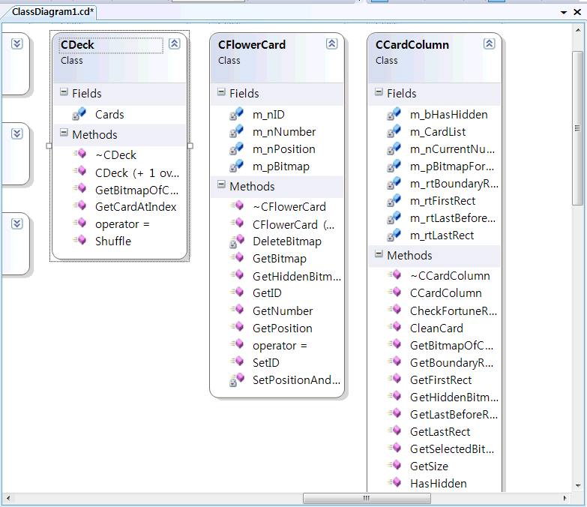
Flower Card class, Deck Class, and CardColumn class diagram.
Using STL Vector(Cards member from CDeck class), list(m_CardList member variables from CCArdColumn class), and shuffle algorithm.

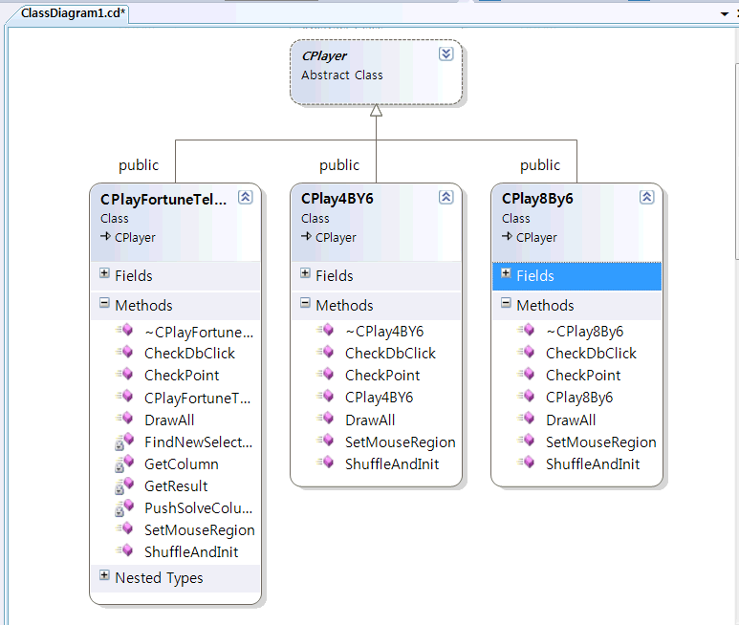

3 kinds of games are inherited from CPlayer. Class.
CPlayer’s methods are pure virtual function
virtual void DrawAll(CDC* pDC)=0;
virtual BOOL CheckDbClick(CPoint pt)=0;
virtual BOOL SetMouseRegion()=0;
virtual BOOL ShuffleAndInit()=0;
virtual int CheckPoint(const CPoint & pt, CRect& rt1, CRect& rt2)=0;

