

User Manual for the

**BPMN to Petri Net Transformation**

Web Application

Dr. Remco DijKman

Contents

Introduction 3

Getting Started 3

Launching the Web Application 3

Using the Web Application 3

System Requirements 7

libraries 7

Conclusion 7

References 8

Appendix I. Test BPMN Process Model (Picture) 9

Appendix II. Test BPMN Process Model (Specification) 10

Appendix III. Transformed petri net Model (picture) 17

Appendix II. Transformed petri net Model (Specification) 18

# Introduction

This document presents a user manual of a web application, called *BPMN 2 Petri Nets Transformation*, that has been developed to present a mapping between a business process model that is designed by Business Process Model and Notation (BPMN)   
  
  
  
  
  
  
  
  
  
  
  
  
  
  
  
  
  
  
  
  
  
  
  
  
  
  
  
  
  
  
  
  
  
  
(OMG Group 2006) modelling language to its semantically similar Petri net model. The theoretical information regarding the mapping between BPMN and Petri nets has been provided in   
  
  
  
  
  
  
  
  
  
  
  
  
  
  
  
  
  
  
  
  
  
  
  
  
  
  
  
  
  
  
  
  
  
  
  
  
  
  
  
  
  
  
  
  
  
  
(Dijkman et al. 2008), where a formal semantics for a large subset of BPMN in terms of Petri nets has been defined.

# Getting Started

The *BPMN 2 Petri Nets Transformation* is a web-browser based program that provides a mapping between a business process model that is desgined by BPMN and Petri nets. This applications receives a BPMN process model as an input and it displays a transformed Petri net model as an output on the web browser of your device through the internet connection.

# Launching the Web Application

To get started using the *BPMN 2 Petri Nets Transformation* application right away, just type the following address into your web browser or click on the link below.

<http://islab1.ieis.tue.nl:6411/Transformation/>

The first time you access the application a large amount of information is transferred to your computer, and it may take up to half-a-minute to load depending on your computer speed, internet connection type, and server load. The average load time is about 5 seconds.

# Using the Web Application

The *BPMN 2 Petri Nets Transformation* web application’s layout is consists of five main parts: (1) Authentication Center, (2) Process Repository Panel, (3) Command Center, (4) BPMN 2.0 Process Model Panel, and (5) Petri Net Process Model Panel.

Each user of this web application needs to be authenticated. Once you access the application, you can register your user profile. To do so, you can use the *Register* button and fill in the registration form. The mandatory fields for the registration procedure, identified by the * sign, are: Email, Password and Role. Currently, you can keep the role field as preselected (i.e., *admin*). Figure 1 shows the registration procedure (this field may be used in future releases).

In case that you would like to use your own profile picture, the best fit is 100px*100px. Also, the maximum size for this picture is 300kb. This information can be found via blue question mark icon.

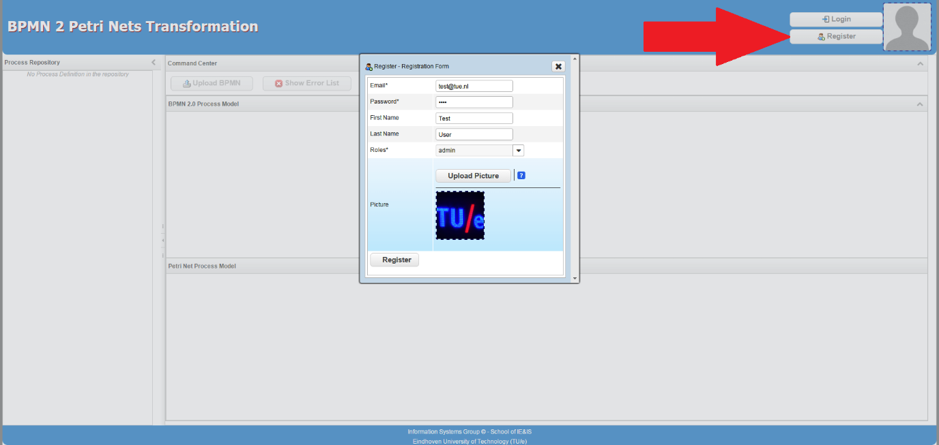

Figure 1- Registration procedure

Having created your own user profile, you can log into the web via the *Login* button. Figure 2 shows the login procedure for the user that have been registered in Figure 1.

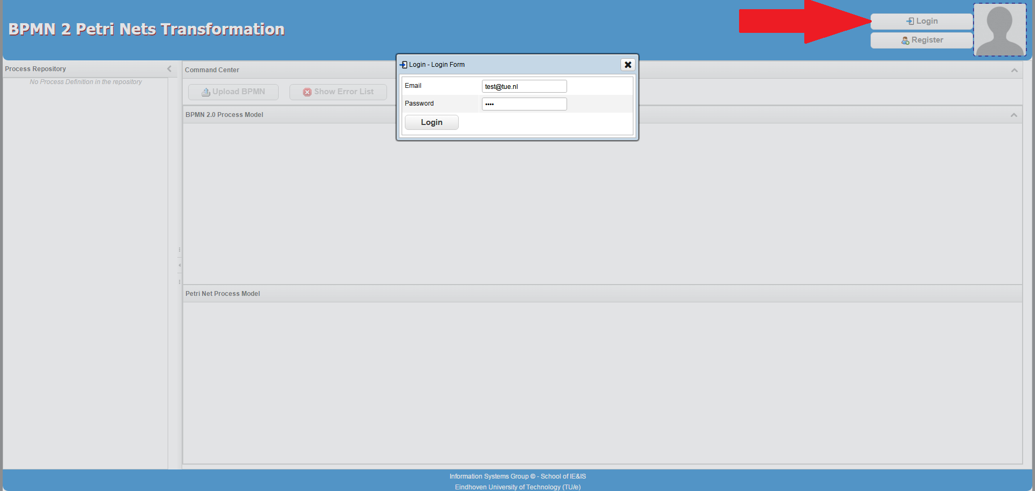

Figure 2 - Login procedure

Once you log into the *BPMN 2 Petri Nets Transformation*, you will be able to see your name and your profile picture at the header of the application. Now, the first two buttons from the command center (i.e., *Upload BPMN*, and *Show Error List*) are enabled. You can upload your BPMN process model by using the first button. Additionally, you can see all the BPMN process models that you have already uploaded into the system at the Process Repositpry panel. Note that, these process models are identified by their file names.

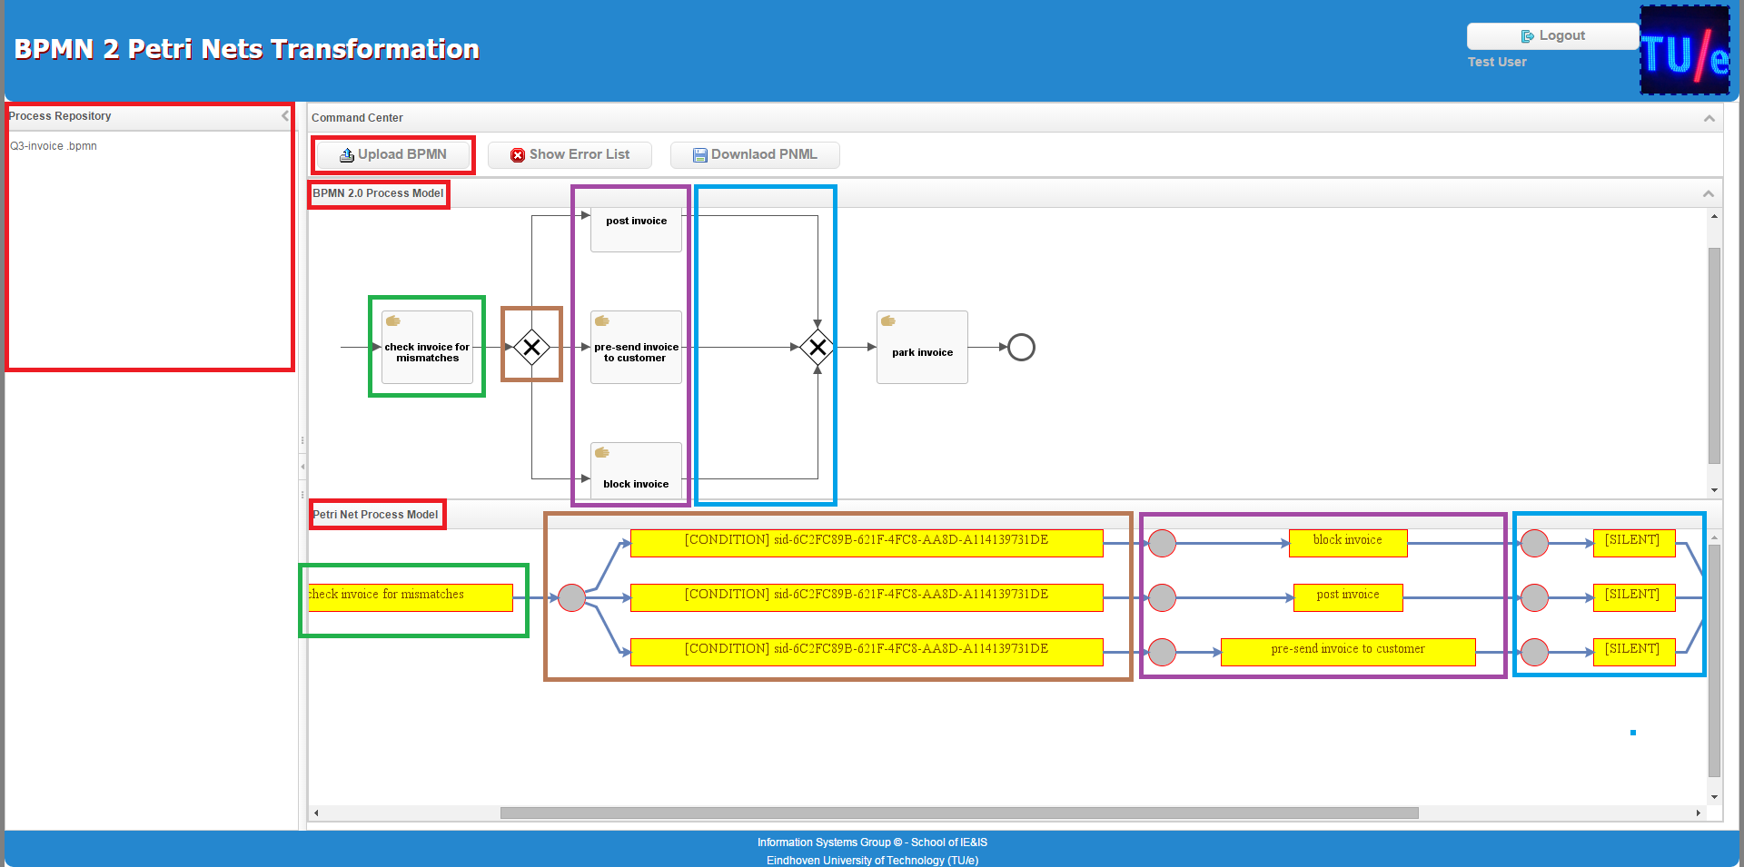

Figure 3 - Mapping of a BPMN to a Petri Net

Figure 3 shows the mapping of a BPMN model (cf. Appendix I and II) to its transformed Petri net (cf. Appendix III). If the mapping has been successfully performed, you will be able to see the transformed Petri net in the Petri Net Process Model Panel. In addition, your BPMN model will be added to the Process Reositry.

Figure 3 also illustrates how the mapping between those two process model has been applied. Each colorful rectangle in the BPMN model is mapped to the same color rectangle in the Petri net model.

You can also download your Petri net model in Petri Net Markup Language   
  
  
  
  
  
  
  
  
  
  
  
  
  
  
  
  
  
  
  
  
  
  
  
  
  
  
  
  
  
  
  
  
  
  
  
  
  
  
  
  
  
  
  
  
  
  
  
  
  
  
  
  
  
  
  
  
  
  
  
  
  
  
  
  
  
  
  
(Billington et al. 2003) (PNML) format via the *Download PNML* button at the Command Center. Note that, te downloaded PNML file only includes the main elements of the Petri net (i.e., labelled transitions and places) and it does not provide the positin elements that are necessary to show a nicely layouted Petri net in an external editor.

If the mapping has not successfully been performed, you will be able to see the error message via the *Show Error List* button. Figure 4 shows the situation in which the input BPMN model contains an error and it cannot be validated. Therefore, a new message will be added to the Error list stating that there is an *Error* in *Parsing* your input *XML* file (i.e., BPMN process model).

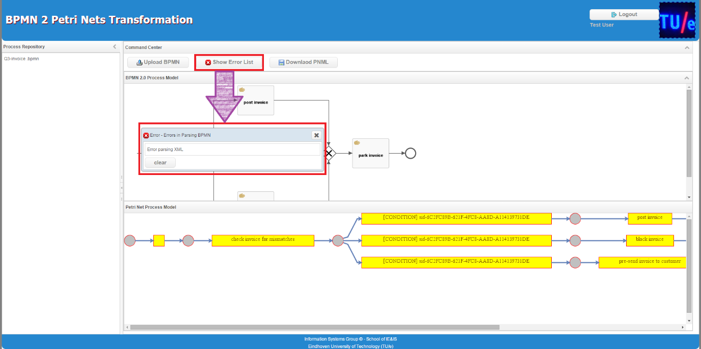

Figure 4 - Error in parsing BPMN file

All the uploaded process models are shown in your personal Process Repository based on their file names. In case that you try to upload a process model with the same name as one that currently exists in your repository, you will receive an error message. This scenario is illustrated in Figure 5.

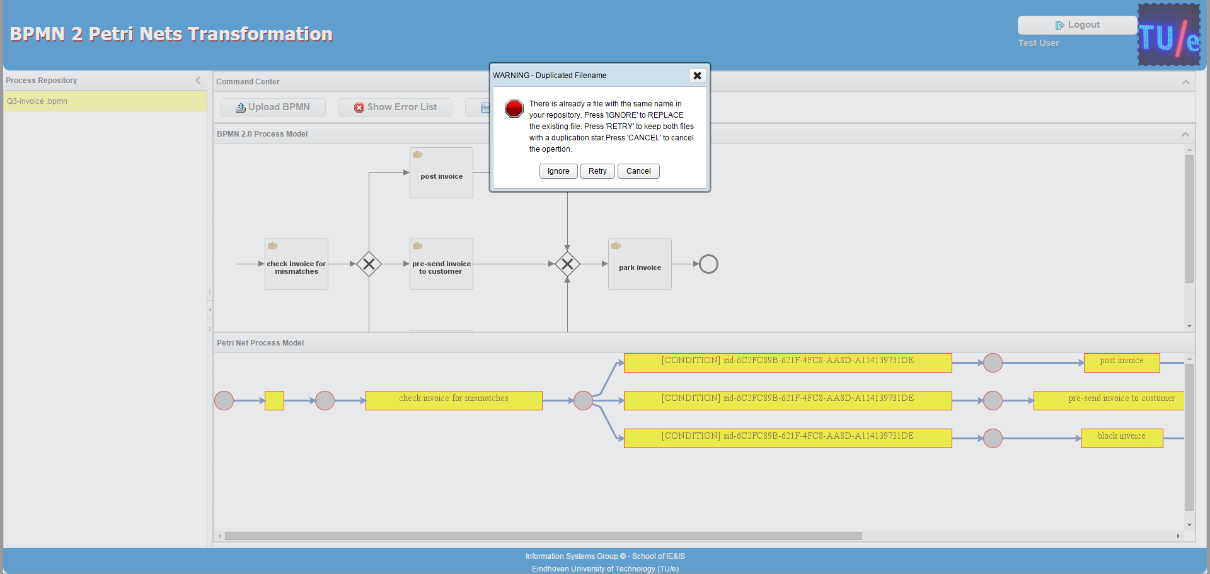

Figure 5 - Duplicated process model

This error message provides you with three options:

* *Ignore*: this option can be used if you want to *replace* the new process model with the existing one;
* *Retry*: this option can be used if you want to *keep* both the old and the new version of the process model. In this case, an additional + sign will be added at the end of the file name for the new process model.
* *Cancel*: this option can be used if you want to cancel the upload operation.

Figure 6 shows the scenario in which the *Retry* option has been selected and consequently the new process model has been added with a + sign (i.e., duplication index) at the end of its file name.

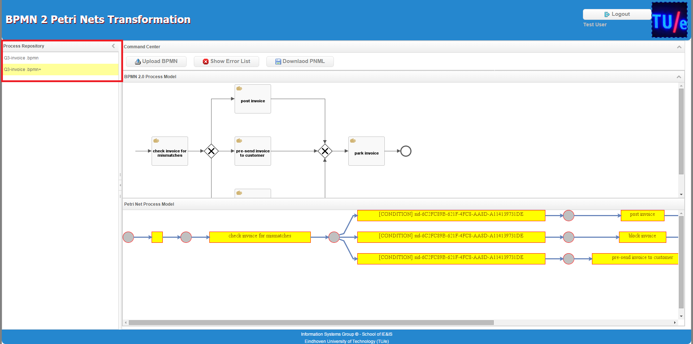

Figure 6 - Keep both old and new process models

# System Requirements

The web application is specially designed for the following web browsers:

* Google Chrome 4.1.0 or higher,
* Microsoft Internet Explorer 9, or
* higher and Mozilla Firefox 3 or higher.

Additional web browsers may work, but have not been tested. Your computer should also meet the minimum system requirements provided by the manufacturer of the browser you are using.

The web application will perform best on devices with a high-speed internet connection similar to digital subscriber line (DSL), cable, or faster.

# libraries

This section introduces the most important libraries that have been employed in developing the BPMN to Petri Net Transformation application.

|  |  |
| --- | --- |
| Library | Description |
| Activiti | BPMN Process Modelling and Validation |
| Appache Common | File uploader, String maker |
| H2 | Database Interface |
| jgraph | Graph Designer (we used this to draw the output Petri net) |
| ZK | User Interface Designer |

# Conclusion

In this document, we demonstrated how one can use the BPMN to Petri Net Transformation web application. The source code of this application can be downloaded from our GitHub:

<https://github.com/shoopi/petrinet-bpmn-transformation>

# References

Billington, J. et al., 2003. The Petri net markup language: concepts, technology, and tools. In *Applications and Theory of Petri Nets 2003*. Springer, pp. 483–505.

Dijkman, R.M., Dumas, M. & Ouyang, C., 2008. Semantics and analysis of business process models in BPMN. *Information and Software Technology*, 50(12), pp.1281–1294.

OMG Group, 2006. Specification of Business Process Modeling Notation. *Needham, MA, USA*, 2(2).

# Appendix I. Test BPMN Process Model (Picture)

This appendix shows the test process model that has been used throuout of this user manual. This process model has been design via the Signavio Process Model Designer.

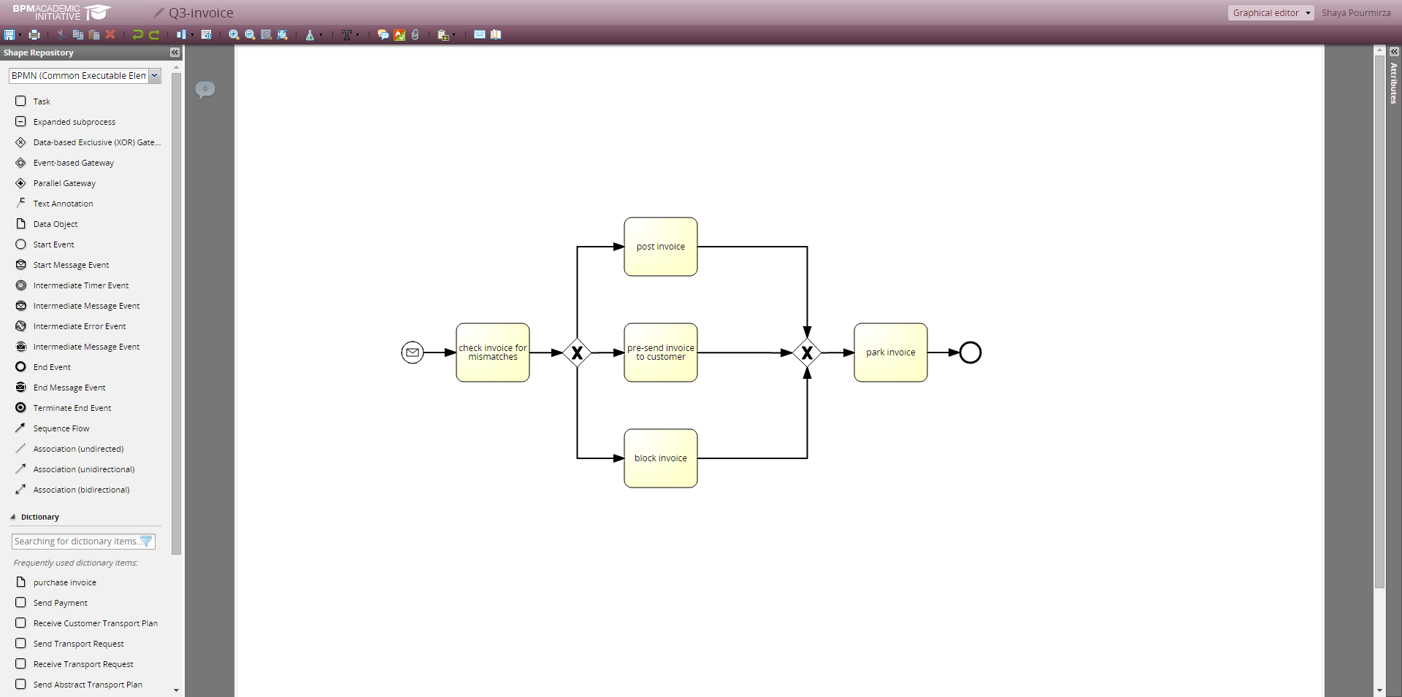

# Appendix II. Test BPMN Process Model (Specification)

This appendix shows the underlying BPMN specification of the process model that has been used throuout of this user manual.

<?xml version="1.0" encoding="UTF-8"?><definitions xmlns="http://www.omg.org/spec/BPMN/20100524/MODEL" xmlns:bpmndi="http://www.omg.org/spec/BPMN/20100524/DI" xmlns:omgdc="http://www.omg.org/spec/DD/20100524/DC" xmlns:omgdi="http://www.omg.org/spec/DD/20100524/DI" xmlns:signavio="http://www.signavio.com" xmlns:xsi="http://www.w3.org/2001/XMLSchema-instance" exporter="Signavio Process Editor, http://www.signavio.com" exporterVersion="8.4.0" expressionLanguage="http://www.w3.org/1999/XPath" id="sid-7dea3c51-a9e4-45c8-9e1c-a6f226b1c500" targetNamespace="http://www.signavio.com/bpmn20" typeLanguage="http://www.w3.org/2001/XMLSchema" xsi:schemaLocation="http://www.omg.org/spec/BPMN/20100524/MODEL http://www.omg.org/spec/BPMN/2.0/20100501/BPMN20.xsd">

<message id="sid-647296b0-4a42-4cb1-b4b3-59c02a6c498e" name="msg"/>

<process id="sid-19e3f083-427c-4f88-99ea-0a2c54206caf" isClosed="false" isExecutable="true" processType="None">

<extensionElements>

<signavio:signavioDiagramMetaData metaKey="revisionid" metaValue="3f46a1cdfeb542079eaac4a17db991bc"/>

</extensionElements>

<startEvent id="sid-0C0636FE-D92F-42AF-95CF-32209AD5A6F9" isInterrupting="true" name="">

<extensionElements>

<signavio:signavioMetaData metaKey="bgcolor" metaValue="#ffffff"/>

<signavio:signavioMetaData metaKey="viaitsystem" metaValue=""/>

<signavio:signavioMetaData metaKey="preceedingprocesses" metaValue="[]"/>

</extensionElements>

<outgoing>sid-52D32C69-2FF4-4699-AFAC-189F2157243F</outgoing>

<messageEventDefinition id="sid-c8af161a-e50a-499d-b896-03052b8fc899" messageRef="sid-647296b0-4a42-4cb1-b4b3-59c02a6c498e"/>

</startEvent>

<task completionQuantity="1" id="sid-1784770B-C64C-4626-9045-5E72C2FF17E1" isForCompensation="false" name="check invoice for mismatches" startQuantity="1">

<extensionElements>

<signavio:signavioMetaData metaKey="bgcolor" metaValue="#ffffcc"/>

<signavio:signavioMetaData metaKey="risklevel" metaValue=""/>

<signavio:signavioMetaData metaKey="externaldocuments" metaValue="[]"/>

</extensionElements>

<incoming>sid-52D32C69-2FF4-4699-AFAC-189F2157243F</incoming>

<outgoing>sid-59553131-F7EE-4A2E-8029-65A3E1F75955</outgoing>

</task>

<exclusiveGateway gatewayDirection="Diverging" id="sid-6C2FC89B-621F-4FC8-AA8D-A114139731DE" name="">

<extensionElements>

<signavio:signavioMetaData metaKey="bgcolor" metaValue="#ffffff"/>

</extensionElements>

<incoming>sid-59553131-F7EE-4A2E-8029-65A3E1F75955</incoming>

<outgoing>sid-6ED322A1-0574-447E-8CDB-4007D1CD1FB7</outgoing>

<outgoing>sid-A5C616D8-01E3-4B6E-8F89-BD99C4647657</outgoing>

<outgoing>sid-19277FE8-CA72-4556-AD7E-4F7A6255AE6C</outgoing>

</exclusiveGateway>

<task completionQuantity="1" id="sid-9003DFAB-7CEB-49DE-BF94-3B86DD4CB5EC" isForCompensation="false" name="post invoice" startQuantity="1">

<extensionElements>

<signavio:signavioMetaData metaKey="bgcolor" metaValue="#ffffcc"/>

<signavio:signavioMetaData metaKey="risklevel" metaValue=""/>

<signavio:signavioMetaData metaKey="externaldocuments" metaValue="[]"/>

</extensionElements>

<incoming>sid-19277FE8-CA72-4556-AD7E-4F7A6255AE6C</incoming>

<outgoing>sid-762FB9A7-F508-4BE5-919F-7B39F1D221B1</outgoing>

</task>

<task completionQuantity="1" id="sid-524C27B1-E0E6-458C-B7E9-F8B0E67910B5" isForCompensation="false" name="pre-send invoice to customer" startQuantity="1">

<extensionElements>

<signavio:signavioMetaData metaKey="bgcolor" metaValue="#ffffcc"/>

<signavio:signavioMetaData metaKey="risklevel" metaValue=""/>

<signavio:signavioMetaData metaKey="externaldocuments" metaValue="[]"/>

</extensionElements>

<incoming>sid-6ED322A1-0574-447E-8CDB-4007D1CD1FB7</incoming>

<outgoing>sid-8BCD0A7F-45A4-46B6-834C-E46470CC8330</outgoing>

</task>

<task completionQuantity="1" id="sid-3BFB7AA5-5A2C-421A-BD01-E1FD08D5FD86" isForCompensation="false" name="block invoice" startQuantity="1">

<extensionElements>

<signavio:signavioMetaData metaKey="bgcolor" metaValue="#ffffcc"/>

<signavio:signavioMetaData metaKey="risklevel" metaValue=""/>

<signavio:signavioMetaData metaKey="externaldocuments" metaValue="[]"/>

</extensionElements>

<incoming>sid-A5C616D8-01E3-4B6E-8F89-BD99C4647657</incoming>

<outgoing>sid-7A7EF49B-732D-4D0D-834F-2BE67D45C420</outgoing>

</task>

<exclusiveGateway gatewayDirection="Converging" id="sid-DE8E5D98-4257-4E49-8596-604B328654F6" name="">

<extensionElements>

<signavio:signavioMetaData metaKey="bgcolor" metaValue="#ffffff"/>

</extensionElements>

<incoming>sid-762FB9A7-F508-4BE5-919F-7B39F1D221B1</incoming>

<incoming>sid-8BCD0A7F-45A4-46B6-834C-E46470CC8330</incoming>

<incoming>sid-7A7EF49B-732D-4D0D-834F-2BE67D45C420</incoming>

<outgoing>sid-BFC94756-08AD-4D72-94B5-4ED54DC82267</outgoing>

</exclusiveGateway>

<task completionQuantity="1" id="sid-14AE8F3F-4CB6-4CDF-8FAC-354B77D27C58" isForCompensation="false" name="park invoice" startQuantity="1">

<extensionElements>

<signavio:signavioMetaData metaKey="bgcolor" metaValue="#ffffcc"/>

<signavio:signavioMetaData metaKey="risklevel" metaValue=""/>

<signavio:signavioMetaData metaKey="externaldocuments" metaValue="[]"/>

</extensionElements>

<incoming>sid-BFC94756-08AD-4D72-94B5-4ED54DC82267</incoming>

<outgoing>sid-5377EE3D-7640-4D36-B63C-CBC293869F27</outgoing>

</task>

<endEvent id="sid-2BFD1513-24C0-4587-AB25-E79A723D7038" name="">

<extensionElements>

<signavio:signavioMetaData metaKey="bgcolor" metaValue="#ffffff"/>

<signavio:signavioMetaData metaKey="followingprocesses" metaValue="[]"/>

</extensionElements>

<incoming>sid-5377EE3D-7640-4D36-B63C-CBC293869F27</incoming>

</endEvent>

<sequenceFlow id="sid-52D32C69-2FF4-4699-AFAC-189F2157243F" name="" sourceRef="sid-0C0636FE-D92F-42AF-95CF-32209AD5A6F9" targetRef="sid-1784770B-C64C-4626-9045-5E72C2FF17E1"/>

<sequenceFlow id="sid-59553131-F7EE-4A2E-8029-65A3E1F75955" name="" sourceRef="sid-1784770B-C64C-4626-9045-5E72C2FF17E1" targetRef="sid-6C2FC89B-621F-4FC8-AA8D-A114139731DE"/>

<sequenceFlow id="sid-6ED322A1-0574-447E-8CDB-4007D1CD1FB7" name="" sourceRef="sid-6C2FC89B-621F-4FC8-AA8D-A114139731DE" targetRef="sid-524C27B1-E0E6-458C-B7E9-F8B0E67910B5"/>

<sequenceFlow id="sid-A5C616D8-01E3-4B6E-8F89-BD99C4647657" name="" sourceRef="sid-6C2FC89B-621F-4FC8-AA8D-A114139731DE" targetRef="sid-3BFB7AA5-5A2C-421A-BD01-E1FD08D5FD86"/>

<sequenceFlow id="sid-19277FE8-CA72-4556-AD7E-4F7A6255AE6C" name="" sourceRef="sid-6C2FC89B-621F-4FC8-AA8D-A114139731DE" targetRef="sid-9003DFAB-7CEB-49DE-BF94-3B86DD4CB5EC"/>

<sequenceFlow id="sid-762FB9A7-F508-4BE5-919F-7B39F1D221B1" name="" sourceRef="sid-9003DFAB-7CEB-49DE-BF94-3B86DD4CB5EC" targetRef="sid-DE8E5D98-4257-4E49-8596-604B328654F6"/>

<sequenceFlow id="sid-8BCD0A7F-45A4-46B6-834C-E46470CC8330" name="" sourceRef="sid-524C27B1-E0E6-458C-B7E9-F8B0E67910B5" targetRef="sid-DE8E5D98-4257-4E49-8596-604B328654F6"/>

<sequenceFlow id="sid-7A7EF49B-732D-4D0D-834F-2BE67D45C420" name="" sourceRef="sid-3BFB7AA5-5A2C-421A-BD01-E1FD08D5FD86" targetRef="sid-DE8E5D98-4257-4E49-8596-604B328654F6"/>

<sequenceFlow id="sid-BFC94756-08AD-4D72-94B5-4ED54DC82267" name="" sourceRef="sid-DE8E5D98-4257-4E49-8596-604B328654F6" targetRef="sid-14AE8F3F-4CB6-4CDF-8FAC-354B77D27C58"/>

<sequenceFlow id="sid-5377EE3D-7640-4D36-B63C-CBC293869F27" name="" sourceRef="sid-14AE8F3F-4CB6-4CDF-8FAC-354B77D27C58" targetRef="sid-2BFD1513-24C0-4587-AB25-E79A723D7038"/>

</process>

<bpmndi:BPMNDiagram id="sid-8653c5fb-7950-4024-a5ca-eb34aad4e7c0">

<bpmndi:BPMNPlane bpmnElement="sid-19e3f083-427c-4f88-99ea-0a2c54206caf" id="sid-b1cc6e3e-0627-48e5-8c34-5a1a738bbdd7">

<bpmndi:BPMNShape bpmnElement="sid-0C0636FE-D92F-42AF-95CF-32209AD5A6F9" id="sid-0C0636FE-D92F-42AF-95CF-32209AD5A6F9_gui">

<omgdc:Bounds height="30.0" width="30.0" x="225.0" y="405.0"/>

</bpmndi:BPMNShape>

<bpmndi:BPMNShape bpmnElement="sid-1784770B-C64C-4626-9045-5E72C2FF17E1" id="sid-1784770B-C64C-4626-9045-5E72C2FF17E1_gui">

<omgdc:Bounds height="80.0" width="100.0" x="300.0" y="380.0"/>

<bpmndi:BPMNLabel labelStyle="sid-fa763e88-d33c-450b-8ffd-22336fc18007">

<omgdc:Bounds height="24.0" width="92.57142639160156" x="303.7142868041992" y="406.0"/>

</bpmndi:BPMNLabel>

</bpmndi:BPMNShape>

<bpmndi:BPMNShape bpmnElement="sid-6C2FC89B-621F-4FC8-AA8D-A114139731DE" id="sid-6C2FC89B-621F-4FC8-AA8D-A114139731DE_gui" isMarkerVisible="true">

<omgdc:Bounds height="40.0" width="40.0" x="445.0" y="400.0"/>

</bpmndi:BPMNShape>

<bpmndi:BPMNShape bpmnElement="sid-9003DFAB-7CEB-49DE-BF94-3B86DD4CB5EC" id="sid-9003DFAB-7CEB-49DE-BF94-3B86DD4CB5EC_gui">

<omgdc:Bounds height="80.0" width="100.0" x="530.0" y="235.0"/>

<bpmndi:BPMNLabel labelStyle="sid-fa763e88-d33c-450b-8ffd-22336fc18007">

<omgdc:Bounds height="12.0" width="72.0" x="544.0" y="267.0"/>

</bpmndi:BPMNLabel>

</bpmndi:BPMNShape>

<bpmndi:BPMNShape bpmnElement="sid-524C27B1-E0E6-458C-B7E9-F8B0E67910B5" id="sid-524C27B1-E0E6-458C-B7E9-F8B0E67910B5_gui">

<omgdc:Bounds height="80.0" width="100.0" x="530.0" y="380.0"/>

<bpmndi:BPMNLabel labelStyle="sid-fa763e88-d33c-450b-8ffd-22336fc18007">

<omgdc:Bounds height="36.0" width="57.42857360839844" x="551.2857131958008" y="400.0"/>

</bpmndi:BPMNLabel>

</bpmndi:BPMNShape>

<bpmndi:BPMNShape bpmnElement="sid-3BFB7AA5-5A2C-421A-BD01-E1FD08D5FD86" id="sid-3BFB7AA5-5A2C-421A-BD01-E1FD08D5FD86_gui">

<omgdc:Bounds height="80.0" width="100.0" x="530.0" y="525.0"/>

<bpmndi:BPMNLabel labelStyle="sid-fa763e88-d33c-450b-8ffd-22336fc18007">

<omgdc:Bounds height="12.0" width="75.42857360839844" x="542.2857131958008" y="557.0"/>

</bpmndi:BPMNLabel>

</bpmndi:BPMNShape>

<bpmndi:BPMNShape bpmnElement="sid-DE8E5D98-4257-4E49-8596-604B328654F6" id="sid-DE8E5D98-4257-4E49-8596-604B328654F6_gui" isMarkerVisible="true">

<omgdc:Bounds height="40.0" width="40.0" x="760.0" y="400.0"/>

</bpmndi:BPMNShape>

<bpmndi:BPMNShape bpmnElement="sid-14AE8F3F-4CB6-4CDF-8FAC-354B77D27C58" id="sid-14AE8F3F-4CB6-4CDF-8FAC-354B77D27C58_gui">

<omgdc:Bounds height="80.0" width="100.0" x="845.0" y="380.0"/>

<bpmndi:BPMNLabel labelStyle="sid-fa763e88-d33c-450b-8ffd-22336fc18007">

<omgdc:Bounds height="12.0" width="71.14286041259766" x="859.4285697937012" y="412.0"/>

</bpmndi:BPMNLabel>

</bpmndi:BPMNShape>

<bpmndi:BPMNShape bpmnElement="sid-2BFD1513-24C0-4587-AB25-E79A723D7038" id="sid-2BFD1513-24C0-4587-AB25-E79A723D7038_gui">

<omgdc:Bounds height="28.0" width="28.0" x="990.0" y="406.0"/>

</bpmndi:BPMNShape>

<bpmndi:BPMNEdge bpmnElement="sid-BFC94756-08AD-4D72-94B5-4ED54DC82267" id="sid-BFC94756-08AD-4D72-94B5-4ED54DC82267_gui">

<omgdi:waypoint x="800.0" y="420.414847161572"/>

<omgdi:waypoint x="845.0" y="420.2183406113537"/>

</bpmndi:BPMNEdge>

<bpmndi:BPMNEdge bpmnElement="sid-19277FE8-CA72-4556-AD7E-4F7A6255AE6C" id="sid-19277FE8-CA72-4556-AD7E-4F7A6255AE6C_gui">

<omgdi:waypoint x="465.5" y="400.0"/>

<omgdi:waypoint x="465.5" y="275.0"/>

<omgdi:waypoint x="530.0" y="275.0"/>

</bpmndi:BPMNEdge>

<bpmndi:BPMNEdge bpmnElement="sid-5377EE3D-7640-4D36-B63C-CBC293869F27" id="sid-5377EE3D-7640-4D36-B63C-CBC293869F27_gui">

<omgdi:waypoint x="945.0" y="420.0"/>

<omgdi:waypoint x="990.0" y="420.0"/>

</bpmndi:BPMNEdge>

<bpmndi:BPMNEdge bpmnElement="sid-7A7EF49B-732D-4D0D-834F-2BE67D45C420" id="sid-7A7EF49B-732D-4D0D-834F-2BE67D45C420_gui">

<omgdi:waypoint x="630.0" y="565.0"/>

<omgdi:waypoint x="780.5" y="565.0"/>

<omgdi:waypoint x="780.5" y="440.0"/>

</bpmndi:BPMNEdge>

<bpmndi:BPMNEdge bpmnElement="sid-8BCD0A7F-45A4-46B6-834C-E46470CC8330" id="sid-8BCD0A7F-45A4-46B6-834C-E46470CC8330_gui">

<omgdi:waypoint x="630.0" y="420.1246882793017"/>

<omgdi:waypoint x="760.0" y="420.4488778054863"/>

</bpmndi:BPMNEdge>

<bpmndi:BPMNEdge bpmnElement="sid-6ED322A1-0574-447E-8CDB-4007D1CD1FB7" id="sid-6ED322A1-0574-447E-8CDB-4007D1CD1FB7_gui">

<omgdi:waypoint x="485.0" y="420.414847161572"/>

<omgdi:waypoint x="530.0" y="420.2183406113537"/>

</bpmndi:BPMNEdge>

<bpmndi:BPMNEdge bpmnElement="sid-52D32C69-2FF4-4699-AFAC-189F2157243F" id="sid-52D32C69-2FF4-4699-AFAC-189F2157243F_gui">

<omgdi:waypoint x="255.0" y="420.0"/>

<omgdi:waypoint x="300.0" y="420.0"/>

</bpmndi:BPMNEdge>

<bpmndi:BPMNEdge bpmnElement="sid-762FB9A7-F508-4BE5-919F-7B39F1D221B1" id="sid-762FB9A7-F508-4BE5-919F-7B39F1D221B1_gui">

<omgdi:waypoint x="630.0" y="275.0"/>

<omgdi:waypoint x="780.5" y="275.0"/>

<omgdi:waypoint x="780.5" y="400.0"/>

</bpmndi:BPMNEdge>

<bpmndi:BPMNEdge bpmnElement="sid-59553131-F7EE-4A2E-8029-65A3E1F75955" id="sid-59553131-F7EE-4A2E-8029-65A3E1F75955_gui">

<omgdi:waypoint x="400.0" y="420.2164502164502"/>

<omgdi:waypoint x="445.0" y="420.4112554112554"/>

</bpmndi:BPMNEdge>

<bpmndi:BPMNEdge bpmnElement="sid-A5C616D8-01E3-4B6E-8F89-BD99C4647657" id="sid-A5C616D8-01E3-4B6E-8F89-BD99C4647657_gui">

<omgdi:waypoint x="465.5" y="440.0"/>

<omgdi:waypoint x="465.5" y="565.0"/>

<omgdi:waypoint x="530.0" y="565.0"/>

</bpmndi:BPMNEdge>

</bpmndi:BPMNPlane>

<bpmndi:BPMNLabelStyle id="sid-fa763e88-d33c-450b-8ffd-22336fc18007">

<omgdc:Font isBold="false" isItalic="false" isStrikeThrough="false" isUnderline="false" name="Arial" size="12.0"/>

</bpmndi:BPMNLabelStyle>

</bpmndi:BPMNDiagram>

</definitions>

# Appendix III. Transformed petri net Model (picture)

This appendix shows the Petri nets of the process model that has been used throuout of this user manual. The output PNML file (cf. Appendix IV) has been imported to the WoPed Designer (<http://woped.dhbw-karlsruhe.de/>) and we applied a auto-layout feature to the model.

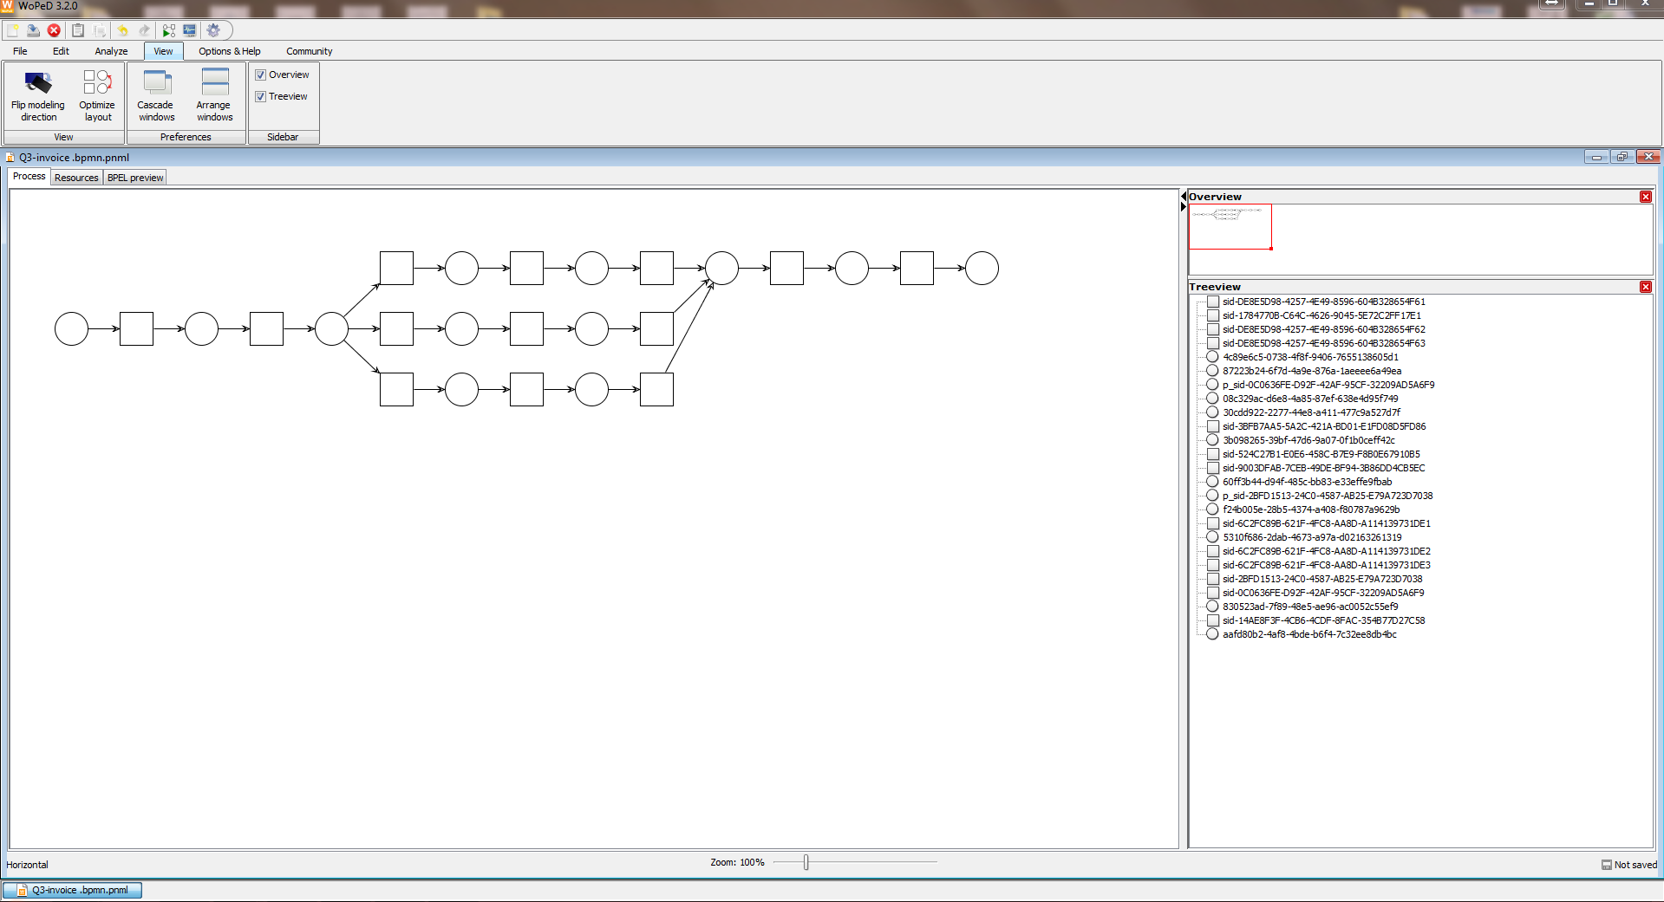

# Appendix II. Transformed petri net Model (Specification)

This appendix shows the underlying PNML specification of the process model that has been used throuout of this user manual.

<?xml version="1.0" encoding="UTF-8"?>

<pnml>

<net id="net" type="PTNet">

<place id="87223b24-6f7d-4a9e-876a-1aeeee6a49ea">

<initialMarking>

<value>null</value>

</initialMarking>

<marking>

<value>null</value>

</marking>

<name>

<value></value>

</name>

</place>

<place id="p_sid-0C0636FE-D92F-42AF-95CF-32209AD5A6F9">

<initialMarking>

<value>null</value>

</initialMarking>

<marking>

<value>null</value>

</marking>

<name>

<value></value>

</name>

</place>

<place id="3b098265-39bf-47d6-9a07-0f1b0ceff42c">

<initialMarking>

<value>null</value>

</initialMarking>

<marking>

<value>null</value>

</marking>

<name>

<value></value>

</name>

</place>

<place id="60ff3b44-d94f-485c-bb83-e33effe9fbab">

<initialMarking>

<value>null</value>

</initialMarking>

<marking>

<value>null</value>

</marking>

<name>

<value></value>

</name>

</place>

<place id="4c89e6c5-0738-4f8f-9406-7655138605d1">

<initialMarking>

<value>null</value>

</initialMarking>

<marking>

<value>null</value>

</marking>

<name>

<value></value>

</name>

</place>

<place id="p_sid-2BFD1513-24C0-4587-AB25-E79A723D7038">

<initialMarking>

<value>null</value>

</initialMarking>

<marking>

<value>null</value>

</marking>

<name>

<value></value>

</name>

</place>

<place id="5310f686-2dab-4673-a97a-d02163261319">

<initialMarking>

<value>null</value>

</initialMarking>

<marking>

<value>null</value>

</marking>

<name>

<value></value>

</name>

</place>

<place id="30cdd922-2277-44e8-a411-477c9a527d7f">

<initialMarking>

<value>null</value>

</initialMarking>

<marking>

<value>null</value>

</marking>

<name>

<value></value>

</name>

</place>

<place id="f24b005e-28b5-4374-a408-f80787a9629b">

<initialMarking>

<value>null</value>

</initialMarking>

<marking>

<value>null</value>

</marking>

<name>

<value></value>

</name>

</place>

<place id="08c329ac-d6e8-4a85-87ef-638e4d95f749">

<initialMarking>

<value>null</value>

</initialMarking>

<marking>

<value>null</value>

</marking>

<name>

<value></value>

</name>

</place>

<place id="830523ad-7f89-48e5-ae96-ac0052c55ef9">

<initialMarking>

<value>null</value>

</initialMarking>

<marking>

<value>null</value>

</marking>

<name>

<value></value>

</name>

</place>

<place id="aafd80b2-4af8-4bde-b6f4-7c32ee8db4bc">

<initialMarking>

<value>null</value>

</initialMarking>

<marking>

<value>null</value>

</marking>

<name>

<value></value>

</name>

</place>

<transition id="sid-DE8E5D98-4257-4E49-8596-604B328654F61">

<name>

<value>[SILENT] </value>

</name>

</transition>

<transition id="sid-DE8E5D98-4257-4E49-8596-604B328654F62">

<name>

<value>[SILENT] </value>

</name>

</transition>

<transition id="sid-6C2FC89B-621F-4FC8-AA8D-A114139731DE1">

<name>

<value>[CONDITION] sid-6C2FC89B-621F-4FC8-AA8D-A114139731DE</value>

</name>

</transition>

<transition id="sid-6C2FC89B-621F-4FC8-AA8D-A114139731DE3">

<name>

<value>[CONDITION] sid-6C2FC89B-621F-4FC8-AA8D-A114139731DE</value>

</name>

</transition>

<transition id="sid-6C2FC89B-621F-4FC8-AA8D-A114139731DE2">

<name>

<value>[CONDITION] sid-6C2FC89B-621F-4FC8-AA8D-A114139731DE</value>

</name>

</transition>

<transition id="sid-524C27B1-E0E6-458C-B7E9-F8B0E67910B5">

<name>

<value>pre-send invoice to customer</value>

</name>

</transition>

<transition id="sid-DE8E5D98-4257-4E49-8596-604B328654F63">

<name>

<value>[SILENT] </value>

</name>

</transition>

<transition id="sid-1784770B-C64C-4626-9045-5E72C2FF17E1">

<name>

<value>check invoice for mismatches</value>

</name>

</transition>

<transition id="sid-2BFD1513-24C0-4587-AB25-E79A723D7038">

<name>

<value></value>

</name>

</transition>

<transition id="sid-14AE8F3F-4CB6-4CDF-8FAC-354B77D27C58">

<name>

<value>park invoice</value>

</name>

</transition>

<transition id="sid-0C0636FE-D92F-42AF-95CF-32209AD5A6F9">

<name>

<value></value>

</name>

</transition>

<transition id="sid-9003DFAB-7CEB-49DE-BF94-3B86DD4CB5EC">

<name>

<value>post invoice</value>

</name>

</transition>

<transition id="sid-3BFB7AA5-5A2C-421A-BD01-E1FD08D5FD86">

<name>

<value>block invoice</value>

</name>

</transition>

<arc id="b598c74a-3d40-442c-a35a-fe925f642e1b" source="sid-14AE8F3F-4CB6-4CDF-8FAC-354B77D27C58" target="5310f686-2dab-4673-a97a-d02163261319">

<inscription>

<value>1</value>

</inscription>

</arc>

<arc id="6607f0b8-d744-4181-8968-85a0c420b6a3" source="30cdd922-2277-44e8-a411-477c9a527d7f" target="sid-6C2FC89B-621F-4FC8-AA8D-A114139731DE3">

<inscription>

<value>1</value>

</inscription>

</arc>

<arc id="96ecf8aa-3658-40ce-a125-113716b0e231" source="4c89e6c5-0738-4f8f-9406-7655138605d1" target="sid-524C27B1-E0E6-458C-B7E9-F8B0E67910B5">

<inscription>

<value>1</value>

</inscription>

</arc>

<arc id="fbc2616a-6fd8-4d87-8957-23bf9ce1232d" source="sid-DE8E5D98-4257-4E49-8596-604B328654F63" target="f24b005e-28b5-4374-a408-f80787a9629b">

<inscription>

<value>1</value>

</inscription>

</arc>

<arc id="c36ce07b-1946-4771-b492-7f9054d929f6" source="830523ad-7f89-48e5-ae96-ac0052c55ef9" target="sid-DE8E5D98-4257-4E49-8596-604B328654F61">

<inscription>

<value>1</value>

</inscription>

</arc>

<arc id="2269a30f-3b21-4f45-80e9-c47735715308" source="3b098265-39bf-47d6-9a07-0f1b0ceff42c" target="sid-DE8E5D98-4257-4E49-8596-604B328654F63">

<inscription>

<value>1</value>

</inscription>

</arc>

<arc id="f5feb2e8-cf47-4b6e-8f97-c6a106266673" source="08c329ac-d6e8-4a85-87ef-638e4d95f749" target="sid-9003DFAB-7CEB-49DE-BF94-3B86DD4CB5EC">

<inscription>

<value>1</value>

</inscription>

</arc>

<arc id="79b2e36b-0636-49d8-accd-08123dd46f4d" source="sid-524C27B1-E0E6-458C-B7E9-F8B0E67910B5" target="aafd80b2-4af8-4bde-b6f4-7c32ee8db4bc">

<inscription>

<value>1</value>

</inscription>

</arc>

<arc id="2c37c2a6-9a97-4bd6-8e06-3143288724bb" source="30cdd922-2277-44e8-a411-477c9a527d7f" target="sid-6C2FC89B-621F-4FC8-AA8D-A114139731DE1">

<inscription>

<value>1</value>

</inscription>

</arc>

<arc id="7c26af4c-53e7-4bb0-a858-a64c9d702d70" source="sid-6C2FC89B-621F-4FC8-AA8D-A114139731DE3" target="08c329ac-d6e8-4a85-87ef-638e4d95f749">

<inscription>

<value>1</value>

</inscription>

</arc>

<arc id="6e4c4f8a-bc7f-4cc8-9587-014a69d592f9" source="sid-DE8E5D98-4257-4E49-8596-604B328654F61" target="f24b005e-28b5-4374-a408-f80787a9629b">

<inscription>

<value>1</value>

</inscription>

</arc>

<arc id="2c8cfa22-4ef9-43cb-a8d7-fa1617f95e57" source="60ff3b44-d94f-485c-bb83-e33effe9fbab" target="sid-3BFB7AA5-5A2C-421A-BD01-E1FD08D5FD86">

<inscription>

<value>1</value>

</inscription>

</arc>

<arc id="b4eedb67-78a8-4100-b3d8-70cdc561bc5f" source="aafd80b2-4af8-4bde-b6f4-7c32ee8db4bc" target="sid-DE8E5D98-4257-4E49-8596-604B328654F62">

<inscription>

<value>1</value>

</inscription>

</arc>

<arc id="bc613411-2b09-4b44-b313-3235f6234ee2" source="30cdd922-2277-44e8-a411-477c9a527d7f" target="sid-6C2FC89B-621F-4FC8-AA8D-A114139731DE2">

<inscription>

<value>1</value>

</inscription>

</arc>

<arc id="f1246667-749b-46fc-b612-9752b8476f73" source="f24b005e-28b5-4374-a408-f80787a9629b" target="sid-14AE8F3F-4CB6-4CDF-8FAC-354B77D27C58">

<inscription>

<value>1</value>

</inscription>

</arc>

<arc id="d493847e-9844-4f1e-a71c-cd453f19efea" source="5310f686-2dab-4673-a97a-d02163261319" target="sid-2BFD1513-24C0-4587-AB25-E79A723D7038">

<inscription>

<value>1</value>

</inscription>

</arc>

<arc id="616f4227-9177-4bb8-acee-c6960844b52a" source="sid-3BFB7AA5-5A2C-421A-BD01-E1FD08D5FD86" target="3b098265-39bf-47d6-9a07-0f1b0ceff42c">

<inscription>

<value>1</value>

</inscription>

</arc>

<arc id="7ab3ca68-f64d-4bf5-9d96-97bbc5905cb6" source="sid-DE8E5D98-4257-4E49-8596-604B328654F62" target="f24b005e-28b5-4374-a408-f80787a9629b">

<inscription>

<value>1</value>

</inscription>

</arc>

<arc id="a18e56f9-756a-4240-aba9-6b844651845e" source="sid-9003DFAB-7CEB-49DE-BF94-3B86DD4CB5EC" target="830523ad-7f89-48e5-ae96-ac0052c55ef9">

<inscription>

<value>1</value>

</inscription>

</arc>

<arc id="757f728e-256e-469d-a8e2-91e8c0d02543" source="87223b24-6f7d-4a9e-876a-1aeeee6a49ea" target="sid-1784770B-C64C-4626-9045-5E72C2FF17E1">

<inscription>

<value>1</value>

</inscription>

</arc>

<arc id="4c78b568-f932-4457-a1a1-ffa00acd28e9" source="sid-6C2FC89B-621F-4FC8-AA8D-A114139731DE1" target="4c89e6c5-0738-4f8f-9406-7655138605d1">

<inscription>

<value>1</value>

</inscription>

</arc>

<arc id="569568b2-0e1d-4dfd-9def-85dc849e620d" source="sid-1784770B-C64C-4626-9045-5E72C2FF17E1" target="30cdd922-2277-44e8-a411-477c9a527d7f">

<inscription>

<value>1</value>

</inscription>

</arc>

<arc id="4ce83969-ade8-4b40-a697-81977b0d7c5b" source="sid-2BFD1513-24C0-4587-AB25-E79A723D7038" target="p_sid-2BFD1513-24C0-4587-AB25-E79A723D7038">

<inscription>

<value>1</value>

</inscription>

</arc>

<arc id="20498aff-1830-4d0b-9a7b-4beadb606f79" source="sid-0C0636FE-D92F-42AF-95CF-32209AD5A6F9" target="87223b24-6f7d-4a9e-876a-1aeeee6a49ea">

<inscription>

<value>1</value>

</inscription>

</arc>

<arc id="93a6f5df-3ca7-4fef-9caf-177b31bcafa0" source="sid-6C2FC89B-621F-4FC8-AA8D-A114139731DE2" target="60ff3b44-d94f-485c-bb83-e33effe9fbab">

<inscription>

<value>1</value>

</inscription>

</arc>

<arc id="e400716a-7a3d-4374-94a6-db416e852145" source="p_sid-0C0636FE-D92F-42AF-95CF-32209AD5A6F9" target="sid-0C0636FE-D92F-42AF-95CF-32209AD5A6F9">

<inscription>

<value>1</value>

</inscription>

</arc>

</net>

</pnml>