**Info Portfolio**

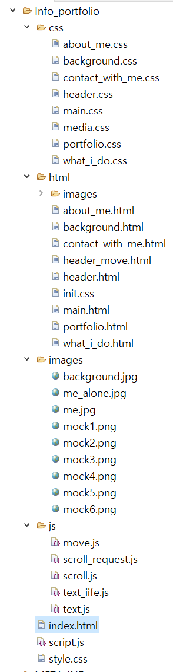

[index.html]

:index 파일안에 모든 내용이 나열 되어 있음 (아래로 펼쳐짐), 하나의 스크롤 바

SU : 클릭하면 메인으로 돌아감

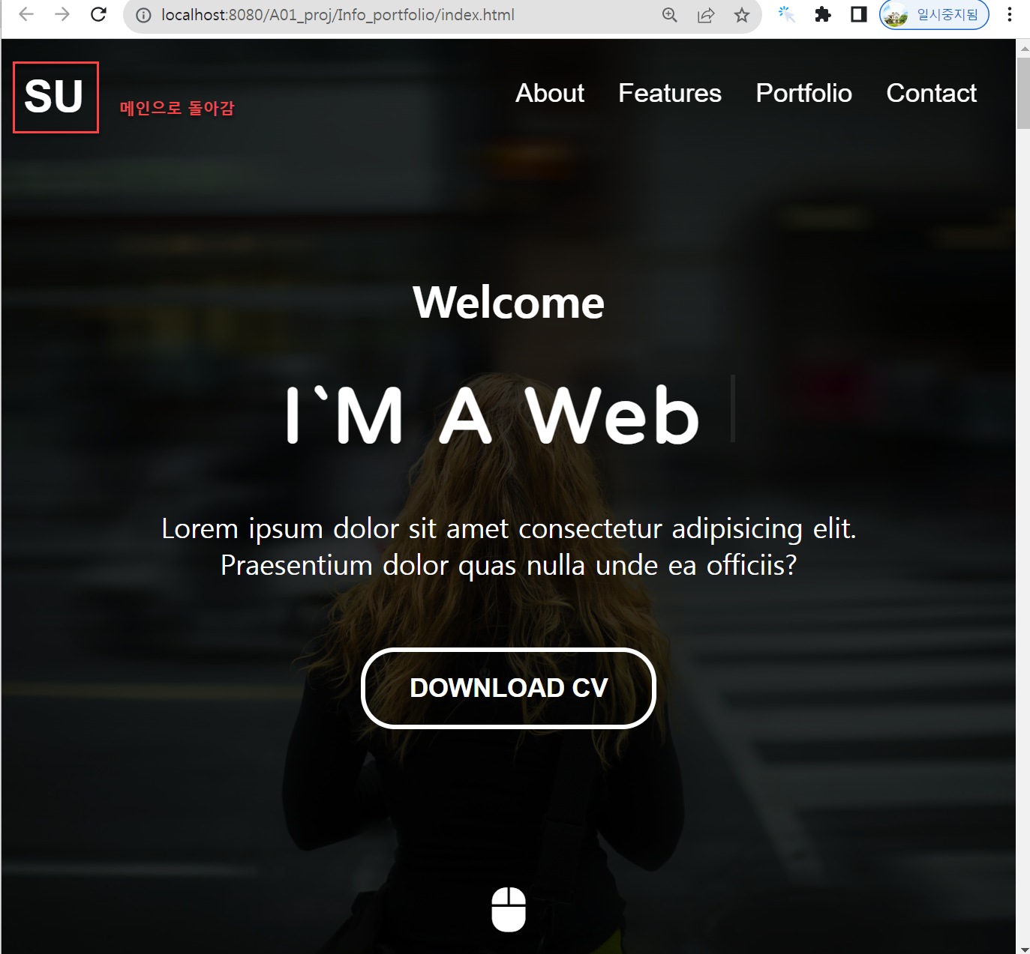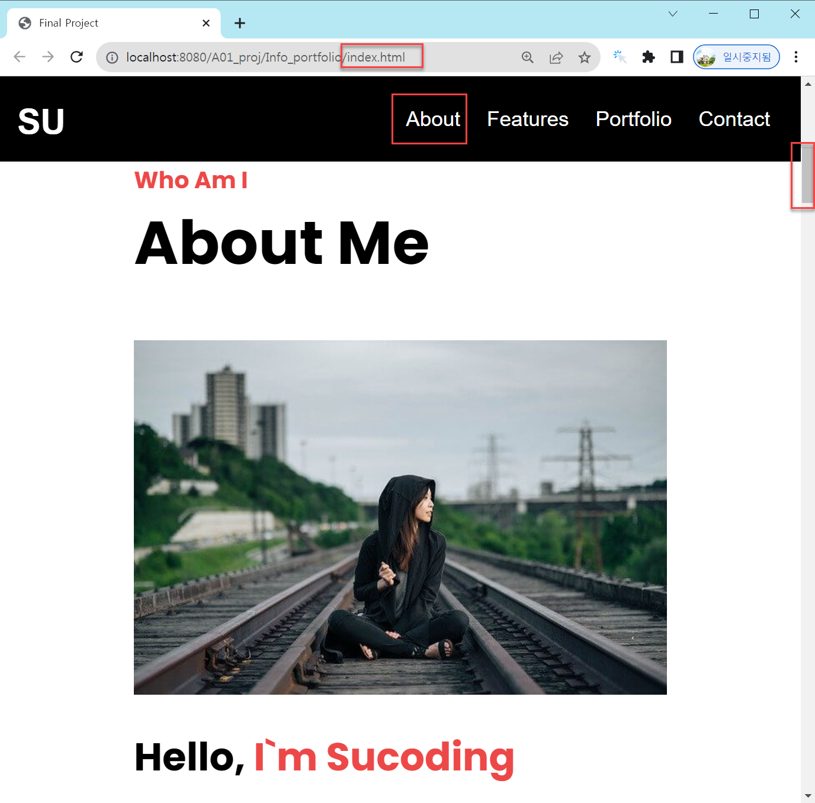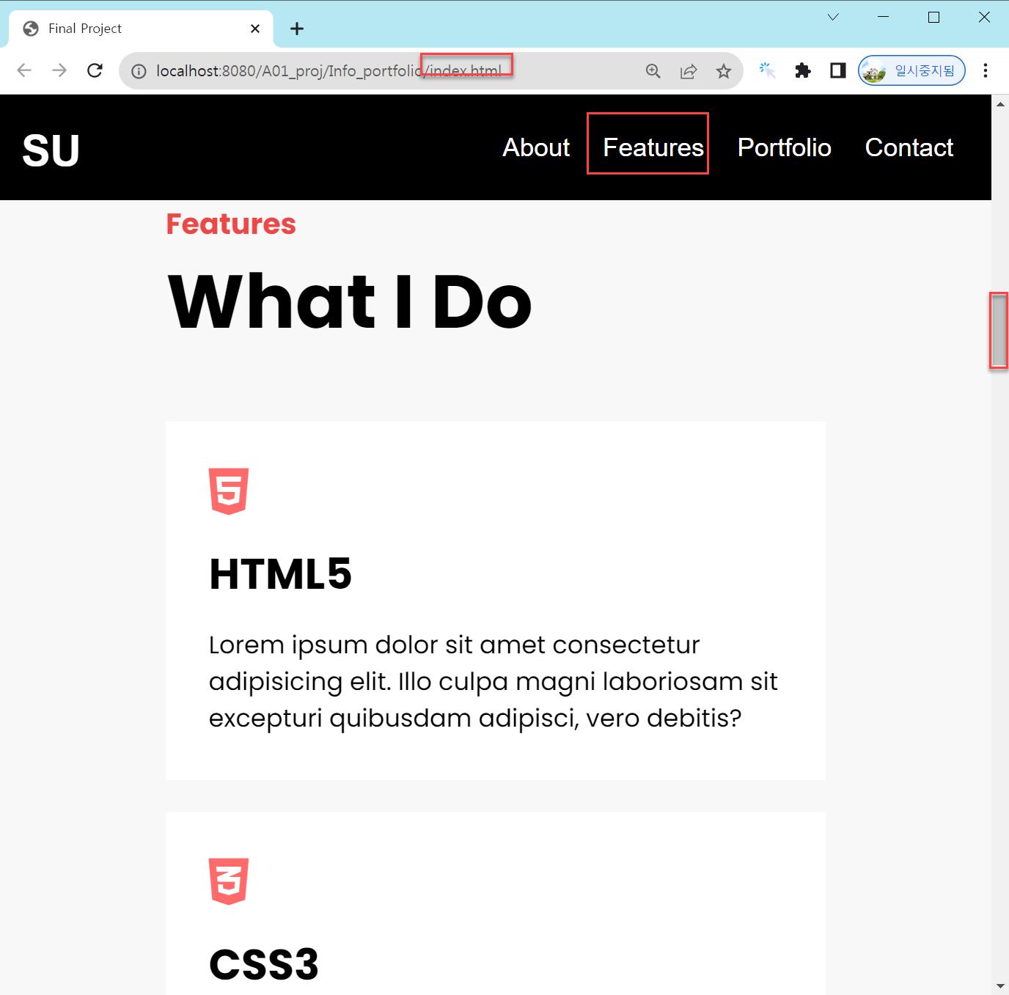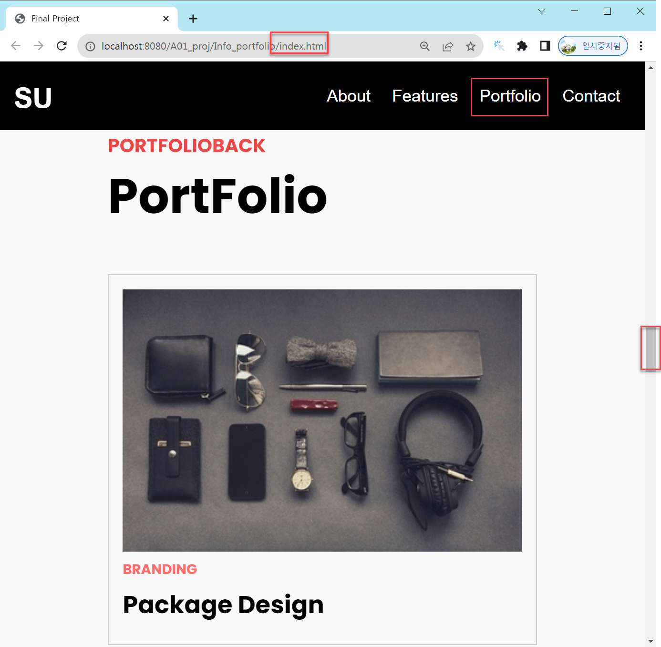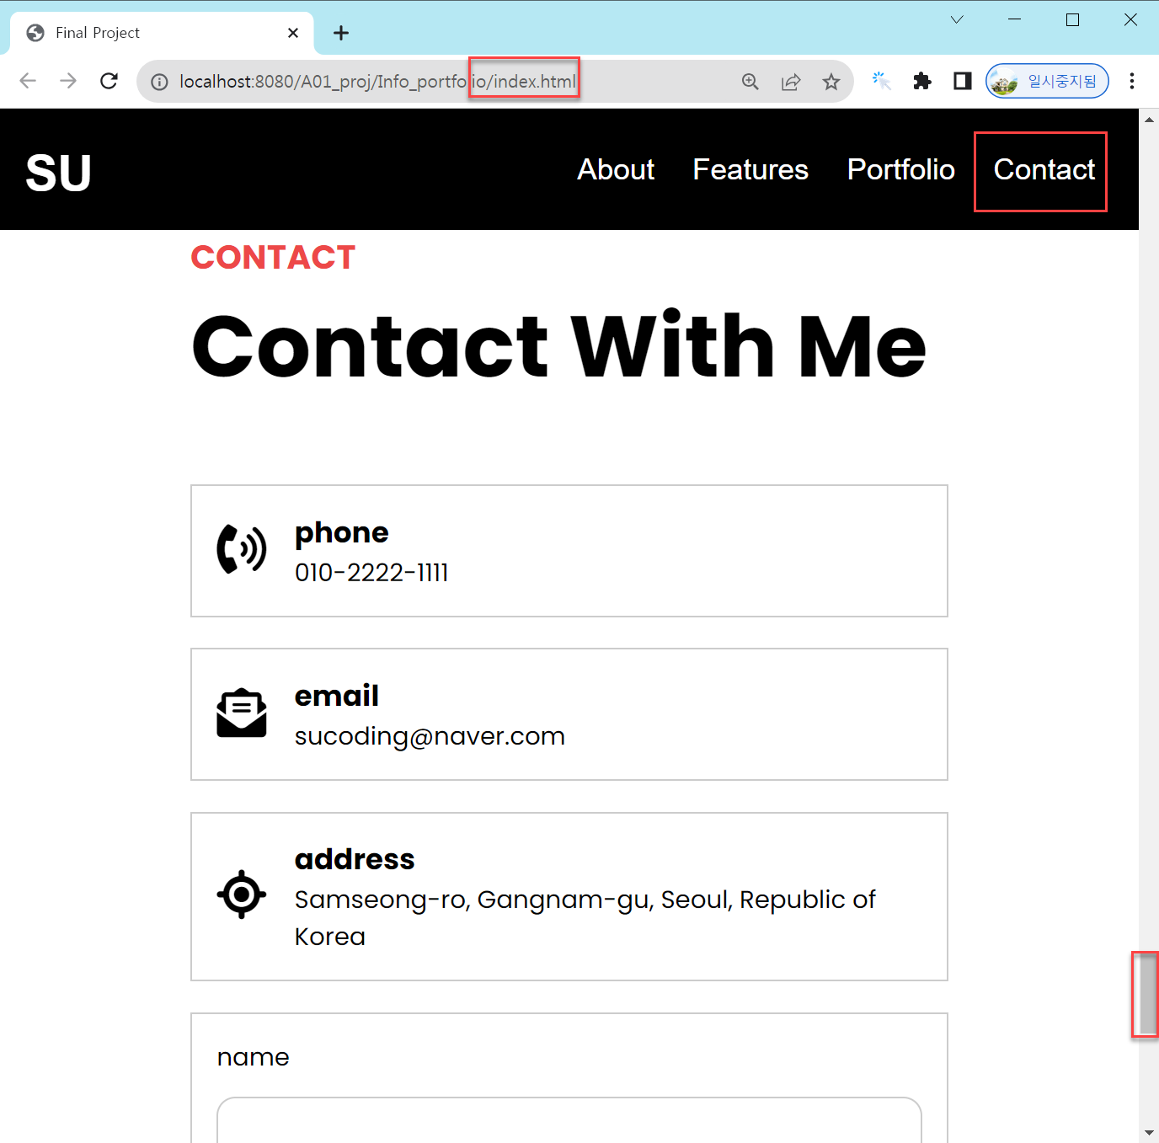

[index.html ]

|  |
| --- |
| <!DOCTYPE html>  <html lang="zxx">  <head>  <meta charset="UTF-8">  <meta http-equiv="X-UA-Compatible" content="IE=edge">  <meta name="viewport" content="width=device-width, initial-scale=1.0">  <title>Final Project</title>  <link rel="stylesheet" href="https://cdnjs.cloudflare.com/ajax/libs/font-awesome/6.1.1/css/all.min.css" integrity="sha512-KfkfwYDsLkIlwQp6LFnl8zNdLGxu9YAA1QvwINks4PhcElQSvqcyVLLD9aMhXd13uQjoXtEKNosOWaZqXgel0g==" crossorigin="anonymous" referrerpolicy="no-referrer" />  <link rel="stylesheet" href="style.css">  </head>  <body>  <!-- header -->  <header>  <div class="container">  <h1>  <button data-animation-scroll="true" data-target="#main">SU</button>  </h1>  <nav>  <ul>  <li>  <button data-animation-scroll="true" data-target="#about">  About  </button>  </li>  <li>  <button data-animation-scroll="true" data-target="#features">  Features  </button>  </li>  <li>  <button data-animation-scroll="true" data-target="#portfolio">  Portfolio  </button>  </li>  <li>  <button data-animation-scroll="true" data-target="#contact">  Contact  </button>  </li>  </ul>  </nav>  </div>  </header>  <!-- //end header -->  <!-- main -->  <main id="main">  <div class="container">  <h4>Welcome</h4>  <h2 class="active">I`M A <span></span></h2>  <p>Lorem ipsum dolor sit amet consectetur adipisicing elit. Praesentium dolor quas nulla unde ea officiis?</p>  <button class="download">DOWNLOAD CV</button>  <button class="mouse"><i class="fa-solid fa-computer-mouse"></i></button>  </div>  </main>  <!-- //end Main -->  <!-- About Me -->  <section id="about" class="about">  <div class="container">  <div class="title">  <h4>Who Am I</h4>  <h2>About Me</h2>  </div>  <div class="about-self">  <div class="left">  <img src="images/me_alone.jpg" alt="">  </div>  <div class="right">  <h3>Hello, <strong>I`m Sucoding</strong></h3>  <p>I`m Web Publisher And Web Front-End Developer.</p>  <p>Lorem ipsum dolor sit amet consectetur adipisicing elit. Saepe veritatis aperiam accusantium.</p>  <p>Lorem ipsum dolor sit amet consectetur adipisicing elit. Sit praesentium doloremque quos quis est officiis.</p>  <p>Lorem, ipsum dolor sit amet consectetur adipisicing elit. Autem, omnis quibusdam.</p>  <div class="social">  <a href="#">  <i class="fa-brands fa-facebook"></i>  </a>  <a href="#">  <i class="fa-brands fa-instagram"></i>  </a>  <a href="#">  <i class="fa-brands fa-twitch"></i>  </a>  <a href="#">  <i class="fa-brands fa-youtube"></i>  </a>  </div>  </div>  </div>  </div>  </section>  <!-- end About Me -->  <!-- What I Do -->  <section id="features" class="do">  <div class="container">  <div class="title">  <h4>Features</h4>  <h2>What I Do</h2>  </div>  <div class="do-me">  <div class="do-inner">  <div class="icon">  <i class="fa-brands fa-html5"></i>  </div>  <div class="content">  <h3>HTML5</h3>  <p>Lorem ipsum dolor sit amet consectetur adipisicing elit. Illo culpa magni laboriosam sit excepturi quibusdam adipisci, vero debitis?</p>  </div>  </div>  <div class="do-inner">  <div class="icon">  <i class="fa-brands fa-css3-alt"></i>  </div>  <div class="content">  <h3>CSS3</h3>  <p>Lorem ipsum dolor sit amet consectetur adipisicing elit. Illo culpa magni laboriosam sit excepturi quibusdam adipisci, vero debitis?</p>  </div>  </div>  <div class="do-inner">  <div class="icon">  <i class="fa-brands fa-bootstrap"></i>  </div>  <div class="content">  <h3>BootStrap v5.0</h3>  <p>Lorem ipsum dolor sit amet consectetur adipisicing elit. Illo culpa magni laboriosam sit excepturi quibusdam adipisci, vero debitis?</p>  </div>  </div>  </div>  </div>  </section>  <!-- //end What I Do -->  <!-- Background -->  <div class="bg"></div>  <!-- //end Background-->  <!-- PortFolio -->  <section id="portfolio" class="portfolio">  <div class="container">  <div class="title">  <h4>PORTFOLIOBACK</h4>  <h2>PortFolio</h2>  </div>  <div class="portfolio-me">  <div class="portfolio-inner">  <img src="images/mock1.png" alt="">  <strong>BRANDING</strong>  <h3>Package Design</h3>  </div>  <div class="portfolio-inner">  <img src="images/mock2.png" alt="">  <strong>DEVELOPMENT</strong>  <h3>Tablet App Dev</h3>  </div>  <div class="portfolio-inner">  <img src="images/mock3.png" alt="">  <strong>MARKETING</strong>  <h3>Coka Cola </h3>  </div>  <div class="portfolio-inner">  <img src="images/mock4.png" alt="">  <strong>APP</strong>  <h3>FaceBook Clone</h3>  </div>  <div class="portfolio-inner">  <img src="images/mock5.png" alt="">  <strong>APP</strong>  <h3>Netflix Clone</h3>  </div>  <div class="portfolio-inner">  <img src="images/mock6.png" alt="">  <strong>WEB</strong>  <h3>FirmBee Web</h3>  </div>  </div>  </div>  </section>  <!-- //end PortFolio -->  <!-- Contact With Me -->  <section id="contact" class="contact">  <div class="container">  <div class="title">  <h4>CONTACT</h4>  <h2>Contact With Me</h2>  </div>  <div class="contact-me">  <div class="left">  <div class="card">  <div class="icon">  <i class="fa-solid fa-phone-volume"></i>  </div>  <div class="info-text">  <h3>phone</h3>  <p>010-2222-1111</p>  </div>  </div>  <div class="card">  <div class="icon">  <i class="fa-solid fa-envelope-open-text"></i>  </div>  <div class="info-text">  <h3>email</h3>  <p>sucoding@naver.com</p>  </div>  </div>  <div class="card">  <div class="icon">  <i class="fa-solid fa-location-crosshairs"></i>  </div>  <div class="info-text">  <h3>address</h3>  <p>Samseong-ro, Gangnam-gu, Seoul, Republic of Korea</p>  </div>  </div>  </div>  <div class="right">  <form action="#">  <div class="form-group">  <label for="name">name</label>  <input type="text" id="name">  </div>  <div class="form-group">  <label for="email">email</label>  <input type="text" id="email">  </div>  <div class="form-group">  <label for="msg">message</label>  <textarea id="msg"></textarea>  </div>  <button>send</button>  </form>  </div>  </div>  </div>  </section>  <!-- end Contact With Me -->  <!-- script 태그는 수정하지 않습니다. -->  <script src="script.js"></script>  </body>  </html> |

[style.css ]

|  |
| --- |
| @import url('https://fonts.googleapis.com/css2?family=Poppins:wght@400;700&family=Varela+Round&display=swap');  /* header.css */  *{  margin:0;  padding:0;  box-sizing:border-box;  }  a, a:link, a:visited{  color:inherit;  text-decoration:none;  }  li{  list-style:none;  }  .container{  width:1140px;  margin:0 auto;  }  header{  position:fixed;  color:white;  top:0;  z-index:1;  width:100%;  padding:1rem;  }  header .container{  display:flex;  justify-content:space-between;  align-items:center;  width:100%;  }  header nav ul{  display:flex;  }  header nav ul li{  padding:10px;  }  header button{  background: transparent;  border:0;  cursor: pointer;  color:white;  }  header h1 button{  font-size: 2rem;  font-weight: bold;  }  header nav ul li button{  font-size: 1.2rem;  }  /* End header.css */  /* main.css */  main{  width:100%;  height:100vh;  color:white;  background:linear-gradient(rgba(0,0,0,0.8), rgba(0,0,0,0.8)), url('images/me.jpg') center center;  background-size:cover;  display:flex;  justify-content:center;  align-items:center;  text-align:center;  }  main h4{  font-size:2rem;  }  main h2{  font-size:3.5rem;  margin:2rem 0;  letter-spacing:3px;  font-family:'Varela Round', sans-serif; /* 웹 폰트 추가 */  }  main p{  max-width:500px;  margin:0 auto;  font-size:1.25rem;  }  main button.download{  background-color:transparent;  border:3px solid white;  border-radius:20px;  padding:1rem 2rem;  margin-top:3rem;  color:white;  font-weight:bold;  cursor:pointer;  }  main button.mouse{  background-color:transparent;  border:none;  color:white;  font-size:2rem;  position:absolute;  bottom:1rem;  left:50%;  transform:translateX(-50%);  animation:upDown 1s ease-in-out infinite;  cursor:pointer;  }  @keyframes upDown{  0%{  bottom:1rem;  }  50%{  bottom:1.5rem;  }  100%{  bottom:1rem;  }  }  main h2 span::after{  content:"";  height:40px;  width:3px;  background-color:#fff;  display:inline-block;  animation: blink .7s ease-in-out infinite;  }  @keyframes blink {  0%{  opacity: 1;  }  100%{  opacity: 0;  }  }  /* about_me.css */  section{  font-family:'Poppins', sans-serif;  padding:5rem 0;  }  section:nth-child(2n){  background-color:#f8f8f8;  }  section .title{  margin-bottom:3rem;  }  section .title h4{  font-size:1.35rem;  color:#ed4848;  position:relative;  }  section .title h2{  font-size:3.5rem;  }  section .title p{  font-size:1.15rem;  }  /* float 속성 해제 */  section .about-self::after{  content:"";  clear:both;  display:block;  }  /* 본문 너비 절반 지정 & 왼쪽 배치 */  section .about-self .left{  width:50%;  float:left;  }  /* 이미지 크기가 부모 영역을 넘지 않도록 부모 영역의 최대 크기로 지정 */  section .about-self .left img{  max-width:100%;  }  /* 본문 너비 절반 지정 & 오른쪽 배치 */  section .about-self .right{  width:50%;  float:left;  padding:0 2rem;  }  /* 본문 오른쪽 h3 태그의 글자 크기와 여백 지정 */  section .about-self .right h3{  font-size:2.25rem;  margin-bottom:1rem;  }  /* 본문 오른쪽 h3 태그의 strong 태그 색상 강조 */  section .about-self .right h3 strong{  color:#ed4848;  }  /* 본문 오른쪽 p 태그의 크기와 여백 지정 */  section .about-self .right p{  font-size:1.15rem;  margin:1rem 0;  }  /* 본문 오른쪽의 아이콘 폰트 크기와 여백 지정 */  section .about-self .right .social a{  font-size:2.5rem;  margin-right:0.2rem;  }  /* End about_me.css */  /* what_i_do.css */  /* float 속성 해제*/  section .do-me::after{  content:"";  display:block;  clear:both;  }  /* 사각형 크기와 간격, 내부 여백 설정 */  section .do-me .do-inner{  background-color:#fff;  width:30%;  padding:2rem;  float:left;  margin-right:5%;  cursor:pointer;  }  /* 마지막 사각형의 외부 여백 설정 */  section .do-me .do-inner:last-child{  margin-right:0;  }  /* 아이콘 폰트 크기와 색상 */  section .do-me .do-inner .icon i{  font-size:2.5rem;  color:#ff6a6a;  }  /* HTML5, CSS3, BootStrap v5.0 텍스트 크기와 간격 */  section .do-me .do-inner .content h3{  font-size:2rem;  margin:1rem 0;  }  /* 사각형 텍스트 크기 */  section .do-me .do-inner .content p{  font-size:1.15rem;  }  /* do-inner 클래스에 마우스를 올리면 배경색과 텍스트 색상 변경 */  section .do-me .do-inner:hover{  background-color:lightcoral;  color:white;  }  /* do-inner 클래스에 마우스를 올리면 아이콘 폰트 색상 변경 */  section .do-me .do-inner:hover i{  color:white;  }  /* End what_i_do.css */  /* background.css */  .bg{  background:url('./images/background.jpg') center center;  background-size:cover;  background-attachment:fixed;  height:650px;  }  /* End background.css */  /* portfolio.css */  /* clear 속성으로 float 속성값 해제*/  section.portfolio::after{  content:"";  display:block;  clear:both;  }  /* portfolio-inner 사각형 꾸미기 */  section.portfolio .portfolio-inner{  width:30%;  margin-right:5%;  padding:1rem 1rem 1.5rem 1rem;  float:left;  background-color:#f8f8f8;  border:1px solid #ccc;  margin-bottom:3rem;  }  /* 3번째마다 margin-right 0 적용 */  section.portfolio .portfolio-inner:nth-child(3n){  margin-right:0;  }  /* 이미지의 크기가 부모 요소를 넘지 않도록 100%로 지정 */  section.portfolio .portfolio-inner img{  width:100%;  display:block;  }  /* strong 태그 색상과 간격 */  section.portfolio .portfolio-inner strong{  color:#ff6a6a;  margin:0.5rem 0;  display:block;  }  /* h3 태그 색상과 간격 */  section.portfolio .portfolio-inner h3{  font-size:1.75rem;  }  /* End portfolio.css */  /* contact_with_me.css */  section.contact .contact-me::after{  content:"";  display:block;  clear:both;  }  section.contact .contact-me .left{  width:30%;  float:left;  }  section.contact .contact-me .right{  float:left;  width:65%;  margin-left:5%;  }  section.contact .contact-me .left .card{  border:1px solid #ccc;  padding:1rem;  display:flex;  align-items:center;  margin-bottom:1.25rem;  }  section.contact .contact-me .left .card .icon i{  font-size:2rem;  margin-right:15px;  }  section.contact .contact-me .right{  float:left;  width:65%;  margin-left:5%;  margin-bottom:2rem;  border:1px solid #ccc;  padding:1rem;  }  /* form-group 사이 간격 지정 */  section.contact .contact-me .right .form-group{  margin-bottom:1.25rem;  }  /* label 태그가 인라인 성격이어서 외부 여백을 적용하기 위해 block으로 변경 */  section.contact .contact-me .right .form-group label{  display:block;  margin-bottom:0.85rem;  }  /* input 요소 꾸미기 */  section.contact .contact-me .right .form-group input{  padding:0.625rem;  width:100%;  outline:none;  border:1px solid #ccc;  border-radius:10px;  }  /* :focus 가상 클래스 선택자로 입력 요소에 커서가 활성화되면 파란색 테두리와 그림자 효과 추가 */  section.contact .contact-me .right .form-group input:focus{  border:1px solid #719ECE;  box-shadow:0 0 10px #719ECE;  }  /* textarea 요소 꾸미기 */  section.contact .contact-me .right .form-group textarea{  height:300px;  width:100%;  resize:none;  border:1px solid #ccc;  border-radius:10px;  }  /* textarea 요소에 커서 활성화가 되면 파란색 테두리와 그림자 효과 추가 */  section.contact .contact-me .right .form-group textarea:focus{  outline:none;  border:1px solid #719ECE;  box-shadow:0 0 10px #719ECE;  }  /* 버튼 요소 꾸미기 */  section.contact .contact-me .right button{  width:100%;  padding:1rem;  background-color:#f78b00;  border:none;  color:white;  }  /* End contact_with_me.css */  /* media.css */  @media screen and (max-width: 1140px){  /* 메인 container 기준 1140 -> 992px */  main .container{  width: 992px;  }  /* 섹션 container 기준 1140 -> 600px */  section .container{  width:600px;  }  /* About me 영역 왼쪽을 너비를 50% -> 100% 변경 */  section .about-self .left{  width:100%;  margin-bottom: 1.5rem;  }  /* About me 영역 오른쪽 너비를 50% -> 100% 변경 */  section .about-self .right{  width:100%;  padding:0;  }  /* What I Do 영역의 콘텐츠 박스의 너비를 30% -> 48% 변경 */  section .do-me .do-inner{  width:48%;  margin-bottom: 1.5rem;  margin-right: 0;  }  section .do-me .do-inner:nth-child(2n+1){  margin-right:4%; /* 1, 3, 5...번째 본문 사각형에 margin-right 4% 적용 */  }  /* PortFolio 영역의 콘텐츠 박스 너비를 30% -> 48% 변경 */  section .portfolio-me .portfolio-inner{  width:48%;  margin-right: 0;  }  section .portfolio-me .portfolio-inner:nth-child(2n+1){  margin-right:4%;  }  /* Contact With Me 영역 */  section.contact .contact-me .left{  width:100%; /* 너비 변경 30% -> 100% */  }  section.contact .contact-me .right{  width:100%;/* 너비 변경 65% -> 100% */  margin-left: 0; /* margin 초기화 */  }  }  @media (max-width: 992px){  html{  font-size: 14px;  }  /* 메인 영역 container 기준 너비 변경 */  main .container{  width: 768px; /* 992px -> 768px */  }  /* PortFolio 영역 */  section .portfolio-me .portfolio-inner{  width:100%; /* 48% -> 100% 변경 */  }  }  @media (max-width: 768px){  html{  font-size: 13px;  }  /* 메인 영역 container 기준 너비 변경 */  main .container{  width: 576px; /* 768px -> 576px */  }  section .container{  width:400px; /* 600px -> 400px */  }  section .do-me .do-inner{  width:100%; /* 48% -> 100% */  margin-right: 0; /* margin 초기화 */  }  }  @media (max-width: 576px){  html{  font-size: 12px;  }  main .container{  width: 400px; /* 576px -> 400px */  }  section .container{  width:360px; /* 400px -> 360px */  }  }  @media (max-width: 400px){  html{  font-size: 11px;  }  main .container{  width: 320px;/* 400px -> 320px */  }  main h4{  font-size: 1.5rem;  }  section .container{  width: 320px;/* 360px -> 320px */  }  section .title h2{  font-size: 3rem; /* 3.5rem -> 3rem */  }  }  /* End media.css */  header.active{  background-color:rgba(0,0,0);  animation:fadeIn 0.5s ease-in-out;  }  @keyframes fadeIn{  0%{  opacity:0;  }  100%{  opacity:1;  }  } |

[script.js ]

|  |
| --- |
| /* text_iife.js */  // 텍스트 작성과 삭제 즉시 실행 함수  (function(){  const spanEl = document.querySelector("main h2 span");  const txtArr = ['Web Publisher', 'Front-End Developer', 'Web UI Designer', 'UX Designer', 'Back-End Developer'];  let index = 0;  let currentTxt = txtArr[index].split("");  function writeTxt(){  spanEl.textContent += currentTxt.shift();  if(currentTxt.length !== 0){  setTimeout(writeTxt, Math.floor(Math.random() * 100));  }else{  currentTxt = spanEl.textContent.split("");  setTimeout(deleteTxt, 3000);  }  }  function deleteTxt(){  currentTxt.pop();  spanEl.textContent = currentTxt.join("");  if(currentTxt.length !== 0){  setTimeout(deleteTxt, Math.floor(Math.random() * 100))  }else{  index = (index + 1) % txtArr.length;  currentTxt = txtArr[index].split("");  writeTxt();  }  }  writeTxt();  })();  /* end text_iife.js */  /* scroll_request.js */  /* 수직 스크롤이 발생하면 header 태그에 active 클래스 추가 및 삭제 */  const headerEl = document.querySelector("header");  window.addEventListener('scroll', function(){  requestAnimationFrame(scrollCheck);  });  function scrollCheck(){  let browerScrollY = window.scrollY ? window.scrollY : window.pageYOffset;  if(browerScrollY > 0){  headerEl.classList.add("active");  }else{  headerEl.classList.remove("active");  }  }  /* end scroll_request.js */  /* move.js */  /* 애니메이션 스크롤 이동 */  const animationMove = function(selector){  // ① selector 매개변로 이동할 대상 요소 노드 가져오기  const targetEl = document.querySelector(selector);  // ② 현재 브라우저의 스크롤 정보(y 값)  const browserScrollY = window.pageYOffset;  // ③ 이동할 대상의 위치(y 값)  const targetScorllY = targetEl.getBoundingClientRect().top + browserScrollY;  // ④ 스크롤 이동  window.scrollTo({ top: targetScorllY, behavior: 'smooth' });  };  // 스크롤 이벤트 연결하기  const scollMoveEl = document.querySelectorAll("[data-animation-scroll='true']");  for(let i = 0; i < scollMoveEl.length; i++){  scollMoveEl[i].addEventListener('click', function(e){  const target = this.dataset.target;  animationMove(target);  });  }  /* End move.js */ |

[ ]

|  |
| --- |
|  |

[ ]

|  |
| --- |
|  |

[ ]

|  |
| --- |
|  |

[ ]

|  |
| --- |
|  |

[ ]

|  |
| --- |
|  |

[ ]

|  |
| --- |
|  |

[ ]

|  |
| --- |
|  |

[ ]

|  |
| --- |
|  |

[ ]

|  |
| --- |
|  |

[ ]

|  |
| --- |
|  |

[ ]

|  |
| --- |
|  |

[ ]

|  |
| --- |
|  |

[ ]

|  |
| --- |
|  |

[ ]

|  |
| --- |
|  |

[ ]

|  |
| --- |
|  |