Canonical Headers

Table of contents

1. Module installation ......................................................................................................................... 3
   1. Add module .................................................................................................................................
   2. Module configuration .....................................................................................................

1. Module Installation

Import the file canonicalheaders.zip in the module part of your Prestashop Admin.

You can also unzip the files and upload the folder canonicalheaders into the folder /modules/ of your website, via ftp client.

Notice: By default, Hooks are already generated and added to the site. No need to manually hook the module to template files.

1. Configuration

The canonical headers and links can be added to the product, category and cms pages.

To add the links, go to backend or admin area > products > add / edit.  
The same step is used to add link to category and cms.

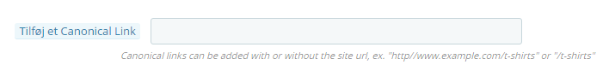

In order for the canonical links to work correctly, please add them in these formats:

1. http//www.example.com/t-shirts

You could also shorten it to

1. /t-shirts

The Module will automatically add the website address if it is missing