Testimonial Module

Table of contents

1. Module installation ......................................................................................................................... 3
   1. Add module ................................................................................................................................. 3
   2. Module configuration .................................................................................................................. 3

* 1. Module installation
  2. Add module

Import the file testimonial.zip in the module part of your Prestashop Admin.

You can also unzip the files and upload the folder testimonial into the folder /modules/ of your website, via ftp client.

Notice: By default, Hooks are already generated and added to the site. No need to manually hook the module to template files.

* 1. Module configuration

Go to the Modules > Modules and services, and search testimonial

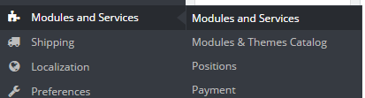

Alternately, you can go to the configuration page via the tab the module will create:

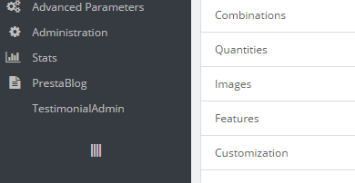

III. Module Positioning

Go to Modules and services > Positions

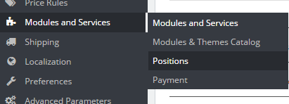

Find the Module name Testimonial and drag it up and down according to where you want it to appear