**Shoroog almalki**

Artificial Intelligence in Robotics

**Task :**

**Use Slam approach with TurtleBot3**

**To do simulation and mapping you should follow these steps :**

1. **Open a terminal window type "source devel/setup.bash" then write this command :**

**$ export TURTLEBOT3_MODEL=burger**

**There are three model of turtlebot3 (burger,waffle or waffle_pi) , we can chose any one of them ,in my case it is burger . then type this command to launch gazebo :**

**$roslaunch turtlebot3_gazebo turtlebot3_world.launch .**

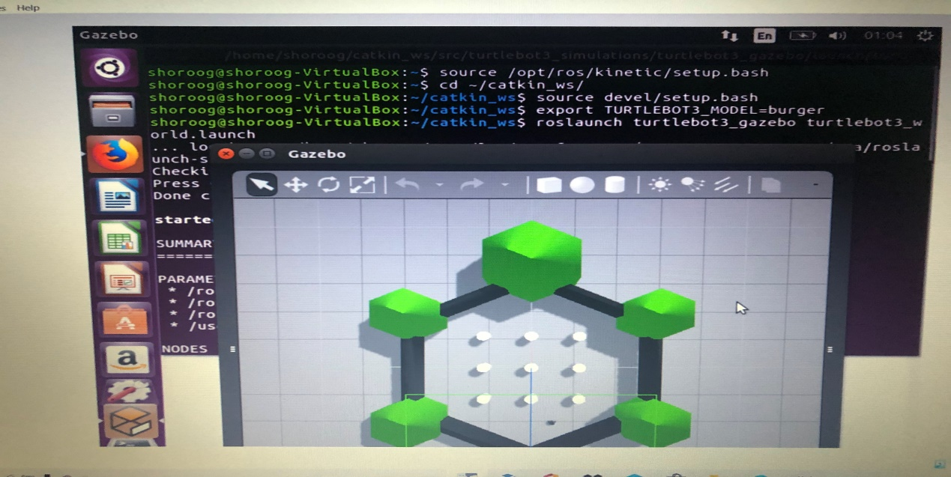

1. **Open new terminal** **window , type "source devel/setup.bash" then write this command :**

**$ export TURTLEBOT3_MODEL=burger . then type this command to launch SLAM :**

**$ roslaunch turtlebot3_slam turtlebot3_slam.launch slam_methods:=gmapping .**

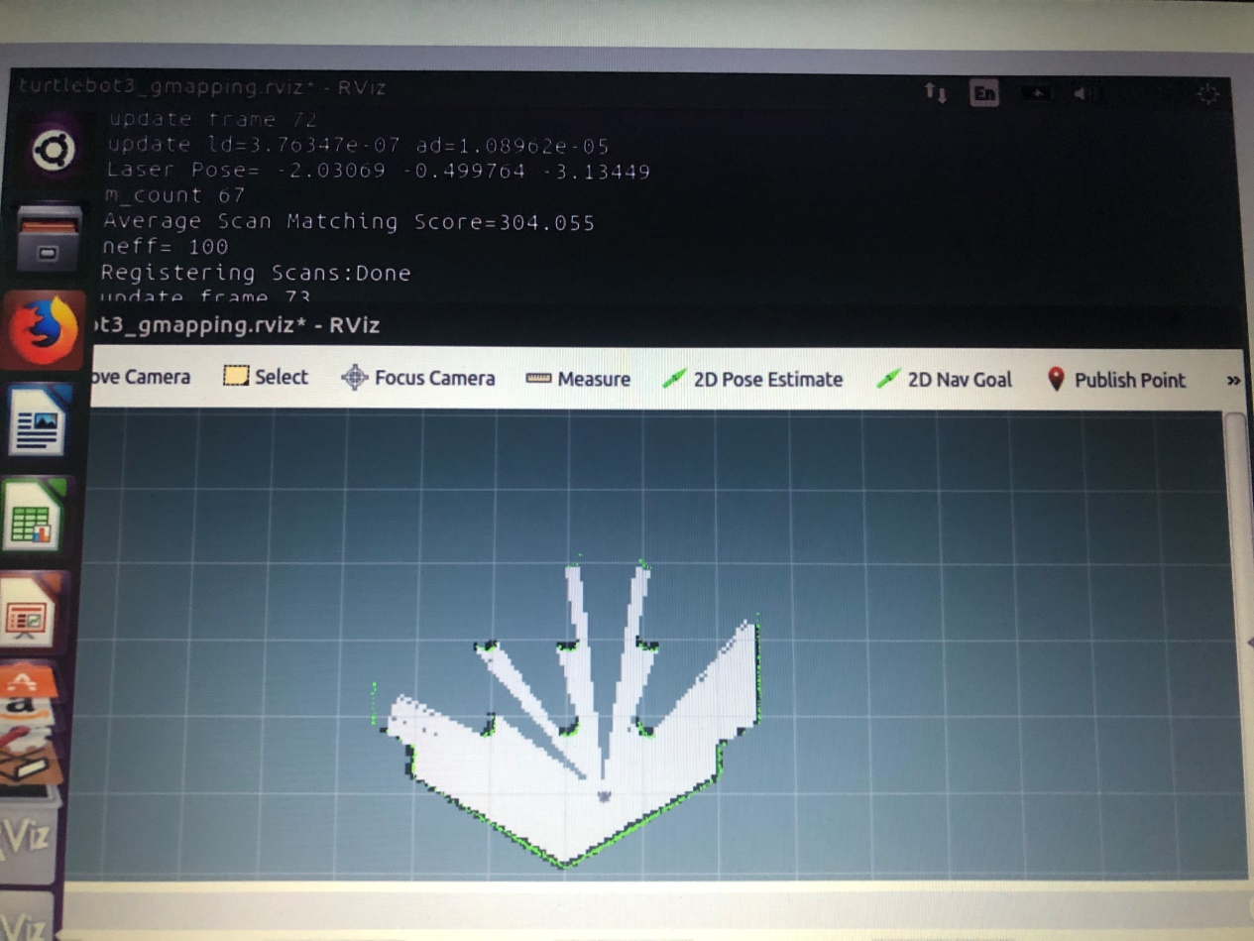

1. **To remotely control and move the robot** , **open new terminal** **window , type "source devel/setup.bash" then write this command :**

**$ export TURTLEBOT3_MODEL=burger .**

**Then type :**

**$ roslaunch turtlebot3_teleop turtlebot3_teleop_key.launch**

**After moving the turtlebot3 in all direction you should have image .**

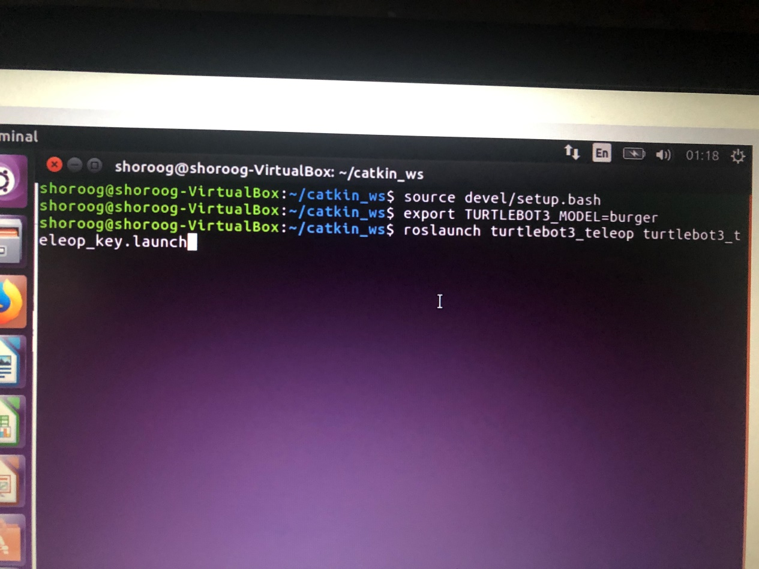

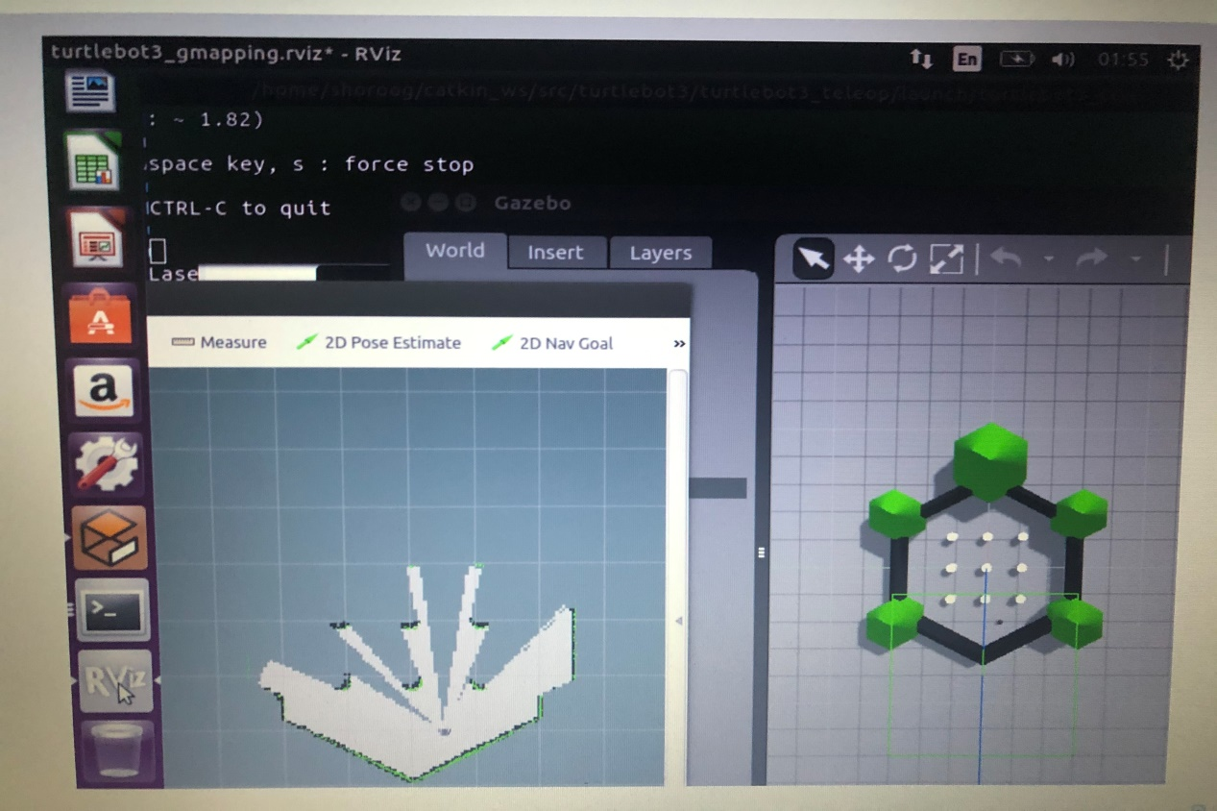

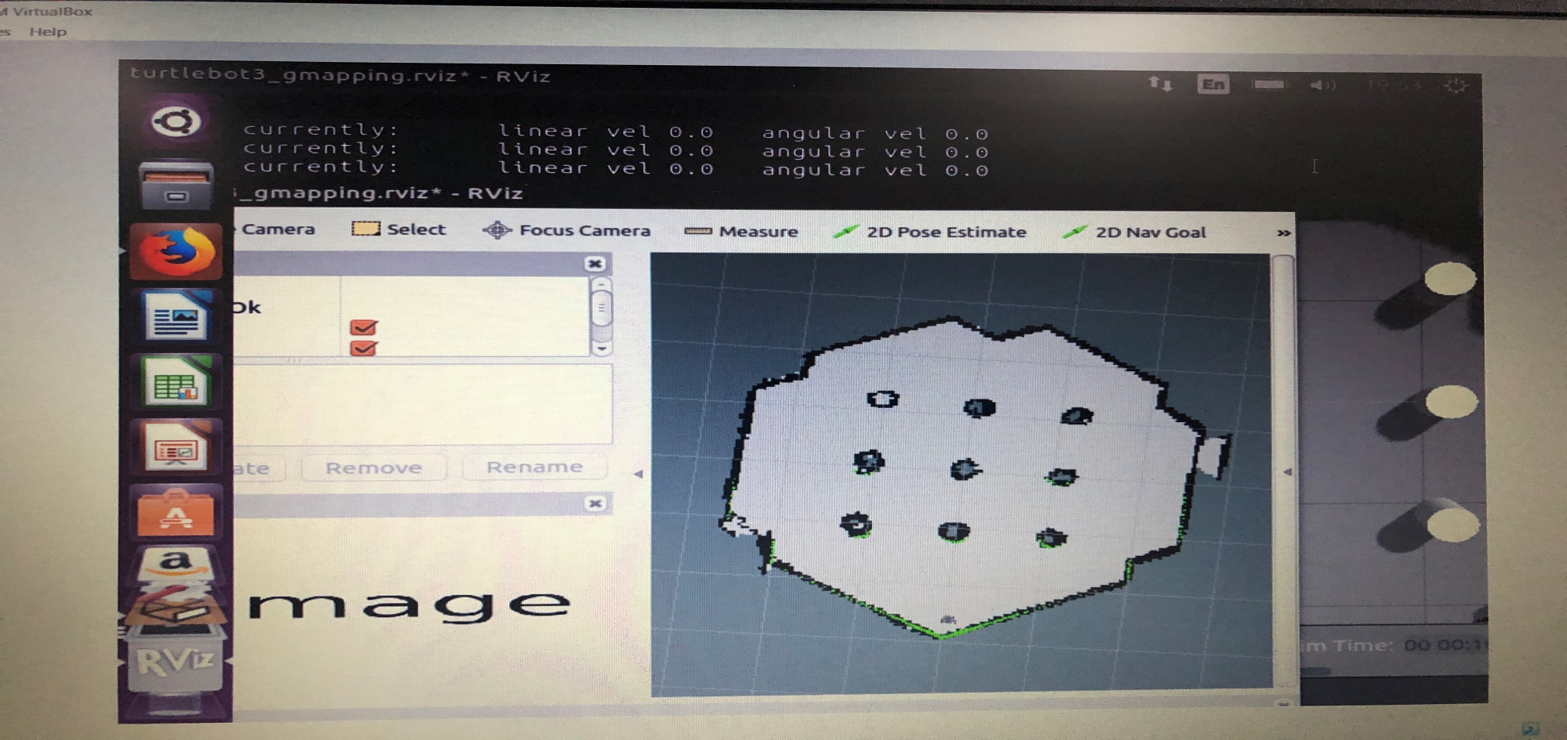

**4 – after that you can save the map by typing this command :**

**$ rosrun map_server map_saver -f ~/map**

**Then you will get "map.pgm"**

**The output**

