**Shoroog almalki**

Artificial Intelligence in Robotics

**Part 2**

**Turtleboot3 simulation**

**1 - Open a terminal window and install the dependent packages** :

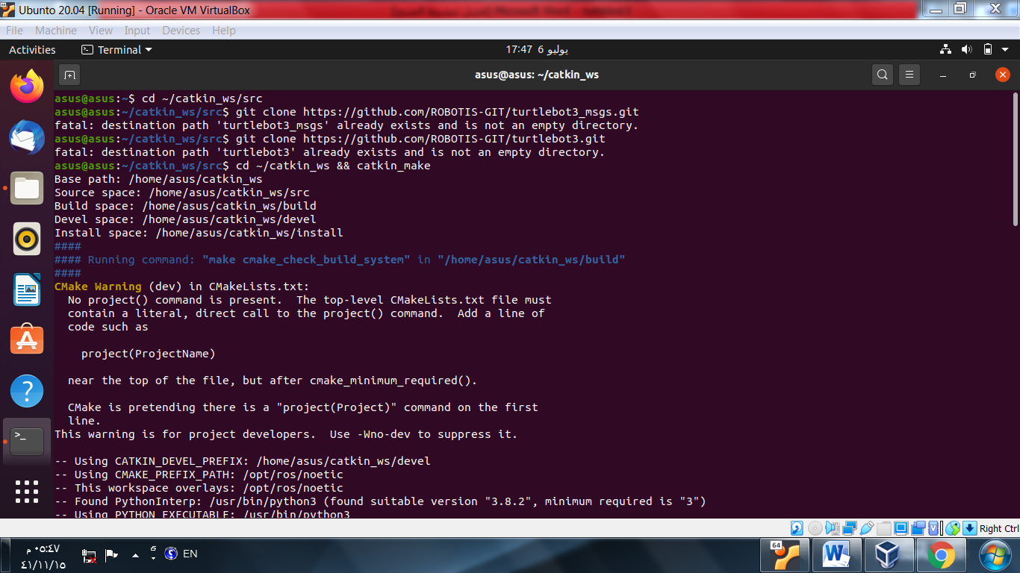

**2- Type this command to open the bashrc file to add this setting:**

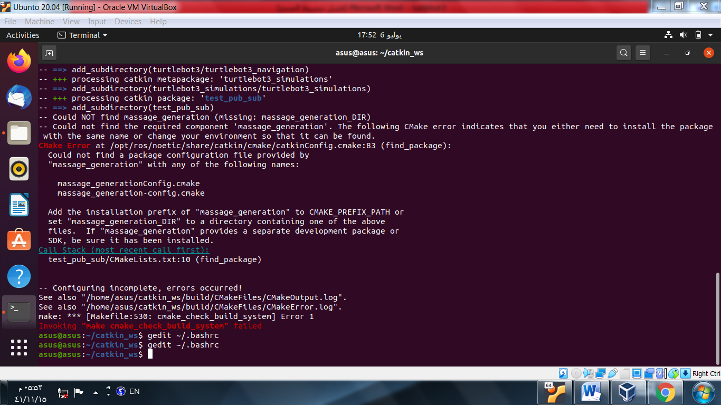

**3- Add this line at the bottom of the file:**

|  |
| --- |
| export TURTLEBOT3_MODEL=burger |

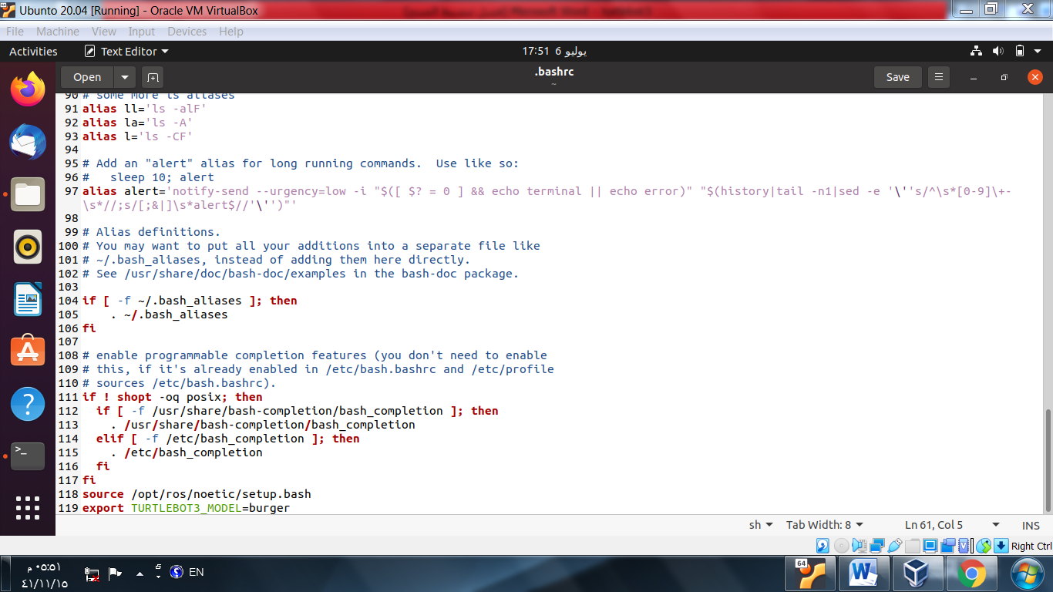

**4- download the TurtleBot3 simulation files.**

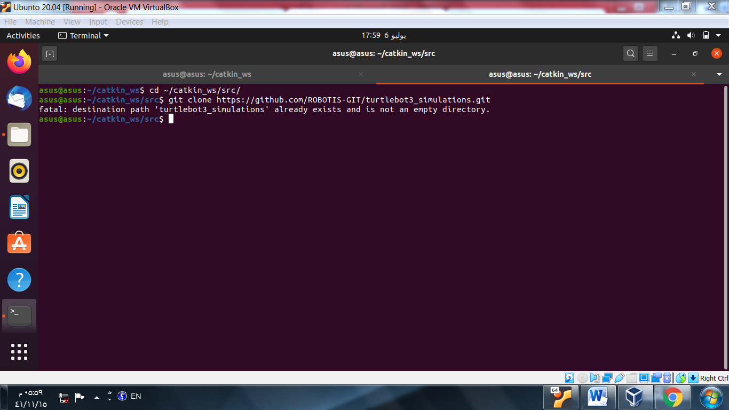

5- cd ~/catkin_ws && catkin_make :

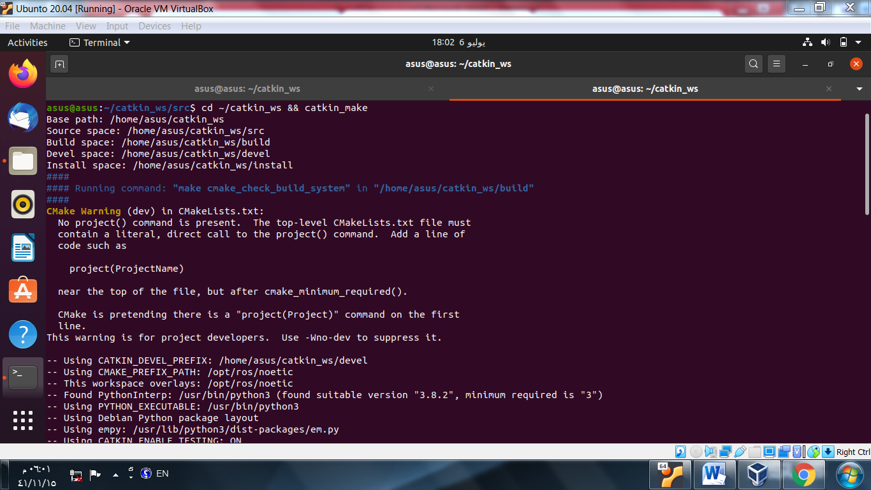

**6 – run simulation :**

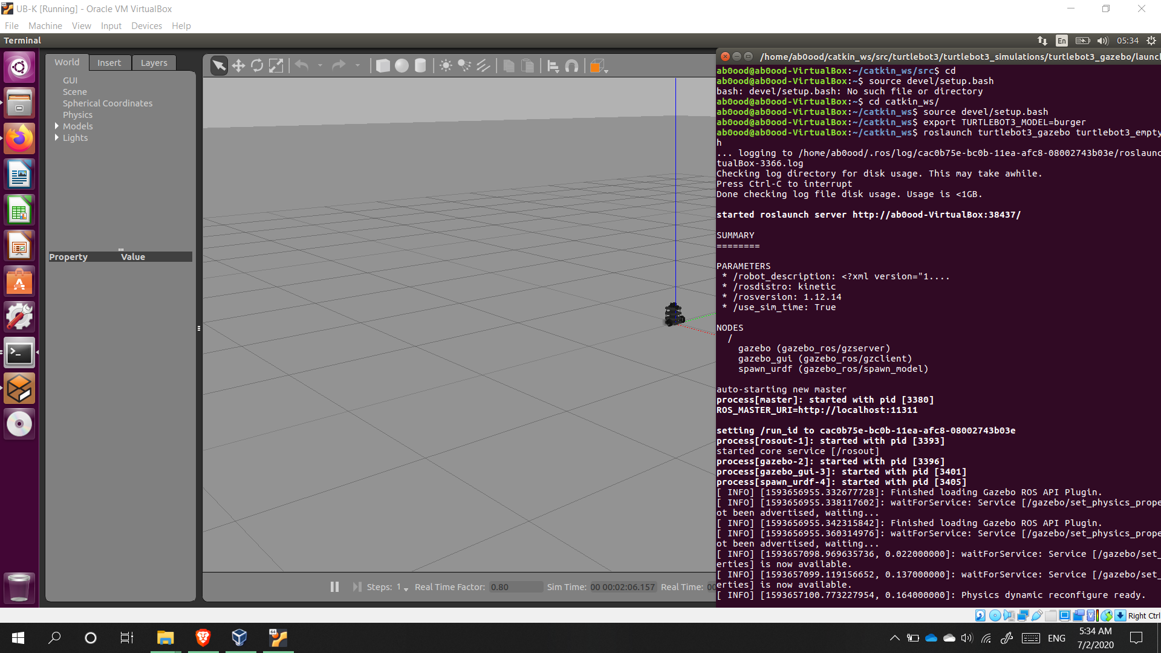

**Output :**



