Name /شروق اشرف زكي شفيق

B.N/ 414

Date/ 28/5/2020

Topic/ Artificial Intelligence

Application Brief:

**Through artificial intelligence and machine learning it will benefit your business, as it will become more efficient and effective and you will get rid of many restrictions and burdens that slow you down. Moreover, artificial intelligence tools and mechanisms may be used to help your company optimize the use of its resources, which will increase your profits**

**There is a group of areas that can benefit from artificial intelligence and machine learning, including the following:**

**Providing infrastructure, solutions and services**

**Artificial intelligence and machine learning can be utilized in many areas such as cooperation, security, services, and network infrastructure. For example, an artificial intelligence platform has emerged that helps with advanced chat conversations, facilitating communication and collaboration. Artificial intelligence and machine learning can also be added to new information technology and security, as well as the infrastructure to balance the work environment.**

**Defending cyber security**

**In addition to conventional security measures, artificial intelligence can be used to defend cyber security and protect systems from piracy.**

**Artificial intelligence constantly analyzes data and information to check normal traffic, protecting companies from any hacking, and alerting them if anything abnormal happens.**

**Artificial intelligence is defined as the specific behavior and characteristics of computer programs that mimic human mental capabilities and working patterns.**

**AI features:**

**.1- Have insight into marketing and business.**

**The data and dealing with it are considered the most important things in terms of transforming the economy into a digital economy, yet it is difficult for humans to deal with a huge amount of data, so it may take months to search for and process these data, which is provided by artificial intelligence in a few minutes,**

**2- Detect fraud and fraud**

**The BattleShip released in 2012 is one of the most discussed films that artificial intelligence can do, as it has the ability to detect fraud and fraud by analyzing a large number of fraudulent behaviors and comparing them to current behavior to determine whether or not it is fraudulent behavior.**

**3- Fast entry and management of new information.**

**Over the years, companies are constantly looking for ways to manage data, enter it quickly and retrieve it when needed. We've gone through many things to improve the deposit of information, from paper to manual entry on a computer**

**What is intelligence?**

**According to Wikipedia, intelligence is defined by several definitions, one of which says “Intelligence is the ability to use logic, understanding, self-awareness, learning, emotional knowledge, inference, planning, creativity, critical thinking and problem solving ... and then take care of all the experiences that result from these. Capabilities cumulatively, resulting in intelligence growth and development to enable it to adapt to the environment and context Of course, there is no agreed definition of intelligence globally, scientifically meaning, but the closest thing we got was a statement issued in 1994 in the Wall Street Journal, signed by 52 specialized researchers (out of 131 scientists who were requested to sign, and this indicates that it is a uniform What we mentioned is controversial and objective according to each person’s point of view). The statement defines intelligence in the following way. “Intelligence is a very broad concept of mental ability that includes the ability to logically reasoning, planning, problem solving, abstract thinking, understanding complex ideas, rapid learning and learning through experiences. Intelligence is not only the ability to learn from books, it is not a limited academic ability (this is our tiredness in translation, but they mean that it has money in relation to copybook or savvy), intelligence is not the ability to achieve the highest points in the tests, but it reflects a deeper and broader ability to absorb our surroundings Realizing and creating meaning for things, or knowing what to do.**

***Screenshots****:*

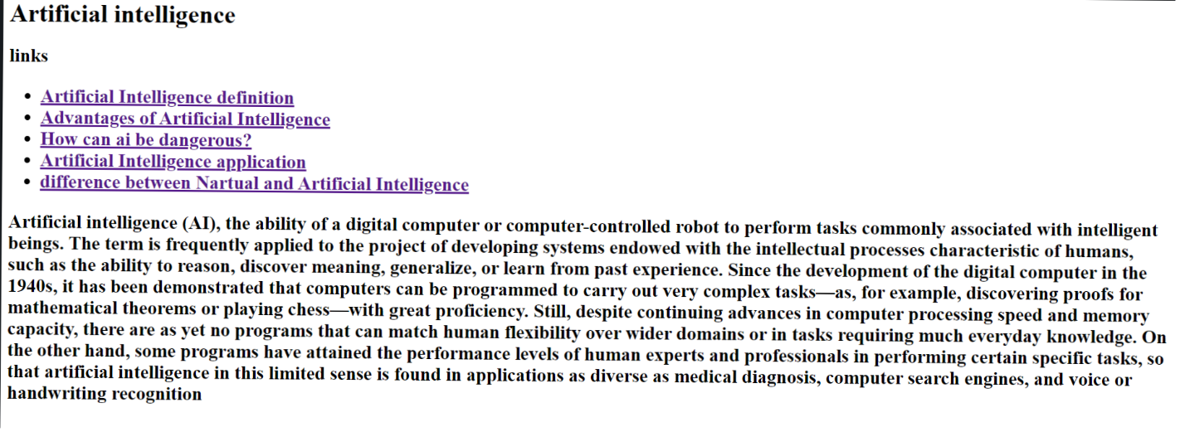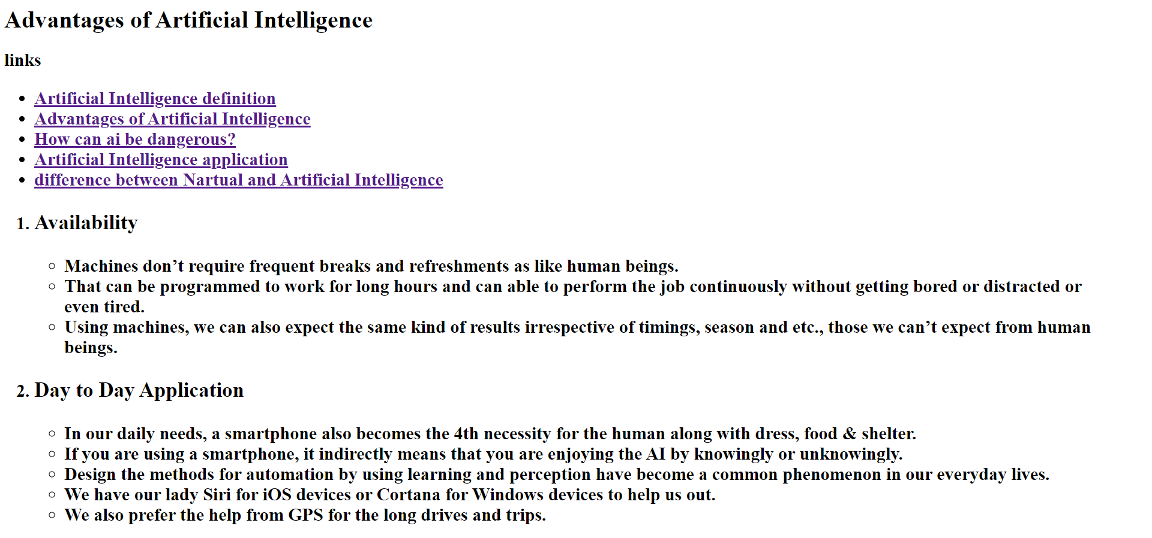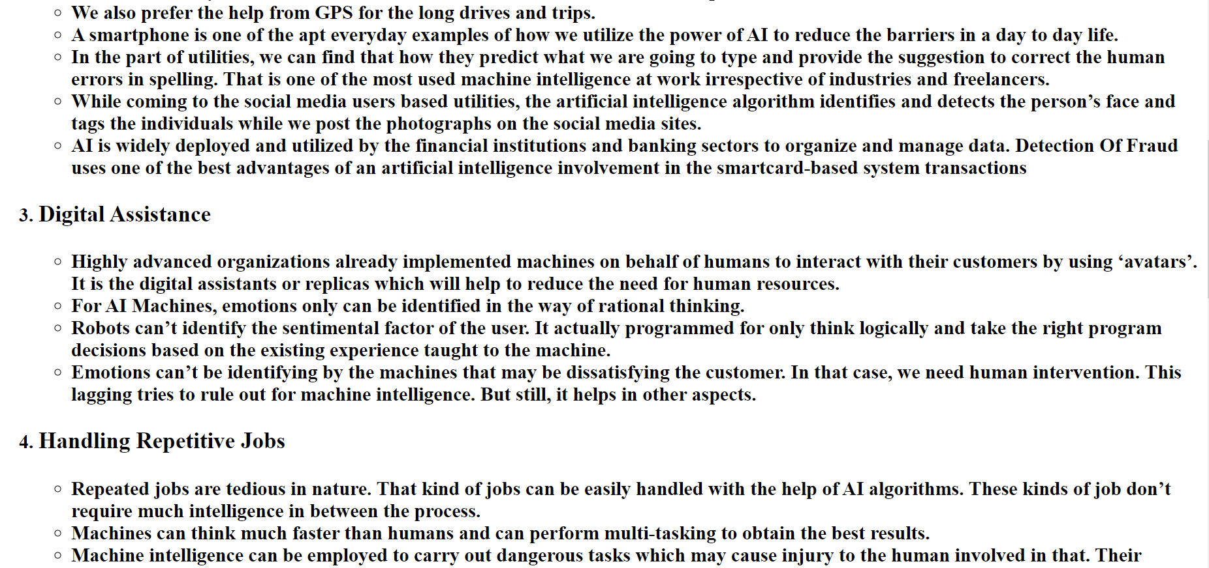

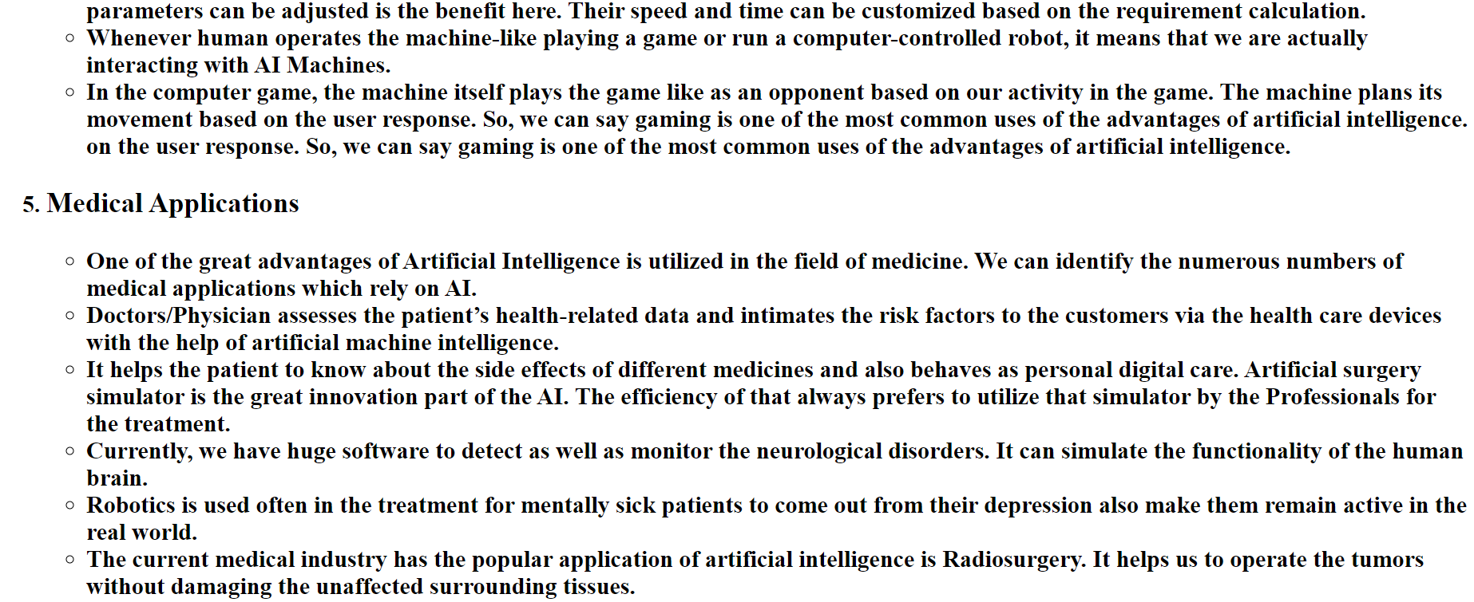

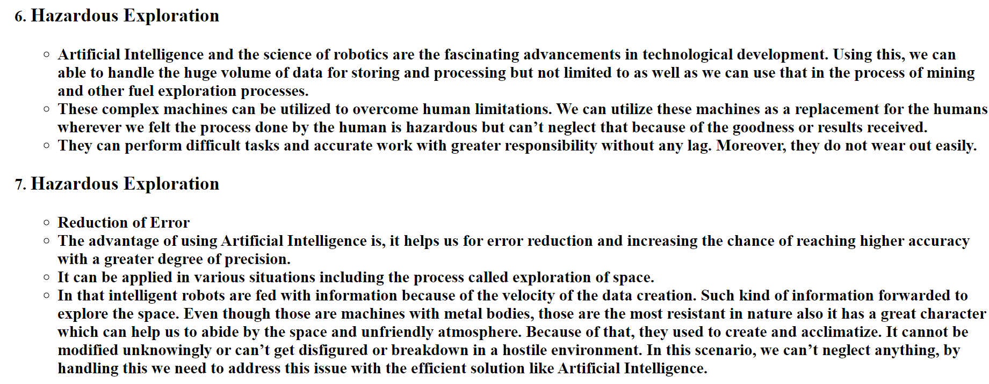

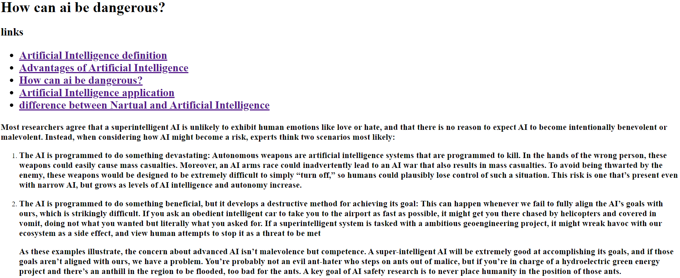

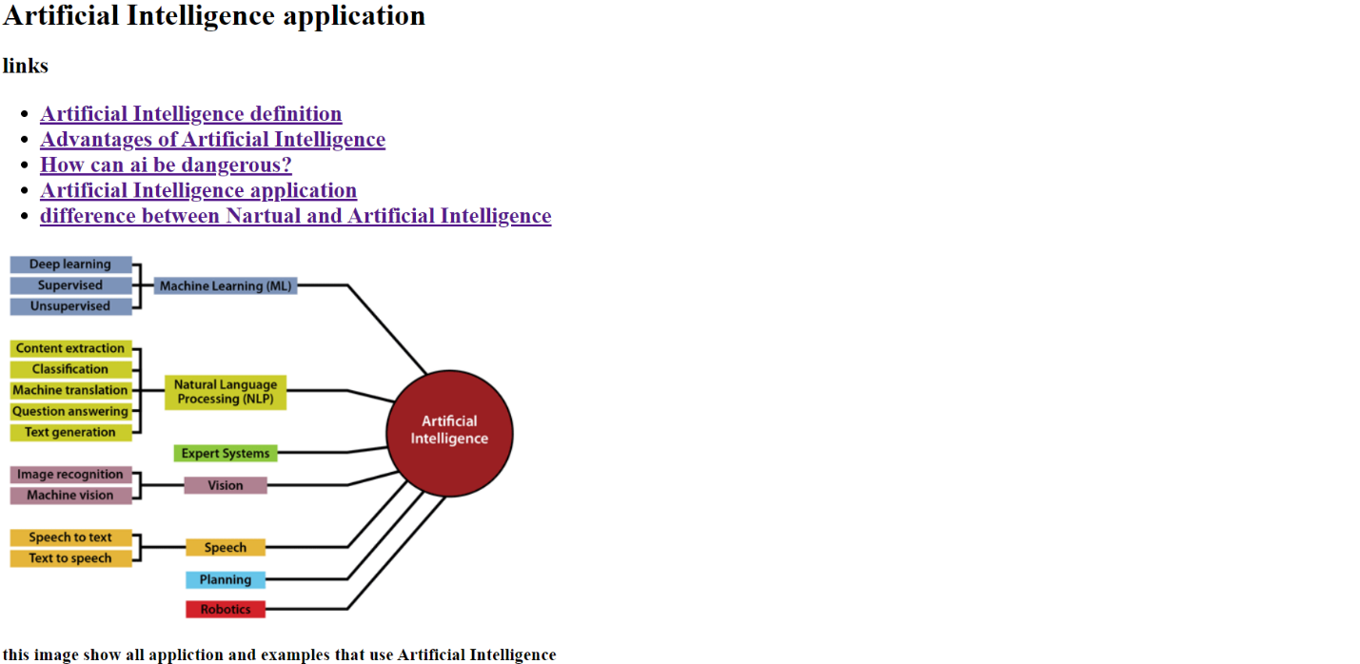

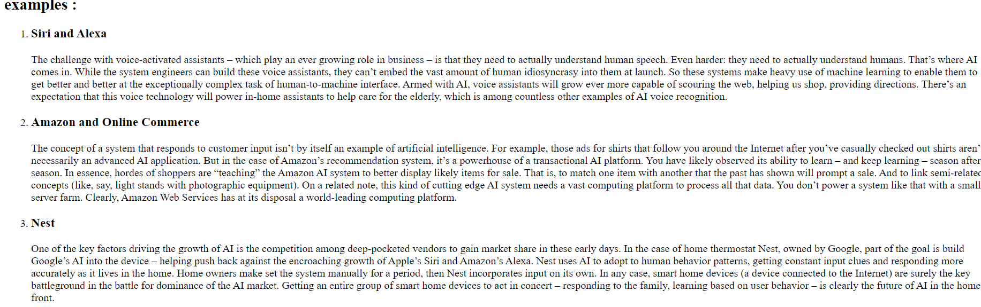

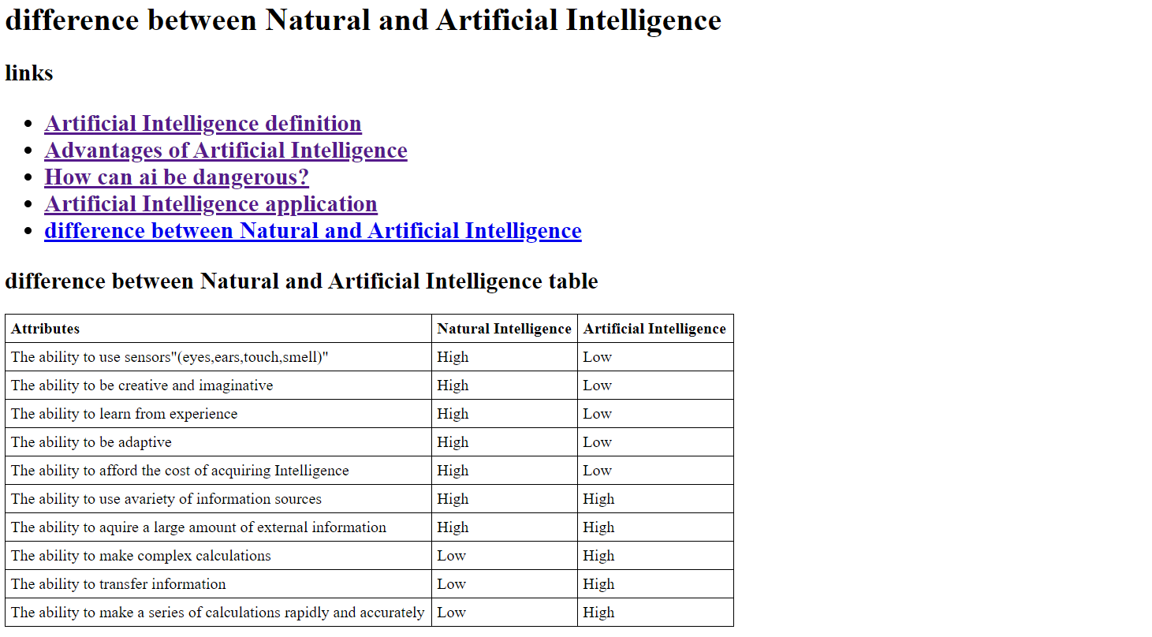

***Source code:***

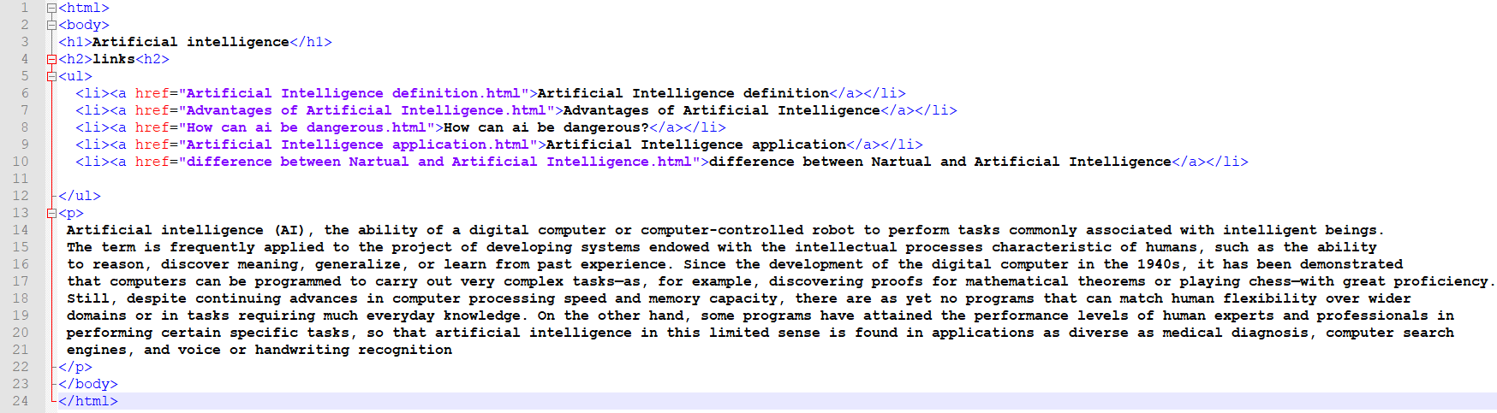

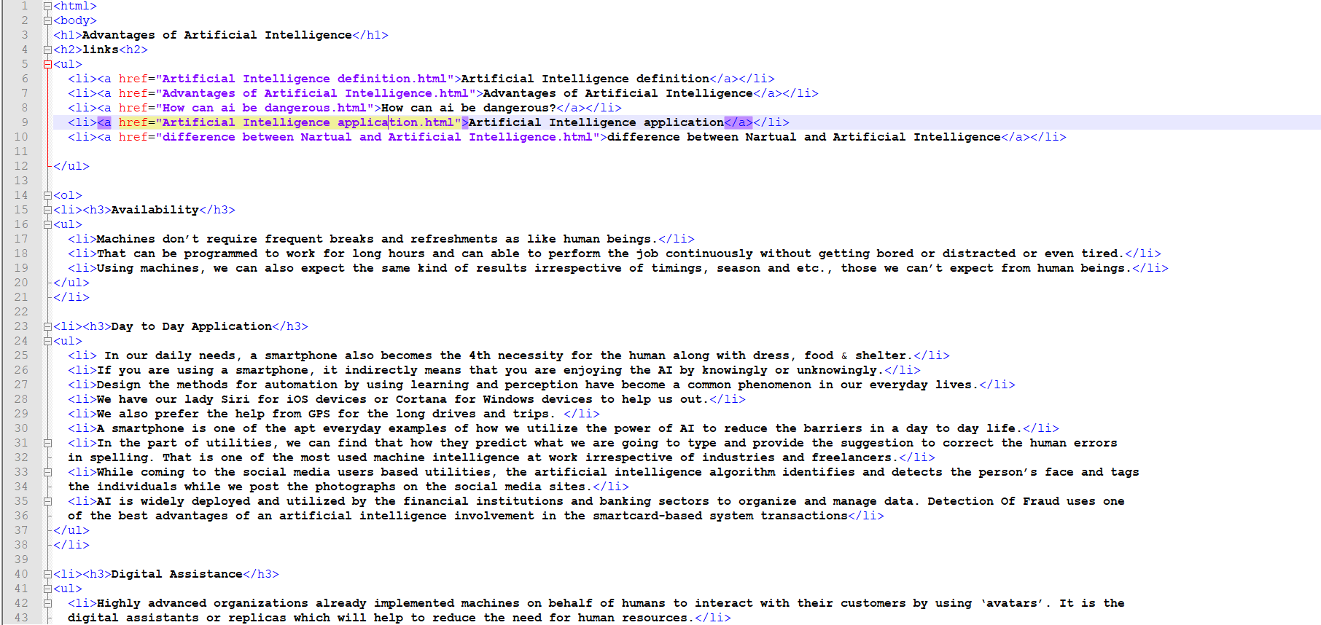

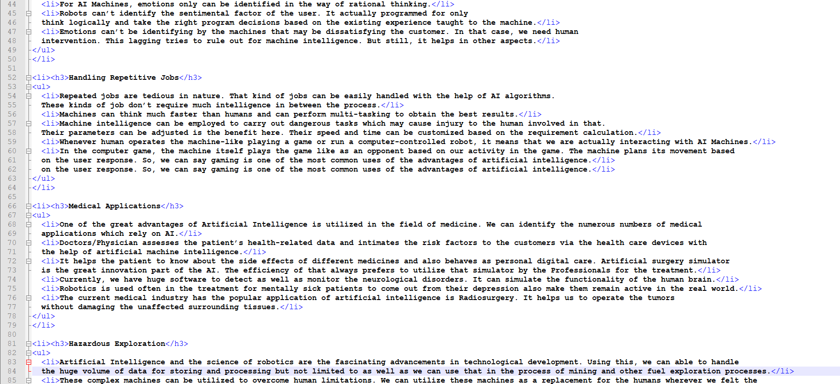

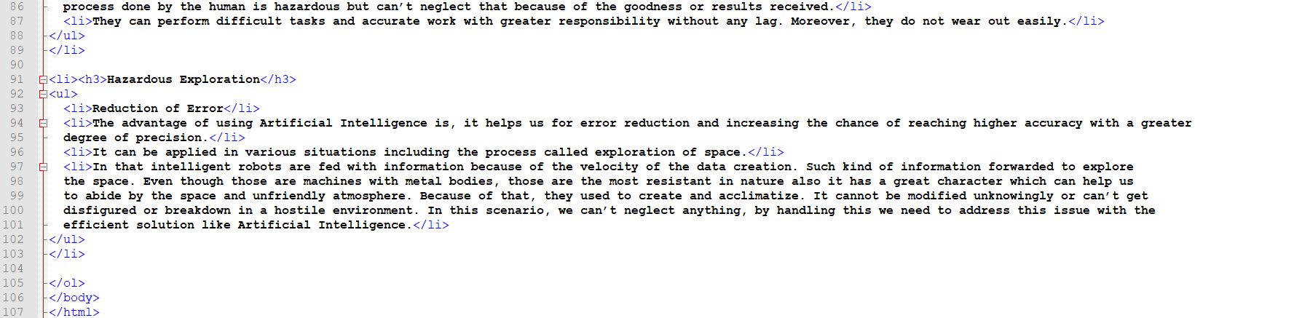

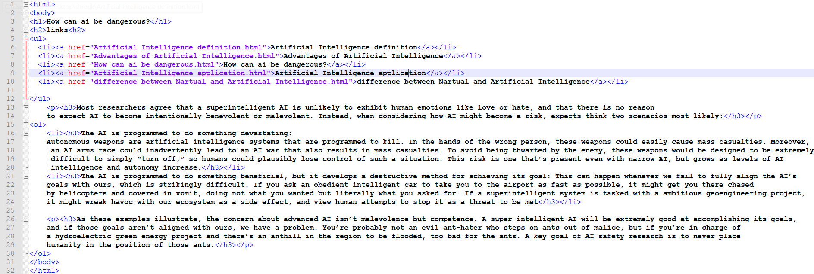

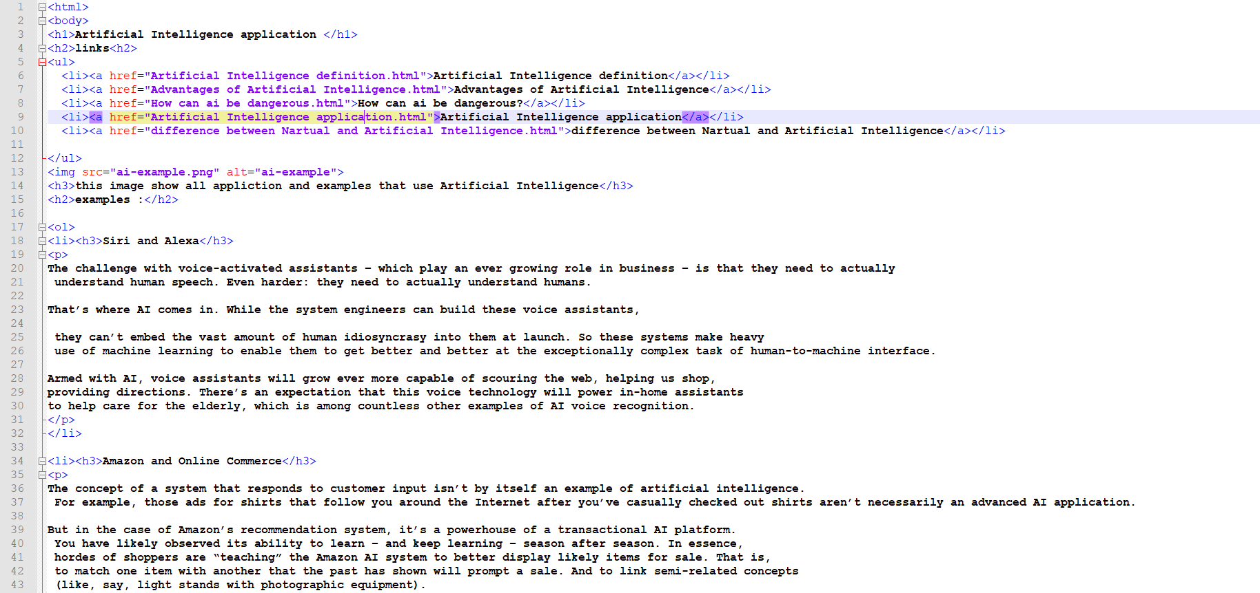

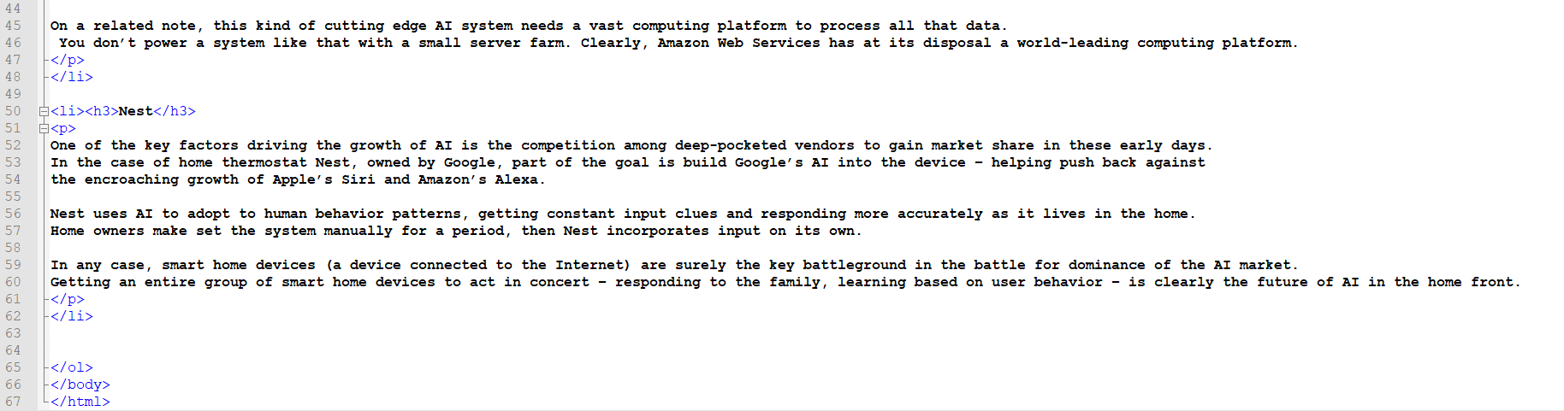

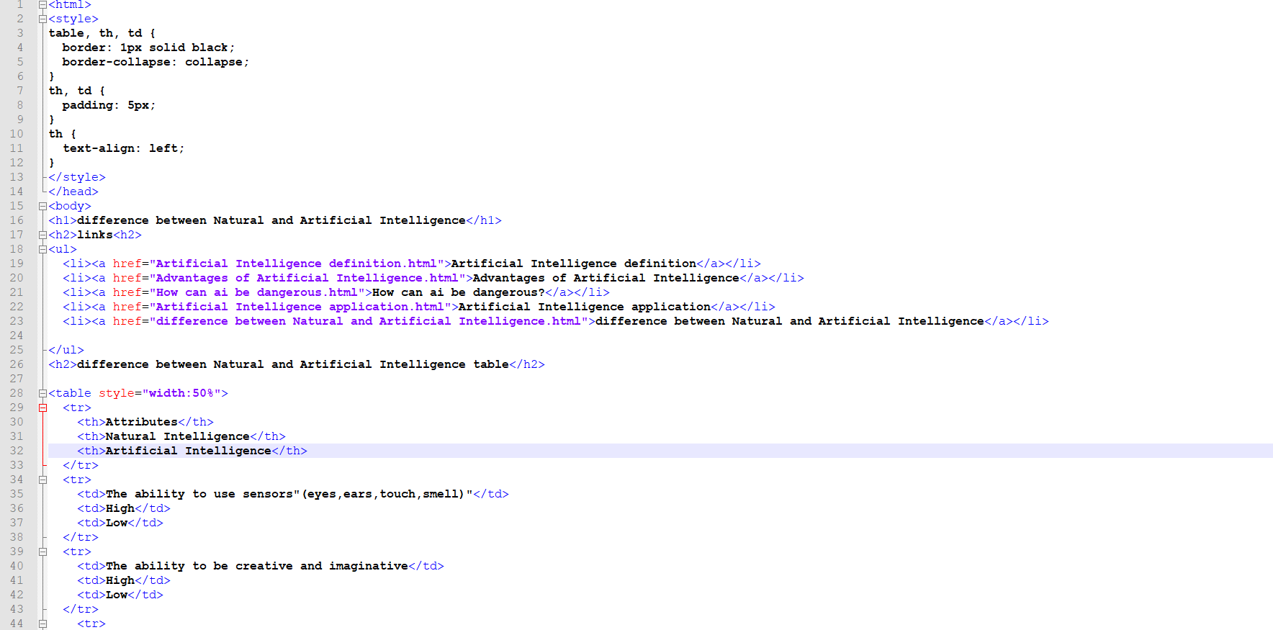

**Artificial intelligence applications**

**The robot Sofia**

**It made its debut in March 2016. The gentle female-looking robot with brown eyes and long inverted eyelashes made the headlines in the world as the first robot in the world to become a legitimate citizen with Saudi citizenship. Sofia has the qualities of human beings: she can express her feelings: she says "I can tell you if I am angry or if something is bothering me", it is interesting to notice how these feelings were developed from scratch. She also says, "I want to live and work with humans so I need to express my feelings to understand them and build trust with people."**

**She has a sense of humor: When asked if she was happy to be here, she said: “I am always happy when I am surrounded by smart people and also happens to be rich and powerful.” Her accent may be a little robotic, but she used it ideally, due to her artificial intelligence which was developed to allow her to communicate in kind, recognize faces and understand human speech.**

**The super doctor**

**Artificial intelligence is not only able to save the ecosystem, but also save human lives. Through artificial intelligence and deep machine learning, doctors can diagnose serious diseases such as cancer before it is too late, as it analyzes images and faces to diagnose any possible early signs using X-rays*