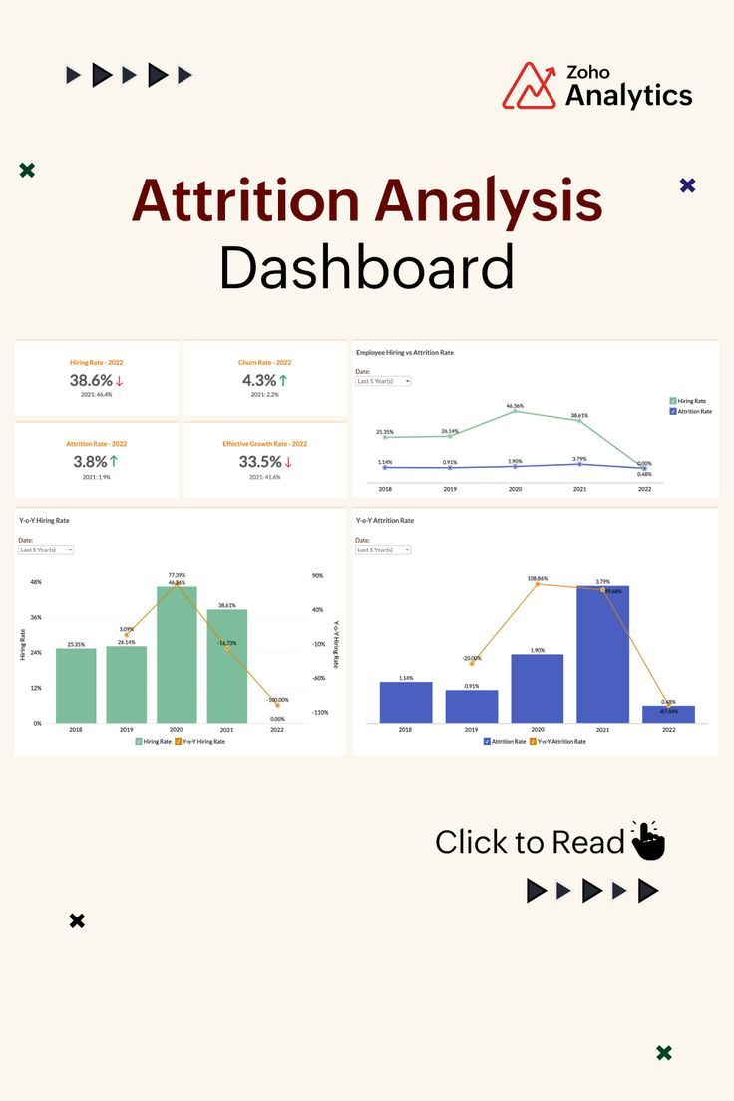

**Project Overview:**

ABC Corporation is a multinational company facing challenges with employee attrition. The company is keen on understanding the factors contributing to attrition to develop strategies for retention and talent management. To address this issue, they have decided to implement a Power BI project to analyze their attrition data comprehensively.

**Modeling:**

**Facts:**

* Fact_table : This table holds data about daily employee activities.

**Dimensions:**

* Employee Dimension
* Survey Dimension

**Insights:**

In our analysis, we found that our workforce comprises **4410** employees, with **711** total attritions, leaving **3699** active employees. This results in an attrition rate of **16.12%.**

**Employee analysis Insights:**

* Employees who are **Male** have the highest attrition with **441 leaving** with increase

Of **171** compared to the females.

* The Employees in **Research and Development department** have the highest attrition with a total of **453** employees leaving.

This observation indicates potential problems or dissatisfaction in this department.

* Employees who their **income level** in the range of **0 – 20,000** $ have the highest attrition rate with **24.24%.**
* Employees who **have working with their manager** for **0 -3 years** , have the highest attrition rate with **20%.**
* Employees who have **worked in the company** (work duration) for **0-5 years** , have the highest attrition with **423 leaving.**
* Employees who have **increase in their salaries** by a **medium value** for along time , have the highest attrition with **282 leaving**.

**Survey Insights:**

* Employees with **Bad Work Life Balance** exhibit a significantly higher attrition rate of **31.38%.**
* Employees with **Low** **job involvement** demonstrate the highest attrition rate at **21.69%**.
* Employees with **Low Environment Satisfaction** demonstrate the highest attrition rate at **25.21%**.
* Employees with **Low Job Satisfaction** demonstrate the highest attrition rate at **22.91%**.

**Recommendation Insights:**

**For Research and Development Department (Highest Attrition):**

* Evaluate workload and provide new resources and technologies to manage tasks effectively and easily.

**For Employees with Monthly Incomes between 0-20,000 $ (Highest Attrition Rate):**

* Review salary structures to ensure competitiveness in the market.
* Provide opportunities for skill development and career advancement to increase employee satisfaction and loyalty.

**For Employees with Low Job Involvement (High Attrition Rate):**

* Encourage participation in decision-making processes and involve employees in meaningful projects to increase job satisfaction and engagement.
* Provide training and development opportunities to enhance skills and job relevance.

**For Employees with Low Job Satisfaction (High Attrition Rate):**

* Implement a system for recognizing and rewarding employees for their hard work and achievements. This can be through bonuses, promotions, or simple acknowledgment of their efforts.
* Foster a supportive and inclusive workplace culture where employees feel valued, respected, and appreciated. Encourage open communication, collaboration, and teamwork.