PHAY0076 Workshops - Getting started guide

Workshops for PHAY0076 will be run using a tool called Jupyter, via another tool called Anaconda.

There are 3 ways we can run the notebooks:

- Recommended: On your own laptop
- Via Jupyter installed on the computers in the compute room
- Via an online website: Google colab

1 – Running on your own laptop

To run on your own laptop you will need to download and install Anaconda: https://www.anaconda.com/download/success

And download the graphical version for your computer (windows or mac)

You can then install as a normal piece of software.

Once you have anaconda installed you can open it as with any other tool:
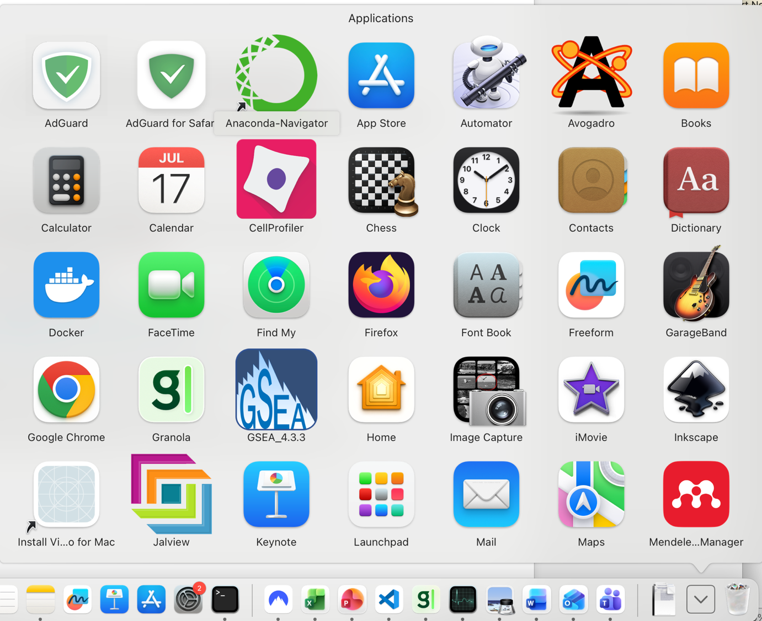

Once open you will have an interface like this:
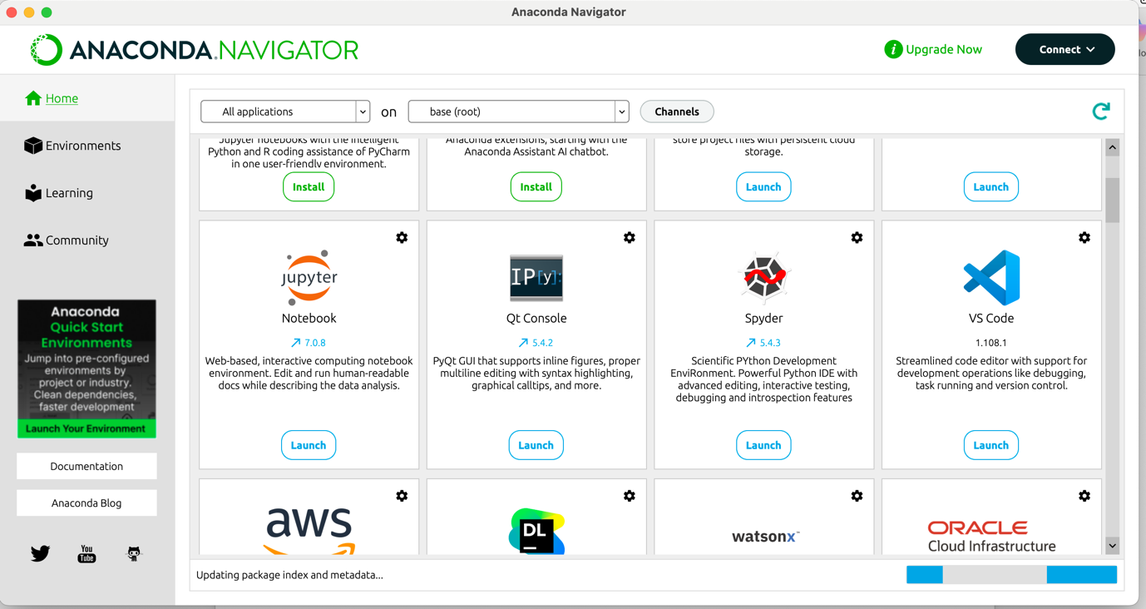
And clicking the button to launch jupyter-notebook (above) will get you started.

This will open up jupyter in your filesystem, and from here you can navigate to where you saved the files from the github and open them.
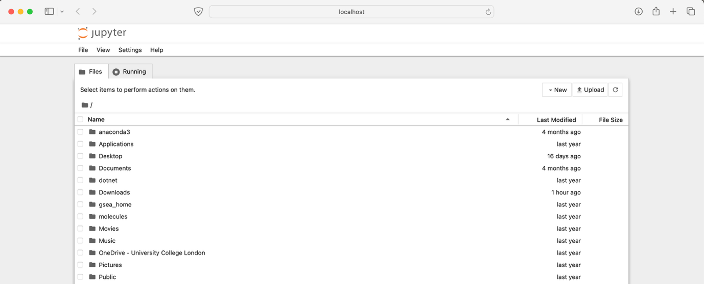

2 – Running via Jupyter installed on UCL computers

Searching for anaconda on the software centre will allow you to open it as in section 1. Be aware – this is very slow!

3 – Running through Google colab

To do this you will need to go to the google colab website and sign in (with a gmail account – or if you have linked your UCL account to google you can use that): https://colab.research.google.com

You will then be able to navigate through the menu on the side:

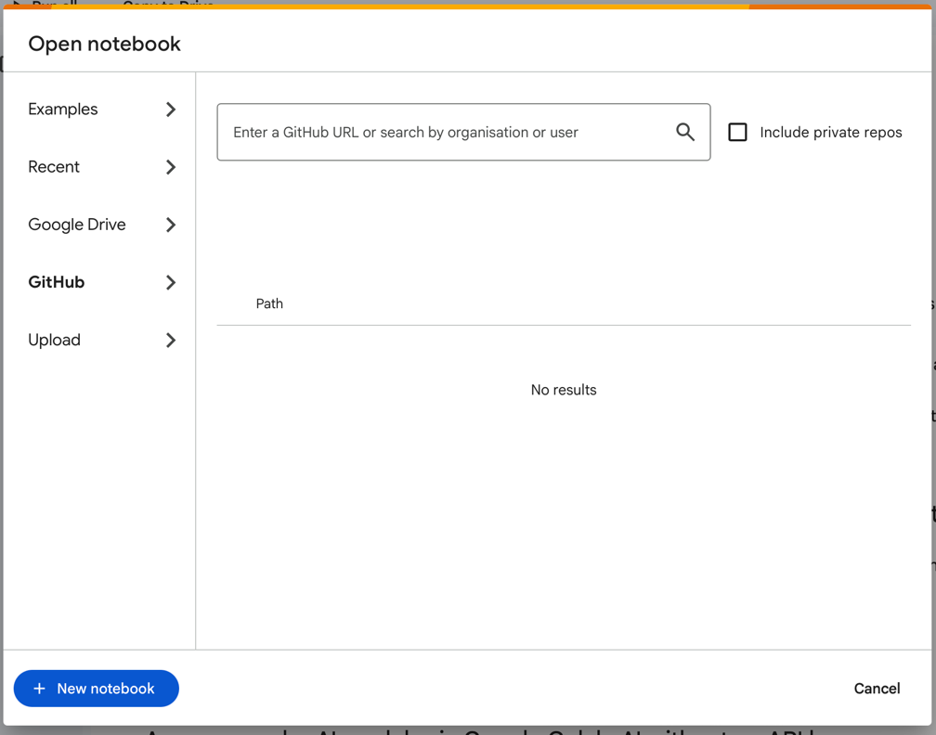

Choose github, and enter: shorthouse-lab:
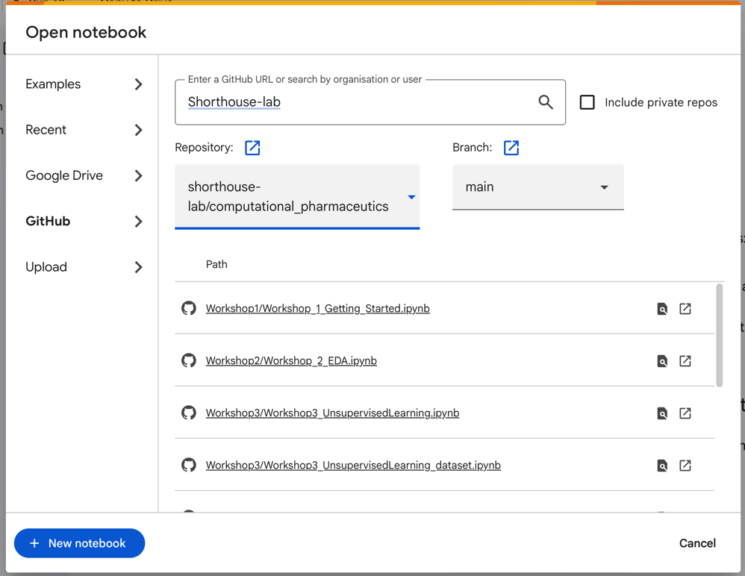
Choose a workshop.

And you are done:
