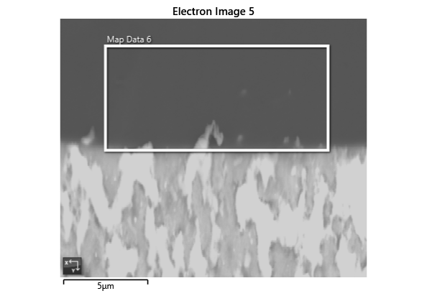

Settings

|  |  |
| --- | --- |
| Accelerating Voltage | 20.00 kV |
| Specimen Tilt (degrees) | 70.00 ° |
| Hit Rate | 96.70 % |
| Speed of Acquisition | 5.92 Hz |

Phases for Acquisition

|  |  |  |  |  |  |  |  |  |
| --- | --- | --- | --- | --- | --- | --- | --- | --- |
| Phase | a | b | c | Alpha | Beta | Gamma | Space Group | Database |
| Iron bcc (old) | 2.87 Å | 2.87 Å | 2.87 Å | 90.00 ° | 90.00 ° | 90.00 ° | 229 | HKL |
| Iron fcc | 3.66 Å | 3.66 Å | 3.66 Å | 90.00 ° | 90.00 ° | 90.00 ° | 225 | HKL |
| Nickel | 3.52 Å | 3.52 Å | 3.52 Å | 90.00 ° | 90.00 ° | 90.00 ° | 225 | OINA Phases |
| Pb FCC | 4.95 Å | 4.95 Å | 4.95 Å | 90.00 ° | 90.00 ° | 90.00 ° | 225 | PbFCC.cry |
| Chromium | 2.88 Å | 2.88 Å | 2.88 Å | 90.00 ° | 90.00 ° | 90.00 ° | 229 | ICSD |

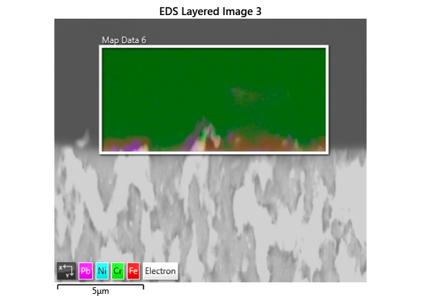

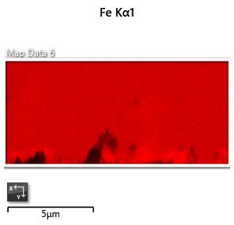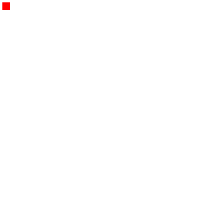

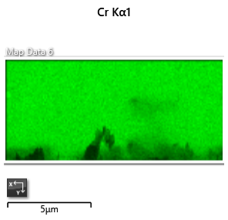

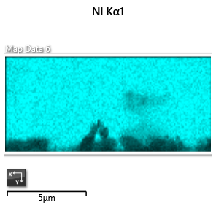

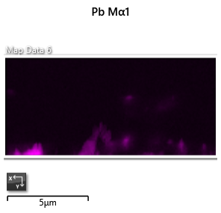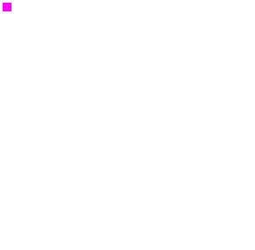

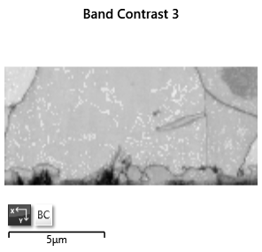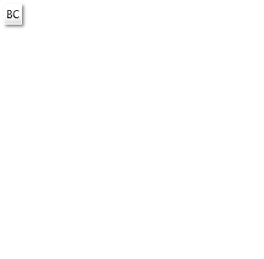

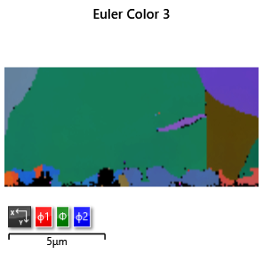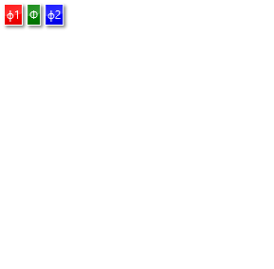

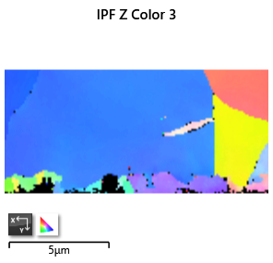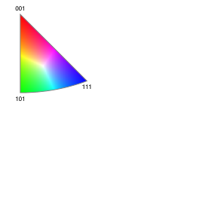

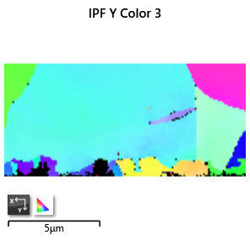

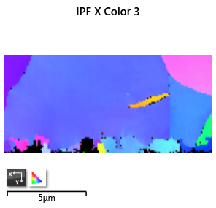

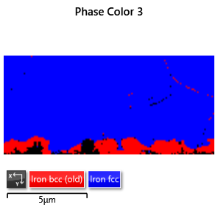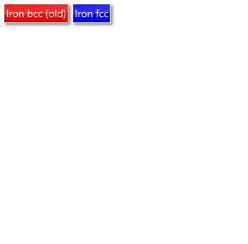

Phase Fraction

|  |  |  |  |  |  |  |  |  |  |  |
| --- | --- | --- | --- | --- | --- | --- | --- | --- | --- | --- |
| Phase Name | Phase Fraction (%) | Phase Count | Mean Band Contrast | Standard Deviation Band Contrast | Min Band Contrast | Max Band Contrast | Mean MAD | Standard Deviation MAD | Min MAD | Max MAD |
| Iron bcc (old) | 9.21 | 934 | 101.96 | 23.20 | 13.00 | 150.00 | 0.52 | 0.24 | 0.18 | 1.88 |
| Iron fcc | 87.49 | 8874 | 134.67 | 13.05 | 34.00 | 180.00 | 0.36 | 0.08 | 0.15 | 1.32 |
| Nickel | 0.00 | 0 | 0.00 | 0.00 | 0.00 | 0.00 | 0.00 | 0.00 | 0.00 | 0.00 |
| Pb FCC | 0.00 | 0 | 0.00 | 0.00 | 0.00 | 0.00 | 0.00 | 0.00 | 0.00 | 0.00 |
| Chromium | 0.00 | 0 | 0.00 | 0.00 | 0.00 | 0.00 | 0.00 | 0.00 | 0.00 | 0.00 |
| Zero Solutions | 3.30 | 335 | 45.61 | 30.53 | 0.00 | 137.00 |  |  |  |  |