**Introduction**

The purpose of project deliverable 6 was to setup Django and become comfortable with creating a static website using pages already previously created in the project.

**Description of my work**

I’ll walk through the different requirements for the project and show evidence of completion

1. First thing first: Create a Git (and GitHub) repository for your Django project. Call it solarpv_<TeamID> or synerd_<TeamID> or ffutche_<TeamID> depending on your project. Be sure to Add your teammate and your instructor (username: kuitche) to your project.

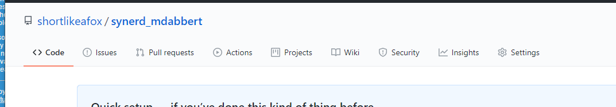

Link: <https://github.com/shortlikeafox/synerd_mdabbert>

1. Develop the pages:

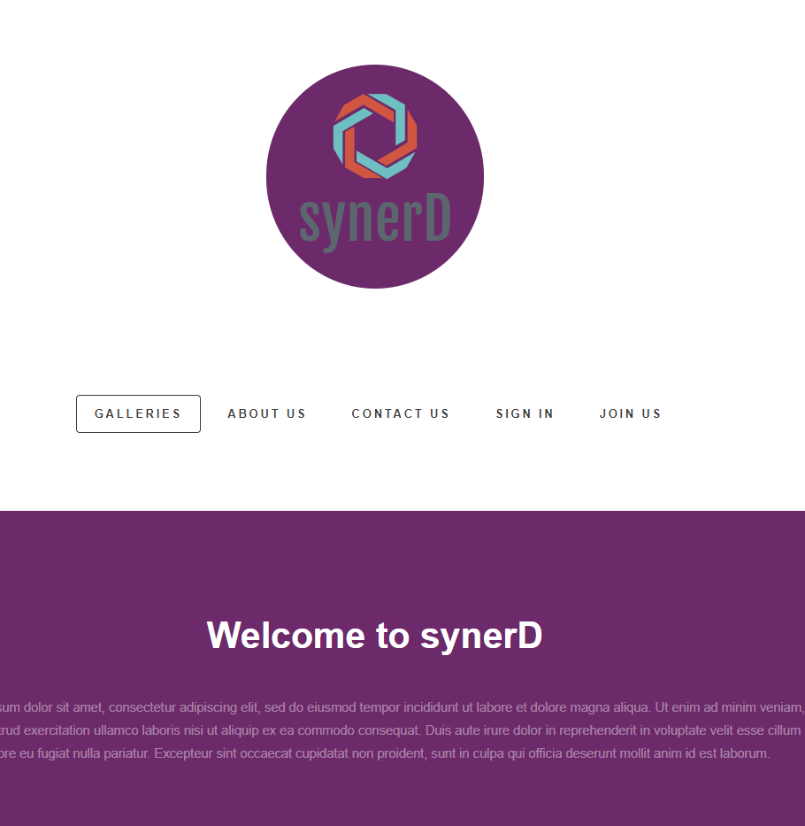

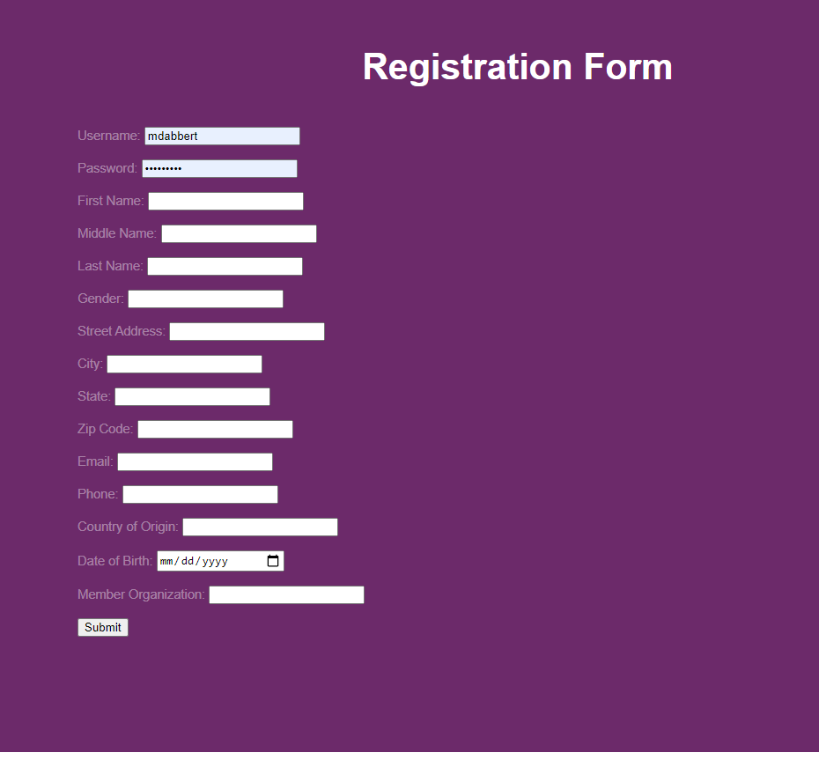

1. Create a Django app add it to settings.py

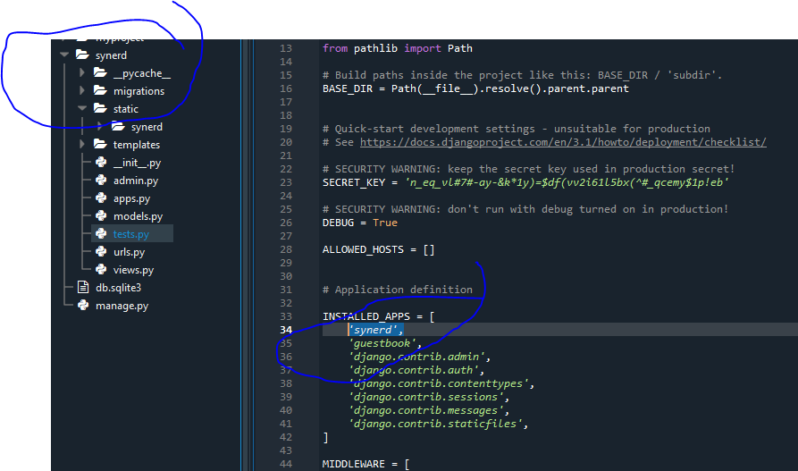

1. Create template folder
2. Put html files in template folder

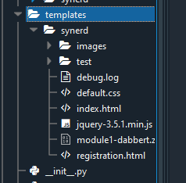

1. Put appropriate files in the static folder

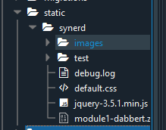

1. Appropriately configure views.py and urls.py

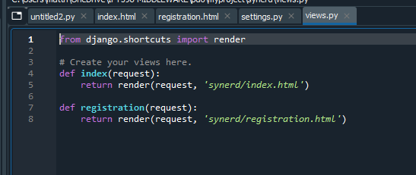

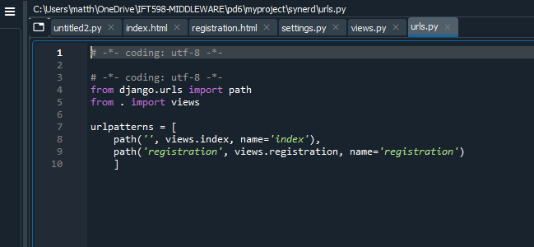

**User manual:**

Unzip the files using whatever unzip program you prefer and examine them. Running them will require Django to interpret the code embedded in the HTML.

**Conclusion:**

I spent a couple of hours trying to get Cygwin set up properly before I completely understood its purpose. Once that became clear I threw up the white flag and moved on to Anaconda’s terminal which worked seamlessly for this deliverable. I have never worked with Django before, so it was all new to me. I worked along with the videos to understand how it works and then took what I learned and implemented it to this assignment. The website can be improved. Visually it isn’t too appealing.