**Introduction**

The purpose of project deliverable 6 was to setup Django and become comfortable with creating a static website using pages already previously created in the project.

**Description of my work**

I’ll walk through the different requirements for the project and show evidence of completion

1. First thing first: Create a Git (and GitHub) repository for your Django project. Call it solarpv_<TeamID> or synerd_<TeamID> or ffutche_<TeamID> depending on your project. Be sure to Add your teammate and your instructor (username: kuitche) to your project.

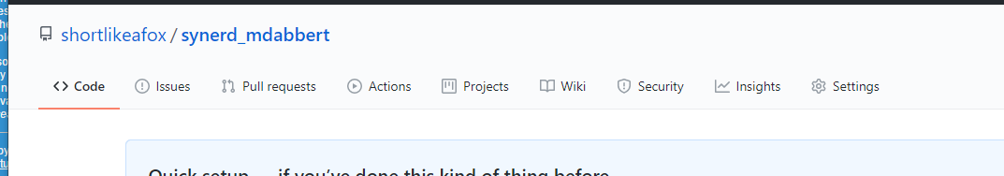

Link: https://github.com/shortlikeafox/synerd_mdabbert