June 10, 2003

Melding Financial Operations and Analytics:
The New Financial Battleground
New federal financial reporting guidelines have accelerated the convergence between financial value chain management (FVCM) and financial analytics software. With compliance stakes rising, three types of technology providers are vying to be the single source of insight into an enterprise’s financial operations. Choosing the right supplier will be key to meeting regulatory and corporate performance management (CPM) requirements.

The Great Leap Forward
The Sarbanes-Oxley Act is compelling public companies to direct the focus of their financial analysis tools at the financial value chain sooner than they expected. Most of these companies are not able to handle these accelerated timeframes on their own. Given the number of vendor boasting Sarbanes-Oxley solutions, picking a technology partner should not be difficult –– but picking the right supplier will be the secret to meeting federal disclosure standards
Although top enterprises are already joining financial analytics (e.g. budgeting, planning and forecasting) with FVCM software (e.g. invoicing, trade credit, and settlement) in corporate performance management initiatives, new regulations aimed at cleaning up financial reporting will accelerate the need for most public companies to join the two technologies.
The reason: many of the information nuggets demanded by the SEC cannot be found by mining traditional sources (see Baring the Financials: More Than Current Financial Systems Can Bear? October 2002.) Instead, enterprises will need to discover knowledge in the operational systems that automate financial functions (see Sarbanes-Oxley: Tightening the Link between Financial Analytics and the Financial Value Chain, May 2003).
The convergence between these technology sets will not be easy. Few enterprises can take the great leap forward without external help. The choice of supplier will be key, and the candidates — financial analytics vendors, FVCM specialists, and enterprise resource planning (ERP) companies — each have strengths and weaknesses. Only enterprises that match up the strengths of their suppliers with the compliance needs of the business will come through with flying colors.

Reconnecting the Financial Dots
Enterprises will need both a top-down and a bottom up strategy for FVCM analytics. The top-down approach emphasizes pulling relevant bits of data through a central financial analytics instrument, such as budgeting and planning. The bottom-up tack requires pushing up important facts from the operational level to management. In practice, any successful implementation of one will include elements of the other. The enterprise’s task is to find a balance that allows all of the technical and managerial elements to work in concert.
Whatever path the enterprise chooses, it will have to identify and map the data in the financial value chain. With department-level purchases still dominating the FVCM landscape, it is all too easy to overlook valuable sources of insight and difficult to avoid redundancies. This pitfall makes data discovery and audit a key element in the data integration process.
Furthermore, as with any insular data sets, an attempt at integration w ll bring festering data quality issues into the light. With data cleansing software, enterprises can juxtapose and reconcile conflicting, redundant, and incomplete records.
Without these two preliminaries, the FVCM foundations for compliance and performance management will not sustain actionable insight.

Delivering the Informational Goods
Sarbanes-Oxley compliance requires the ability to not only collect financial value chain information, but also deliver it in a prompt and understandable manner. That means that the enterprise must use a judicious mix of three mechanisms:
- Proactive alerts of significant events;
- Reports on both specific processes and corporate-wide financial health; and
- An analytical view into the context of financial processes and events.

An Avalanche of Alerts
For management, investors and other stakeholders to receive early warning of significant events, the corporation must use software to scan all events that could have a material impact on the state of the business. These tools can be as simple as rules engines, as complex as artificial intelligence, or take the middle ground with statistical profiling.
But the task is not as simple as it sounds. Not all deviations from standard business are cause for alarm, and not all seemingly normal transactions are without risk. Without the knowledge of the customized arrangements businesses often make with their best customers, for example, the software will “cry wolf” at innocuous fact patterns until the cry is ignored.
To manage a flood of alerts, businesses will need to think about how their tools support event stream management (ESM), a methodology for routing and prioritizing events throughout the enterprise (see Event Stream Management: Re-Synching Analytics with Business, July 2002).

Two Levels of Reporting
A complementary insight delivery mechanism is reporting. Reporting often provides a macro view — e.g., risk factors for all sides of the business. But the technology can also pinpoint metrics associated with a particular business process — e.g., the breakdown of days sales outstanding (DSO) that identifies the time it takes to collect and the bottlenecks extending that process.
Not all reporting is created equal, and there are several potential pitfalls that can mislead the enterprise. Reports that are too granular may hide the forest for the trees, and those that are too general miss important risk factors that may only arise in connection with certain businesses, such as leasing or wholesaling.

One Contextual View
Drill-down and drill-across analytical mechanisms can make the difference between a well-oiled disclosure function and one that moves in fits and starts. The software must allow the analyst to discover the operational context for any event. Getting to the root cause is an exceptionally difficult task –– but also one of the most rewarding.
By allowing decision makers to see the operational context behind any financial event, an analytical tool that sources data from FVCM systems on demand can save countless frustrations and guesswork. Tying individual events with the big picture complements both the low level of alerts and the high level of reporting.

A Cornucopia of Suppliers
Many vendors are already trying to corner this nascent market. The best indicator of what each supplier brings to the table is the company’s heritage (Figure 1). The top contenders include suppliers of financial analytics, FVCM, and ERP.

Financial Analytics Vendors
Financial analytics companies such as Cognos, Longview Solutions, MIS AG, and Hyperion, have significant expertise in helping corporations compile GAAP-conformant financial statements. As a result, they are well known among executives with signing responsibility and are perceived as an invaluable source for structuring processes and practices around new requirements.
The true strength of financial analytics vendors is twofold: analysis and a deep understanding of accounting practices. Enterprise will call upon this heritage because drilling into an FVCM environment presents some challenges, especially in creating what will constitute best practices.
High-level reporting will also be a strong element of a financial analytics solution. With years of expertise in managing the attention of CFOs and applying financial techniques and reporting formats, financial analytics vendors are the best candidates to craft reports that articulate the overall position of the company.
Although these suppliers will need to take a close look at the frequency and depth of reporting as they turn their gaze to the financial value chain, their analytic systems have always leveraged external data sources. Some have been used to examine the separate links in the financial chain but they have rarely been called upon to study the interplay between these financial processes.

FVCM Specialists
Although most FVCM vendors have not yet articulated their Sarbanes-Oxley strategies, they are beginning top make a case for being included in the Sarbanes-Oxley technological budget. Good candidates include suppliers of FVCM suites, e.g, Alterna, Emagia, and XRT, as well as a host of narrow specialists for accounts receivable and enterprise treasury. Although many point-solution providers may need to adapt their message for the CFO’s ears, these suppliers have great insight into what really matters on

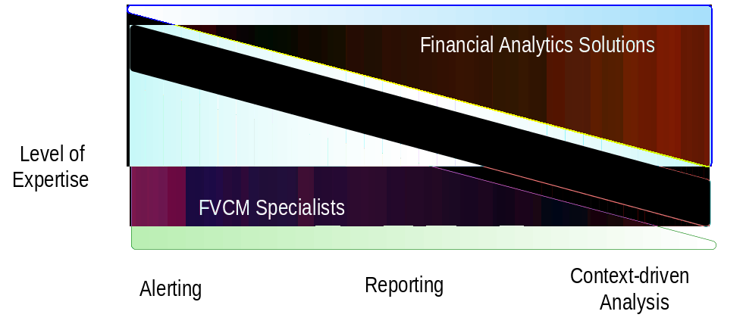Figure 1. Impact of Supplier Heritage on Sarbanes-Oxley Solutions

Source: Aberdeen Group, June 2003

the operational front, and what metrics are the best indicators of cash success.
However, while FVCM specialists are proficient at reporting about what is going on with any given process in the financial value chain, these vendors must become skilled at aggregating and condensing informative metrics for executives. This level of summarization is hard enough, but delivering detailed (ad hoc) analysis across the chain will be even more of a challenge. Few if any FVCM specialists will be able to traverse this area without a strong BI (business intelligence) partner.

ERP Suppliers
The big ERP vendors enter new markets with a consistent strategy — be a fast follower, not an innovator; emphasize breadth over depth; and ensure that the technology choice is safe for the CIO. ERP suppliers such as Oracle, PeopleSoft and SAP have FVCM offerings and are among the earliest to tout their wares in a Sarbanes-Oxley context.
ERP vendors hold a trump card in being able to meld the analytical and operational. They control the general ledger — a key data source for much of FVCM and financial analytics.

Aberdeen Conclusions
Joining FVCM and financial analytics has long been on corporate technology wish lists. But until recently, technologists have regarded a single process/analytical view of accounts receivable, accounts payable, treasury, and other financial functions as either superfluous or a pipe dream of technological neophytes.
Today, new regulatory and competitive imperatives have forced enterprises and their suppliers to reconsider what they once deemed impossible or foolish. In the Sarbases-Oxley call to action enterprises and should not only think in term of accelerated time frames but also in terms of new, if difficult, approaches to the problem.

Current financial analytic suppliers and ERP vendors will have the first shot at soothing the fears of executives who now have to certify their filings personally. But if these vendors fail to deliver the infrastructure that systematically delivers prompt alerts of materially significant events, user organizations will trigger a change in the FVCM marketplace. That change could start an evolution: innovative FVCM suppliers will either add analytic capability to their current offerings or re-forge the financial value chain so that it becomes the anchor of corporate compliance.
Whatever the battle’s outcome, user organizations that avoid the costs and notoriety of being a Sarbanes-Oxley test case will be the biggest winners. Equally important, many of the demands of Sarbanes-Oxley also make for good business. What enterprise wouldn’t want to have timely alerts of a cash crunch or other materially significant event? So, although financial transparency and timely disclosure may be a bitter medicine to swallow today, it will prove to be more than bromide in the very near future.
~ Alex Veytsel

Abstract
InSight title: Melding Financial Operations and Analytics: The New Financial Battleground
Company Name: N/A
Date: June 10, 2003
Body: Although top enterprises are already joining financial analytics (e.g. budgeting, planning and forecasting) with FVCM software (e.g. invoicing, trade credit, and settlement) in corporate performance management initiatives, the Sarbanes-Oxley Act will accelerate the need for most public companies to join the two technologies.
Few enterprises can take this great leap forward without external help. The choice of supplier will be key, and the candidates — financial analytics vendors, Financial Value Chain Management (FVCM) specialists, and enterprise resource planning (ERP) companies — each have strengths and weaknesses. Only enterprises that match up the strengths of their suppliers with the compliance needs of the business will come through with flying colors.
Author: Alex Veytsel
Coverage Area: Corporate Performance Management
Keywords: Sarbanes-Oxley, compliance, financial, reporting, analysis, alerts, analytics, regulation, regulatory, disclosure, budgeting, planning, forecasting, invoice, treasury, accounting, accounts payable, accounts receivable, general ledger, FVCM, financial value chain, ERP, CPM, BPM

