Volume 2, Number 4
Winter, 1972
Published quarterly by PHI Computer Services. Inc.,
800 Massachusetts Avenue. Arlington. Massachusetts
02174, to keep our customers end ourselves up to date
on recent company developments of Interest to both.

PHI update

A MESSAGE FROM THE EDITOR
From a cellar operation back In 1959, when
our total corporate capability consisted of
four technically sophisticated professionals
(fondly called "whiz kids") who possessed
the ability to pragmatically apply technical
theory to the solution of specific problems
and at the same time apply sound business
practices to the management of projects,
we've grown to become one of the leading
full service data processing companies in
the nation. Our three operating divisions
now provide a wide variety of computer
services and products to more than four
hundred clients. Professional computer con
sulting and programming, our sole "prod
uct" in 1959, is still a major corporate activ
ity. Today, these functions are performed
by PHI’S Professional Services Division
(PSD) in the same proud tradition as estab
lished by the "whiz kids." This issue of
Update focuses on PSD's special compe
tencies.
Manufacturers,
Distributors, And
Retailers Data Processing
Needs Met By PHI’s
Business Applications
And System Specialists
A highly specialized group within the com
pany's Professional Services Division enables
PHI to offer the business community a
comprehensive series of business applica
tions which may be used on a standalone
basis to solve individual problems or in
combination to create an integrated business
system. Each application employs simplified
data entry techniques, a flexible and com
prehensive report generation facility, and a
complete series of linkages which permit
the application to communicate with a
centralized data base and with other applica
tion modules. These application modules
have been developed as a result of PHI'S
experience with the commercial, industrial,
and institutional environments. They are
operating on a production basis at clients'
computer facilities and at the PHI Data
Center on a service bureau basis for cus
tomers who do not have their own data
processing equipment.
We use these business applications as
modular building blocks to create specialized
systems to solve individual customer prob
lems. Our basic philosophy is that a
customer should not have to compromise
his business information or data processing
requirements to suit the constraints of an
"off the shelf” package; but rather that these
exact requirements should be fulfilled by
an integrated system constructed from
standard, modular building blocks. By com
bining the talents of this expert staff of
business systems specialists with our library
of proven applications, such systems have
been built, installed, and are successfully
operating in all types of business environments. For a new brochure describing PHI'S
integrated business system use the handy
Data Retriever or contact Wolly Morin.
Professional Consulting
And Systems Services Of-
fered For Users Of Honeywell Large Scale Computers
PHI’s Professional Services Division recently
formed a special consulting team to pro
vide professional assistance to users of
large-scale Honeywell computers. These
data processing professionals have years of
experience in the implementation of large-
scale data processing systems and possess
a working knowledge of the newly an
nounced Honeywell Series 6000 Computer
line.
Their expertise includes the design and
implementation of business data processing
systems for the manufacturing, distribution,
insurance, retailing, hospital/medical,
and educational industries. To each of these
industries, the group can bring broad
based fourth generation technical knowledge.
Specialists are also available in the area
of telecommunication processing who are
familiar with both of its aspects — remote
batch and on-line inquiry; and in data
base design utilizing Honeywell's Integrated
Data Store (IDS). A unique automated
structure testing technique is used to control,
verify, and generate documentation prior
to installation. This technique also provides
a fast, easy, and economical method for
modifying the data base during and after
installation.
With the formation of this group, Honeywell
customers can now benefit from the
professional resources of PHI that have long
been enjoyed by users of other major com
puters. For more information contact
John Pryke or just fill out and mail the
Data Retriever form in this issue of Update.
This Is PSD
Professional Services is the PHI Division
responsible for the design, specification,
implementation, and installation of program
ming and software systems for computer
users and manufacturers. The Division
is composed of four groups — Commercial
Programming, Financial Systems, Systems
Analysis and Design, and Systems Program
ming — each specializing in a particular
discipline or industry. The Division’s capa
bilities extend from the evaluation and
selection of computer hardware and software
for customers installing their first data
processing equipment to providing system
programming, applications, and tele
communication programs for sophisticated
EDP users.
Lawrence J. Munini, Division Manager, states
that “Rather than attempting to be a uni
versal programming organization with the motto 'Have coding pad will travel,’ we have
identified certain specialty areas where
the expertise of our professional staff mem
bers can have the greatest effect. In addition
to performing projects for clients, Profes
sional Services has been responsible for the
in-house development of PHI'S Payroll and
Fixed Amount Billing Systems, as well as
for the continued evolution of enhanced op
erating systems for our Data Center. We
also work closely with our parent company,
Wang Laboratories, Inc., in new product
development For example, our R&D group
helped develop the software for the new
WANG 3300 computer series, using third
generation computer technology.” To give a
more precise picture of how PSD performs
its specialized professional activities,
Mr. Munini briefly outlined the functions
of each Group.
Commercial Programming Group develops
Integrated Business Systems to solve the
data processing problems of manufacturers,
distributors, and retailers. Each business
system developed by PHI, is constructed from
a series of application modules such as
accounts receivable, accounts payable, gen
eral ledger, inventory control, order entry,
sales analysis, and production control.
These individual applications are next
tailored to the exact machine environment
and information needs of the client and then
integrated into a complete system. The
Group’s basic philosophy is that a customer's
requirements should not have to be com
promised to fit a "canned" computer
package but rather they should be met to
the letter. Typical of the problems that
have been solved are: an integrated order
entry/sales analysis/inventory control
system for a leading concern in the optical
products industry; a comprehensive ma
terials planning and work center accounting
system for an electronics manufacturer;
and a total manufacturing information system
for a plastics company. In each of these
cases, PHI’s system provided the client with
the controls he needed, as well as increased
his profit potential.
Financial Systems Group develops custom
systems and packages for the banking
and financial communities. This Group has
assisted banks throughout the United States
and Canada with both their automated
customer services and internal banking appli
cations. PHI is well known and respected
by the people who staff banks' Automated
Customer Services Departments (responsible
for the marketing of a bank's data proc
essing services) as a result of our compre
hensive payroll systems, application
management system, and Fixed Amount
Billing system. Within the internal banking
systems environment, the Group’s pro
fessional activities include: implementation
of a correspondent bank demand deposit
accounting system, a bond portfolio analysis
(Continued pg. 2)
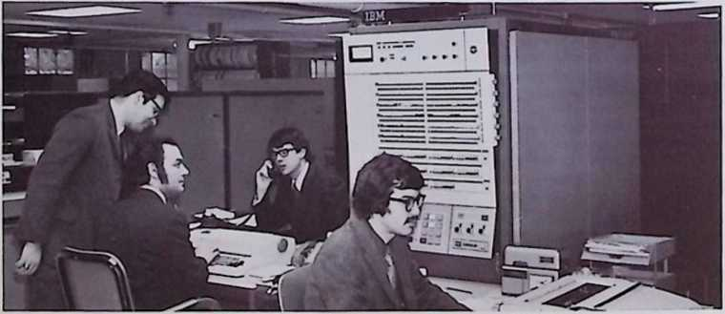
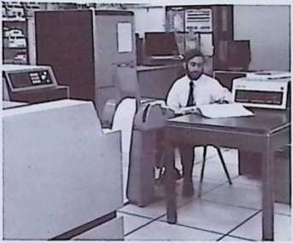

Teamwork Pays Dividends For Both PHI And Its Clients
The team (left to right) W. B. Morin, A. G. Yaffo, P. S. Kastner, R. A. Siegel.
Or. Gerry Paul tests now System/360 interface.
I (Use this handy form to get additional information on the PHI products or services
| described in these pages.)
■ UPDATE “DATA RET PI EV EP’’
□ Gonllomen:

j Please send mo more inputs on PHI’s
□

0
Q Name & Title —— —— .............. . ......
I

| Org an iza 11 on .. — — ......— ...........— ............ ......... ..........................
| Address ............. — .—... ..._{M}
City. Slate & Zip —..—.... —..
□ (Clip and mail to UPDATE Editor, PHI Computer Services, Inc.. 8C0 Massachusetts Avenue, Arlington, Massa
chusetts 02174.)
system, and a mutual fund processing
system. Other financial systems which have
been developed include a comprehensive
personal trust accounting system which
is completely responsive to the stringent
legal requirements of the Massachusetts Pro
bate Court System: a flexible general
ledger accounting system; and an on-line
terminal system that provides small account
ing firms with an accurate, fast, and
economical way to handle transaction data
entry, processing, and report functions
for their clients, while relieving them of the
enormous clerical burden inherent in a
manual operation.
Today the Financial Systems Group is com
mitted to applying the knowledge and
experience gained in the development of
these systems and PHI's proprietary software
packages to individual problems faced by
the financial community.
Systems Analysis and Design Group provides
consulting, product evaluation, and design
services to manufacturers developing
new products for the computer industry and
to users of the IBM Systems/360 and 370.
In the former area, the Group has worked
closely with manufacturers developing
products compatible to the IBM System/360
and System/370 product lines. Activities
include: consultation on IBM systems tech
niques and protocols to help the non-IBM
vendor understand the System/360 and
Syslem/370 environment: evaluation of
different design concepts with an eye towards
maximum product reliability, and competi
tive position; and the specification of
diagnostic software for testing new products.
The Group’s assignments range from a
few days' consulting to comprehensive
testing of systems utilizing PHI-developed
diagnostic routines and the facilities of the
PHI Data Center. To date, the Group has
assisted in the development and testing of
seven different System/360 multiplexor
and selector channel interfaces for teleproc
essing controllers and front-end communi
cation processors, as well as providing
nine different remote interfaces for IBM-
compatible terminal devices.
For sophisticated System/360 and
System/370 users, the Group has concen
trated on the continued development and
enhancement of the IBM Operating System
(OS/360). Typical of its achievements
have been the effective utilization of the
Ampex Extended Core Memory at the PHI
Data Center, the development of new
billing algorithms for the service bureau
environment which base rates upon machine
resources used rather than elapsed time,
effective utilization of new System/370
hardware, and improvements in the
System/360 telecommunications software.
Serving in the role of PHI's "think tank,” the
Group paves the way for large scale imple
mentation efforts which solve product
development, systems programming, and
telecommunications problems.
Systems Programming Group implements
sophisticated systems software and on-line
applications. In the former area, the Group
has developed assemblers, cross assemblers,
compilers, and operating systems for
leading manufacturers of computer equip
ment including: IBM, Honeywell, Hewlett-

Packard, and Sanders Associates. Some of
the Group's most significant efforts include:
the development of the tape and disk
utilities for the IBM System/360 Model 20
(systems software which is provided as
Class A support by IBM); disk IOCS for the
Honeywell H-516; the System/360-resident
simulator for the Hewlett-Packard 2100
series computers; and a real time operating
system for the SANDAC 200 communications
processor.
In addition to assisting computer manufac
turers, the Group has participated exten
sively with end-users in the design and
implementation of on-line systems. Projects
have ranged from the development of several
teleprocessing concentrators for use in
airline passenger reservation systems to the
implementation of an automated dirt com
paction test system for the New York State
Bureau of Soil Mechanics. One of the
Group's major accomplishments has been
the development of the PHI Telecommunica
tions Programming System (TPS) which is
People are PSD'S prime resource. Our
success in providing top quality professional
services to clients throughout the United
States, is directly attributable to the dedica
tion, professionalism, and teamwork of our
talented staff of consultants, analysts,
and programmers. We'd like you to meet a
few of the people that make our professional
activities possible.
Peter S. Kastner has been involved in the
development of a broad range of systems
and applications in the financial area, from
PHI's own internal accounting system to
a correspondent bank demand deposit
accounting system for a large Chicago bank.
He is presently a Systems Analyst with
PSD's Financial Systems Group.
Robert A. Siegel is a Supervisory Analyst
with PSD's Systems Analysis and Design
Group. In this professional capacity, he is
responsible for applying his special expertise
to projects in the areas of System/360
hardware and its Operating System (OS).
Among his achievements are the implemen
tation of Operating System modifications
to support efficient use of the Ampex ECM on
the PHI System/360 Model 65 and the
implementation and enhancement of
RJE/HASP.

regarded as the most comprehensive front
end software available for the IBM telecom
munications environment. This system, when
Implemented on a minicomputer, permits
operation both as a plug-for-plug replace
ment for an IBM 2700 series Transmission
Control Unit, and as a full front-end pre
processor which relieves the System/360
CPU of much of its communications over
head. This system is currently operating at
several locations, including the PHI Data
Center. TPS which can be considered as a
"customizable package,” is sold on a nation
wide basis to System/360 teleprocessing
installations. The Group also offers a series
of demonstration and diagnostic programs
designed to test, demonstrate, and maintain
IBM-compatible terminal devices. Programs
are currently available for the IBM 2260/2265
keyboard display units and for Binary Syn
chronous devices including the IBM 2780
and 3270. PHI is now regarded as one of the
foremost authorities on the IBM communi
cation environment.
Wollaston B. Morin is an expert in the area
of integrated business systems, having
designed and successfully implemented a
wide variety of accounting and management
information systems for commercial, indus
trial, and retail firms. A practical business
man, as well as a professional analyst, Wolly
now serves as Supervisory Analyst for PSD’s
Commercial Programming Group. In this
capacity, he is primarily involved in tech-
nical/marketihg activities. He holds a degree
in Business Administration from Boston
University.
Arthur G. Yafte possesses a broad profes
sional background in the area of minicom
puter assemblers, systems design in the
communications environment, operating
systems, and data communications facilities.
As a Supervisory Analyst with PSD’s Systems
Programming Group, Art has served as
project leader for the implementation of a
large on-line mutual fund system and for the
development of a System/360 front-end
preprocessor for a major insurance com
pany. Arthur holds a degree in Electrical
Engineering from Carnegie Institute of
Technology.

New PHITAX Package
Cuts Payroll Tax
Maintenance
PHI announces the development and
availability of PHITAX — a packaged module
for the calculation of Federal, State, and
local payroll tax deductions. The new module
has been designed for use with PHI Payroll
Systems, as well as most other payroll
systems. By generalizing tax calculation
procedures and isolating actual tax rates in
tables, the module reduces tax maintenance
expense.
In an actual payroll processing environment,
program control is passed from the payroll
system to PHITAX for tax calculation on
regular, supplemental or any other type of
payment. All calculation procedures are
accomplished and then individual tax tables
are accessed and deductions executed.
Because the tax tables are thus isolated, the
updating of any new tax information is
simplified and streamlined, and PHI esti
mates that PHITAX can reduce maintenance
time and expense. The PHITAX module is
written in COBOL, can be installed easily and
is available as either a package or as an
enhancement to PHI Payroll Systems. Pur
chasers of the new module are also provided
with installation manuals, training manuals,
and documentation, as well as a twelve
month warranty and maintenance contract
at no additional cost. For more information,
just fill out and mail the handy Data Retriever
coupon or contact James Lees.

Verification
The Update extends its congratulations to:
• James Lees — promoted to Manager of
Proprietary Products
• John Morse — promoted to Manager of
PSD's Systems Programming Group
• John Pryke — promoted to Sales Man
ager for Professional Services Division
We are pleased to welcome Leo Fleck to
PHI. Leo recently joined PSD’s staff as a
Senior Consultant. At PHI, Leo will direct
PSD’s newly formed consulting service group
for users of Honeywell Large Scale Systems.
As both a former Honeywell employee and a
user of Honeywell Large Scale Systems, Mr.
Fleck brings to his new assignment an
extensive professional background and
knowledge of the Honeywell environment.
We are also pleased to announce that Bob
McLaughlin, a familiar face to all of PHI's
Payroll users, has recently joined Profes
sional Services. Bob will be assisting our
Payroll customers in the use of PHI's
professional consulting and programming
services.

Systems Analysis And
Design Operates PHI’s
Computer Interface
Laboratory
Passing through the back corner of the PHI
Data Center, one is forced to stop and stare
at a collection of strange cabinets and
computers hooked to our System/360 Model
65. This area, nicknamed "PHI's Interface
Laboratory" represents a growing segment
of PHI’s business: developing and testing
360 channel interfaces — seven in all, each
with a different computer. The Honeywell
H-516, Bunker Ramo keyboard display
channel interface. Data General Nova. DEC
PDP-11, and Tempo 1 are among the ma
chines already tested by our laboratory.
Operated by PSD's Systems Analysis and
Design Group, the "Laboratory" is the final
testing ground of the Group's consulting
aclivilies with manufacturers of IBM-
compatible hardware. Answering basic
questions regarding IBM channel protocols,
reviewing interface hardware designs,
developing diagnostic and test programs for
both the System/360 and the device being
interfaced, providing test time on our
System/360 Model 65, and assisting during
tests, the Group has been referred to by
one client as "the Underwriters Laboratory
of the 360 Interface." One of our staff
members has even suggested blue tags for
each interface marked "Approved by PHI."
Data Measurements
Corporation Licensed To
Sell Special Version Of
PHI Airline Terminal
Support Package
Data Measurements Corporation of Santa
Clara, California, manufacturers of the DMC
201 hard-copy airline reservation terminal,
has recently been licensed to sell a type
writer-only version of the PHI Airline Ter
minal Support Package. The new version of
the package will support 32, 48, or 64 DMC

201 or IBM 1977 terminals from an 8K
Honeywell H-316 computer. The package is
designed as a direct replacement for the
Honeywell Programmable Terminal Inter
change software (which will only support 32
terminals) and allows an airline to add
more terminals without adding any new
H-316 hardware. It also provides error
logging and diagnostics for individual lines.
The new software is available either from
Data Measurements Corporation as part of a
terminal procurement or direct from PHI. The
package can be easily upgraded to support
standalone CRTs, as well as hard-copy
terminals. This feature provides emulation of
both an IBM 1006 and 2948 Terminal Inter
changes in a single H-316. The CRT-version
of the package has been in operation at
Texas International Airlines for over six
months.

Binary Synchronous
On-Line Diagnostic And
Demonstration Program
Now Available
Based upon the immediate success that
PHI's 2260/2265 Diagnostic and Demonstra
tion Program gained with CRT manufacturers
of 2260 compatible products, we have
developed a similar program for testing and
demonstrating IBM binary synchronous-
compatible devices. The new program sup
ports the following IBM terminal types and
their functional equivalents:
• 2780 Data Transmission Terminal
• 2770 Data Communications System
• 2972 General Banking Terminal System
• 2715 Transmission Control Unit
• 3270 Information Display System
• 3735 Programmable Buffered Terminal
• Programmable remote batch terminals
and concentrators which use Binary
Synchronous line discipline.
Users find that the program serves as an
engineering and marketing tool, as well as a
field testing facility for their respective
terminal.
For more information, fill out and mail the
Data Retriever form in this issue of Update
or contact Dick Stenger.
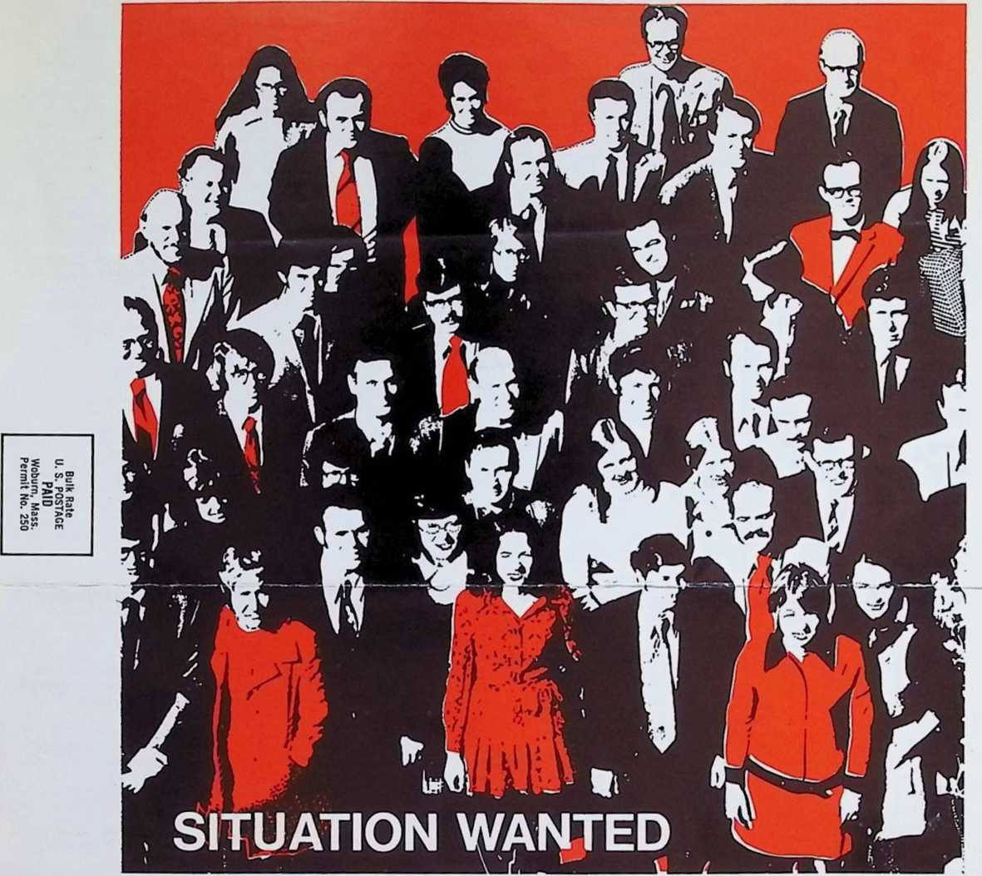


Opportunity to retain professional team with one
of the most successful track records in the
industry. In 12 years, we’ve grown from a small
group of "whizz kids" to third in the nation.
Particular expertise in product line software for
hardware manufacturers; System 360 interface;
on-line control; real-time systems; Commercial
Applications; IMS programming; and hardware
evaluation and consulting. Significant on-going
experience with leading corporations and institu
tions including Chase Manhattan Bank, Braniff
Airlines, Bunker-Ramo, Digital Equipment Cor
poration, Penn Mutual Life Insurance, Hewlett-
Packard, Marine Midland Banks, Honeywell
Computer Control Division and IBM. Success of our own packages (such as Telecommunications
Programming System, Payroll System, Fixed
Amount Billing, Cosmos, etc.) is proof of ability.
On-site Data Center (largest in New England)
available for development and implementation.
Will travel. Contact John Pryke at (617) 648-8550.
Subsidiary ol WANGL laboratories. Inc.

COMPUTER SERVICES, INC.
SOO MASSACHUSETTS AVE . ARLINGTON. MASS 02174 • (SI 7) 648 SSSO
consultants for systems applications and development -an array of
supporting software -a computer network offering sophisticated
hardware, software, and technical assistance - comprehensive data
processing services.

