0)
o
0
■ MH
o
E
O
■ MH
c5
E
o
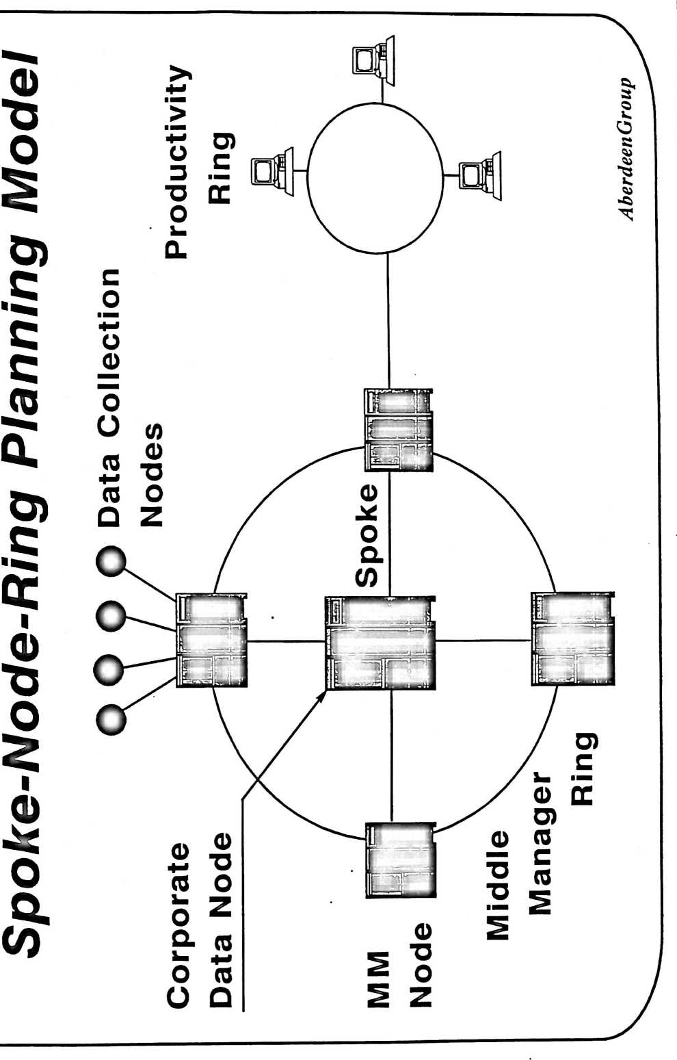
c
A Critical Technology^

Planning Areas
Hardware
Systems
Software

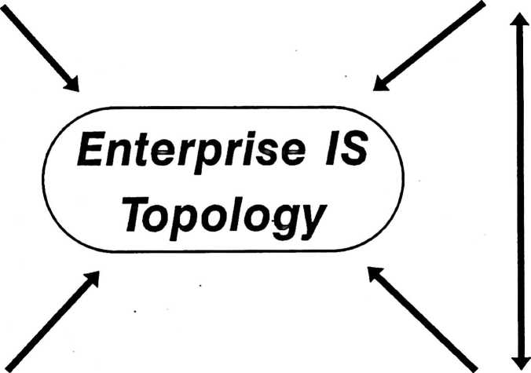

Networking
Application
Development
Acquisition

Enterprise
Topology
⁰ Three-tier Plus
State-of-the-art downsizing
Enterprise server Plus decision support

Production |  |  |  | ^{L}' - - ■ ^{J}
System | J | — | —

Analytical
System

Replicated/departmental systems
PCs, Workstations, Macs, Terminals
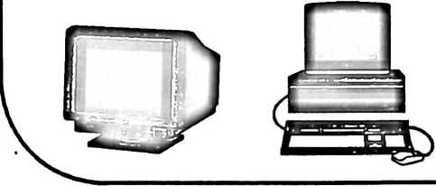
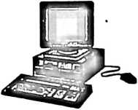

tetris®

T©[p©D©gy
© Client-server for future
Much hype -- minimal
application implementation
At least 6 common definitions

Interface
• Product Look-up
• Pricing Information
• Order Entry
• Master
Database
Enterprise spoke
• Current
inventory
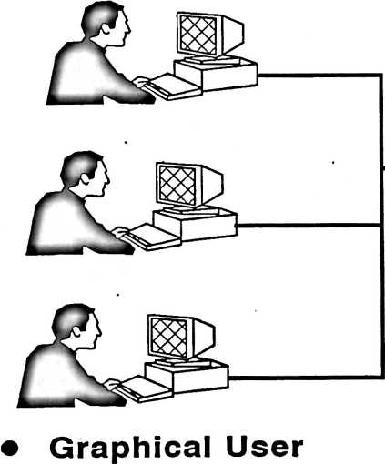
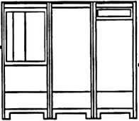

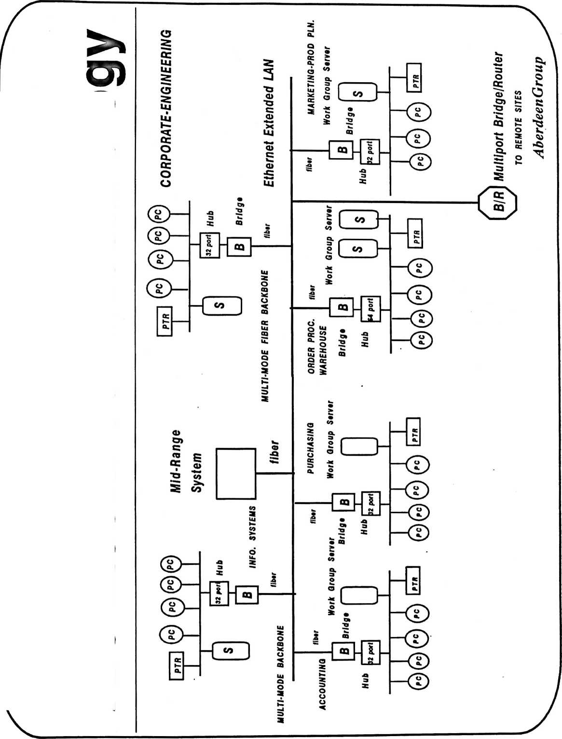
Blending Information
Architectures & Technolo

